**Cables and Connectors *FDD / HDD Cable***

|  |  |  |  |
| --- | --- | --- | --- |
|  | **SATA HDD Cable** | | |
|  |  |  |  |
| **Model Name** | **32801-000703-400-RS** | **32102-000100-100-RS** | **32000-080700-RS** |
| Cable Type | SATA HDD cable | SATA power cable | SATA + Power cable |
| Connector | SATA 7-pin | 4-pin + 2 x SATA 15-pin | SATA 7-pin + 4-pin |
| Connector Type | Lockable | SATA power connector |  |
| Length | 50 cm | 15 cm | SATA cable 20 cm  Power cable 10 cm |

|  |  |  |  |  |
| --- | --- | --- | --- | --- |
|  | **SATA HDD Cable** | | **IDE HDD Cable** | |
|  |  |  |  |  |
| **Model Name** | **32801-000201-300-RS** | **32801-000100-300-RS** | **CB-HD32-RS** | **32200-000009-RS** |
| Cable Type | SATA + Power cable | SATA + Power cable | IDE HDD flat cable | IDE HDD flat cable |
| Connector | SATA 7-pin + 2-pin wafer (P=2 mm) | SATA 7-pin + 4-pin wafer (P=2.54 mm) | 40p-44p | 44p-44p |
| Connector Type | 2-pin PH 2.0 | 4-pin PH 2.54 mm | 2.54mm-2.0mm | 2.0mm -2.0mm |
| Length | SATA cable 15 cm Power cable 15 cm | SATA cable 20 cm Power cable 20 cm | IDE cable: 39 cm Power cable: 20 cm | 40 cm |

|  |  |  |  |  |
| --- | --- | --- | --- | --- |
|  | **Serial cable** | | | |
|  |  |  |  |  |
| **Model Name** | **45002-008103-RS** | **19800-000300-100-RS** | **19800-010900-200-RS** | **19800-000051-RS** |
| Cable Type | Serial port | Serial port cable | Serial port cable | Serial port cable |
| Board Side | N/A | 10-pin (2x5) connector (2.0 mm) | 10-pin (2x5) connector (2.54 mm) | 2 x 10-pin (2x5) connector (2.54 mm) |
| Board Side Pitch | 2.54 mm | 2.0 mm | 2.54 mm | 2.54 mm |
| Device Side | 2 x DE9M | DE9M | DE9M | 2 x DE9M |
| Bracket | Yes | Yes | Yes | Yes |
| Length | 9 cm | 30 cm | 50 cm | 23 cm |

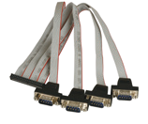

**Cables and Connectors *Paralle / Serial Cable***

|  |  |  |  |  |
| --- | --- | --- | --- | --- |
|  | **Serial cable** | | | |
|  |  |  |  |  |
| **Model Name** | **19800-003600-100-RS** | **19800-000112-RS** | **32205-000702-100-RS** | **32200-000049-RS** |
| Cable Type | Serial port cable | Serial port cable | Serial port cable | Serial port cable |
| Board Side | 2 x 10-pin (2x5)  connector (2.54mm) | 2 x 10-pin (2x5)  connector (2.0 mm) | 10-pin (2x5)  connector (2.54 mm) | 10-pin (2x5)  connector (2.0 mm) |
| Board Side Pitch | 2.54 mm | 2.0 mm | 2.54 mm | 2.0 mm |
| Device Side | 2 x DE9M | 2 x DE9M | DE9M | DE9M |
| Bracket | Yes | Yes | No | No |
| Length | 40 cm | 30 cm | 23 cm | 20 cm |

|  |  |  |  |
| --- | --- | --- | --- |
|  | **Serial cable** | | |
|  |  |  |  |
| **Model Name** | **32205-001203-200-RS** | **32200-025401-RS** | **19800-004400-200-RS** |
| Cable Type | Serial port cable | Serial port cable | RS-232 & RS-422/485 cable |
| Board Side | 40-pin (2x20)  connector (2.54 mm) | 40-pin (2x20)  connector (2.0 mm) | 14-pin (2x7)  connector (2.54 mm) |
| Board Side Pitch | 2.54 mm | 2.0 mm | 2.54 mm |
| Device Side | 4 x DE9M | 4 x DE9M | 2 x DE9M |
| Bracket | No | No | Yes |
| Length | 40/40/40/40 cm | 30 cm | 25.5 cm |

|  |  |  |  |
| --- | --- | --- | --- |
|  | **Serial cable** | | |
|  |  |  |  |
| **Model Name** | **19800-004300-100-RS** | **32200-026500-RS** | **32205-003800-300-RS** |
| Cable Type | RS-232 & RS-422/485 cable | RS-232 & RS-422/485 cable | RS-422/485 cable |
| Board Side | 14-pin (2x7)  connector (2.0 mm) | 14-pin (2x7)  connector (2.0 mm) | 4-pin (1x4)  connector (2.0 mm) |
| Board Side Pitch | 2.0 mm | 2.0 mm | 2.0 mm |
| Device Side | 2 x DE9M | 2 x DE9M | DE9M |
| Bracket | Yes | No | No |
| Length | 25 cm | 29 cm | 20 cm |

|  |  |  |  |
| --- | --- | --- | --- |
|  | **Paralle cable** | | |
|  |  |  |  |
| **Model Name** | **19800-000049-RS** | **19800-003500-100-RS** | **32223-000700-100-RS** |
| Cable Type | Parallel port cable | Parallel and  serial port cable | Parallel port cable |
| Board Side | 26-pin (2x13) connector (2.54 mm) | 26-pin (2x13) connector (2.0 mm) 10-pin (2x5)  connector (2.0 mm) | 26-pin (2x13) connector (2.0 mm) |
| Board Side Pitch | 2.54 mm | 2.0 mm | 2.0 mm |
| Device Side | DB25F | DB25F + DE9M | DB25F |
| Bracket | Yes | Yes | No |
| Length | 24 cm | 24 cm | 28 cm |

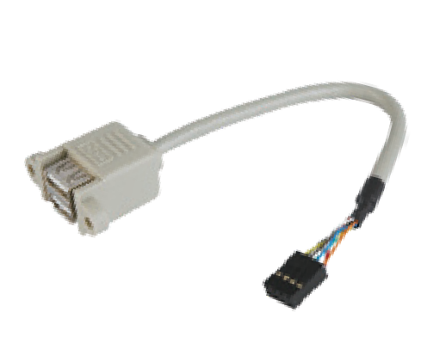**Cables and Connectors *USB / Keyboard / Mouse / Power Cable***

|  |  |  |  |  |
| --- | --- | --- | --- | --- |
|  | **USB cable** | | | |
|  |  |  |  |  |
| **Model Name** | **32001-010800-100-RS** | **32001-006404-100-RS** | **19800-000100-200-RS** | **19800-003100-300-RS** |
| Cable type | USB able | USB cable | USB cable | USB cable |
| Board side | 2 x 4-pin  connector (2.54 mm) | 2 x 4-pin  connector (2.0 mm) | 2 x 8-pin (2x4) connector (2.54 mm) | 2 x 4-pin (1x4) connector (2.54 mm) |
| Board side pitch | 2.54 mm | 2.00 mm | 2.54 mm | 2.54 mm |
| Device side | 2 x USB | 2 x USB | 4 x USB | 2 x USB |
| Bracket | No | No | Yes | Yes |
| Length | 20 cm | 22 cm | 30 cm | 30 cm |

|  |  |  |  |  |
| --- | --- | --- | --- | --- |
|  | **USB cable** | | | **Power cable** |
|  |  |  |  |  |
| **Model Name** | **CB-USB02A-RS** | **32000-044300-RS** | **32001-008600-200-RS** | **32100-087100-RS** |
| Cable type | USB cable | USB cable | USB cable | 12V power cable |
| Board side | 1 x 8-pin (2x4) connector (2.0 mm) | 1 x 8-pin (2x4) connector (2.54 mm) | 1 x 8-pin (2x4) connector (2.0 mm) | 1 x 4-pin (2x2) connector |
| Board side pitch | 2.0 mm | 2.54 mm | 2.0 mm |  |
| Device side | 2 x USB | 2 x USB | 2 x USB | 2 x 4-pin (1x4) molex |
| Bracket | Yes | No | No | No |
| Length | 30 cm | 21 cm | 21 cm | 13 cm |

|  |  |  |  |  |
| --- | --- | --- | --- | --- |
|  | **Keyboard / Mouse cable** | | | |
|  |  |  |  |  |
| **Model Name** | **19800-000066-RS** | **19800-000075-RS** | **32006-000300-100-RS** | **32000-023800-RS** |
| Cable type | Keyboard and mouse cable | Y-Cable | Y-Cable | Y-Cable |
| Board side | 2 x 5-pin (1x5) connector (2.54 mm) | 1 x 6-pin (1x6) connector (2.0 mm) | 1 x male PS/2 | 1 x 6-pin (1x6) connector (2.0 mm) |
| Board side pitch | 2.54 mm | 2.0 mm |  | 2.0 mm |
| Device side | 2 x Female PS/2 | 2 x Female PS/2 | 2 x Female PS/2 | 2 x Female PS/2 |
| Bracket | Yes | Yes | No | No |
| Length | 30 cm | 22 cm | 12 cm (KB) + 14 (MS) | 13 cm |

**Cables and Connectors *Audio / LAN / VGA / Adapter Cable***

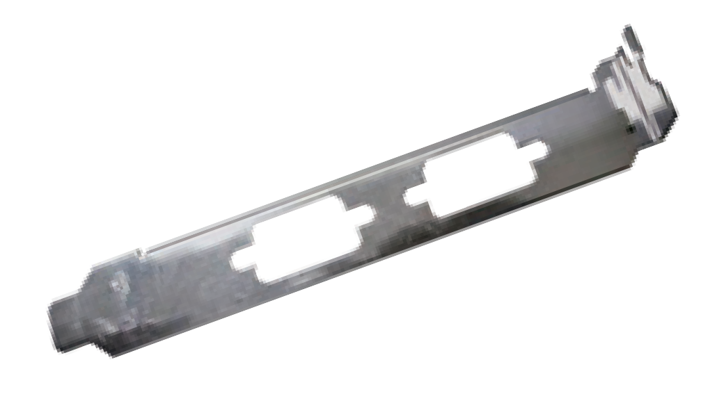

|  |  |  |  |  |
| --- | --- | --- | --- | --- |
|  | **Audio cable** | | | **Bracket** |
|  |  |  |  |  |
| **Model Name** | **19800-000111-RS** | **32007-002600-100-RS** | **32000-028800-RS** | **45002-0081C0-00-RS** |
| Cable type | Audio cable | Audio cable | Audio cable | COM port bracket |
| Board side | 10-pin (2x5) connector (2.0 mm) | 10-pin (2x5) connector (2.0 mm) | 12-pin (2x6) connector (2.54 mm) | - |
| Board side pitch | 2.0 mm | 2.0 mm | 2.54 mm | - |
| Device side | 3 x Audio jacks | 3 x Audio jacks | 4 x Audio jacks | - |
| Bracket | Yes | No | No | Yes |
| Length | 30 cm | 30 cm | 25 cm | - |

*Part numbers listed in the product catalog are for reference purposes. IEI reserves the right to implement substitution parts when the function is not affected.*

# Rackmount Slide

***Optional Chassis Accessories***

|  |  |  |
| --- | --- | --- |
|  | **SLIDE** | |
|  |  |  |
| **Model Name** | **SLIDE-18** | **SLIDE-24** |
| **Specification** | 18" rackmount slide | 24" rackmount slide |
| **Description** | For rackmount chassis w/ depth up to 500 | For rackmount chassis w/ depth up to 600 |

# DIN Rail Kit

|  |  |  |  |
| --- | --- | --- | --- |
|  | **KIT** | | |
|  |  |  |  |
| **Model Name** | **DK-75-R10** | **DK-100-R10** | **DK-84MB** |
| **Specification** | 850 mm (W) x 75mm (D) | 110 mm (W) x 100 mm (D) | 168 mm (W) x 96 mm (D) |
| **Description** | VESA 75 to DIN-rail kit | VESA 100 to DIN-rail kit | DIN mount kit for ECW-281 series, black, RoHS |