**AIMB-217**

Intel Pentium , Celeron & Atom x7

Mini-ITX with HDMI/DP/VGA, 6 COM, and Dual LAN

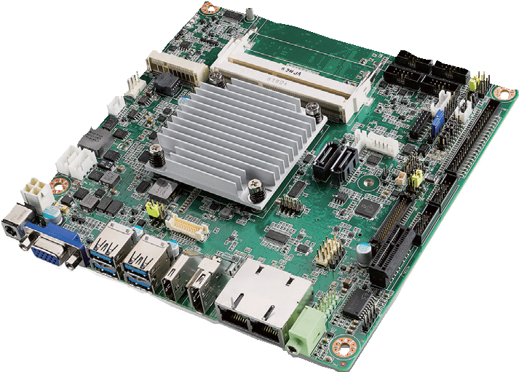

**NEW**



**Features**

* Supports Intel Pentium, Celeron Quad Core & Dual Core processor
* Two 204-pin SO-DIMM up to 8 GB DDR3L 1866 MHz SDRAM
* Supports DP 1.2/HDMI 1.4b/VGA
* Supports 1 PCIE x1 and 1 M.2 (E key) + 1 MiniPCIe, 6 COMs, 4 USB 3.0, and

4 USB 2.0

* Lower total cost of ownership with DC12V support and onboard TPM1.2/2.0 (optional)
* Supports WISE-PaaS/RMM and Embedded Software APIs

**Software APIs:**

H/W Monitor Brightness Watchdog GPIO

**Utilities:**

BIOS flash Monitoring

Specifications

|  |  |  |
| --- | --- | --- |
| Processor System | CPU (14nm) | N4200 N3350 x7-E3950 |
| Core Number | 4 2 4 |
| Max. Speed | 1.1 GHz 1.1 GHz 1.6 GHz |
| BIOS | AMI 128 Mbit SPI |
| Expansion Slot | M.2 E key for wireless module (Type: 2230) | |
| Mini-PCIe | 1 (F/S with SIM card holder) |
| PCIe | PCI Express x1 (Gen2), colay M.2 E key |
| Memory | Technology | Dual channel DDR3L 1866 MHz SDRAM |
| Max. Capacity | 8 GB/8 GB per SO-DIMM |
| Socket | 2 x 204-pin SO-DIMM (Non-ECC) |
| Graphics | Controller | Intel Gen 9 Graphics Engines and media encode/decode engine |
| VGA/eDP | 1 VGA supports up to 1920 x 1200 @ 60Hz co-lay eDP. eDP is BOM optional which supports up to 4096 x 2160 @ 60 Hz |
| HDMI | 1 HDMI 1.4b supports up to 3840 x 2160 @ 30 Hz |
| DP++/LVDS | 1 DP 1.2 supports up to 4096 x 2160 @ 60 Hz; co-lay with LVDS supports dual channel 48-bit up to 1920 x 1200 |
| Triple display | VGA (or EDP) + DP (or LVDS) + HDMI |
| Ethernet | Interface | 10/100/1000 Mbps |
| Controller | GbE LAN1: Realtek 8111G GbE LAN2: Realtek 8111G |
| Connector | RJ-45 x 2 |
| SATA | Max Data Transfer Rate | 600 MB/s |
| Channel | 2, SATA 2 colay mSATA |
| Rear I/O | VGA | 1 |
| DP 1.2 | 1 |
| HDMI 1.4b | 1 |
| Ethernet | 2 |
| USB | 4 (USB 3.0) |
| Audio | 1 (supports Line-out by default, converts to Mic in or Line in) |
| DC jack | 1 (2.5 mm) |
| Internal Connector | LVDS & Inverter | 1/1 |
| eDP | 1 (optional) |
| USB | 4 (USB 2.0) |
| Serial | 6 (5 x RS-232, 1 x RS-232/422/485; COM 3 support RS-232/422/485 auto flow control; COM 6 support 5V/12V by jumper selection) |
| IDE | None |
| SATA | 2 |
| SATA PWR Connector | 2 |
| Parallel | None |
| Mini-PCIe | 1 (F/S with SIM card holder), co-lay mSATA |
| M.2 1 (E key for wireless module support) | |
| GPIO | 8-bit |
| PS/2 KB & MS | 1 |
| Watchdog Timer | Output | System reset |
| Interval | Programmable 1 ~ 255 sec/min |
| Power | Power Type | Single voltage 12V DC input; 1 x External DC jack; 1 x Internal 4-pin (2x2) power connector; Supports AT/ATX mode |
| Typical Power Consumption | Windows Idle mode: 7.546W (Intel N4200 1.1GHz /DDR3L 1866MHz 4GB x 2pcs) |
| Environment | Operating Non-Operating | |
| Temperature | 0 ~ 60° C (32 ~ 140° F) with 0.7m/s air flow  (for D/N SKU) -40 ~ 85° C (-40 ~ 185° F)  -20 ~ 70° C (-4 ~ 158° F) with 0.7m/s air flow (for Z SKU) |
| Physical Characteristics | Dimensions | 170 x 170 mm (6.69" x 6.69") |

**Industrial Motherboards & Systems**

All product specifications are subject to change without notice. Last updated: 17-Oct-2018

AIMB-217

|  |
| --- |
| 4 USB 3.0 port |
| 8 USB 2.0 ports (USB910 & USB1112 is optional) |
| Realtek Audio Codec ALC888S |
| BIOS |

Ordering Information

**Block Diagram**

Channel A

Channel B

48-bit LVDS

PCIe x1

600 MB/s

PCIe x1

USB 3.0

SATA

USB 2.0

PCIex1/USB)

(PCIex1/USB signal) PCIe x1

HD Audio

SPI

LPC

2 SATA ports (SATA2 colay mSATA)

eDP (colay VGA, optional)

DP 1.2 (colay LVDS)

HDMI 1.4b

5 RS-232, 1 RS-232/422/485

PS/2, WDT,

8-bit GPIO

Infineon TPM 1.2/2.0 (optional)

Super I/O Nuvoton NCT6106D

PCIe x 1 slot (colay M.2 E key)

M.2 E key (co-lay PCIex1)

Full-size MiniPCIe with

SIM card holder (co-lay mSATA)

GbE LAN2:

Realtek RTL8111G

GbE LAN1:

Realtek RTL8111G

VGA (colay eDP)

LVDS (colay DP)

DDR3L 1866 MHz SO-DIMM

DDR3L 1866 MHz SO-DIMM

Intel N4200/ N3350/x7-E3950

processor

|  |  |  |  |  |  |  |  |  |  |  |  |  |  |  |  |  |
| --- | --- | --- | --- | --- | --- | --- | --- | --- | --- | --- | --- | --- | --- | --- | --- | --- |
| **Part Number** | **CPU** | **Memory** | **VGA/eDP** | **HDMI** | **DP/LVDS** | **GbE LAN** | **COM** | **SATA III** | **USB3.0/2.0** | **MiniPCIe** | **M.2** | **TPM** | **AMP** | **PCIex1** | **Thermal Solution** | **Operating Temp.** |
| AIMB-217D-S6A1E | N4200 | 2 | 1 / (1) | 1 | 1 | 2 | 6 | 2 | 4/4 | 1 (F/S) | 1 | (1) | (2 x 6W) | 1 | Passive | 0 ~ 60° C |
| AIMB-217N-S6A1E | N3350 | 2 | 1 / (1) | 1 | 1 | 2 | 6 | 2 | 4/4 | 1 (F/S) | 1 | (1) | (2 x 6W) | 1 | Passive | 0 ~ 60° C |
| AIMB-217Z-S6A1E | x7-E3950 | 2 | 1 / (1) | 1 | 1 | 2 | 6 | 2 | 4/4 | 1 (F/S) | 1 | (1) | (2 x 6W) | 1 | Passive | -20 ~ 70° C |

Note: Passive = fanless

* () BOM options available on MP version

Packing List

|  |  |  |
| --- | --- | --- |
| **Part Number** | **Description** | **Quantity** |
| 1700003194 | SATA HDD cable | 1 |
| 1700018785 | SATA power cable | 1 |
| 1700008876 | 1-to-4 serial ports cable kit, 35 cm | 1 |
| 1700100250 | 1-to-1 serial port cable, 25 cm | 2 |
| 1960079933T000 | I/O port bracket | 1 |
| 2006B21701 | Startup manual | 1 |
| 1960064228N001 | Fanless heatsink for AIMB-217D/N | 1 |
| 1960071473T011 | Fanless heatsink for AIMB-217Z | 1 |

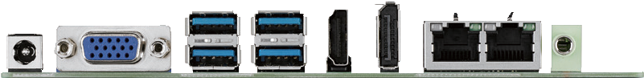I/O View

Optional Accessories

|  |  |
| --- | --- |
| **Part Number** | **Description** |
| 96PSA-A60W12V1-1 | Adapter AC100-240V 60W +12V/5A |
| 96PSA-A84W12V1 | Adaptor AC100-240V 84W, 12V/7A |
| 1703060191 | KBMS cable 1*6P-2.5/DIN-6P(F)*2, 25 cm |
| 1700023082-11 | ATX 2*10P to 1*3P-2.0 15cm cable |
| 1700024790-01 | A Cable USB-A 4P(F)*2/2*5P-2.0 20CM F/10 |
| 1700023474-01 | A Cable USB-A 4P(F)*2/2*5P-2.0 34.5CM F/10 |

Optional Chassis Embedded OS/API

|  |  |
| --- | --- |
| **Part Number** | **Description** |
| AIMB-B2000-00YE | Mini-ITX chassis with optional DC Adaptor |

|  |  |  |
| --- | --- | --- |
| **OS/API** | **Part No.** | **Description** |
| Win 10 IoT | 2070014970 | img W10 16EL AIMB-217 64bit 1701 Eng |

**Online Download** [www.advantech.com/products](http://www.advantech.com/products)