# LGA775 Intel® Core™2 Quad SBC with VGA/DVI/Dual GbE LAN

**PCA-6011**

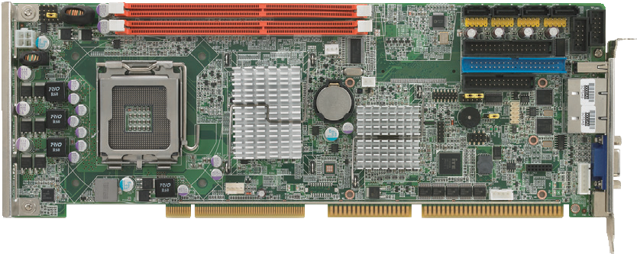

DDR3 1333

Max 8GB

USB * 8

LPT SATA * 4

COM1 COM2

FDD IDE

LAN2

LAN1 VGA1

KBMS1

Core™ 2 Quad

FSB 1333 MHz

Processors

G41

ICH7/ICH7R LPC1 DVI HDAUD1

**Features**

* Compliant with PICMG 1.0
* Supports LGA 775 Intel® Core™2 Quad FSB 1333 MHz processors
* Supports Dual Channel DDR3 1333 SDRAM up to 8 GB
* Dual GbE LAN via two PCIe x1 lane
* 2 COM ports, 4 SATA ports, 8 USB ports
* Dual display with VGA and DVI-D (G2 only)

**Specifications**

|  |  |  |
| --- | --- | --- |
| Processor System | CPU (45nm/65nm) | Intel Core 2 Quad Intel Core 2 Duo Intel Pentium Intel Celeron |
| Max Speed | Q9650 3.0 GHz E8500 3.16 GHz E6500 2.93 GHz E1500 2.2 GHz |
| L2 Cache | 12 MB 6 M 8 M 512 KB |
| Chipset | Intel G41 + ICH7/ICH7R (only for G2 SKU) |
| BIOS | AMI 16 Mb SPI Flash |
| FSB | 800/1066/1333 MHz |
| Bus | PCI | 32 bit/33 MHz PCI |
| ISA | HISA (ISA High Driver) |
| Memory | Technology | Dual-channel DDR3 800/1066/1333 DIMMs |
| Max. Cap. | 8 GB |
| Socket | 240-pin DIMM x 2 |
| Graphics | Controller | Intel Graphics Media Accelerator X4500 |
| VRAM | Shared with system memory up to 352 MB |
| Video Output | 15-Pin VGA D-sub Connector x1/DVI connector x1 (only for G2 SKU) |
| Ethernet | Interface | 10/100/1000 Mbps |
| Controller | Intel 82583 V |
| Connector | RJ-45 with LED Connector x 2 (G2 SKU), x1 (VG SKU) |
| SATA | Bandwidth | 300 MB/s |
| Channel | 4 ports |
| RAID | 0, 1, 5, 10 (only for G2 SKU) |
| EIDE | Mode | ATA 100/66/33 |
| Channel | 1 (Supports up to 2 IDE devices; Master device is alternative for CF socket) |
| CF | (Optional) |
| I/O Interface | USB 2.0 | 8 ports by pin header(VG SKU); 6 ports by pin header/1 port on bracket I/O (G2 SKU) |
| Serial | 2 RS-232 on board pin-headers, plus for ports of RS-485 with auto-flow control by module (optional, Advantech P/N: PCA-COM485-00A1E) |
| 1 (EPP/ECP/SPP) | |
| FDD | 1 |
| PS/2 | 1 (for mouse and keyboard, Y cable is included in the package) |
| Watchdog Timer | Output | System reset |
| Interval | Programmable, 1~255 sec |
| Miscellaneous | Audio Output | Intel High Definition audio interface  (requires an audio extension module P/N: PCA-AUDIO-HDA1E) |
| Power Requirement | CPU | Configuration1: Core 2 Quad Q9400 (3.0 G, 95 W) + DDR3 1066 2 G x2 |
| Voltage | +12 V +5 V +3.3 V +5 VSB -12 V -5 V |
| Curent | 5.14 A 4.04 A 0 A 0.17 A 0 A 0 A |
| CPU | Configuration 2: Core2 Duo E8400 (3.0G, 65W) + DDR3 1066 2 GB x2 |
| Voltage | +12 V +5 V +3.3 V +5 VSB -12 V -5 V |
| Curent | 3.63 A 3.4 A 0 A 0.15 A 0 A 0 A |
| Environment | Operating Non-Operating | |
| Temperature | 0 ~ 60 °C (32 ~ 140 °F) -40 °C ~ 85 °C  (operating humidity: 40 °C @ 85% RH Non-Condensing) and 60 °C @ 95% RH Non-Condensing |
| Physical | Dimensions (L x H) | 338 x 122 mm (13.3" x 4.8") |

**Slot SBC & Passive Backplanes**

All product specifications are subject to change without notice. Last updated: 13-Sep-2017

# PCA-6011

1066 / 1333

MHz FSB

**Ordering Information**

LPC Bus

PCI Bus

HD Audio

USB 2.0/1.1

PCI Bus

300 MHz

PCIe x1

DMA 33/66/100

PCIe x1

Channel B

Display port

Channel A

VGA

**Block Diagram**

GPIO

2 COM

Ports

Super I/O Winbond 83627DHG-P

BIOS

Backplane (PICMG 1.0)

HD Audio (Optional)

8 USB Ports

PCI to ISA Bridge ITE8888

4 SATA II Ports

G-LAN2

Intel 82583V

ICH7/ ICH7R

IDE

G-LAN1

Intel 82583V

DDR3 800/1066/1333

DVI

(only for G2 SKU)

G41 GMCH

CRT

DDR3 800/1066/1333

Intel LGA775 C2Q/C2D

SPI

|  |  |  |  |  |  |  |  |  |
| --- | --- | --- | --- | --- | --- | --- | --- | --- |
| **Part Number** | **LAN** | **VGA** | **COM** | **SATA** | **S/W RAID** | **USB** | **DVI** | **CF** |
| PCA-6011VG-00A1E | Single GbE | Yes | 2 | 4 | - | 8 | No (Optional) | No (Optional) |
| PCA-6011G2-00A1E | Dual GbE | Yes | 2 | 4 | Yes | 7 | Yes | No (Optional) |

**Packing List**

|  |  |  |
| --- | --- | --- |
| **Part Number** | **Description** | **Quantity** |
| 1701400452 | IDE HDD cable | x 1 |
| 1700008461-11 | USB cable with 4 ports | x 1 |
| 1700022749 | Serial ATA HDD power cable | x 1 |
| 1700003194 | Serial ATA HDD data cable | x 2 |
| 1700060202 | Y-cable for PS/2 mouse & keyboard | x 1 |
| 1701260305 | Printer + COM cable | x 1 |
| 9689000068 | Jumper pack | x 1 |
| 2190000902 | Warranty card | x 1 |
| 2002601110 | Startup manual | x 1 |
| 2062601100 | Utility CD | x 1 |

**I/O View**

**Optional Accessories**

|  |  |
| --- | --- |
| **Part Number** | **Description** |
| 1750000332 | LGA 775 CPU cooler for 115 W TDP CPUs |
| PCA-AUDIO-HDA1E | Audio extension module |
| 1701090401 | Single COM cable kit |
| PCA-COM485-00A1E | 4 x 422/485 COM module |
| 1700008822-11 | DVI-D cable |

DMI

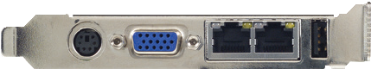 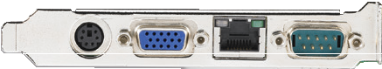

PCA-6011G2-00A1E PCA-6011VG-00A1E

**Online Download** [www.advantech.com/products](http://www.advantech.com/products)