

**ARK-2232L** **Intel® Atom® E3940 SoC Modular Fanless Box PC**

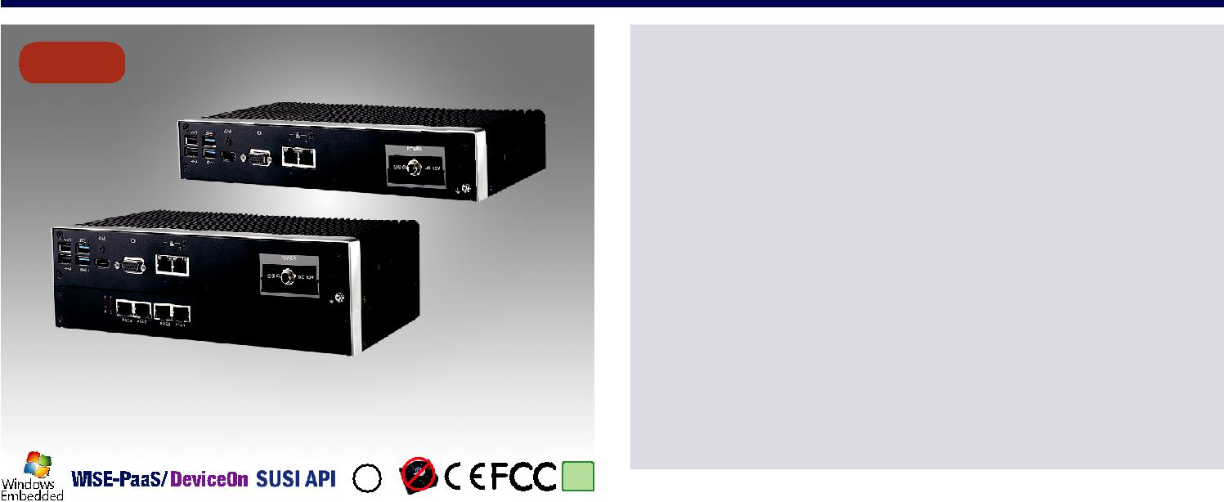

**NEW**

*Dual Layer model is ARK-2232 with ARK Plus module

**LISTED**

|  |  |  |
| --- | --- | --- |
| **C U®L US** | **RoHS** |  |
| **COMPLIANT** |  |
| **2002/95/EC** |  |

*E180881*

**Specifications**



**Features**

**** Intel®Atom®E3940 Quad Core SoC

**** Dual independent displays with one 4K HDMI and one VGA **** 12V lockable DC jack power input

**** 9-36V power module compatible with all-in-one ordering **** -20 ~ 60 °C extend operating temperature

**** Mini PCIe expansion with SIM holder for communication module **** M.2 NGFF 2230 E Key for WiFi communication module **** mSATA and 1 x 2.5" SATA storage device

**** Advantech iDoor module compatible

**** Advantech EMIO miniPCIe module compatible with all-in-one ordering **** Advantech MIOe module compatible with all-in-one ordering (2 Layers)

|  |  |  |  |
| --- | --- | --- | --- |
|  |  | ARK-2232L-S6A1 |  |
|  | CPU | Intel Atom E3940 Quad Core SoC |  |
| Processor System | Frequency | 1.6 GHz, turbo burst 1.8 GHz |  |
| L2 Cache | 2MB |  |
|  |  |
|  | BIOS | AMI EFI 64-bit |  |
|  | Technology | DDR3L 1866 MHz |  |
| Memory | Max. Capacity | 8 GB |  |
|  | Socket | 1 x 204-pin SO-DIMM |  |
|  | Chipset | Intel HD Graphics 500 |  |
|  | Graphic Engine | 4K Codec Decode& Encode for H.264, MPEG2, MVC, VC-1, WMV9, H.265 / HEVC, VP8, JPEG / MJPEG |  |
| Graphics | VGA | Up to 1920 x 1200 @ 60Hz |  |
|  | HDMI | HDMI 1.4b for HD video playback, 3840 x 2160 at 30Hz |  |
|  | Dual Display | Yes, VGA + HDMI |  |
| Ethernet | LAN1 | 10/100/1000 Mbps Intel i210-IT GbE, supports Wake On LAN |  |
| LAN2 | 10/100/1000 Mbps Intel i210-IT GbE, supports Wake On LAN |  |
|  |  |
| Audio | Interface | Realtek ALC888S, High Definition Audio. Line-out, Mic-in |  |
|  | Serial Ports | 2 x RS-232 ports, 2 x RS-232/422/485 port with auto flow control |  |
| IO Interface | Digital I/O | 8-bit programmable general purpose input/output |  |
| USB Interface | 2 x USB 3.0, 4 x USB 2.0 |  |
|  |  |
|  | TPM | TPM 2.0 power by Infineon SLB9665TT2.0 (by project support) |  |
| Other | Watchdog timer | 255 levels timer interval, setup by software |  |
| Expansion | Mini PCIe | 1 x full size Mini PCIe with SIM holder (PCIex1, USB 2.0, UIM, SATA III) |  |
| M.2 | 1 x M.2 2230 E Key (PCIex1, UBS 2.0) |  |
|  |  |
| Storage | HDD | Supports one SATA 2.5" HDD Bay (Compatible with 12.5mm height HDD) (Max. Data Transfer Rate 300 MB/s) |  |
| mSATA | 1 x full size mSATA socket (share with miniPCIe) |  |
|  |  |
| Software Support | Microsoft Windows | Windows 10 |  |
| Linux | Support by project |  |
|  |  |
|  | Power Type | AT/ATX |  |
| Power Requirements | Power Input Voltage | 12VDC (9-36V as option) |  |
| Minimum Power Input | 12 V, 5 A |  |
|  |  |
|  | Power Adapter | AC to DC, DC12V/5A, 60W (Optional) |  |
| Power Consumption | Typical | 7.79W |  |
| (CPU/Memory only) | Max. | 17.48W |  |
|  | Construction | Aluminum housing |  |
| Mechanical | Mounting | Desk/Wall-mounting (Default), Din-Rail mounting (Optional kit), VESA mounting (Optional kit) |  |
| Dimensions (W x H x D) | 260 x 44 x 140.2 mm (10.24" x 1.73" x 5.52") |  |
|  |  |
|  | Weight | Net Weight: 1.9kg (4.19 lbs); Gross Weight: 2.9kg (6.39 lbs) |  |
|  | Operating Temperature | With extended temperature peripherals: -20 ~ 60 °C (-4 ~ 140 °F) with 0.7m/s air flow |  |
|  | With 2.5-inch hard disk 0 ~ 40 °C (32 ~ 104 °F) with 0.7m/s air flow |  |
|  |  |  |
|  | Storage Temperature | - 40 ~ 85 °C ( -40 ~ 185 °F) |  |
| Environment | Relative Humidity | 95% @ 40 °C (non-condensing) |  |
| Vibration During Operation | With SSD: 3 Grms, IEC 60068-2-64, random, 5 ~ 500 Hz, 1 hr/axis. |  |
|  |  |
|  | Shock During Operation | With SSD: 30 G, IEC 60068-2-27, half sine, 11 ms duration |  |
|  | EMC | CE/FCC Class B, CCC, BSMI |  |
|  | Safety Certifications | UL, CB, CCC, BSMI |  |



**Fanless Embedded Box PCs**

All product specifications are subject to change without notice. Last updated: 29-Apr-2019

**ARK-2232L**

**Dimensions**

Unit: mm

|  |  |  |  |  |
| --- | --- | --- | --- | --- |
|  |  | Ø4.0 |  |  |
|  |  | Ø5.0 |  |  |
| 140.20 |  | 578.06. | 140.20 |  |
|  | 78.6 | 276.0 |  |  |
|  |  |  |  |
| 260.00 |  | 260.40 |  |  |
|  |  |  |  |
| 044. |  |  |  |  |
|  |  | 288 |  |  |
| **Front Panel External I/O Mechanical Layout/Drawing** | **Rear Panel External I/O Mechanical Layout/Drawing** | | |  |
|  |  |  | COM1 |  |
|  |  | COM2 | Digital IO |  |

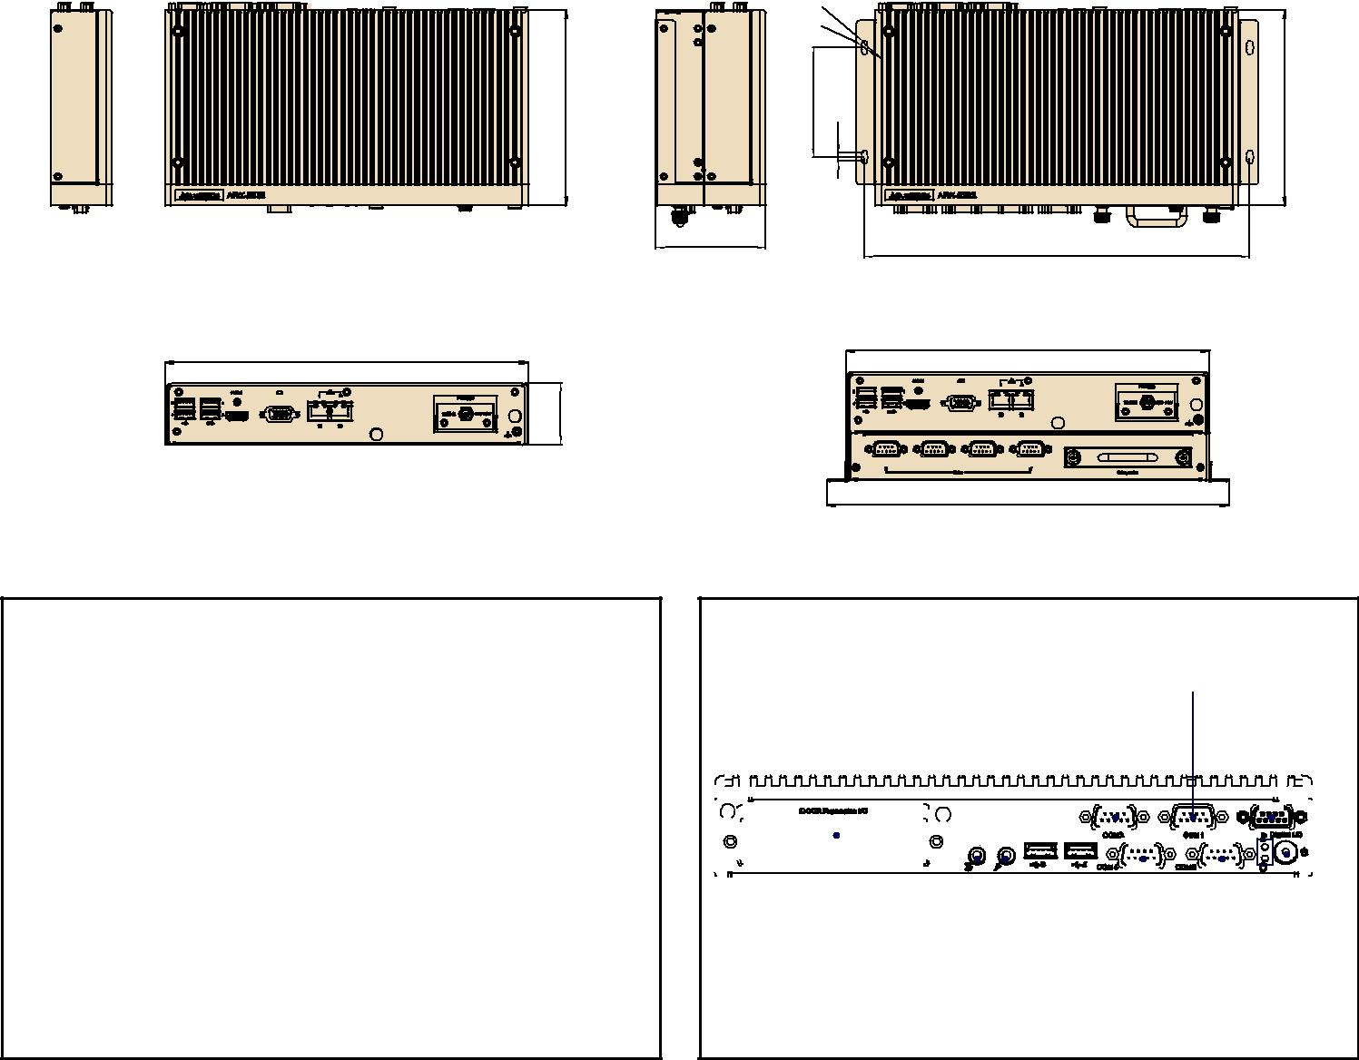

|  |  |  |  |  |  |  |  |  |  |  |  |  |  |  |  |  |  |  |  |  |  |  |  |  |  |  |  |  |  |  |  |  |  |  |  |  |  |  |  |  |  |  |  |  |  |  |  |  |  |  |  |  |  |  |  |  |  |  |  |  |  |  |  |  |  |  |  |  |  |  |  |  |  |  |  |  |  |  |  |  |  |  |  |  |  |  |  |  |  |  |  |  |  |  |  |  |  |  |  |  |  |  |  |  |  |  |  |  |  |  |  |  |  |  |  |  |  |  |  |  |  |  |  |  |  |  |  |  |  |  |  |  |  |  |  |  |  |  |  |  |  |  |  |  |  |  |  |  |  |  |  |  |  |  |  |  |  |  |  |  |  |  |  |  |  |  |  |  |  |  |  |
| --- | --- | --- | --- | --- | --- | --- | --- | --- | --- | --- | --- | --- | --- | --- | --- | --- | --- | --- | --- | --- | --- | --- | --- | --- | --- | --- | --- | --- | --- | --- | --- | --- | --- | --- | --- | --- | --- | --- | --- | --- | --- | --- | --- | --- | --- | --- | --- | --- | --- | --- | --- | --- | --- | --- | --- | --- | --- | --- | --- | --- | --- | --- | --- | --- | --- | --- | --- | --- | --- | --- | --- | --- | --- | --- | --- | --- | --- | --- | --- | --- | --- | --- | --- | --- | --- | --- | --- | --- | --- | --- | --- | --- | --- | --- | --- | --- | --- | --- | --- | --- | --- | --- | --- | --- | --- | --- | --- | --- | --- | --- | --- | --- | --- | --- | --- | --- | --- | --- | --- | --- | --- | --- | --- | --- | --- | --- | --- | --- | --- | --- | --- | --- | --- | --- | --- | --- | --- | --- | --- | --- | --- | --- | --- | --- | --- | --- | --- | --- | --- | --- | --- | --- | --- | --- | --- | --- | --- | --- | --- | --- | --- | --- | --- | --- | --- | --- | --- | --- | --- | --- | --- |
|  |  |  |  |  |  | | | | | | | | | | | | | | | | | | | | | | | | | | | | | | | | | | | | | | | | | | | | | | | | | | | | | | |  |  |  |  | | | | | | | | | | | | | | | | | | | | | | | | | | | | | | | | | | | | | | | | | | | | | | | | | | | | | | | | | | | | | | | | | | | |  | | | | | | | | | | | | | | | | | | | | | | | | | | | | | | |  | | | | | | | |  | |
|  |  | | | | |  |  | | | |  | | | | | | | | |  | | | | | | | | | | | | | |  | | | | | | | | | | | | | | | | |  | | | | | | | | | | |  |  | | | | | | | | | | | | | | | | | | | |  | | | | | | | | | | | | | | | | | | | | | | |  | | | | |  | | | | | | | | | |  | | | | | | | | | | | | | | | | |  | | | | | | | | | | | | | |  | | | | | | | | |  | | |  | | | | | |  |  |
|  | | | | | |  |  | | | |  | | | | | | | | |  | | | | | | | | | | | | | |  | | | | | | | | | | | | | | | | |  | | | | | | | | | | | | | | | | | | | | | | | | | | | | | | | |  | | | | | | | | | | | | | | | | | | | | | | |  | | | | |  | | | | | | | | | |  | | | | | | | | | | | | | | | | |  | | | | | | | | | | | | | |  | | | | | | | | |  | | | | | | | | | |  |
| USB3 USB1 | | | | | | | | | | | VGA | | | | | | | | | | | | | | | | | | | | | | | DC INPUT | | | | | | | | | | | | | | | | | | | | | | | | | | | | | | | | | | | | | | | i Door Module | | | | | | | | | | | | | | | | | | | | | | | | | | | | | | | | | MIC-IN | | | | | | | | | | | | | | | COM4 | | | | | | | | | | | | | | | | | | | | | | | | | | | | | | | PWR LED | | | | | | | | | | | | | | | | | | |  |
| USB4 USB2 | | | | | | | | | | |  | | | | | | | | | | | | | | | | | | | | | | |  | | | | | | | | | | | | | | | | | | | | | | | | | | | | | | | | | | | | | | | | | | | | | | | | | | | | | | | | | | | | | | | | | | | | | | | |  | | | | | | | | | | | | | | |  | | | | | | | | | | | | | | | | | | | | | | | | | | | | | | | HDD LED | | | | | | | | | | | | | | | | | | |  |
| HDMI | | | | | | | | | | | | | | | | | | | | | | | | LAN2 LAN1 | | | | | | | | | | | | | | | | | | | | | | | | | | | | | | | | | | | | | | | | | | | | | | | | | | | | | | | | | | | | | | | | | | | | | | | | | LINE-OUT USB5 | | | | | | | | | | | | | | | | | | | | | | | | | | | | | | | | | | | | | | | | | | | | | | | | | COM3 ON/OFF | | | | | | | | | | | | | | | | | | | | | | | | | |
| USB6 | | | | | | | | | | | | | | | | | | | | | | | | | | | | | | | | | | | | | | | | | | | | | | | | | | | | | | | | | | | | | | | | | | | | | | | | | | | | | | | | | | | | | | | | | | | | | | | | | | | | | | | | | | | | | | | | | | | | | | | | | | | | | | | | | | | | | | | | | | | | | | | | | | | | | | | | | | | | | | | | | | | | | | | | | | | |
| *Power Input module by option | | | | | | | | | | | | | | | | | | | | | | | | | | | | | | | | | | | | | | | | | | | | | | | | | | | | | | | | | | | | | | | | | | | | | | | | | | | | | | | | | | | | | | | | | | | | | | | | | | | | | | | | | | | | | | | | | | | | | | | | | | | | | | | | | | | | | | | | | | | | | | | | | | | | | | | | | | | | | | | | | | | | | | | | | | | |

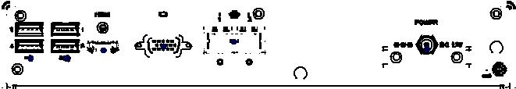

**Ordering Information**

|  |  |  |  |  |  |  |  |  |  |  |  |  |  |  |  |  |  |
| --- | --- | --- | --- | --- | --- | --- | --- | --- | --- | --- | --- | --- | --- | --- | --- | --- | --- |
| **Part No.** | **CPU** | **VGA** | **HDMI** | **GbE** | **USB** | **USB** | **RS-232** | **RS-232/422/485** | **Audio** | **Full-size** | **M.2** | **SIM** | **mSATA** | **2.5**" **SATA III** | **Power** | **Operating** |  |
|  |  |  |  |  | **2.0** | **3.0** |  |  |  | **MinePCIe** |  |  |  | **HDD Bay** | **Input** | **Temp.** |  |
| ARK-2232L-S6A1 | Intel Atom E3940 | Yes | Yes | 2 | 4 | 2 | 2 | 2 | Lin-out, | 1 | 1 | 1 | 1 | 1 | 12 VDC | -20 ~ 60 °C |  |
| 1.6 GHz SoC | MIC-IN |  |
|  |  |  |  |  |  |  |  |  |  |  |  |  |  |  |  |

Note: Memory, storage and operating system bundled by request.

**Packing List**

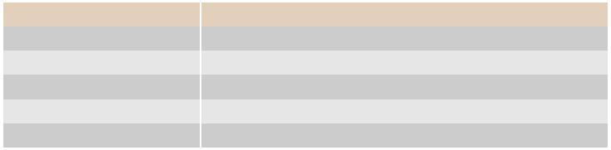

|  |  |
| --- | --- |
| **Part Number** | **Description** |
| - | 1 x ARK-2232L Unit |
| - | 1 x User Manual (Simplified Chinese) |
| - | 1 x China RoHS |
| - | Wall mounting kit |
| - | RMM 3.2 Utility CD Package |

**Online Download** www.advantech.com/products

**ARK-2232L**

**ARK-2232 Default SKU Option Items**

**Optional Embedded OS**



|  |  |
| --- | --- |
| **Part Number** | **Description** |
| 20706WX6ES0019 | W10 16EL ARK-2232 64bit 1709 ENG |

**Optional Item for Default SKU**

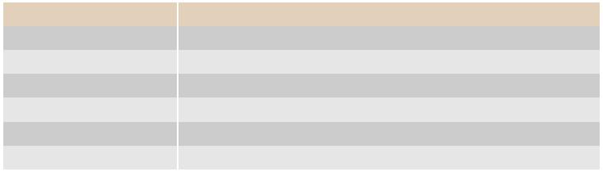

|  |  |
| --- | --- |
| **Part Number** | **Description** |
| 96PSA-A60W12W6 | AC-to-DC Adapter, DC12V/5A 60W |
| 1702002600 | Power cable 3-pin 183cm, USA type |
| 1702002605 | Power cable 3-pin 183cm, EU type |
| 1702031801 | Power cable 3-pin 183cm, UK type |
| AMK-R005E | DIN Rail mount kits |
| AMK-V019E | VESA mount kits |

**ARK-2232 Single Layer Expansion Option Items**

**Optional MOS Modules for iDoor Expansion**

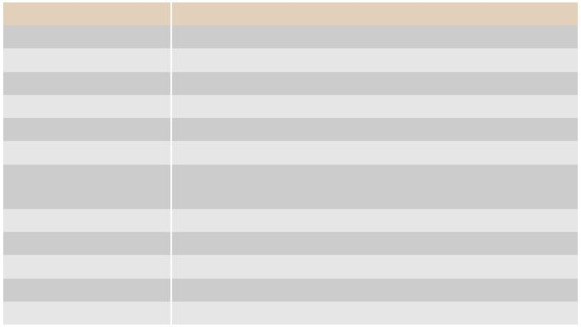

|  |  |  |
| --- | --- | --- |
| **Part Number** | **Description** |  |
| MOS-2220-X1101E | Parallel LPT module, 1-Ch, USB Interface |  |
| MOS-2110Z-1201E | USB module, 2-Ch, PCIe Interface |  |
| MOS-2120-Z1101E | Giga LAN Ethernet module, 1-Ch, PCIe Interface |  |
| MOS-1120Y-0202E | Isolated RS-232, 2-Ch, DB9, PCIe Interface |  |
| MOS-1121Y-0202E | Isolated RS-422/485, 2-Ch, DB9, PCIe Interface |  |
| MOS-1120Y-1402E | Non-Isolated RS-232, DB37 to 4-ch DB9, PCIe Interface |  |
| MOS-1121Y-1402E | Non-Isolated RS-422/485, DB37 to 4-ch DB9, PCIe |  |
| Interface |  |
|  |  |
| MOS-1130Y-0201E | Isolated CANBus, 2-Ch, DB9, PCIe Interface |  |
| MOS-1110Y-0101E | Isolated 16 DI/8 DO, 1-Ch, DB37, PCIe Interface |  |
| MOS-2220-Z1101E | High Speed COM USB module, 1-Ch, PCIe Interface |  |
| MOS-2120-Z1201 | Dual Intel I210 GbE LAN iDoor, 2-Ch, PCIe Interface |  |
| MOS-2230-Z1201E | CANBus module, 2-Ch, USB Interface |  |

*ARK-2232L can support only one iDoor.

**Optional 9-36V DC Power Module**



|  |  |
| --- | --- |
| **Part Number** | **Description** |
| MIOE-PWR2-00A1E | 9-36V DC input power module |
| 96PSA-A65W19P2-1 | AC-to-DC Adapter, DC19V/3.42A 65W (for MIOe-PWR2) |
| 96PSA-A65W19P2-2 | AC-to-DC Adapter, DC19V/3.42A 65W (for MIOe-PWR2) |
| 1700001524 | Power cable 3-pin 183cm, USA type (for MIOe-PWR2) |
| 170203183C | Power cable 3-pin 183cm, EU type (for MIOe-PWR2) |
| 170203180A | Power cable 3-pin 183cm, UK type (for MIOe-PWR2) |

**ARK-2232 Dual Layer Expansion Option Items**

**Optional Modules for ARK Plus Expansion**

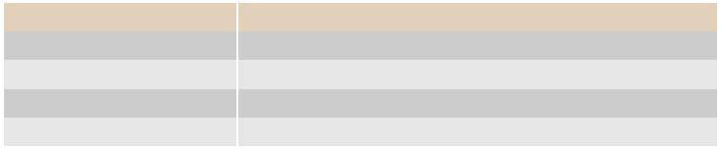

|  |  |
| --- | --- |
| **Part Number** | **Description** |
| AMO-2201E (2nd Layer) | 4 x RS232/422/485 + removable 2.5" drive |
| AMO-2202E (2nd Layer) | 4x10/100/1000Base T(X) PoE |
| AMO-2203E (2nd Layer) | 2-Port isolated CAN-Bus |
| AMO-2204E (2nd Layer) | 3-port GbE + iDoor |



**Fanless Embedded Box PCs**

**ARK Plus Extended Modules**

**AMO-2201E**

**4 x RS232/422/485 + removable 2.5" drive bay**

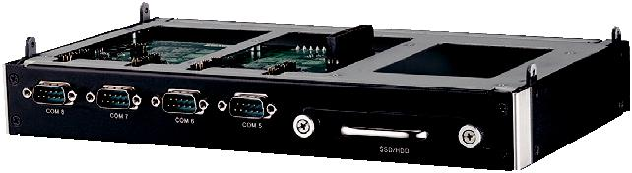

**Specifications**

**General**

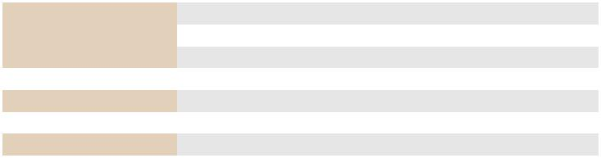

|  |  |
| --- | --- |
| Bus interface | MIOe |
| Ports | 4 x RS232/422/485 (set up by jumper) |
| Others | Removable 2.5" drive bay |
| **Mechanical** |  |
| Dimension | 260 x 34.6 x 140.2 mm (10.24" x 1.36" x 5.52") |
| **Environment** |  |
| Operating Temp. | 0 ~ 40 °C |

**Ordering Information**



|  |  |
| --- | --- |
| **P/N** | **Description** |
| AMO-2201E | 4 x RS232/422/485 + removable 2.5" drive bay |

**AMO-2202E (AMO-I018)**

**4 x 10/100/1000Base T(X) PoE**

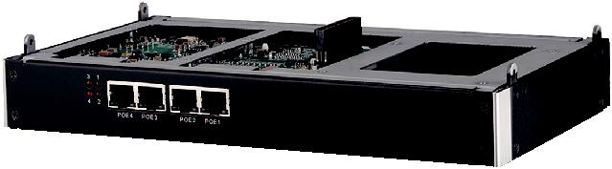

**Specifications**

**General**

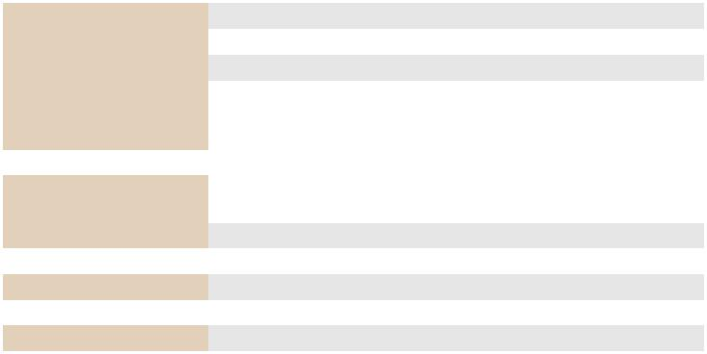

|  |  |  |
| --- | --- | --- |
| Bus interface | MIOe |  |
| Ports | 4 x RJ45 10/100/1000 Mbps PoE ports |  |
| Power consumption | Typical 15W, Max: 60W |  |
|  | IEEE 802.3, IEEE 802.3u, IEEE802.3ab, IEEE802.3x,IEEE802.3af |  |
| Compatibility | Powered Device (PD) auto detection and classification Supports |  |
|  | IEEE 802.3u Auto-Negotiation |  |
| **Power** |  |  |
| Input | 12 VDC power input 4 pin phoenix power (Change System Power |  |
| input Cable) |  |
|  |  |
| Output PoE Power | 15W at 48 VDC per PoE port |  |
| **Mechanical** |  |  |
| Dimension | 260 x 34.6 x 140.2 mm (10.24" x 1.36" x 5.52") |  |
| **Environment** |  |  |
| Operating Temp. | 0 ~ 40 °C |  |

**Ordering Information**



|  |  |
| --- | --- |
| **P/N** | **Description** |
| AMO-2202E | 4 x 10/100/1000Base T(X) PoE |

**AMO-2203E**

**2-Port isolated CAN-Bus**

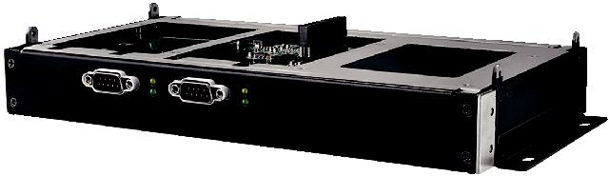

**Specifications**

**General**

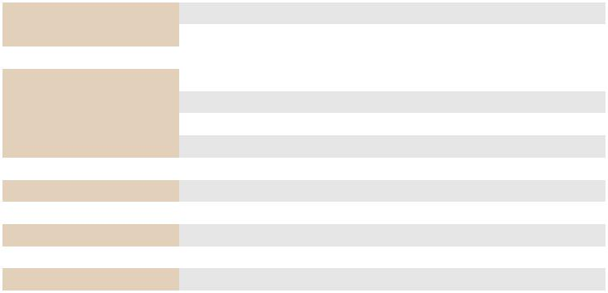

|  |  |
| --- | --- |
| Bus interface | MIOe |
| Ports | 2 x DB9 isolated CAN-Bus |
| **Communications** |  |
| Signal Support | CAN_H, CAN_L |
| Protocol | CAN 2.0 A/B |
| Data Transfer Rate | Programmable up to 1Mbps |
| CAN Frequency | 16MHz |
| **Protection** |  |
| Isolation Protection | 2,500 VDC |
| **Mechanical** |  |
| Dimension | 260 x 34.6 x 140.2 mm (10.24" x 1.36" x 5.52") |
| **Environment** |  |
| Operating Temp. | 0 ~ 40 °C |

**Ordering Information**



|  |  |
| --- | --- |
| **P/N** | **Description** |
| AMO-2203E | 2-Port isolated CAN-Bus |

**AMO-2204E**

**3-Port GbE + iDoor**

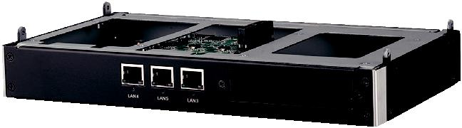

**Specifications**

**General**

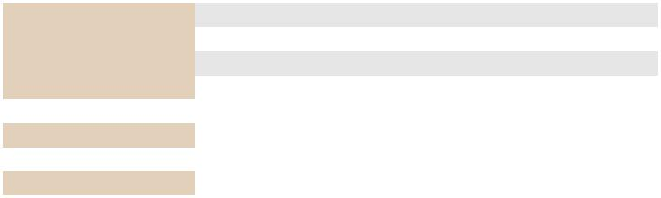

|  |  |
| --- | --- |
| Bus interface | MIOe |
| Ports | 3 x RJ45 10/100/1000 Mbps ports |
| Chipset | Intel 82583V Gigabit Ethernet Controller |
| Other | 1 x iDoor |
| **Mechanical** |  |
| Dimension | 260 x 34.6 x 140.2 mm (10.24" x 1.36" x 5.52") |
| **Environment** |  |
| Operating Temp. | 0 ~ 40 °C |

**Ordering Information**



|  |  |
| --- | --- |
| **P/N** | **Description** |
| AMO-2204E | 3-Port GbE + iDoor |

*ARK-2232 supports one iDoor only.

**Online Download** www.advantech.com/products