# Single Board Computer

***Peripherals***

***w w w . i ei w or l d .c om***

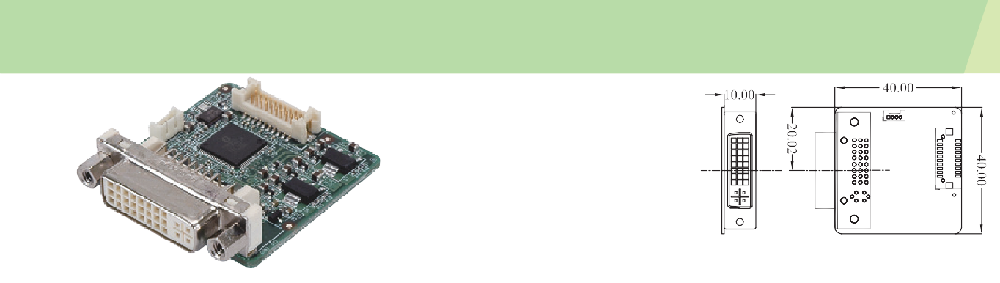

***Dimensions (mm)***

***Features***

***Supported Models***

***18-bit LVDS to DVI Converter Board, Resolution Support up to 1366x768 (Support IEI Model Only)***

**LVDS-DVI**

* Provide DVI option for dual display output

|  |  |  |
| --- | --- | --- |
| WSB-PV-D5251 | PICOe-PV-D5251 | PCISA-PV-D5251 |
| KINO-PV-D5252 | NOVA-PV-D5251 | NANO-PV-D5251 |
| NANO-PV-D5252 | WAFER-PV-D5252 | |

* Resolution supported: 1366x768, 1024x768, 800x600, 640x480
* 18 or 24-bit LVDS to DVI converter board

# *Packing List Ordering Information*

|  |
| --- |
| 1 x LVDS to DVI converter board |
| 1 x SMBus cable |
| 1 x QIG |

|  |  |
| --- | --- |
| LVDS-DVI-R10 | 18/24-bit LVDS to DVI converter board |
| 32602-012200-100-RS | 20-pin to 30-pin LVDS connecting cable for WAFER-PV-D5252 only |
| 32602-012300-100-RS | 20-pin to 20-pin LVDS connecting cable |

**LVDS-VGA-R10**

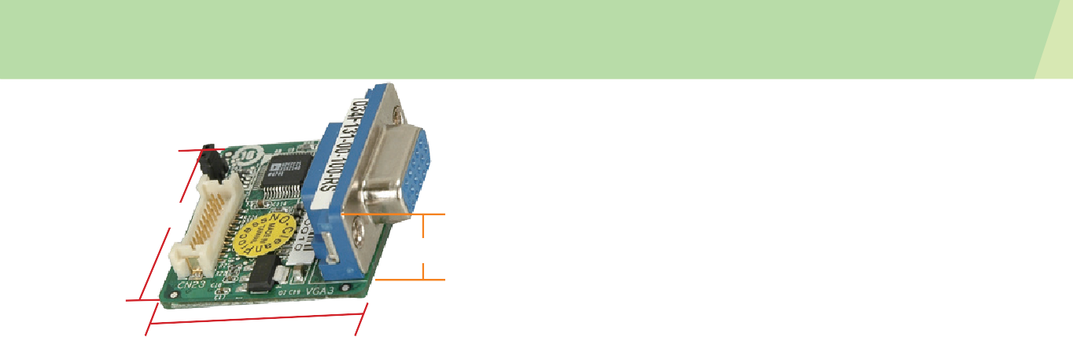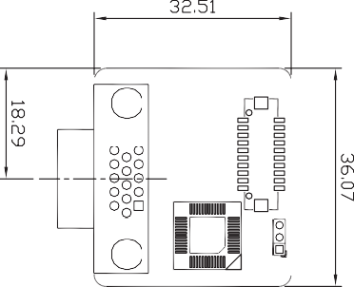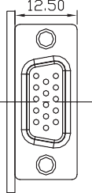

***Single-channel LVDS to VGA Converter Board (Support IEI Model Only)***

***Dimensions (mm)***

**36.07mm**

**12.50mm**

***Features***

**32.51mm**

* Provide 2nd VGA option for dual VGA display
* Resolution adjusted by BIOS: Support 1024x768, 800x600, 640x480
* 18-bit LVDS to VGA converter board

# *Packing List*

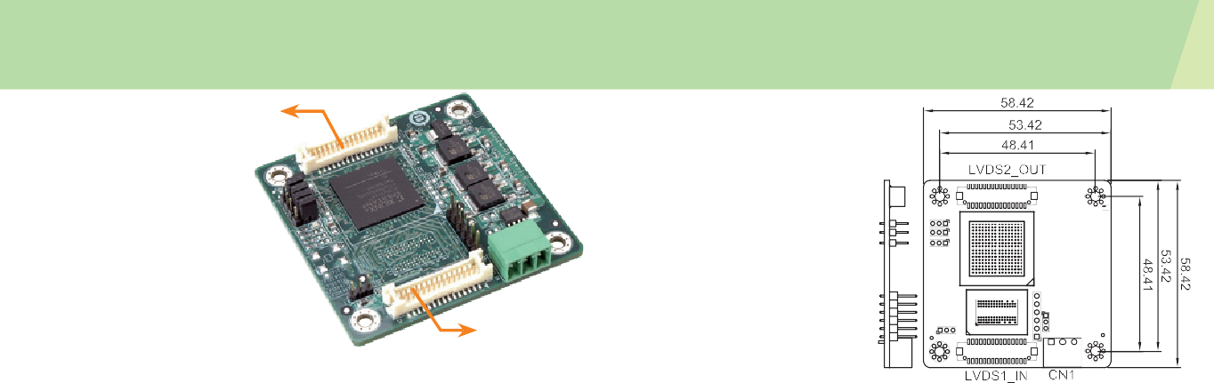

**LVDS24-01**

24-bit dual-channel output

***18-bit to 24-bit LVDS Converter Board***

***Dimensions (mm)***

***Features***

* Resolution supports up to 1280x1024
* Support below configuration:

» Single-channel 18-bit to single-channel 24-bit

» Single-channel 18-bit to dual-channel 24-bit

18-bit single/

dual-channel input

* Note: The module does not support dual-channel 18-bit to single-channel 24-bit conversion. ***Ordering Information***

» Dual-channel 18-bit to dual-channel 24-bit

|  |
| --- |
| 1 x LVDS to VGA converter board |
| 1 x QIG |

***Packing List***

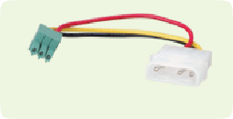

**Power cable**

P/N: 32100-130300-RS

***Ordering Information***

|  |  |
| --- | --- |
| Part No. | Description |
| LVDS-VGA-R10 | 18-bit LVDS to VGA converter board |
| 32600-112300-RS | 30-pin LVDS connecting cable |
| 32602-026400-100-RS | 20-pin LVDS connecting cable |





LVDS-DVI-2018-V10

|  |  |
| --- | --- |
| Part No. | Description |
| LVDS24-01-R10 | 18-bit to 24-bit LVDS converter board |
| 32602-007900-100-RS | Single-channel 18-bit 20-pin to 24-bit 30-pin LVDS connection cable |
| 32602-008000-200-RS | Dual-channel 18-bit 30-pin to 24-bit 30-pin LVDS connection cable |

|  |
| --- |
| 1 x 18-bit to 24-bit LVDS converter board |
| 1 x Power cable |
| 1 x QIG |