# Single Board Computer

***Peripherals***

***w w w . i ei w or l d .c om***



***PCI Express Mini Dual Intel® GbE LAN Module, Full Size, RoHS***

**MPCIE-DLAN-R10**

# *Specifications*

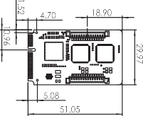Form Factor: PCI Express Mini card BIOS: UEFI BIOS

Ethernet Controller: Dual Intel***®*** I210-IT Speed: 10/100/1000Mbps

External Connector: 2 x 8-pin RJ-45 Power Supply: On board 3.3V Compitable OS

Windows XP/Server 2003/ Server 2008/ Vista/ 7 /8.1/10 Linux kernel version 2.6.32 above

Operating Temperature: -10°C ~ 70°C Operating Humidity: 5% ~ 95%, non-condensing Dimensions (LxW) : 51 mm x 30 mm

Weight: 55g CE/FCC compliant

# *Packing List*

***Dimensions (mm)***

|  |  |  |
| --- | --- | --- |
| 1 x MPCIE-DLAN module | 2 x Flat cable (pitch=1.25mm), 340mm length | 1 x QIG |

# *Features*

* Support dual GbE LAN by Intel® I210-IT
* Compliant with PCI Express Mini specification 1.2



***PCI Express Mini GbE LAN Module, Full Size, RoHS***

**MPCIE-LAN-R10**

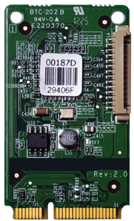 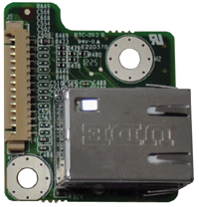

# *Features*

* Support one GbE LAN by RTL8111E
* Compliant with PCI Express Mini specification 1.2

# *Ordering Information*

|  |  |
| --- | --- |
| Part No. | Description |
| MPCIE-DLAN-R10 | PCI Express Mini dual Intel® GbE LAN module, full size, RoHS |

|  |  |  |
| --- | --- | --- |
| 1 x MPCIE-LAN module | 1 x Flat cable (pitch=1.25mm), 340mm length | 1 x QIG |

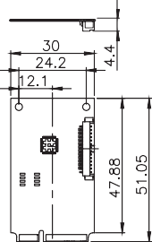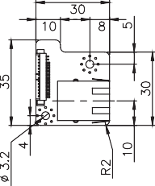***Ordering Information***

|  |  |
| --- | --- |
| Part No. | Description |
| MPCIE-LAN-R10 | PCI Express Mini GbE LAN module, full size, RoHS |



***PCI Express Mini 3G Adapter Card, RoHS***

**MPCIE-3G-R20**

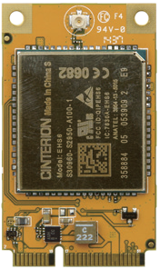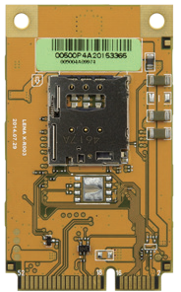***Specifications***

Form Factor

PCI Express Mini card

Antenna 50Ohms. Main GSM/UMTS antenna Frequency Bands

GSM/GPRS/EDGE:

850/900/1800/1900 GPRS/EDGE Class12 UMTS/HSPA+:

Dual band UMTS 800/850/900/1900/2100 MHz

# *Packing List*

USB

USB 2.0 High Speed (480Mbit/s) device interface Compatible OS

Windows®8, Windows®7, Windows EC, Linux, Android

Operating Temperature

Normal operation: -30°C to +85°C Restricted operation: -40°C to +95°C

Dimensions (W x D x H)

51.0 mm × 30.0 mm × 4.75 mm

1 x PCI Express Mini 3G adapter card





MPCIE-DLAN-2019-V10

# *Features*

* Real time clock: Timer functions via AT commands
* Phonebook: SIM and phone
* TTY/CTM support: Integrated CTM modem

# *Ordering Information*

|  |  |
| --- | --- |
| Part No. | Description |
| MPCIE-3G-R20 | PCI Express Mini 3G adapter card, RoHS |
| 32501-000705-100-RS | RF antenna cable |
| 32503-000100-100-RS | GSM antenna cable |