***Fanless Embedded System with Intel® Solution***

**ECN-360A-D2550**

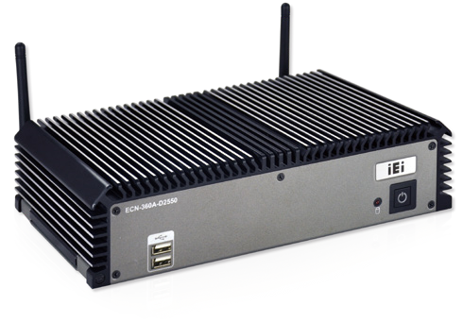

# *Specifications*

***Features***

#### On-board CPU

» ECN-360A-D2550: Intel® Atom™ D2550 dual-core 1.86 GHz

#### Rich video output solution

» ECN-360A-D2550: 2 x VGA

#### Ruggedized embedded computer

» Supports -10°C~60°C (w/ SSD, air flow)



Fanless



Expansion

PCIe Mini



***USB***

USB 3.0



Dual GbE



Dual Display

|  |  |  |
| --- | --- | --- |
| **Model Name** | | **ECN-360A-D2550** |
| **Chassis** | **Color** | Black |
| **Dimensions (WxDxH) (mm)** | 255 x 130 x 63 |
| **System Fan** | Fanless |
| **Chassis Construction** | SECC |
| **Motherboard** | **Motherboard Model** | NANO-CV-D25502 |
| **SBC Size (mm)** | EPIC, 165 x 115 |
| **CPU** | Intel® Atom™ dual-core D2550 1.86GHz |
| **Chipset** | Intel® NM10 |
| **System Memory** | 1 x 204-pin DDR3 SDRAM SO-DIMM (system max: 4 GB) Pre-installed 2 GB DDR3 memory |
| **Storage** | **Hard Drive** | 1 x 2.5'' SATA HDD bay |
| **I/O Interfaces** | **USB 3.0** | 0 |
| **USB 2.0** | 6 |
| **Ethernet** | 2 x Realtek RTL8111E with ASF 2.0 support |
| **COM Port** | 3 x RS-232  1 x RS-422/485 |
| **Digital I/O** | N/A |
| **Display** | 2 x VGA |
| **Resolution** | VGA: Up to 1920 x 1200@60Hz |
| **Audio** | 1 x Line-out |
| **Wireless** | 1 x 802.11b/g/n (optional) |
| **Expansions** | **PCIe Mini** | 1 x Full-size (supports mSATA) 1 x Half-size |
| **Power** | **Power Input** | 9 V~36 V DC  Power 1: DC jack  Power 2: Terminal block |
| **Power Consumption** | [12V@1.59A](mailto:12V@1.59A)  (Intel® dual-core D2550 CPU  with 4 GB 1333 MHz DDR3 memory) |
| **Reliability** | **Mounting** | Wall mount, VESA 100 |
| **Operating Temperature** | -10°C~60°C with air flow (SSD), 5% ~ 95%, non-condensing |
| **Operating Shock** | Half-sine wave shock 3G, 11ms, 3 shocks per axis |
| **Operating Vibration** | MIL-STD-810F 514.5C-2 (SSD) |
| **Weight (Net/Gross)** | 2.2 kg/3 kg |

# *Friendly to Use*

## Easy for installation



Expansion

PCIe Mini

### Hinge design for rear cover

* + Easy assembly of storage/memory/PCIe Mini card

**Wide range of DC power input**

* ECN-360A-D2550: 9 V~28 V DC



130

100

50

100

50

104

***Fully Integrated I/O***

***Front view Rear view***

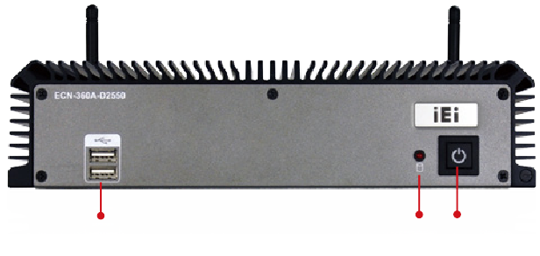

2 x USB 2.0

HDD LED Power LED

***Dimensions (Unit: mm)***

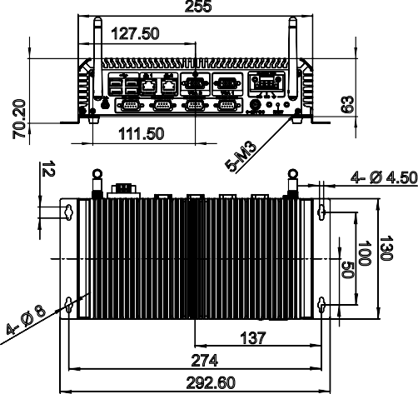

255

127.50

111.50

4- Ø 4.50

137

274

292.60

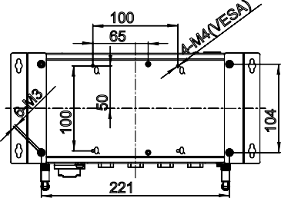

100

65

221

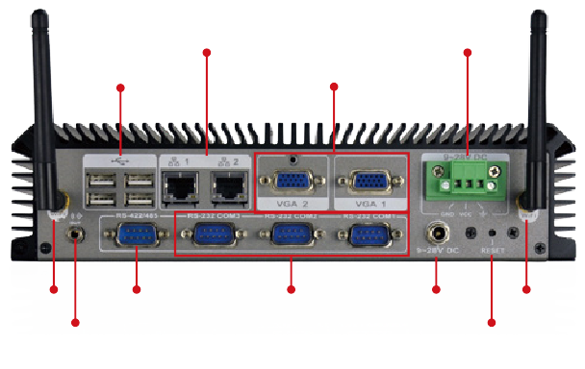

2 x Gigabit LAN

Power Connector

4 x USB 2.0

2 x VGA

Wi-Fi RS-422/485

3 x RS-232 Power Connector Wi-Fi

Audio Line-out Reset

12

70.20

63

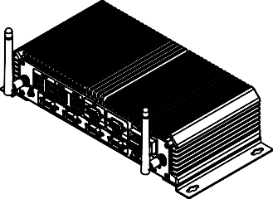

# *Ordering Information*

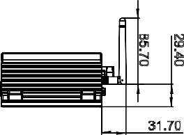

31.70

29.40

85.70

|  |  |
| --- | --- |
| **Part No.** | **Description** |
| **ECN-360A-D2550/2G-R11** | Embedded system with NANO-CV-D25502, Intel® Atom™ D2550 dual-core 1.86 GHz CPU, with 2 x VGA, 3 x RS-232, 1 x RS-422/485, 2GB DDR3 SO-DIMM pre-installed, dual Realtek LAN, 9 V~28 V DC, RoHS |

***Packing List***

|  |  |
| --- | --- |
| 1 x Power cord | 1 x Screw set |
| 1 x Power adapter (with PSE/ErP certified) | 1 x Wall mount bracket |