[***www.ieiw or ld.com***](http://www.ieiworld.com/)

***AI Solution***

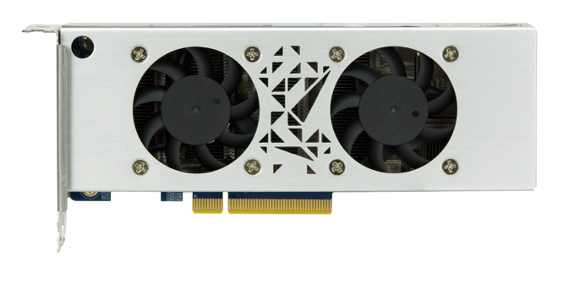

Mustang-F100-A10

# *Specifications*

***Feature***

* Half-Height, Half-Length, Double-slot.
* Power-efficiency, low-latency.
* Supported OpenVINO™ toolkit, AI edge computing ready device.
* FPGAs can be optimized for different deep learning tasks.
* Intel® FPGAs supports multiple float-points and inference workloads.



|  |  |
| --- | --- |
| **Model Name** | **Mustang-F100-A10** |
| Main FPGA | Intel® Arria® 10 GX1150 FPGA |
| Operating Systems | Ubuntu 16.04.3 LTS 64-bit, CentOS 7.4 64-bit (Windows® & more OS are coming soon) |
| Voltage Regulator and Power Supply | Intel® Enpirion® Power Solutions |
| Memory | 8G on board DDR4 |
| Dataplane Interface | PCI Express x8 |
| Compliant with PCI Express Specification V3.0 |
| Power Consumption | <60W |
| Operating Temperature | 5°C~60°C (ambient temperature) |
| Cooling | Active fan |
| Dimensions | Standard Half-Height, Half-Length, Double-slot |
| Operating Humidity | 5% ~ 90% |
| Power Connector | *Preserved PCIe 6-pin 12V external power |
| Dip Switch/LED indicator | Identify card number |
| Support Topology | AlexNet, GoogleNet V1/V2/V4, Yolo Tiny V1/V2, Yolo V2/V3, SSD300,SSD512, ResNet-18/50/101/152, DenseNet121/161/169/201, SqueezeNet 1.0/1.1, VGG16/19, MobileNet-SSD, Inception-ResNet- v2,Inception-V1/V2/V3/V4,SSD-MobileNet-V2-coco, MobileNet-V1-0.25-128, MobileNet-V1-0.50-160,  MobileNet-V1-1.0-224, MobileNet-V1/V2, Faster-RCNN |

*Standard PCIe slot provides 75W power, this feature is preserved for user in case of different system configuration.

# *Ordering Information*

|  |  |
| --- | --- |
| Part No. | Description |
| Mustang-F100-A10-R10 | PCIe FPGA Highest Performance Accelerator Card with Arria 10 1150GX support DDR4 2400Hz 8GB, PCIe Gen3 x8 interface |
| 7Z000-00FPGA00 | 7Z0-OTHERS PERIPHERAL DEVICE;FPGA Download Cable; IEI USB DOWNLOAD CABLE;GALAXY;USB Download+USB CABLE+IDE CABLE+FPGA CABLE |

*It’s Mandatory to use this FPGA programmer kit (7Z000-00FPGA00)to upgrade the FPGA bitstreams between different Intel® OpenVINO™ toolkit versions

# *Packing List*

|  |
| --- |
| 1 X Full height bracket |
| 1 x External power cable |
| 1 x QIG |

80.02

81.64

63.59

58.40

[***www.ieiw or ld.com***](http://www.ieiworld.com/)



***AI Solution***

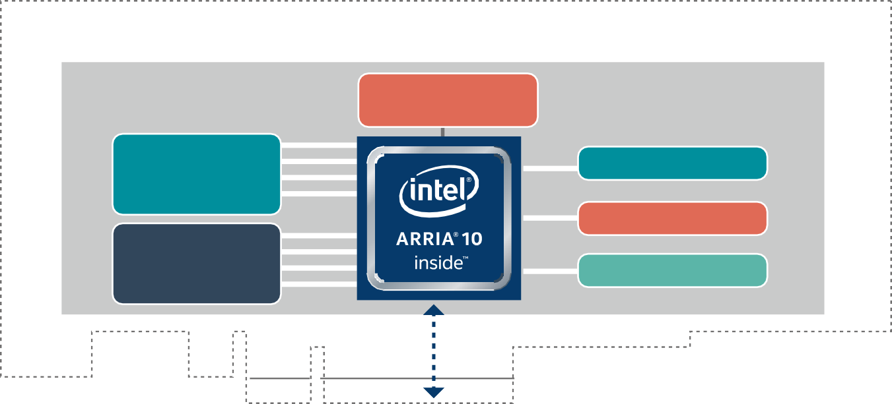

**Scalable FPGA Deep Learning Acceleration Add-in Card**

**PCIe Gen3 x8**

**DDR4 8GB**

**System Clocks**

**JTAG conn**

**Flash**

**MCU**

**Intel® Enpirion® Power Solutions**

**Active Thermal Solution**

**Mustang-F100-A10 Block Diagram**

* + Intel® Arria® 10 1150 GX FPGAs delivering up to 1.5 TFLOPs
  + Interface: PCIe Gen3 x 8
  + Form Factor: Standard Half-Height, Half-Length, Double-slot
  + Cooling: Active fan.
  + Operation Temperature : 5°C~60°C(ambient temperature)
  + Operation Humidity : 5% to 90% relative humidity
  + Power Consumption: < 60W
  + Power Connector: *Preserved PCIe 6-pin 12V external power
  + DIP Switch/LED Indicator: Identify card number.
  + Voltage Regulator and Power Supply: Intel® Enpirion® Power Solutions

*Standard PCIe slot provides 75W power, this feature is preserved for user in case of different system configuration.

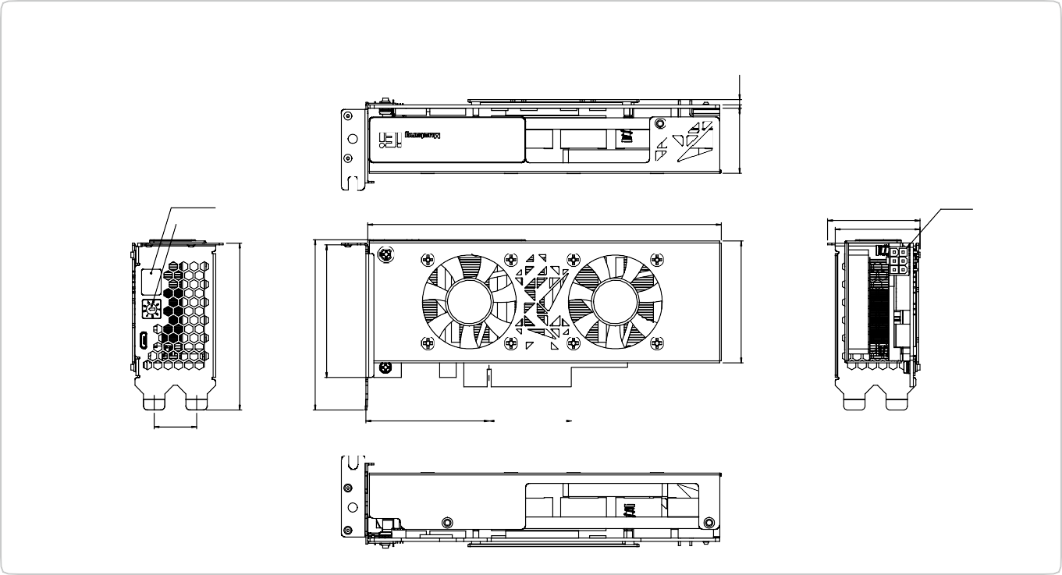

***Mustang-F100-A10 Dimensions (Unit: mm)***

Number Led

Adjustment Button

Power In

169.54

44.25

40.67

20.32

59.05

39.72

31.20

2.50