# Single Board Computer

***Half-size***

***w w w . i ei w or l d .c om***

**PCISA-BT**



***Half-size PCISA CPU Card supports 22nm Intel® Atom™ On-board SoC with VGA, iDP, Dual Intel® PCIe GbE, USB 3.1 Gen 1 (5Gb/s), PCIe Mini, SATA, mSATA, COM, Audio and RoHS***

TPM

2 x SATA 3Gb/s

KB/MS

microSD DDR3L 1066/1333 MHz

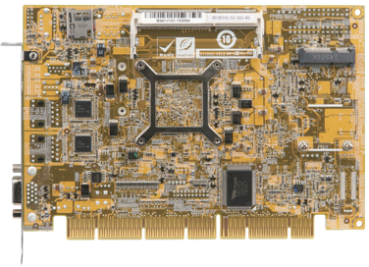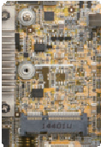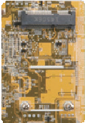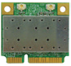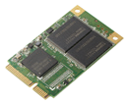

LPT

2 x RS-232

DIO 4 x USB 2.0

RS-422/485

**Intel** ® **E3800**

USB 2.0

Type A

USB 3.1

Gen 1

USB 2.0

LAN

mSATA

VGA

### *Specifications*

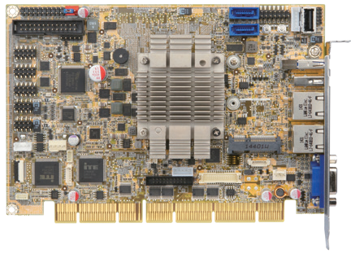

SoC

iDP

PCIe Mini LVDS (optional)

**PCIe Mini slot**

PCIe Mini slot for full-size or half-size devices

## mSATA

mSATA slot for full-size mSATA

Intel® Atom™ E3845 on-board SoC (1.91GHz, quad-core, 2MB cache, TDP=10W) Intel® Atom™ E3827 on-board SoC (1.75GHz, dual-core, 1MB cache, TDP=8W) Intel® Atom™ E3826 on-board SoC (1.46GHz, dual-core, 1MB cache, TDP=7W) Intel® Atom™ E3825 on-board SoC (1.33GHz, dual-core, 1MB cache, TDP=6W) Intel® Atom™ E3815 on-board SoC (1.46GHz, single-core, 512KB cache, TDP=5W) Memory



PCISA-BT-2019-V10

One 204-pin 1333/1066 MHz single-channel DDR3L SDRAM unbuffered SO-DIMM slot supports up to 8GB

Graphics Engine

Intel® HD Graphics Gen 7 Engines with 4 execution units, supporting DX11.1, OpenGL 4.2 and OpenCL1.2

Display Output

Dual independent display

1 x VGA (up to 2560x1600@60Hz)

1 x 18/24-bit dual-channel LVDS (up to 1920x1200@60Hz) (optional, MOQ: 100 pcs/lot) 1 x iDP interface for HDMI, LVDS, VGA, DVI, DP (up to 2560x1600@60Hz)

Ethernet

LAN1: Intel® I211-AT PCIe controller LAN2: Intel® I211-AT PCIe controller External I/O Interface

1 x USB 2.0

1 x USB 3.1 Gen 1 (5Gb/s) Internal I/O Interface

1 x KB/MS (1x6 pin) 1 x USB 2.0 (180° Type-A)

1 x LPT (2x13 pin) 2 x RS-232 (2x5 pin, P=2.54)

1 x mSATA 2 x SATA 3Gb/s

1 x RS-422/485 (1x4 pin, P=2.0) 4 x USB 2.0 (2x4 pin, P=2.54)

Audio

Supports 7.1-channel HD Audio by IEI AC-KIT-892HD kit 1 x Front Audio (2x5 pin)

TPM

1 x TPM (2x10 pin) SMBus

1 x SMBus (1x4 pin)

I²C

1 x I²C (1x4 pin) Infrared Interface

1 x Infrared interface (1x5 pin)

Expansion

1 x microSD socket 1 x PCIe Mini slot

PCI and ISA signal via golden finger Watchdog Timer

Software programmable supports 1~255 sec. system reset

Digital I/O

8-bit digital I/O (2x5 pin) Fan Connector

1 x CPU smart fan (1x4 pin)

1 x System smart fan (1x3 pin) Power Supply

5V/12V, AT/ATX support

Power Consumption

5V@1.55A,12V@0.74A (Intel® Atom™ E3845 1.91GHz CPU with one 8 GB 1333 MHz memory)

Operating Temperature

-20°C ~ 60°C

Storage Temperature

-30°C ~ 70°C

Dimensions

185 mm x 128 mm Weight

GW: 1000g / NW: 250g

CE/FCC compliant



DDR3L

1.35V



Jumper-less



***USB***

USB 3.1



mSATA



Expansion

PCIe Mini

### *Features*

* Half-size PCISA CPU card supports 22nm Intel® Atom™ or Celeron® on-board SoC
* Supports dual LAN by Intel® I211-AT PCIe controllers
* Supports 1.35 V 1333/1066 MHz DDR3L SDRAM up to 8 GB
* Supports dual independent display with one analog CRT, iDP and one 24-bit dual- channel LVDS (optional)
* COM, USB 3.1 Gen 1 (5Gb/s), SATA 3Gb/s, PCIe Mini, mSATA and HD Audio support
* IEI One Key Recovery solution allows you to create rapid OS backup and recovery

# *Packing List*

1 x QIG

1 x SATA cable

1 x PCISA-BT single board computer

***Ordering Information***

|  |  |
| --- | --- |
| Part No. | Description |
| PCISA-BT-E38451-R11 | Half-size PCISA CPU card supports Intel® Atom™ E3845 (10W) on-board SoC with VGA, iDP, dual Intel® PCIe GbE, PCIe Mini, USB 3.1 Gen 1 (5Gb/s), SATA, mSATA, COM, Audio and RoHS |
| PCISA-BT-E38251-R11 | Half-size PCISA CPU card supports Intel® Atom™ E3825 (6W) on-board SoC with VGA, iDP, dual Intel® PCIe GbE, PCIe Mini, USB 3.1 Gen 1 (5Gb/s), SATA, mSATA, COM, Audio and RoHS |
| 19800-000049-RS | LPT flat cable, 240mm, P=2.54 |
| 19800-000075-RS | PS/2 KB/MS cable with bracket, 220mm, P=2.0 |
| 19800-020100-100-RS | RS-232 cable with bracket, Dual 10-pin to dual DB-9, 230mm, P=2.54 |
| 32102-000100-200-RS | SATA power cable, MOLEX 5264-4P to SATA15P |
| 32205-003800-300-RS | RS-422/485 cable, 200mm, P=2.0 |
| AC-KIT-892HD-R10 | Realtek ALC892 7.1-channel HD Audio peripheral board |
| DP-DP-R10 | DisplayPort to DisplayPort converter board (for IEI iDP connector) |
| DP-DVI-R10 | DisplayPort to DVI-D converter board (for IEI iDP connector) |
| DP-HDMI-R10 | DisplayPort to HDMI converter board (for IEI iDP connector) |
| DP-LVDS-R10 | DisplayPort to LVDS converter board (for IEI iDP connector) |
| DP-VGA-R10 | DisplayPort to VGA converter board (for IEI iDP connector) |
| TPM-IN01-R20 | 20-pin Infineon TPM module, software management tool, firmware v3.17 |

Note: Models with other CPUs not listed in the table are requested by MOQ - 100 pcs/lot.