# Single Board Computer

***Industrial Motherboard***

***w w w . i ei w or l d .c om***

***Mini-ITX SBC supports AMD Merlin Falcon SoC Proccessor, HDMI 2.0, M.2, PCIe Mini, SATA 6Gb/s, USB 3.1 Gen 1 (5Gb/s), HD audio and RoHS***

**gKINO-DMF**

2 x DDR4 SO-DIMM Front Panel

TPM

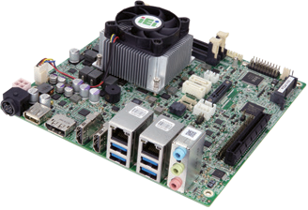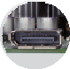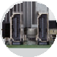

DP++ ►

M.2 SSD support

◄HDMI

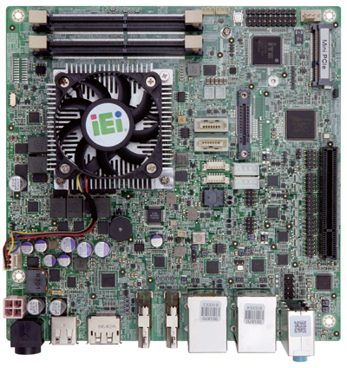

Full/Half size PCIe Mini card slot

M.2 B Key

(vertical type)

DIO

RS-232/422/485

PCIe x8 RS-232

Front Audio

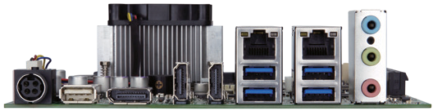

Dual LAN

# *Specifications*

SoC

2 x SATA 6Gb/s ccTALK

USB 2.0

12V

power input

USB 2.0

DP++

HDMI

USB 3.1 Gen 1

Audio

FP4 BGA supports AMD Merlin Falcon SoC



gKINO-DMF-2019-V10

RX-421BD on-board SoC (2.1GHz, quad-core, 2MB cache, TDP=35W) RX-216GD on-board SoC (1.6GHz, quad-core, 1MB cache, TDP=15W) BIOS

UEFI BIOS

Memory

Two 260-pin 2400MHz dual-channel DDR4 non-ECC unbuffered SO-DIMMs support up to 64 GB

Graphics Engine

AMD Radeon HD 10000graphic,3rd Gen. graphic core,support DX 12, HSA 2.0 UVD v6 decode for H.265 MPEG2/4, VC-1, MVC

VCE v3.1 encode for H.254 VCE Display Output

Triple independent display

2 x HDMI 1.4 (up to 4096x2160@24Hz)

1 x DP++ (up to 3840x2160@60Hz) Ethernet

Dual GbE RTL 8111GN

External I/O Interface

4 x USB 3.1 Gen 1 (5Gb/s)

1 x USB 2.0

Internal I/O Interface

1. x MicroSD card slot 2 x RS-232/422/485 (2x5 pin, P=2.0)
2. x RS-232 (2x5 pin, P=2.0) 2 x RS-232 (support Cctalk, TTL)(1x4 pin, P=2.54) 4 x USB 2.0 (2x4 pin, P=2.0) 2 x SATA with 5V/12V output

Audio

Realtek ALC662 HD audio codec

1. x Audio jacks (line-out, line-in, mic-in) on rear IO 1 x Front audio (2x5-pin)

Front Panel

1. x Front panel (2x7 pin, power LED, HDD LED, speaker, power button, reset button) LAN LED
2. x LAN LED (1x2 pin)

SMBUS

1 x SMBus (1x4 pin) I²C

1 x I²C (1x4 pin)

TPM

1 x TPM (2x10 pin)

Digital I/O: 8-bit digital I/O (2x5 pin) Expansion

1 x PCIe x 8 slot

1 x Full size PCIe Mini card slot

Watchdog Timer: Software programmable, supports 1~255 sec. system reset Chassis Intrusion Detection: 1 x Chassis intrusion connector (1x2 pin)

Power Supply

12V DC input 1 x Internal power connector (2x2 pin) Support AT/ATX mode 1 x External DC jack (4-pin DIN)

FAN Connector

1 x CPU smart fan (1x4 pin)

1 x System smart fan (1x4 pin) Power Consumption

[12V@5.54A](mailto:12V@5.54A) (AMD RX-421BD 2.1GHz CPU with 2400 MHz 16GB DDR4 memory)

Storage Temperature: -10°C ~ 70°C Operating Temperature: 0°C ~ 60°C

Operating Humidity: 5% ~ 95%, non-condensing Dimensions: 170mm x 170 mm

Weight: GW: 1100g / NW: 700g CE/FCC compliant



M.2

Expansion

PCIe Mini



ULTRA**HD**

DP++

Display

Triple

***USB***

USB 3.1 SATA 6Gb/s

# *Features*

* Mini ITX form factor with AMD Merlin Falcon processor supports dual-channel DDR4 SO-DIMMs
* Triple independent display support via dual HDMI and DP++
* Full size PCIe Mini slot and vertical type M.2 B key slot for expansion
* COM, Cctalk, TTL, and USB 3.1 Gen 1 (5Gb/s) support
* IEI one key recovery solution allows you to create rapid OS backup and recovery

# *Packing List*

|  |
| --- |
| 1 x gKINO-DMF single board computer with CPU cooler |
| 1 x SATA cable |
| 1 x I/O shielding |
| 1 x QIG |

***Ordering Information***

|  |  |
| --- | --- |
| Part No. | Description |
| gKINO-DMF-421-R10 | Mini-ITX SBC supports AMD RX-421BD on board SoC (quad- core 2.1GHz, 35W), DDR4 ,triple independent displays,HDMI/ DP, dual GbE, SATA 6Gb/s, USB3.0, PCIe Mini, M.2,HD audio and RoHS |
| gKINO-DMF-216-R10 | Mini-ITX SBC supports AMD RX-216GD on board SoC (dual- core 1.6GHz, 15W), DDR4 ,triple independent displays, HDMI/ DP, dual GbE, SATA 6Gb/s, USB3.0, PCIe Mini, M.2, HD audio and RoHS |
| 19800-000300-100-RS | RS-232 cable with bracket, 300mm, P=2.0 |
| CB-USB02A-RS | Dual-port USB cable with bracket, 300mm, P=2.0 |
| TPM-IN01-R20 | 20-pin Infineon TPM module, software management tool, firmware v3.17 |