# Single Board Computer

***Industrial Motherboard***

***w w w . i ei w or l d .c om***

**KINO-DQM170**

***Mini-ITX SBC supports 6th Intel® Core™ Mobile CPU, HDMI 2.0, M.2, SATA 6Gb/s, dual Intel® GbE, USB 3.1 Gen 1 (5Gb/s), PCIe Mini, HD Audio and RoHS***

Dual-channel DDR4 2133 MHz up to 64 GB

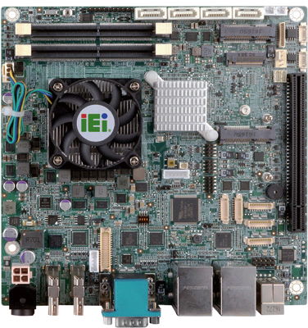

4 x SATA 6Gb/s

1 x Full-size PCIe Mini (support mSATA)

## Flexible Selection of Modules with Different Functions

1 x M.2 (A key)

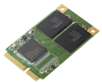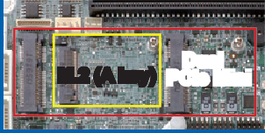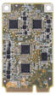

**PCIe Mini**

**mSATA**

**Dual**

**M.2 (A key) PCIe Mini**

1 x Half-size PCIe Mini

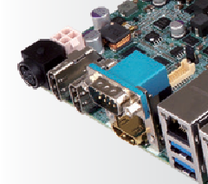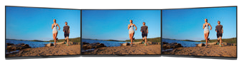

1 x PCIe x16

## Triple Independent Displays

LVDS

3 x RS-232

2 x RS-232/422/485

HDMI Interface



KINO-DQM170-2019-V10

# *Specifications*

CPU

6th generation Intel® Core™ mobile processor

Intel® Core™ i7-6820EQ (up to 3.5GHz, quad-core, 8M cache, TDP=45W) Intel® Core™ i5-6440EQ (up to 3.4GHz, quad-core, 6M cache, TDP=45W) Intel® Core™ i3-6102E (up to 1.90GHz, dual-core, 3M cache, TDP=25W) Intel® Celeron® G3902E (up to 1.60GHz, dual-core, 2M cache, TDP=25W) Chipset: Intel® QM170

BIOS: UEFI BIOS

Memory

Two 260-pin 2133/1866 MHz dual-channel unbuffered DDR4 SDRAM SO-DIMMs support up to 64GB

Graphics Engine

Intel® HD Graphics Gen 9 support for DX11/12, OCL 2.x, OGL 4.3/4.4, ES 2.0 Display Output

Triple independent display

2 x HDMI 1.4 (up to 4096x2160@24Hz)

1 x HDMI 2.0 (up to 4096x2160@60Hz)

1 x 18/24-bit dual-channel LVDS (up to 1920x1200@60Hz) Ethernet

LAN1: Intel® I219LM with (Intel® AMT 11.0 support)

LAN2: Intel® I211 PCIe controller with NCSI support External I/O Interface

4 x USB 3.1 Gen 1 (5Gb/s) 1 x RS-232

Internal I/O Interface

1. x KB/MS (1x6 pin, P=2.0) 4 x SATA 6Gb/s (RAID 0/1/5/10 support)

2 x RS-232/422/485 (1x9 pin, P=1.25) 4 x USB 2.0 (2x4 pin, P=2.0)

3 x RS-232 (1x9 pin, P=1.25)

Audio

Realtek ALC662 HD Audio codec supports 5.1-channel

1. x audio jacks(line out, mic in) on rear I/O (colay with 3x audio jack) 1 x Front audio (2x5 pin)

Front Panel

1 x Front panel (2x7 pin, power LED, HDD LED, speaker, power button, reset button) LAN LED: 2 x LAN LED (1x2 pin)

SMBus: 1 x SMBus (1x4 pin) I²C: 1 x I²C (1x4 pin)

Digital I/O: 8-bit digital I/O (2x5 pin) Expansion

1 x PCIe x16 slot 1 x Full-size PCIe Mini card slot (support mSATA)

1 x M.2 2230 (A key) 1 x Half-size PCIe Mini card slot Cooler Module

19100-000219-00-RS for Intel® Core™ i7/i5 (45W)

19100-000203-00-RS for Intel® Core™ i3/Celeron® (25W) Watchdog Timer

Software programmable supports 1~255 sec. system reset by super I/O

Chassis Intrusion Detection: 1 x Chassis intrusion connector (1x2 pin) Power Supply

12V DC input

1 x External DC jack (4-pin DIN)

1 x Internal power connector (2x2 pin) Support AT/ATX mode

Fan Connector

1 x CPU smart (1x4 pin) 1 x System fan (1x4 pin) Power Consumption

[12V@5.08A](mailto:12V@5.08A) (Intel® Core™ i7-6820EQ, 3.5GHz CPU with 16 GB (two 8 GB) 2133 MHz

DDR4 memory)

Operating Temperature: -20°C ~ 60°C Operating Humidity: 5% ~ 95%, non-condensing Dimensions: 170mm x 170 mm

Weight: 900g / NW: 450g CE/FCC compliant

RS-232 Dual LAN

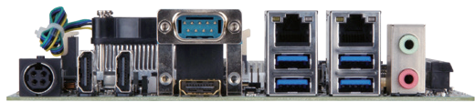

HDMI 2.0 HDMI 1.4 4 x USB 3.1 Gen 1 Audio



DDR4

2133

mSATA

Expansion

PCIe Mini

Display

Triple

# *Features*

* Mini ITX form factor with 6th Gen Intel® Core™ i7/i5/i3/Celeron® processor support DDR4 memory
* Support HDMI 2.0 (4096x2160@60Hz)
* Triple display with independent audio via HDMI
* PCIe x16, dual PCIe Mini and M.2 A key feature support for various function module
* Rich High speed I/O interface for USB 3.1 Gen 1 (5Gb/s) and SATA 6Gb/s
* Support IEI jumpless

# *Packing List*

|  |  |
| --- | --- |
| 1 x KINO-DQM170 single board computer with CPU cooler | 2 x SATA cable |
| 1 x I/O shielding | 1 x QIG |

***Ordering Information***

|  |  |
| --- | --- |
| Part No. | Description |
| KINO-DQM170-i7-R10 | Mini-ITX SBC with BGA 1440 supports 6th Gen Intel® Core™ i7-6820EQ processor, HDMI 2.0, SATA 6Gb/s, dual Intel® GbE, USB 3.1 Gen 1 (5Gb/s), PCIe Mini, M.2, HD Audio and RoHS |
| KINO-DQM170-i5-R10 | Mini-ITX SBC with BGA 1440 supports 6th Gen Intel® Core™ i5-6440EQ processor, HDMI 2.0, SATA 6Gb/s, dual Intel® GbE, USB 3.1 Gen 1 (5Gb/s), PCIe Mini, M.2, HD Audio and RoHS |
| KINO-DQM170-i3E-R10 | Mini-ITX SBC with BGA 1440 supports 6th Gen Intel® Core™ i3-6102E processor, HDMI 2.0, SATA 6Gb/s, dual Intel®GbE, USB 3.1 Gen 1 (5Gb/s), PCIe Mini, M.2, HD Audio and RoHS |
| KINO-DQM170-CE-R10 | Mini-ITX SBC with BGA 1440 supports 6th Gen Intel® Celeron® G3902E processor, HDMI 2.0, SATA 6Gb/s, dual Intel®GbE, USB 3.1 Gen 1 (5Gb/s), PCIe Mini, M.2, HD Audio and RoHS |
| 32000-023800-RS | PS/2 KB/MS cable, 135mm/110mm, P=2.0 |
| 32001-008600-200-RS | Dual-port USB cable, 210mm, P=2.0 |
| 32001-008600-200-RS | Dual-port USB cable, 210mm, P=2.0 |
| 32005-000900-200-RS | RS-232/422/485 cable, 100mm, P=1.25 |