

***Vehicle Fleet Management System***

**IVS-110-AL**

# *Features*

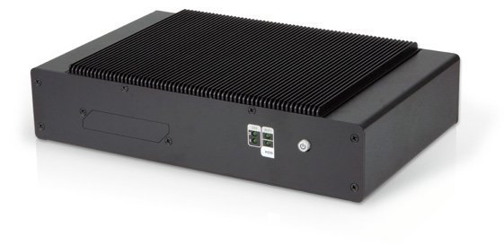

OBD-II

**E**

E-Mark

Dual SIM

-30°C~70°C

### Intel® Apollo Lake processor

* Dual SIM slot
* Optional 3G/Wi-Fi
* 16 x DI/DO
* 1 x HDMI (lockable), 1 x VGA
* Built-in GPS function
* E-Mark certification
* Built-in OBD-II/J1939
* IP4X protection



Fanless



3.75G/HSUPA



GPS



Wi-Fi

***Specifications***

|  |  |  |
| --- | --- | --- |
| **Model** | | **IVS-110-AL** |
| **Chassis** | **Color** | Black |
| **Dimensions (WxHxD) (mm)** | 261 x 170 x 60 |
| **System Fan** | Fanless |
| **Chassis Construction** | Extruded aluminum alloy |
| **Motherboard** | **CPU** | Intel® Atom™ x7-E3950 Processor (quad-core 1.6GHz, 12W TDP) |
| **Chipset** | SoC |
| **System Memory** | 1 x 204-pin DDR3L SO-DIMM. 4GB pre-installed |
| **Storage** | **Hard Drive** | 1 x 2.5'' SATA 6Gb/s HDD/SSD drive bay |
| **mSATA / eMMC** | 1 x mSATA (PCIe Mini Slot) 1 x eMMC 5.0 (reserved) |
| **Communication** | **WLAN** | PCIe Mini Wi-Fi 802.11 a/b/g/n/ac (optional) |
| **Bluetooth** | BT 4.0/3.0+HS (combo with WLAN optional module) |
| **WWAN** | PCIe Mini WCDMA/HSDPA/HSUPA (optional) |
| **GPS** | On board GPS |
| **I/O Interfaces** | **USB 3.1 Gen 1** | 4 |
| **Ethernet** | 1 x RJ-45 PCIe GbE by Intel® I211 |
| **COM Port** | 1 x RS-232/422/485 (BIOS configuration) |
| **Digital I/O** | 1 x 16-bit digital I/O (8-bit input / 8-bit output) |
| **OBD-II/J1939** | 1 x DB9 OBD-II/J1939 |
| **Display** | 1 x VGA, 1 x HDMI |
| **Resolution** | VGA : Up to 1920 x 1200 @ 60 Hz HDMI : Up to 3840 x 2160 @ 30 Hz |
| **Audio** | 1 x Line out |
| **SIM** | 2 x on board SIM card slot |
| **Expansions** | **Mini PCIe** | 1 x Full/Half-size PCIe Mini slot (reserved for WWAN)  1 x Full/Half-size PCIe Mini slot (reserved for mSATA or E-window) 1 x Half-size PCIe Mini slot (reserved for WLAN) |
| **Power** | **Power Input** | Cigarette lighter power cable: 9 V~ 36 V DC |
| **Consumption** | 12V @ 5A  (Intel® Atom™ x7-E3950 with 8GB DDR3 memory) |
| **Reliability** | **Mounting** | Wall mount / VESA 100 |
| **Operating Temperature** | -30°C ~ +70°C with air flow |
| **Storage Temperature** | -40°C ~ 80°C |
| **Humidity** | 10% ~ 95%, non-condensing |
| **Operating Shock** | 50 Grms, Half-sine 11 ms Duration (w/ SSD, according to IEC60068-2-27) |
| **Operating Vibration** | 5 Grms, 5-500 Hz, 3 Axes(with SSD, according to IEC60068-2-64) MIL-STD-810F 514.5C-2 (SSD) |
| **Weight (Net/Gross)** | 2.4 kg / 3.8 kg |
| **Safety/EMC** | CE/FCC/E-Mark/IP rating : IP 4X compliant |
| **OS** | **Supported OS** | Microsoft® Windows 10 IoT Enterprise |

***Fleet Management Tracking System***

***Fully Integrated I/O Dimensions (Unit: mm)***



**Control Center**

**1**

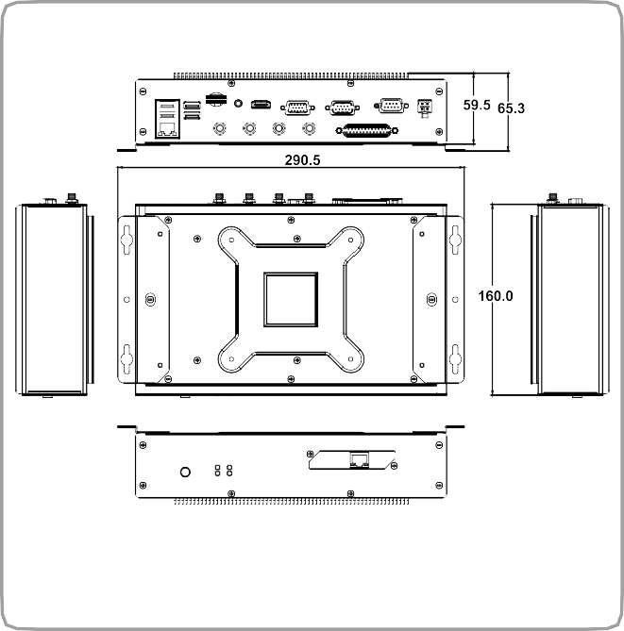

***IVS-110-AL***

***Front view***

E-WINDOWS Power Switch

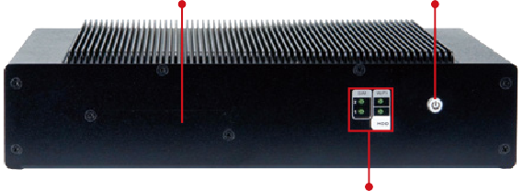

## *Side view*

LED Indicators: HDD, Wi-Fi, SIM

Bluetooth HDMI RS-232/422/485 Power In

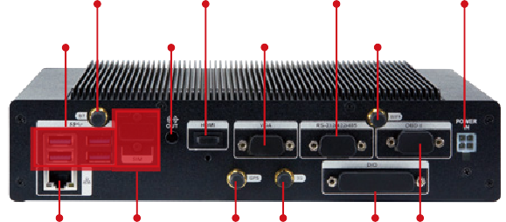

4 x USB 3.1

Gen 1

Audio

VGA

Wi-Fi

LAN

2 x SIM

GPS 3G

DIO OBD-II

# *Ordering Information*

#### Part No. Description

**IVS-110-AL-E3/4G-R10** Fanless embedded system with Intel® Atom™ x7-E3950 (12W) Processor with 4GB DDR3L pre-installed memory, on board GPS, HDMI, VGA, one GbE LAN, one 2.5” SATA HDD bay, two SIM slots, RoHs

# *Options*

#### Item Part No. Description

Integration Antenna, Magnetic Antenna Base+GPS/4G LTE ANTENNA, RG 174, 5000MM, AU-4S-LTE, GPS

#### GPS/LTE antenna

**Power adapter OBD-II cable**

**Cigarette lighter power cable**

**Wireless kit WWAN kit**

**ACC power cable**

***Packing List***

32506-000400-100-RS

IVIPOWER-4PIN-R10 32025-003400-100-RS

32002-004000-100-RS

IVS-WIFI-KIT02-R10

IVS-3G-KIT02-R10 32002-001900-100-RS

Gain:27dB, LTE, Gain:0dBi, 50Ω, SANAV, 1575.42MHz/704-960MHz/1710-2766MHz, VSWR ≤ 2.0, SMA PLUG, REVERSE SMA PLUG, RoHS

Power adapter with 4-pin transfer cable, RoHS

Round cable, OBD-II cable, 2000 mm, 24 AWG, (A) OBD-II 16P male, (B) D-sub 9P female, one piece package with label, RoHS

Round cable, power cable, car cigarette lighter cable, 2000 mm, 18 AWG, (A) cigarette lighter (5 A 250 V)+ ψ3 green

LED, (B) MOLEX 5557-0400 P=4.2, SHANGHAI YING YU, RoHS

1T1R Wi-Fi module kit for embedded system, IEEE802.11a/b/g/n/ac Wi-Fi with Bluetooth 4.0/3.0+HS, 1 x Wi-Fi module, 2 x Antenna, RoHS

3G module kit for embedded system, F260, 1 x 3G module, RoHs

Round cable, power cable, 3000 mm, 16 AWG, (A) MOLEX 5557-04P P=4.2, SHANGHAI YING YU, RoHS



**E-Window (for ATO assembly)**

**Part No.**

**Description**

E-MPCIE-LAN-R10

PCIe Mini card supports 1-port GbE with Realtek RTL8111E controller, with PMS 194C I/O bracket and 250mm cable, R10

E-MPCIE-DLAN-R10

PCIe Mini card supports 2-port GbE with Intel I211 controller, with PMS 194C I/O bracket and 250mm cable, R10



**Item**

**Screw pack**

**Part No.**

44005-030083-RS

42005-000603-RS

44003-030052-RS

44045-020031-RS

**Qty**

4

4

4

5

**SATA Cable**

32801-003608-100-RS

1

**Wall Mount Kit** 41020-0482C2-00-RS

2

**Description** Screw pack Screw pack Screw pack Screw pack

Sata cable, 3, 150mm/150mm, 26AWG, SATA 7+15P female 180°,

SATA 7P female 90°+lock, JST PHR-2 P=2.0, One pcs PKG W/

label, RoHS

Wall mount bracket