Vehicle Surveillance System
IVS-200-ULT2

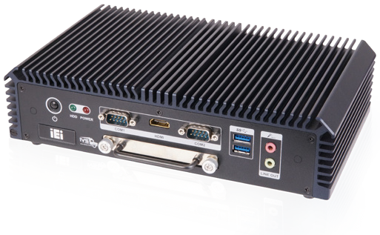Features
mSATA
-20°C~60°C
- Intel® i5-5350U dual-core 1.8 GHz CPU or Intel® Celeron® 3755U dual-core 1.7 GHz CPU
- Four Intel® GbE LAN ports
- 9 V~36 V DC input
- Two RS-232/422/485
- E-Mark certification



E
E-Mark

Four LAN

Fanless

9~36V
DV Input
Specifications

Model Name |  | IVS-200-ULT2
Chassis | Color | Blue C
Chassis | Dimensions (WxHxD) (mm) | 255 x 63 x 150
Chassis | System Fan | Fanless
Chassis | Chassis Construction | Extruded aluminum alloy
Motherboard | CPU | Intel® Core™ i5-5350U Processor (dual-core, 1.8 GHz, 15W TDP) or Intel® Celeron® 3765U Processor (dual-core, 1.9 GHz, 15W TDP)
Motherboard | Chipset | SoC
Motherboard | System Memory | 2 x 204-pin DDR3L SO-DIMM slot  4 GB Pre-installed (system max. 16 GB)
Storage | Hard Drive | 1 x 2.5" SATA 6Gb/s HDD/SSD removable drive bay
Storage | mSATA | 1 x mSATA (SATA 6Gb/s)
Communication | WLAN | PCIe Mini Wi-Fi 802.11b/g/n (optional)
Communication | Bluetooth | Bluetooth 2.1 (combined with WWAN optional module)
Communication | WWAN | PCIe Mini WCDMA/HSDPA/HSUPA (optional)
I/O Interfaces | USB 3.1 Gen 1 | 2
I/O Interfaces | USB 2.0 | 2
I/O Interfaces | Ethernet | 4 x RJ-45 connector  LAN1: PCIe GbE by Intel® I218 LAN2: PCIe GbE by Intel® I211 LAN3: PCIe GbE by Intel® I211 LAN4: PCIe GbE by Intel® I211
I/O Interfaces | COM Port | 2 x DB-9 RS-232/422/485  4 x DB-9 RS-232 (optional)
I/O Interfaces | Display | 1 x VGA, 1 x HDMI
I/O Interfaces | Resolution | VGA: up to 2560 x 1600 @ 60 Hz  HDMI: up to 3840 x 2160 @ 60 Hz
I/O Interfaces | DIO | 8 bit digital I/O (4-bit input, 4-bit output) (optional)
I/O Interfaces | SIM | 1 x on board SIM card slot
I/O Interfaces | Antenna | 1 x 3G, 1 x BT, 1 x Wi-Fi
I/O Interfaces | Audio | 1 x Line out, 1 x Mic in
Expansions | PCIe Mini | 1 x Full-size PCIe Mini (reserved for WWAN or mSATA)*  1 x Full-size PCIe Mini (reserved for WLAN)
Power | Power Input | DC jack : 9 V~36 V DC
Power | Consumption | 12 V @ 2.1 A (Intel® i5-5350U with 4 GB DDR3 memory)
Reliability | Mounting | VESA 100
Reliability | Operating Temperature | -20°C ~ 60°C with air flow (SSD)
Reliability | Storage Temperature | -30°C ~ 70°C
Reliability | Humidity | 10% ~ 95%, non-condensing
Reliability | Operating Shock | Half-sine wave shock 5G, 11ms, 3 shocks per axis
Reliability | Operating Vibration | MIL-STD-810F 514.5C-2 (with SSD)
Reliability | Weight (Net/Gross) | 2.2 kg/3 kg
Reliability | Safety/EMC | CE/FCC/E-Mark
OS | Supported OS | Microsoft® Windows® Embedded 8, Microsoft® Windows® Embedded Standard 7 E
*IVS-200-ULT2-QGW-R10 has only one PCIe mini slot(Full size)

Fully Integrated I/O
Front view Rear view

LED Indicators:
HDD, Power COM 1 HDMI COM 2

2 x USB 3.1
Gen 1 ACC Mode Reset

ATX/AT
Mode 2 x USB 2.0

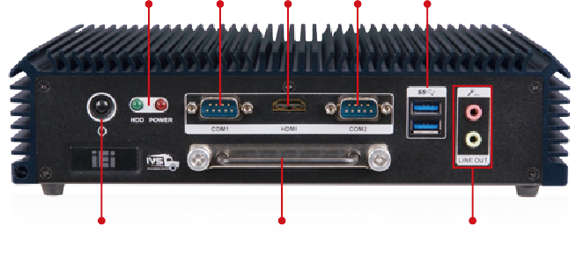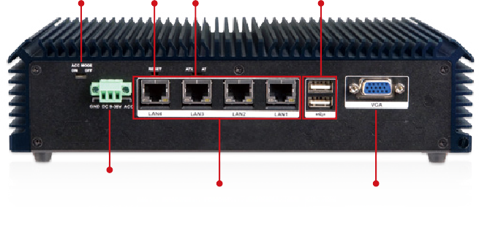
Power Switch
2.5" HDD/SSD Drive Bay
Audio
Power In (Terminal Block)
4 x LAN
VGA

Dimensions (Unit: mm)
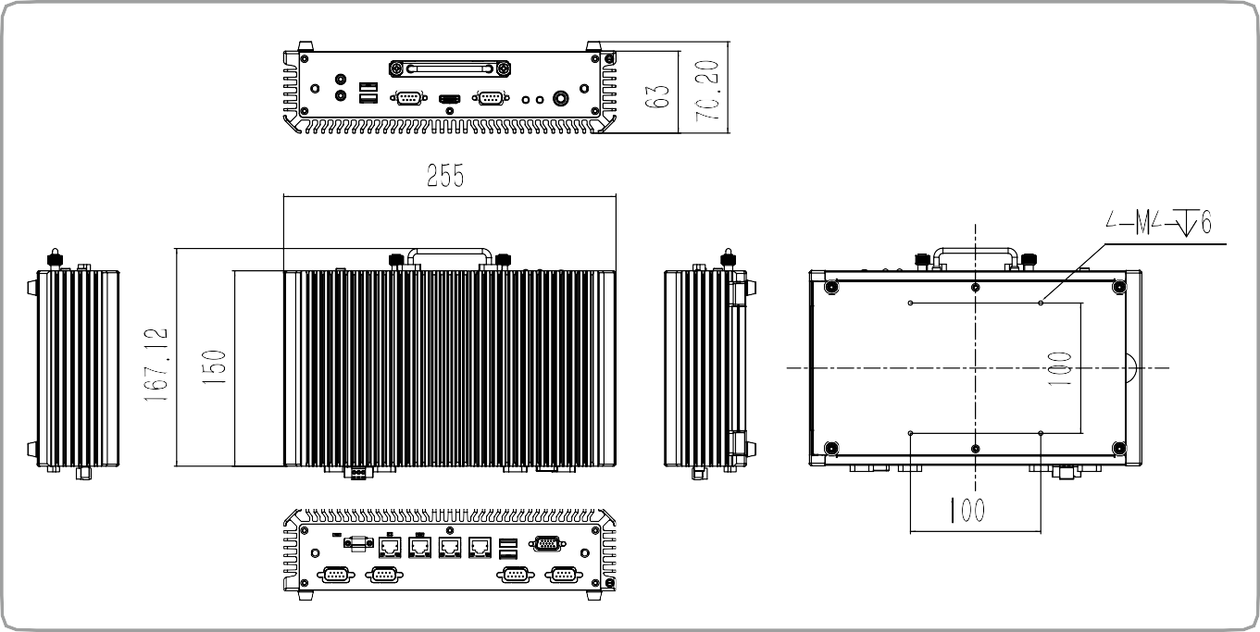
IVS-200-ULT2

Ordering Information
Part No. | Description
IVS-200-ULT2-i5/4G-R10 | Fanless system with Intel® Core™ i5-5350U CPU, up to 2.9GHz, TDP 15W, four GbE LAN ports, one HDMI, one VGA, two RS-232/422/485, one 2.5" removable SATA HDD bay, 4 GB memory pre-installed, 9 V~36 V DC, R10, RoHS
IVS-200-ULT2-C/4G-R10 | Fanless system with Intel® Celeron® 3765U 1.7GHz CPU, TDP 15W, four GbE LAN ports, one HDMI, one VGA, two RS-232/422/485, one 2.5" removable SATA HDD bay, 4 GB memory pre-installed, 9 V~36 V DC, R10, RoHS
IVS-200-ULT2-QGW-R10 | Fanless System with Intel® Core™ i5-5350U up to 2.9GHz, TDP 15W, 4 x GbE LAN port , 1 x HDMI, 1 x VGA, 2 x RS-232/422/485, 1 x 2.5’’ removable SATA HDD bay, 8G memory pre-installed, with QTS-Gateway, 9~36V DC, RoHS
Options
Item | Part No. | Description
OS | IVS-200-ULT2-WES7E64-R10 | OS Image with Windows® Embedded Standard 7 E 64-bit for IVS-200-ULT2, DVD-ROM, RoHS
Serial cable | 32205-005400-100-RS | RS-232 cable, 150 mm, 2x5 pin
DIO cable | 32231-000100-200-RS | DIO cable, 150 mm, 2x5 pin
Packing List
Item | Part No. | Qty | Description
Screw pack | 44013-030041-RS | 4 | Screw pack
Screw pack | 44005-030083-RS | 4 | Screw pack
Wall Mount Kit | 41020-0433C2-00-RS | 2 | Wall mount bracket

