***w w w . i ei w or l d .c om***

Intel® Core™ i5 and Celeron® ULT Processor

INOX-F15C-ULT3

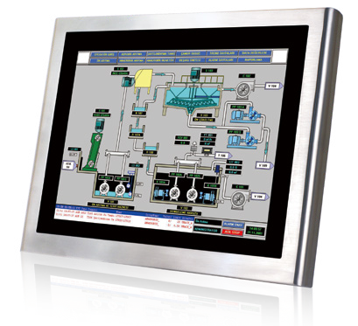***Specifications***

***Features***

* 15’’ fanless panel PC with Intel® Skylake ULT processor
* IP69K high pressure, high temperature protection
* SUS304 stainless steel housing
* Operating temperature : -20°C ~ 50°C
* Flat glass PCAP touch with 6H hardness, resistive touch window
* Accessible HDD Bay
* M12 connections





***Display System***

|  |  |  |
| --- | --- | --- |
| **Model** | | **INOX-F15C-ULT3** |
| LCD | LCD Display | 15" |
| Max Resolution | 1024(W) x 768(H) |
| Brightness (cd/m²) | 450 |
| Contrast Ratio | 800:1 |
| LCD Color | 16.2M |
| Pixel Pitch (mm) | 0.297(H) x 0.297(V) |
| Viewing Angle (H-V) | 160**º** /150**º** |
| Backlight MTBF (Hrs) | 70000 |
| Motherboard | CPU | 6th generation Intel® Core™ i5 and Celeron® ULT processor |
| RAM | 2 x 260-pin 2133/1867 MHz dual-channel DDR4 SO-DIMMs (system max. 32 GB) |
| Ethernet | 2 x PCIe GbE by Intel® I210 controller |
| Touchscreen | | Resistive Touch / PCAP Touch |
| Input Interfaces | I/O Ports | 2 x 8-pin M12 connector for RS-232/422/485 2 x 8-pin M12 X-Code connector for GbE LAN 2 x 8-pin M12 connector for two USB 2.0  1 x 5-pin M12 connector for DC jack (9-36V DC) 1 x Power switch with power LED indicator  1 x Pressure relief valve |
| Expansions | 1 x Full-size PCIe Mini card slot (SATA 6Gb/s)  1 x Full-size/half-size (PCIe x1 and USB 2.0 signals)  1 x M.2 B-key slot (2242/2260/2280 with USB 3.1 Gen 1 (5Gb/s), PCIe x2 and SATA signals) |
| Storage | | 1 x 2.5” SATA SSD bay / 1 x mSATA / 1 x M.2 B-key (2242/2260/2280) |
| Physical | ME Construction | SUS304 stainless steel housing |
| Mounting | VESA 100mm x 100mm with M8 screw |
| Dimensions (WxHxD) (mm) | 414 x 328.4 x 51.9 |
| Environment | Operating Temperature (with air flow) | -20°C ~ 50°C |
| Storage Temperature | -30°C ~ 60°C |
| IP Level | Front: IP69K; Others: IP66 |
| Safety | CE / FCC |
| Power | Adapter | 60 W; 63000-CLG6012IC-RS |
| 60W/12V waterproof power adapter VAC:90V~264V; 12V/5A; 60W |
| Requirement | 9-36V DC |
| Consumption | 43W |

***w w w . i ei w or l d .c om***

***Ordering Information***

|  |  |
| --- | --- |
| Part No. | Description |
| INOX-F15C-ULT3-C/R/4G-R10 | 15” 450cd/m² XGA fanless stainless panel PC with Intel® 14nm 6th generation mobile Celeron® 3955U (15W) on-board processor (ULT), one 4GB DDR4 RAM, resistive touch, R10 |
| INOX-F15C-ULT3-C/PC/4G-R10 | 15” 450cd/m² XGA fanless stainless panel PC with Intel® 14nm 6th generation mobile Celeron® 3955U (15W) on-board processor (ULT), one 4GB DDR4 RAM, PCAP touch, R10 |
| INOX-F15C-ULT3-i5/R/4G-R10 | 15” 450cd/m² XGA fanless stainless panel PC with Intel® 14nm 6th generation mobile Core™ i5-6300U (15W) on-board processor (ULT), one 4GB DDR4 RAM, resistive touch, R10 |
| INOX-F15C-ULT3-i5/PC/4G-R10 | 15” 450cd/m² XGA fanless stainless panel PC with Intel® 14nm 6th generation mobile Core™ i5-6300U (15W) on-board processor (ULT), one 4GB DDR4 RAM, PCAP touch, R10 |

***Packing List***

|  |  |
| --- | --- |
| Item | P/N |
| Power Cable | 32000-127500-RS |
| USB Cable | CB-M12USB02-R20 |

***Optional Cables and Adapter***

***Options***



P/N

Item

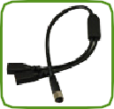 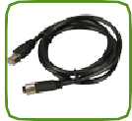 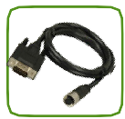 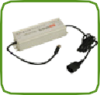

USB cable

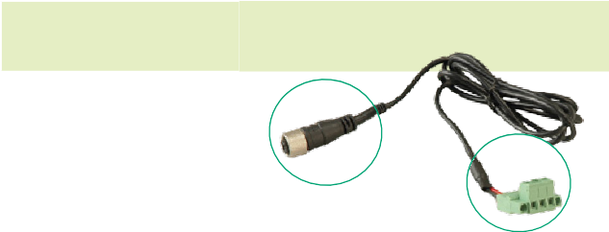

32000-127500-RS

(B)

STAND-A19-RS STAND-C19-R10 STAND-A21-R10

Stand

ARM-31-RS

Arm

|  |  |
| --- | --- |
| Item | P/N |
| USB Cable | CB-M12USB02-R20 |
| RJ-45 LAN Cable | CB-M12RJ45X-R10 |
| DB-9 COM Port Cable | CB-M12COM-R20 |
| Water-proof Power Adapter | 63040-030080-000-RS |

RJ-45 LAN cable

DB-9 COM port Cable Water-proof Power Adapter

(CB-M12USB02-R20)

(CB-M12RJ45X-R10) (CB-M12COM-R20)

(63040-030080-000-RS)

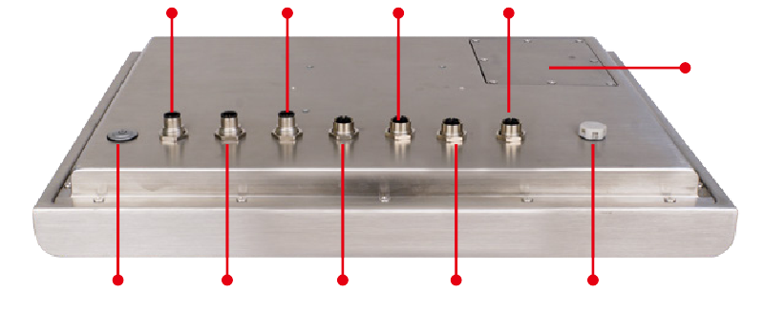DC in 9V~36V

COM 2

LAN 2

USB 2.0

# *I/O Interface*

2.5” SATA SSD bay

Power switch with power LED indicator

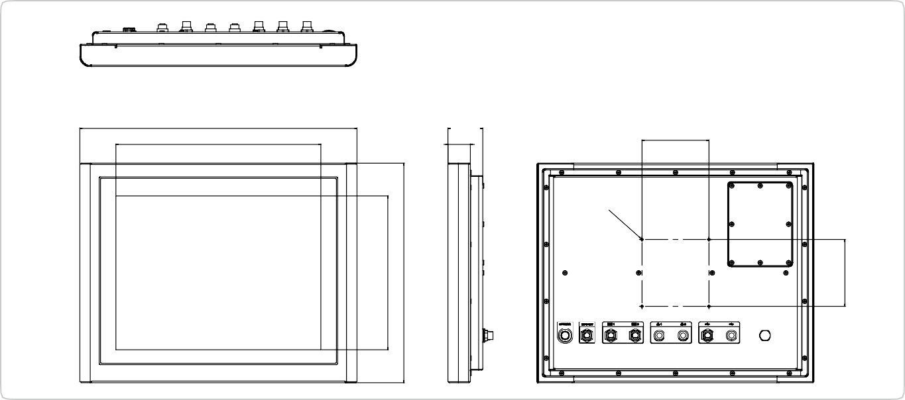

***INOX-F15C Dimensions (Unit: mm)***

414

306

51.9

100

4-M4

33.2

COM 1

LAN 1

USB 2.0 Pressure relief valve



***Display System***

230

328.4

100