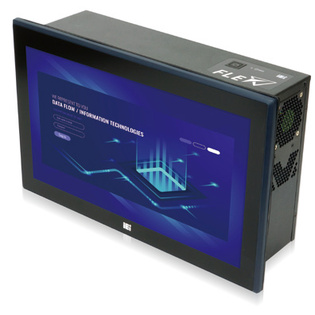

**PPC-F-Q370 Series**

**15”/15.6”/17” AI Ready Panel PC Based on Intel® OpenVINO™ toolkit**

***Features***

* 15”~24" Panel PC with 8th Generation LGA 1151 Intel® Core™ i7/i5/i3

and Pentium® processor

* Four hot-swappable and accessible HDD drive bays, support RAID

0/1/5/10

* Two PCIe 3.0 by 4 and two PCIe 3.0 by 8 slots
* Dual M.2 2280 PCIe Gen 3.0 x4 NVMe™ SSD support

*Specifications*

|  |  |  |  |  |
| --- | --- | --- | --- | --- |
| **Model** | | **PPC-F15C-Q370** | **PPC-F17C-Q370** | **PPC-FW15C-Q370** |
| TFT LCD | LCD Size | 15” | 17” | 15.6" |
| Max. Resolution | 1024x768 | 1280x1024 | 1366x768 |
| Brightness (cd/m²) | 450 | 350 | 400 |
| Contrast Ratio | 800:1 | 1000:1 | 500:1 |
| LCD Color | 16.2M | 16.7M | 16.2M |
| Viewing Angle (H/V) | 160°/150° | 170°/160° | 170°/160° |
| Backlight MTBF (Hrs) | 70,000 | 50,000 | 50,000 |
| Touch Screen | | PCAP touch with 10-point multitouch, anti-glare coating | | |
| Mainboard | CPU | 8th Generation Intel® Core™ i7/i5/i3 and Pentium® processor in the LGA 1151 package | | |
| Chipset | Intel® Q370 Chipset | | |
| Memory | 2 x 288-pin 2666/2400 MHz dual-channel DDR4 unbuffered DIMM slot supporting up to 64GB | | |
| Graphics Engine | Intel® HD Graphics Gen 9 Engines with 16 low-power execution units, supports DX2015, OpenGL 5.X and OpenCL 2 x,  ES 2.0 | | |
| Ethernet | Intel® I211 controller | | |
| Storage | | 1. 4 x Accessible 2.5” SATA 6Gb/s HDD/SSD bay (RAID 0/1/5/10 support) with LED indicator 2. 2 x M.2 2280 PCIe Gen 3.0 x4 NVMe™ SSD socket | | |
| I/O Ports and Switches | | 1. x HDMI output 1 x Line out 2. x GbE LAN 1 x AC power in Inlet   6 x USB 3.1 Gen 1 (5Gb/s) Type-A Power button with power LED (power on=Blue) 2 x RS-232 DB-9 type AT/ATX mode switch  1 x Mic in Reset button | | |
| Expansion Slots | | 2 x PCIe 3.0 by 8 (by 16 slot)  2 x PCIe 3.0 by 4 ( maximum card size supported: 68 mm x 167 mm) | | |
| Thermal Solution | | Smart Fan | | |
| Power Supply | | AC input ATX power supply   1. 250W power supply   - Input: 115VAC~230VAC, 50/60Hz  - Output (max.): 3.3V@12A, 5V@14A, 12V@25A, -12V@0.3A,+5Vsb@3A   1. 350W power supply (Build to Order)   - Input: 115VAC~264VAC, 50/60Hz  - Output (max.): 3.3V@14A, 5V@16A, 12V@29A, -12V@0.3A,+5Vsb@3A  -Efficiency: Full load (100%) 87%, Typical load (50%) 90%, Light load (20%) 87% | | |
| Watchdog Timer | | Software Programmable support 1~255 sec. system reset | | |
| Construction | IP Rating | IP66-rated front panel | | |
| Chassis Construction | Metal Housing | | |
| Mounting | Rack/Panel Mount | | |
| Color | Front Bezel : Cyan-blue (PSM 296C), Others: Black C | | |
| Cut-out dimensions (LxDxH) (mm) | 361.1 x 285.6 | 391 x 324 | 379.1 x 232.3 |
| Dimensions (LxDxH) (mm) | 378.5 x 303 x 118 | 408.4 x 341.4 x 119 | 400.1 x 253.3 x 121 |
| Environmental | Operating Temperature | -20°C ~ 50°C (with SSD and up to TDP 65W processor)  -20°C ~ 40°C (with HDD or add-on cards without fan) | | |
| Storage Temperature | -30°C ~ 60°C | | |
| Operating Humidity | 5% ~95%, non-condensing | | |
| Vibration | 5~17Hz, 0.1 double amplitude displacement 17~640Hz 1.5G acceleration peak to peak | | |
| Shock | 10G acceleration part to part (11ms) | | |

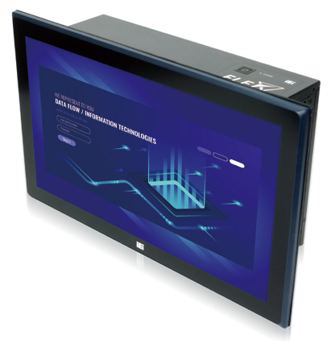

**PPC-F-Q370 Series**

**18.5”/21.5”/23.8” AI Ready Panel PC Based on Intel® OpenVINO™ toolkit**

***Features***

* 15”~24" Panel PC with 8th Generation LGA 1151 Intel® Core™ i7/i5/i3

and Pentium® processor

* Four hot-swappable and accessible HDD drive bays, support RAID

0/1/5/10

* Two PCIe 3.0 by 4 and two PCIe 3.0 by 8 slots
* Dual M.2 2280 PCIe Gen 3.0 x4 NVMe™ SSD support

*Specifications*

|  |  |  |  |  |
| --- | --- | --- | --- | --- |
| **Model** | | **PPC-FW19C-Q370** | **PPC-FW22C-Q370** | **PPC-FW24C-Q370** |
| TFT LCD | LCD Size | 18.5" | 21.5” | 23.8” |
| Max. Resolution | 1366x768 | 1920x1080 | 1920x1080 |
| Brightness (cd/m²) | 400 | 250 | 250 |
| Contrast Ratio | 1000:1 | 1000:1 | 3000:1 |
| LCD Color | 16.7M | 16.7M | 16.7M |
| Viewing Angle (H/V) | 170°/160° | 170°/160° | 178°/178° |
| Backlight MTBF (Hrs) | 50,000 | 30,000 | 30,000 |
| Touch Screen | | PCAP touch with 10-point multitouch, anti-glare coating | | |
| Mainboard | CPU | 8th Generation Intel® Core™ i7/i5/i3 and Pentium® processor in the LGA 1151 package | | |
| Chipset | Intel® Q370 Chipset | | |
| Memory | 2 x 288-pin 2666/2400 MHz dual-channel DDR4 unbuffered DIMM slot supporting up to 64GB | | |
| Graphics Engine | Intel® HD Graphics Gen 9 Engines with 16 low-power execution units, supports DX2015, OpenGL 5.X and OpenCL 2 x,  ES 2.0 | | |
| Ethernet | Intel® I211 controller | | |
| Storage | | 1. 4 x Accessible 2.5” SATA 6Gb/s HDD/SSD bay (RAID 0/1/5/10 support) with LED indicator 2. 2 x M.2 2280 PCIe Gen 3.0 x4 NVMe™ SSD socket | | |
| I/O Ports and Switches | | 1. x HDMI output 1 x Line out 2. x GbE LAN 1 x AC power in Inlet   6 x USB 3.1 Gen 1 (5Gb/s) Type-A Power button with power LED (power on=Blue) 2 x RS-232 DB-9 type AT/ATX mode switch  1 x Mic in Reset button | | |
| Expansion Slots | | 2 x PCIe 3.0 by 8 (by 16 slot)  2 x PCIe 3.0 by 4 ( maximum card size supported: 68 mm x 167 mm) | | |
| Thermal Solution | | Smart Fan | | |
| Power Supply | | AC input ATX power supply   1. 250W power supply   - Input: 115VAC~230VAC, 50/60Hz  - Output (max.): 3.3V@12A, 5V@14A, 12V@25A, -12V@0.3A,+5Vsb@3A   1. 350W power supply (Build to Order)   - Input: 115VAC~264VAC, 50/60Hz  - Output (max.): 3.3V@14A, 5V@16A, 12V@29A, -12V@0.3A,+5Vsb@3A  -Efficiency: Full load (100%) 87%, Typical load (50%) 90%, Light load (20%) 87% | | |
| Watchdog Timer | | Software Programmable support 1~255 sec. system reset | | |
| Construction | IP Rating | IP66-rated front panel | | |
| Chassis Construction | Metal Housing | | |
| Mounting | Rack/Panel Mount | Panel Mount | |
| Color | Front Bezel : Cyan-blue (PSM 296C), Others: Black C | | |
| Cut-out dimensions (LxDxH) (mm) | 447.8 x 267.2 | 533 x 341 | 577.6 x 359.6 |
| Dimensions (LxDxH) (mm) | 469.8 x 289.2 x 120.8 | 550.4 x 358.4 x 117.8 | 600 x 356.6 x 119 |
| Environmental | Operating Temperature | -20°C ~ 50°C (with SSD and up to TDP 65W processor)  -20°C ~ 40°C (with HDD or add-on cards without fan) | | |
| Storage Temperature | -30°C ~ 60°C | | |
| Operating Humidity | 5% ~95%, non-condensing | | |
| Vibration | 5~17Hz, 0.1 double amplitude displacement 17~640Hz 1.5G acceleration peak to peak | | |
| Shock | 10G acceleration part to part (11ms) | | |

*Ordering Information*

|  |  |
| --- | --- |
| Part No. | Description |
| PPC-F15C-Q370-P/PC/25-R10 | 15" 450cd/m² 1024 x768 AI modular Panel PC , Intel® Pentium® Gold G5400T Processor (2-core, 4-thread, 3.10 GHz) TDP  35W, two PCIe x4 and two PCIe x8 slots, four HDD bays, 250W PSU, R10 |
| PPC-F15C-Q370-i3/PC/25-R10 | 15" 450cd/m² 1024 x768 AI modular Panel PC, Intel® Core™ i3-8100T Processor (4-core, 4-thread, 3.10 GHz) TDP 35W, two  PCIe x4 and two PCIe x8 slots, four HDD bays, 250W PSU, R10 |
| PPC-F15C-Q370-i5/PC/25-R10* | 15" 450cd/m² 1024 x768 AI modular Panel PC, Intel® Core™ i5-8500T Processor (6-core, 6-thread, 2.1 GHz) TDP 35W, two  PCIe x4 and two PCIe x8 slots, four HDD bays, 250W PSU, R10 |
| PPC-F15C-Q370-i7/PC/25-R10* | 15" 450cd/m² 1024 x768 AI modular Panel PC, Intel® Core™ i7-8700T Processor (6-core,12-thread,2.4 GHz) TDP 35W, two  PCIe x4 and two PCIe x8 slots, four HDD bays, 250W PSU, R10 |
| PPC-F17C-Q370-P/PC/25-R10 | 17" 350cd/m² 1280 x 1024 AI modular Panel PC, Intel® Pentium® Gold G5400T Processor (2-core, 4-thread, 3.10 GHz) TDP  35W, two PCIe x4 and two PCIe x8 slots, four HDD bays, 250W PSU, R10 |
| PPC-F17C-Q370-i3/PC/25-R10 | 17" 350cd/m² 1280 x 1024 AI modular Panel PC, Intel® Core™ i3-8100T Processor (4-core, 4-thread, 3.10 GHz) TDP 35W,  two PCIe x4 and two PCIe x8 slots, four HDD bays, 250W PSU, R10 |
| PPC-F17C-Q370-i5/PC/25-R10* | 17" 350cd/m² 1280 x 1024 AI modular Panel PC, Intel® Core™ i5-8500T Processor (6-core, 6-thread, 2.1 GHz) TDP 35W,  two PCIe x4 and two PCIe x8 slots, four HDD bays, 250W PSU, R10 |
| PPC-F17C-Q370-i7/PC/25-R10* | 17" 350cd/m² 1280 x 1024 AI modular Panel PC, Intel® Core™ i7-8700T Processor (6-core,12-thread,2.4 GHz) TDP 35W,  two PCIe x4 and two PCIe x8 slots, four HDD bays, 250W PSU, R10 |
| PPC-FW15C-Q370-P/PC/25-R10 | 15.6" 400cd/m² 1366 x 768 AI modular Panel PC, Intel® Pentium® Gold G5400T Processor (2-core, 4-thread, 3.10 GHz) TDP  35W, two PCIe x4 and two PCIe x8 slots, four HDD bays, 250W PSU, R10 |
| PPC-FW15C-Q370-i3/PC/25-R10 | 15.6" 400cd/m² 1366 x 768 AI modular Panel PC, Intel® Core™ i3-8100T Processor (4-core, 4-thread, 3.10 GHz) TDP 35W,  two PCIe x4 and two PCIe x8 slots, four HDD bays, 250W PSU, R10 |
| PPC-FW15C-Q370-i5/PC/25-R10* | 15.6" 400cd/m² 1366 x 768 AI modular Panel PC, Intel® Core™ i5-8500T Processor (6-core, 6-thread, 2.1 GHz) TDP 35W,  two PCIe x4 and two PCIe x8 slots, four HDD bays, 250W PSU, R10 |
| PPC-FW15C-Q370-i7/PC/25-R10* | 15.6" 400cd/m² 1366 x 768 AI modular Panel PC, Intel® Core™ i7-8700T Processor (6-core,12-thread,2.4 GHz) TDP 35W,  two PCIe x4 and two PCIe x8 slots, four HDD bays, 250W PSU, R10 |
| PPC-FW19C-Q370-P/PC/25-R10 | 18.5" 400cd/m² 1366 x 768 AI modular Panel PC, Intel® Pentium® Gold G5400T Processor (2-core, 4-thread, 3.10 GHz) TDP  35W, two PCIe x4 and two PCIe x8 slots, four HDD bays, 250W PSU, R10 |
| PPC-FW19C-Q370-i3/PC/25-R10 | 18.5" 400cd/m² 1366 x 768 AI modular Panel PC, Intel® Core™ i3-8100T Processor (4-core, 4-thread, 3.10 GHz) TDP 35W,  two PCIe x4 and two PCIe x8 slots, four HDD bays, 250W PSU, R10" |
| PPC-FW19C-Q370-i5/PC/25-R10* | 18.5" 400cd/m² 1366 x 768 AI modular Panel PC, Intel® Core™ i5-8500T Processor (6-core, 6-thread, 2.1 GHz) TDP 35W,  two PCIe x4 and two PCIe x8 slots, four HDD bays, 250W PSU, R10 |
| PPC-FW19C-Q370-i7/PC/25-R10* | 18.5" 400cd/m² 1366 x 768 AI modular Panel PC, Intel® Core™ i7-8700T Processor (6-core,12-thread,2.4 GHz) TDP 35W,  two PCIe x4 and two PCIe x8 slots, four HDD bays, 250W PSU, R10 |
| PPC-FW22C-Q370-P/PC/25-R10 | 21.5" 250cd/m² 1920 x 1080 AI modular Panel PC, Intel® Pentium® Gold G5400T Processor (2-core, 4-thread, 3.10 GHz)  TDP 35W, two PCIe x4 and two PCIe x8 slots, four HDD bays, 250W PSU, R10 |
| PPC-FW22C-Q370-i3/PC/25-R10 | 21.5" 250cd/m² 1920 x 1080 AI modular Panel PC, Intel® Core™ i3-8100T Processor (4-core, 4-thread, 3.10 GHz) TDP 35W,  two PCIe x4 and two PCIe x8 slots, four HDD bays, 250W PSU, R10 |
| PPC-FW22C-Q370-i5/PC/25-R10* | 21.5" 250cd/m² 1920 x 1080 AI modular Panel PC, Intel® Core™ i5-8500T Processor (6-core, 6-thread, 2.1 GHz) TDP 35W,  two PCIe x4 and two PCIe x8 slots, four HDD bays, 250W PSU, R10 |
| PPC-FW22C-Q370-i7/PC/25-R10* | 21.5" 250cd/m² 1920 x 1080 AI modular Panel PC, Intel® Core™ i7-8700T Processor (6-core,12-thread,2.4 GHz) TDP 35W,  two PCIe x4 and two PCIe x8 slots, four HDD bays, 250W PSU, R10 |
| PPC-FW24C-Q370-P/PC/25-R10 | 23.8" 250cd/m² 1920 x 1080 AI modular Panel PC, Intel® Pentium® Gold G5400T Processor (2-core, 4-thread, 3.10 GHz)  TDP 35W, two PCIe x4 and two PCIe x8 slots, four HDD bays, 250W PSU, R10" |
| PPC-FW24C-Q370-i3/PC/25-R10 | 23.8" 250cd/m² 1920 x 1080 AI modular Panel PC, Intel® Core™ i3-8100T Processor (4-core, 4-thread, 3.10 GHz) TDP 35W,  two PCIe x4 and two PCIe x8 slots, four HDD bays, 250W PSU, R10" |
| PPC-FW24C-Q370-i5/PC/25-R10* | 23.8" 250cd/m² 1920 x 1080 AI modular Panel PC, Intel® Core™ i5-8500T Processor (6-core, 6-thread, 2.1 GHz) TDP 35W,  two PCIe x4 and two PCIe x8 slots, four HDD bays, 250W PSU, R10 |
| PPC-FW24C-Q370-i7/PC/25-R10* | 23.8" 250cd/m² 1920 x 1080 AI modular Panel PC, Intel® Core™ i7-8700T Processor (6-core,12-thread,2.4 GHz) TDP 35W,  two PCIe x4 and two PCIe x8 slots, four HDD bays, 250W PSU, R10" |

*Build to order

**350W AC PSU models are by build-to-order manufacturing

*Options*

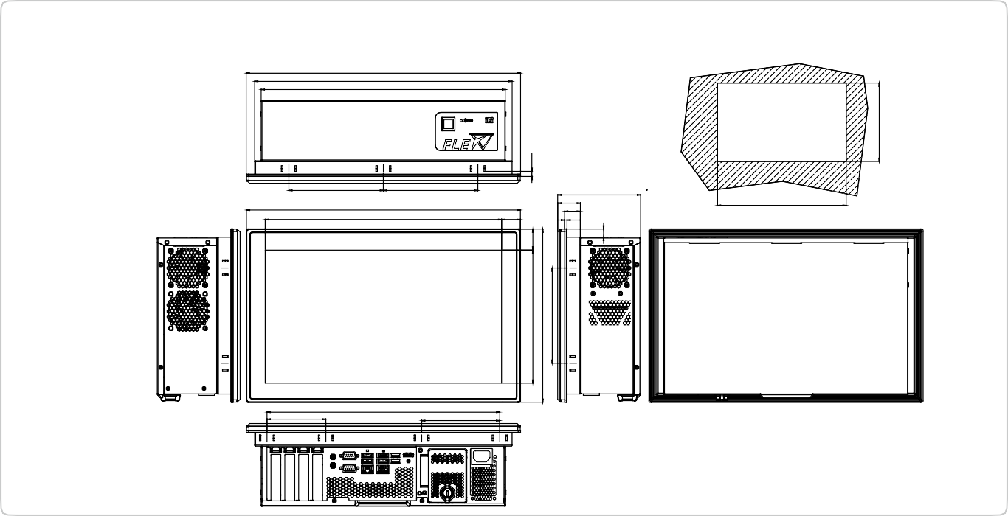

114

339.90

86

3.50

27.34

379.1

33

23

400.10

345.43

121

138.05

138.05

Suggested Cut out Size

Scale 1:2

***PPC-FW15C-Q370 Dimensions***

***(Unit: mm)*** 400.70

376.10

357

34.75

20

20

34.75

10

230

303

10

7.50

7.50

194.74

253.30

139.30

30.71

20

170.60

20 34.75

12

53.60

282.60

232.3

285.6

|  |  |  |  |  |  |  |
| --- | --- | --- | --- | --- | --- | --- |
| Item | PPC-F15C | PPC-FW15C | PPC-F17C | PPC-FW19C | PPC-FW22C | PPC-FW24C |
| Panel Mount Kit | FPK-12-R10 | FPK-14-R10 | FPK-13-R10 | FPK-13-R10 | FPK-13-R10 | FPK-14-R10 |
| Rack Mount Kit | FRK15C-R10 | FRKW15C-R10 | FRK17C-R10 | FRKW19C-R10 | N.A. | N.A. |

*Packing List*

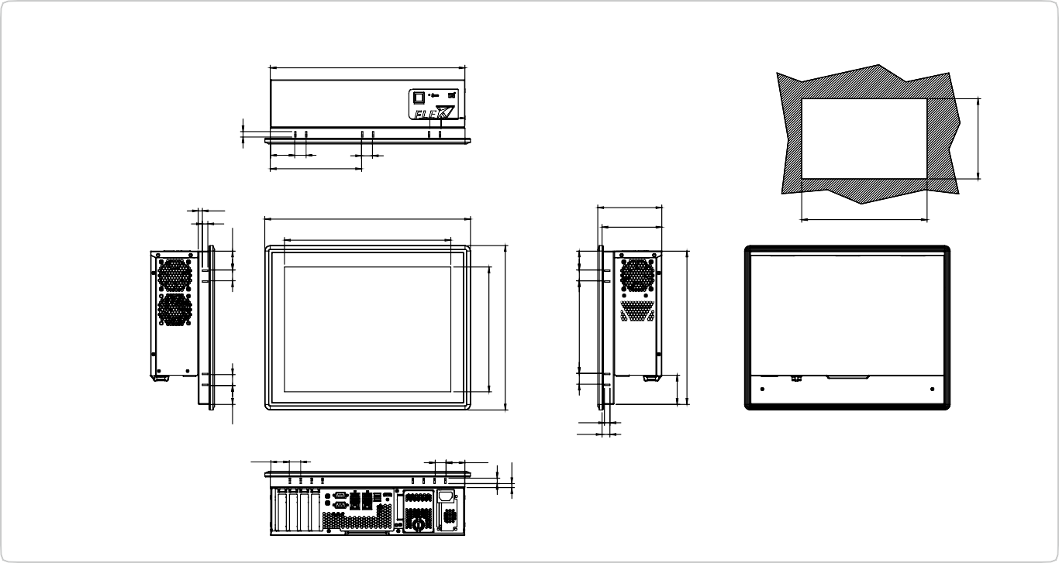

20 34.75

34.75 20

10

14.50

361.1

Suggested cut out size

306

110

378.50

117.96

7.50

10

20

44.7520

167.80

358.10

***(Unit: mm)***

***PPC-F15C-Q370 Dimensions***

|  |  |  |
| --- | --- | --- |
| Item | Q'ty | Description |
| 44013-030041-RS | 16 | Flat head screws for HDD bracket, M3*4 |
| 32702-000200-100-RS | 1 | European power cord, 1830mm |

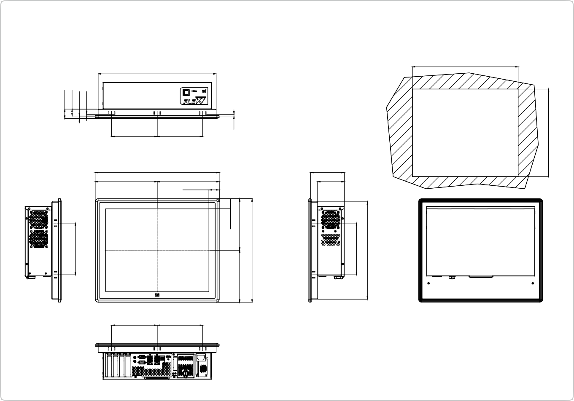

150

150

111

88

204.20

34.20

204.20

408.40

Suggested Cutout Size

150

150

388

391

***PPC-F17C-Q370 Dimensions***

***(Unit: mm)***

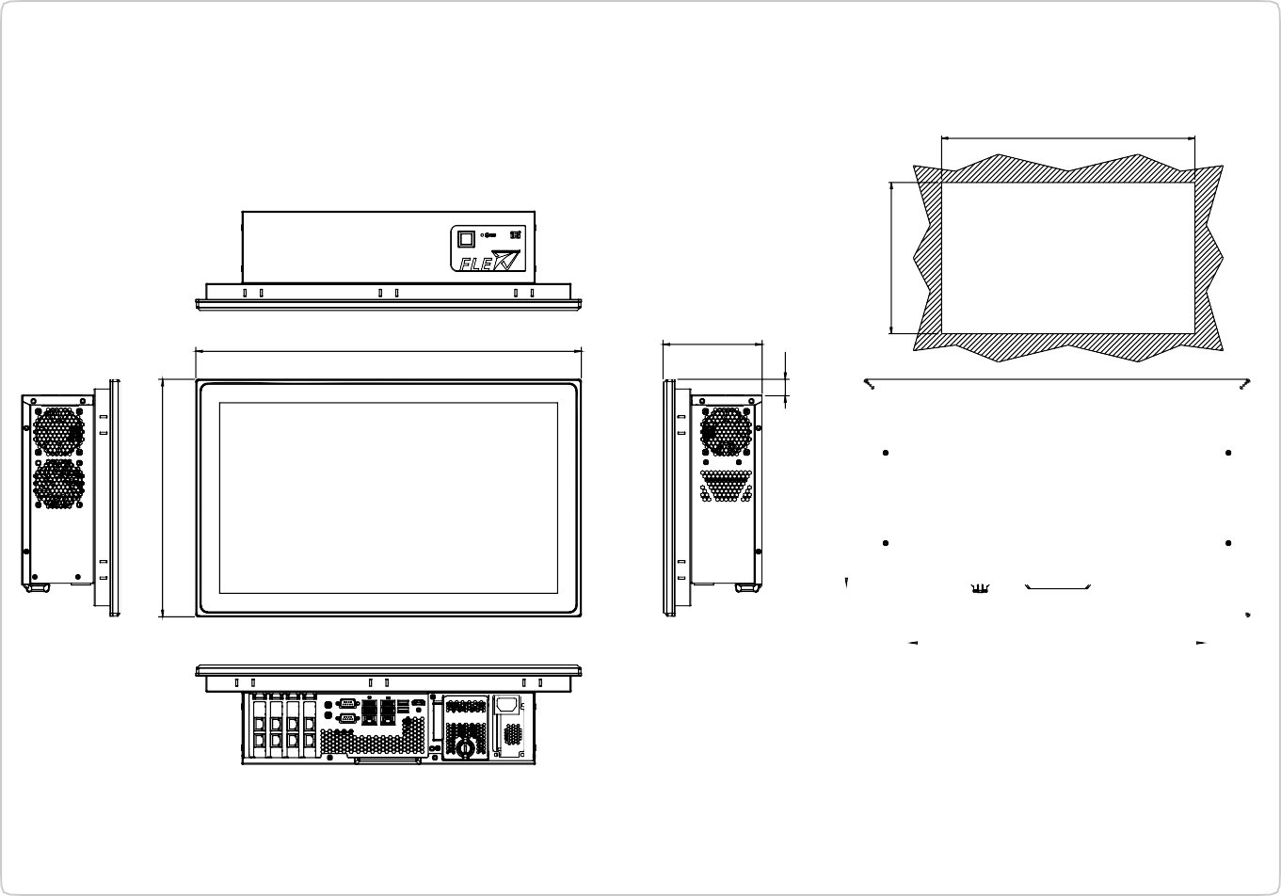

***PPC-FW19C-Q370 Dimensions***

***(Unit: mm)***

447.80

469.80

120.80

Suggested Cut Out Size

31

23

8

6

289.20

170

33.55

169.70

6

171.70

341.40

20.10

170

321

230

267.20

324

|  |  |  |  |
| --- | --- | --- | --- |
|  |  |  |  |
|  |  |  |
|  | | 357 |  |

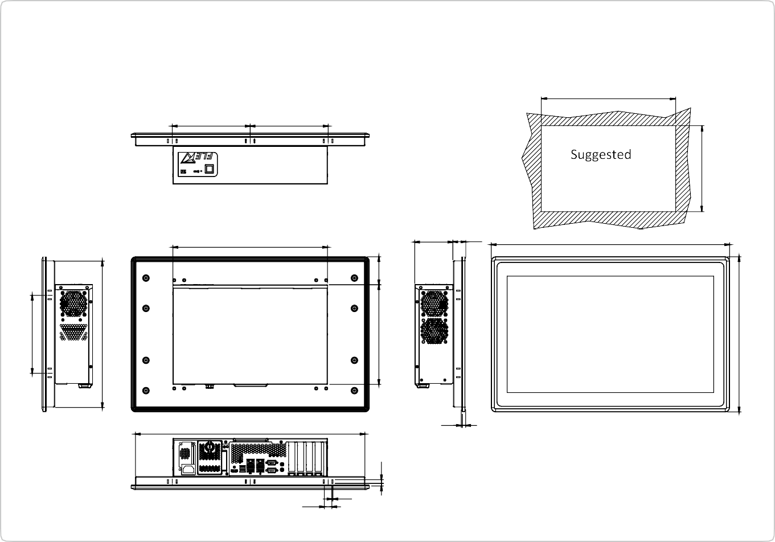

17.50

2.50

530

2.30 8

550.40

88 29.80

357

Cut out Size

180

180

533

***PPC-FW22C-Q370 Dimensions***

***(Unit: mm)***

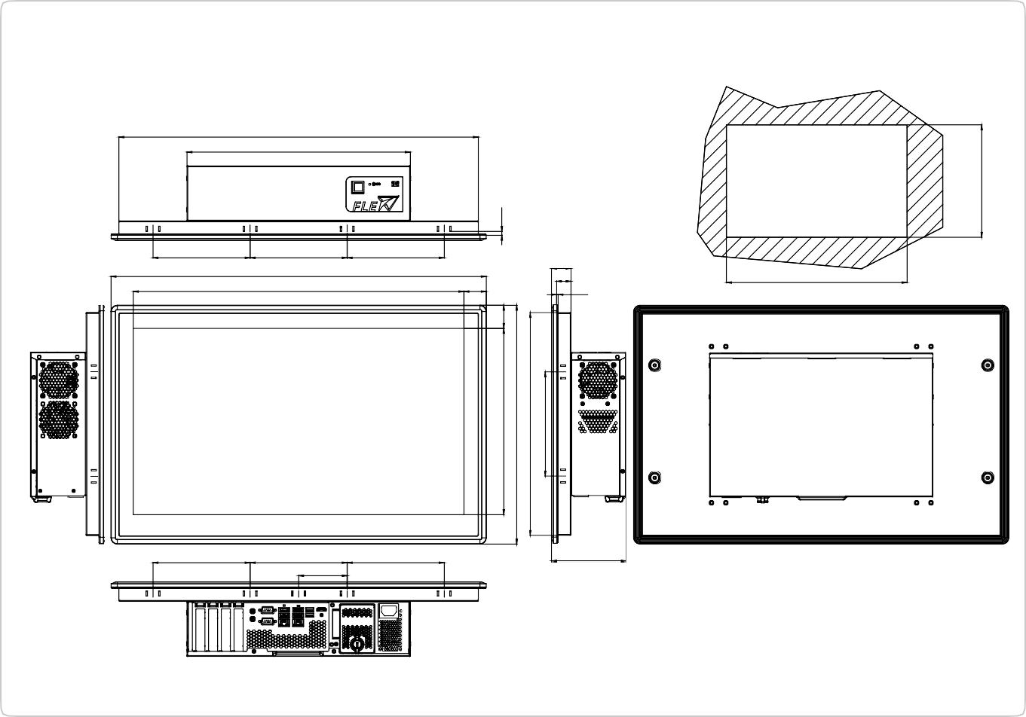

119

155.2

155.2

77.6

155.2

577.6

31

23

2.3

35.7

155.2

155.2

600

528.6

155.2

Suggested Cut Out Size Scale 1:2

574.6

357

***PPC-FW24C-Q370 Dimensions***

***(Unit: mm)***

180

338

6.3

298

382

356.6

166.6

37

230

64.70

6

8.50

341

358.40

359.6