***w w w . i ei w or l d .c om***

**UPC Series**

Intel® Atom™ D525 Dual Core Processor

UPC-V312-D525

***Specifications***

***Features***

* Fully IP 65 compliant with Intel® Atom™ D525 1.8GHz dual-core processor

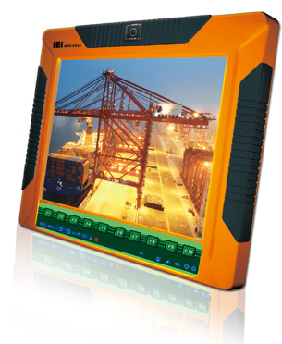

* 12.1’’ 600 nits 1024 x 768 LCD with LED backlight
* Dual DC input, 9V ~ 36V and 10.5V ~ 36V, switch automatically
* Dual-band 2.4/5 GHz Wi-Fi 802.11 a/b/g/n 3T3R MIMO design
* Reserved space for 3.75G HSUPA USB module
* Optional GPS receiver
* Optional EM or Mifare RFID reader
* Optional Bluetooth module
* Built-in 2-mgeapixel webcam with AF, AE and AWB capabilities
* CAN-bus interface with isolation
* Robust die-casting aluminum chassis

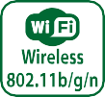



***Display System***

|  |  |  |
| --- | --- | --- |
| **Model Name** | | **UPC-V312-D525-R13** |
| Display | LCD Size | 12.1” |
| Max. Resolution | 1024(W) x 768(H) |
| Brightness (cd/m²) | 600 |
| Contrast Ratio | 700:1 |
| LCD Color | 16.2M |
| Pixel Pitch (mm) (HxV) | 0.24(H) x 0.24(V) |
| Viewing Angle (V/H) | 150° / 130° |
| Backlight MTBF (hrs) | 50000 |
| Touch | Touchscreen | 5-wire resistive type with RS-232 interface |
| Touch Controller | DMC 9000 |
| Motherboard | SBC | UPCMB-V312-D525-R10 |
| CPU | Intel® Atom™ D525 1.8GHz dual-core processor |
| Chipset | Intel® ICH8M |
| RAM | On-board 2GB DDR3 SO-DIMM (system max. 2GB ) |
| Ethernet | Realtek RTL8111CP PCIe GbE controller |
| Audio Codec | Realtek ALC888 audio codec |
| I/O Ports and Switches | | RS-422/485 (4-pin box header) RS-232 (DB-9 connector)  CAN-bus (3-pin terminal block)  GbE LAN (RJ-45 connector) 4 x USB connector  Audio jack (Line-out, Mic)  VGA port (DB-15 connector)  DC-IN 1 (terminal block) / DC-IN 2 (DC jack) Reset button  AT/ATX switch |
| Connectivity | Wireless | IEEE 802.11a/b/g/n 3T3R module (WIFI-RT5393-DB-R10)  Telec certified |
| Bluetooth | Bluetooth V2.0+EDR with USB interface (optional) |
| 3G | Reserved USB connector (optional) |
| Driver Bay | SSD | CF Type II / mSATA (SATA2 signal) |
| Physical | Front Panel Contruction | Aluminum die-casting |
| Chassis Construction | Extruded aluminum alloy |
| Mounting | VESA 100mm x 100mm and 75mm x 75mm with M8 screws |
| Front Panel Color | Orange (Pantone 151C) |
| Dimensions (WxHxD) (mm) | 338.5 x 276.25 x 62.86 |
| Cut Out Dimensions (WxH) (mm) | 338.5 x 276.25 |
| Net/Gross Weight | 4.5 kg/ 6.8 kg |
| Expansion Slot | | PCIe Mini slot for Wi-Fi module |
| PCIe Mini slot |
| System Cooling | | Fanless |
| Environment | Operating Temperature | -20°C~60°C |
| Storage Temperature | -40°C~85°C |
| Vibration | MIL-STD-810F 514.5C-2 (with CF card or SSD) |
| Shock | Half-sine wave shock 3G; 11ms; 3 shocks per axis |
| IP Level | Full IP 65 |
| Safety & EMC | CE / FCC |
| Power | Adapter | 65W power adapter (meets PSE)  (Power adapter supports operating temperature 0°C ~ 40°C) |
| Input: 90VAC~264VAC, 50/60Hz; Output: 19V DC |
| Requirement | Power 1: 9V (+/-0.3)~36V |
| Power 2: 10.5V (+/-0.3)~36V |
| Consumption | 52W |

***w w w . i ei w or l d .c om***

***Ordering Information***

|  |  |
| --- | --- |
| **Part No.** | **Description** |
| UPC-V312-D525/R/2G-R13 | 12.1” 600cd/m² XGA fanless full IP 65 panel PC with Intel® Atom™ D525 dual core 1.8GHz,802.11a/b/g/n wireless module, resistive touch screen, 2-megapixel camera, microphone, 2GB DDR3 RAM, R13 |

***Options Packing List***

|  |  |
| --- | --- |
| **Item** | **P/N** |
| Arm | ARM-11-RS/ARM-31-RS |
| Wall Mounting Kit | AFLWK-19B/ AFLWK-12 |
| Stand | STAND-A19-RS/STAND-A21-R10/STAND-210-R11 |
| EM RFID Kit | UPC-EM-RFID-KIT01-R10 |
| MiFARE RFID Kit | UPC-MF-RFID-KIT01-R11 |
| OS: Win CE 6.0 (128MB CF Card) | UPCCF-V312-D525-CE060-128M-R10 |
| OS: Win XPE (4GB CF Card) | UPCCF-V312-D525-XPE-4G-R10 |
| OS: Win 7 Embedded (4GB CF Card) | UPCCF-V312-D525-WES7E-4G-R10 |

|  |  |  |
| --- | --- | --- |
| **Item** | **P/N** | **Q'ty** |
| Utility CD | 7B000-000741-RS | 1 |
| One Key Recovery CD |  | 1 |
| IR Remote Controller | 7Z000-SLPCB005-RS | 1 |
| RJ-45 to DB-9 COM Port Cable | 32005-000200-200-RS | 1 |
| M8 Screw | 44325-080081-RS | 8 |
| M4 Screw | 44005-040082-RS | 8 |
| Mounting Bracket | 41003-0382C2-00-RS | 2 |
| Screw Driver | 45019-001004-00 | 1 |
| Power Adapter | 63040-010065-200-RS | 1 |
| Power Cord (European Standard) | 32702-000401-100-RS | 1 |
| RS-422 Cable | 32205-002400-100-RS | 1 |
| Power Transfer Cord | 32702-000300-100-RS | 1 |
| M8 to M4 Screw | 44300-040061-RS | 8 |

***I/O Interface***

Power 2 (DC Jack)

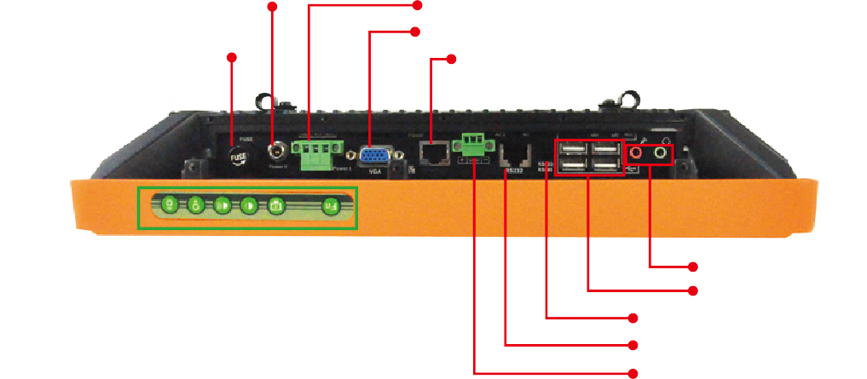Fuse

Power1 (Terminal block)

VGA

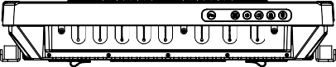LAN



***Display System***

MIC, Line-out USB

COM2 (RS-485) COM1 (RS-232)

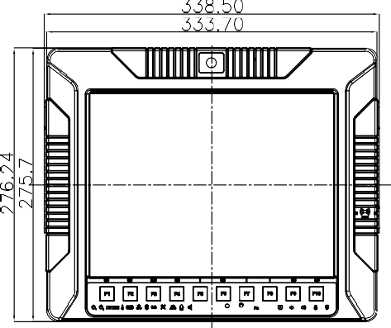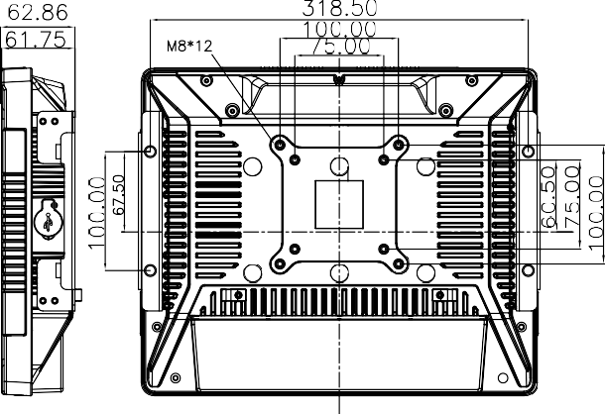CAN-bus

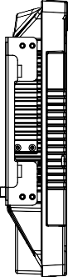

***UPC-V312 Dimensions (Unit: mm)***