

ECW-281B/2550-2018-V11



***Industrial Computer Chassis***

***w w w . i ei w or l d .c om***

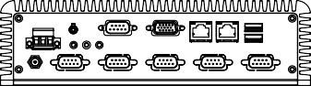



***Features***

* Fanless system with Intel® Atom™ D2550 dual-core 1.86 GHz CPU
* Supports 4 COM ports (3 x RS-232, 1 x RS-422/485)
* 2 PCIe Mini slots (1 x Full-size, 1 x Half-size)
* 12V DC and 9 V~36 V DC model available
* 2T2R 802.11b/g/n wireless model available

Fanless

mSATA

***Specifications***

***Dimensions (Unit: mm)***

***Fanless Embedded System with Intel® Atom™ Dual-core D2550 CPU***

**ECW-281B-D2550**

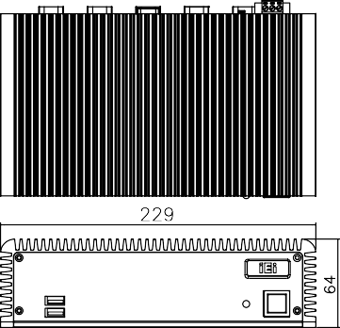 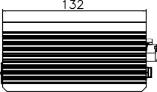

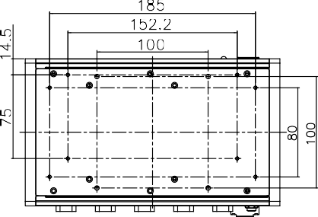

*Ordering Information*

|  |  |  |
| --- | --- | --- |
| **Part No.** | | **Description** |
| **12V DC**  **Input** | **ECW-281B-R11/ D2550/2GB** | Fanless embedded system with WAFER-CV-D25501, with dual-core Intel® Atom™ D2550 1.86GHz CPU, 4 serial ports, with 2 GB DDR3 pre-installed SO-DIMM memory, 12 V DC in, 60W power adapter, black, RoHS |
| **9 V~36 V**  **DC Input** | **ECW-281BWD-R10/ D2550/2GB** | Fanless embedded system with WAFER-CV-D25501, with dual-core Intel® Atom™ D2550 1.86GHz CPU, 4 serial ports, with 2 GB DDR3 pre-installed SO-DIMM memory, 9 V~36 V DC in, 60W power adapter, black, RoHS |

*Packing List*

|  |  |  |
| --- | --- | --- |
| **Model Name** | | **ECW-281B-D2550** |
| **Chassis** | **Color** | Black |
| **Dimensions (WxDxH) (mm)** | 229 x 132 x 64 |
| **System Fan** | Fanless |
| **Chassis Construction** | Aluminum alloy with heavy duty metal |
| **Motherboard** | **Motherboard Model** | WAFER-CV-D25501 |
| **SBC Size (mm)** | 3.5", 146 x 102 |
| **CPU** | Intel® Atom™ dual-core D2550 1.86GHz |
| **Chipset** | Intel® NM10 |
| **System Memory** | 2GB DDR3 204-pin SO-DIMM memory  pre-installed |
| **Storage** | **Hard Drive** | 1 x 2.5'' SATA HDD bay |
| **I/O Interfaces** | **USB 2.0** | 4 |
| **Ethernet** | 2 x Realtek RTL8111E PCIe GbE controller |
| **COM Port** | 3 x RS-232  1 x RS-422/485 |
| **Digital I/O** | 8-bit digital I/O |
| **Display** | 1 x VGA |
| **Resolution** | VGA: Up to 1920 x 1200@60Hz |
| **Audio** | 1 x Line-out |
| **Wireless** | 1 x 802.11b/g/n (optional) |
| **Expansions** | **PCIe Mini** | 1 x Full-size (supports mSATA) 1 x Half-size |
| **Power** | **Power Input** | DC jack: 12 V DC  3-pin terminal: 9 V~36 V DC |
| **Power Consumption** | 12 [V@1.53](mailto:V@1.53) A  (Intel® Atom™ D2550 CPU with 2 GB DDR3 memory) |
| **Reliability** | **Mounting** | DIN-rail, VESA 100, wall mount |
| **Operating Temperature** | -10°C~50°C with air flow (SSD),  5% ~ 95%, non-condensing |
| **Operating Shock** | Half-sine wave shock 3G, 11ms, 3 shocks per  axis |
| **Operating Vibration** | MIL-STD-810F 514.5C-2 (SSD) |
| **Weight (Net/Gross)** | 2.1 kg/3.9 kg |

|  |  |
| --- | --- |
| 1 x Power cord only for 12V | 1 x HDD thermal pad |
| 1 x 12V 60W power adapter only for 12V | 1 x Screw set |
| 1 x Wall mount bracket | |