

**ADAM-5017UH**

**ADAM-5018**

**ADAM-5018P**

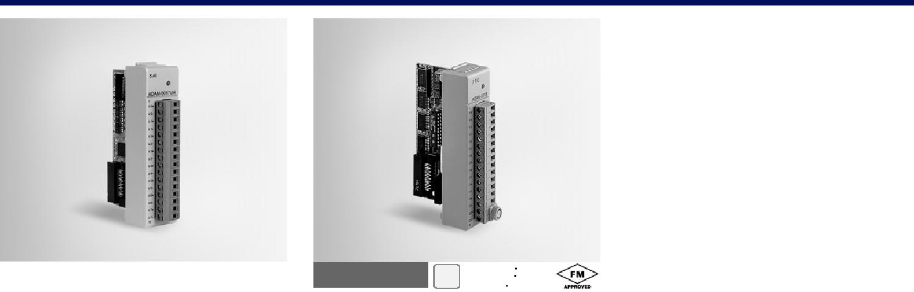

**8-ch Ultra High Speed Analog Input Module**

**7-ch Thermocouple Input Module**

**7-ch Thermocouple Input Module with Independent Input Range**

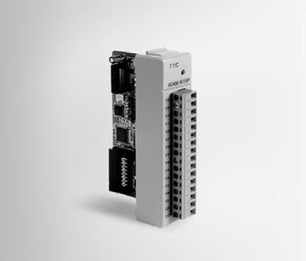

|  |  |  |
| --- | --- | --- |
| **ADAM-5017UH** | **RoHS** |  |
| **COMPLIANT** |  |
| 2002/95/EC |  |



**Specifications**

**General**

|  |  |  |
| --- | --- | --- |
| ** Certification** | CE |  |
| ** Connectors** | 1 x Plug-in screw terminal |  |
| ** Enclosure** | (# 14 ~ 22 AWG) |  |
| ABS+PC |  |
| ** Power Consumption** | 2.2 W (max.) |  |

**Analog Input**

|  |  |  |
| --- | --- | --- |
| ** Accuracy** | ±0.1% or better |  |
| ** Bandwidth** | 200 kHz |  |
| ** Channels** | 8 differential |  |
| ** Differential Non-linear ±1 LSB** | |  |
| ** Input Impedance** | Voltage: 2 MΩ |  |
| ** Integral Non-linear** | Current: 120 Ω (Build-in) |  |
| ±1 LSB |  |
| ** Input Range** | ±10 V, +0 ~ 10 V, |  |
| ** Low pass filter** | 0 ~ 20 mA, +4 ~ 20 mA |  |
| Configured by User |  |
| ** Resolution** | 12-bit |  |
| ** Sampling Rate** | Depends on base unit |  |
| ADAM-5000/485 & 5000E: | |  |
| 100 Samples/sec max (Total): one ADAM-5017UH | |  |
| installed |  |  |
| ADAM-5000/TCP & 5000L/TCP: | |  |
| 100 Samples/sec max (Total) :one ADAM-5017UH | |  |
| installed |  |  |
| ADAM-5510 : |  |  |
| 200K Samples/sec max (Single Channel): one ADAM- | |  |
| 5017UH installed |  |  |
| ADAM-5550 & ADAM-5560: | |  |
| 1K Samples/sec max(single channel): one ADAM- | |  |
| 5017UH installed |  |  |
| *Depending on the performance of client server or | |  |
| controller |  |  |
| ** Signal Input** | 200 kHz for both voltage |  |
| **Bandwidth** | and current inputs |  |

**Protection**

|  |  |
| --- | --- |
| ** Isolation Voltage** | 3,000 VDC |
| **Note:** |  |

1. The voltage difference between any two pins must not exceed 15 V
2. Distinct range settings allowed on each channel

Note: Not support ADAM-5510KW series

**Ordering Information**

** ADAM-5017UH** 8-ch Ultra High Speed

Analog Input Module



**ADAM-5018** **RoHS** 

**COMPLIANT**

2002/95/EC

**Specifications**

**General**

** Certification** CE, FM

** Connectors** 1 x Plug-in screw terminal

(# 14 ~ 22 AWG)

** Enclosure** ABS+PC

** Power Consumption** 0.63 W (max.)

**Thermocouple Input**

** Accuracy** ±0.1% or better

** Bandwidth** 13.1 Hz @ 50 Hz

15.72 Hz @ 60 Hz

** Channels** 7 differential

** CMR @ 50/60 Hz** 92 dB min

** Input Impedance** 2 MΩ

** lnput Range** ±15 mV, ±50 mV, ±100 mV,

±500 mV,

±1 V, ±2.5 V, ±20 mA

** lnput Type** mV, V, mA, thermocouple

** Resolution** 16-bit

** Sampling Rate** 10 samples/sec. (total)

** Span Drift** ±25 PPM/ °C

** Zero Drift** ±6 μV/ °C

** T/C Type and Temperature Range**

|  |  |  |  |
| --- | --- | --- | --- |
| J | 0° | ~ | 760°C |
| K | 0° | ~ | 1,370°C |
| T | -100° | ~ | 400°C |
| E | 0° | ~ | 1,000°C |
| R | 500° | ~ | 1,750°C |
| S | 500° | ~ | 1,750°C |
| B | 500° | ~ | 1,800°C |

**Protection**

|  |  |  |
| --- | --- | --- |
| **** | **Fault and** | Withstands overvoltage up |
|  | **Overvoltage** | to ±35 V |
|  | **Protection** |  |
| **** | **Isolation Voltage** | 3,000 VDC |

**Ordering Information**

** ADAM-5018** 7-ch Thermocouple Input

Module

** ADAM-5018SK** ADAM-5018 with CJC kit/

external

|  |  |  |
| --- | --- | --- |
| **ADAM-5018P** | **RoHS** |  |
| **COMPLIANT** |  |
| 2002/95/EC |  |



**Specifications**

**General**

|  |  |  |
| --- | --- | --- |
| ** Certification** | CE, FCC class A |  |
| ** Connectors** | 1 x Plug-in screw terminal |  |
| ** Enclosure** | (# 14 ~ 22 AWG) |  |
| ABS+PC |  |
| ** Power Consumption** | 0.63 W (max.) |  |

**Thermocouple Input**

|  |  |  |
| --- | --- | --- |
| ** Accuracy** | Voltage mode: ±0.1% or |  |
|  | better |  |
|  | Current mode: ±0.2% or |  |
| ** Bandwidth** | better |  |
| 13.1 Hz @ 50 Hz |  |
| ** Channels** | 15.72 Hz @ 60 Hz |  |
| 7 (differential, each channel |  |
|  | can be configured with |  |
| ** CMR @ 50/60 Hz** | different range) |  |
| 92 dB min |  |
| ** Input Impedance** | 20 MΩ. (Build-in 120 Ω |  |
|  | Register for Current Input) |  |

|  |  |  |  |
| --- | --- | --- | --- |
| ** lnput Range and Types** | |  |  |
| Thermocouple | |  |  |
| J | 0 | ~ | 760°C |
| K | 0 | ~ | 1,370°C |
| T | -100 | ~ | 400°C |
| E | 0 | ~ | 1,000°C |
| R | 500 | ~ | 1,750°C |
| S | 500 | ~ | 1,750°C |
| B | 500 | ~ | 1,800°C |

|  |  |  |
| --- | --- | --- |
| Current | ±20 mA, 4 ~ 20 mA |  |
| Voltage | ±15 mV (0.2%), ±50 mV, |  |
|  | ±100 mV, ±500 mV |  |
| ** Resolution** | ±1 V, ±2.5 V |  |
| 16-bit |  |
| ** Sampling Rate** | 10 samples/sec. (total) |  |
| ** Span Drift** | ±25 PPM/°C |  |
| ** Zero Drift** | ±6 μV/°C |  |
| ** High Common Mode** | 200 VDC |  |

**Protection**

|  |  |  |
| --- | --- | --- |
| **** | **Fault and** | Withstands overvoltage up |
|  | **Overvoltage** | to ±35 V |
|  | **Protection** |  |
| **** | **Isolation Voltage** | 3,000 VDC |
| **** | **Filter function** | Yes |

** Built-in TVS/ESD Protection Note:** Not support ADAM-5510KW series

**Ordering Information**

** ADAM-5018P** 7-ch Thermo. Input Module

w/ Ind. Input Range

**Programmable Automation Controllers**

All product specifications are subject to change without notice Last updated : 28-Aug-2013