**ADAM-4510I ADAM-4520I ADAM-4117**

**Robust RS-422/485 Repeater**

**Robust RS-232 to RS-422/485 Converter**

**Robust 8-ch Analog Input Module with Modbus**

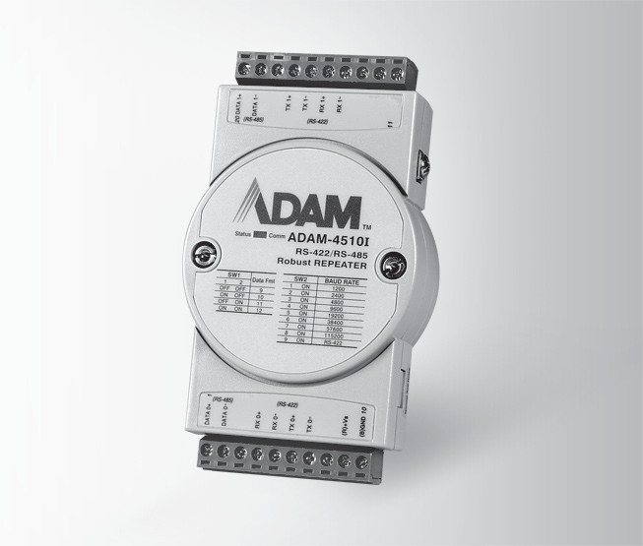

**ADAM-4510I**

RoHS

**COMPLIANT**

2002/95/EC

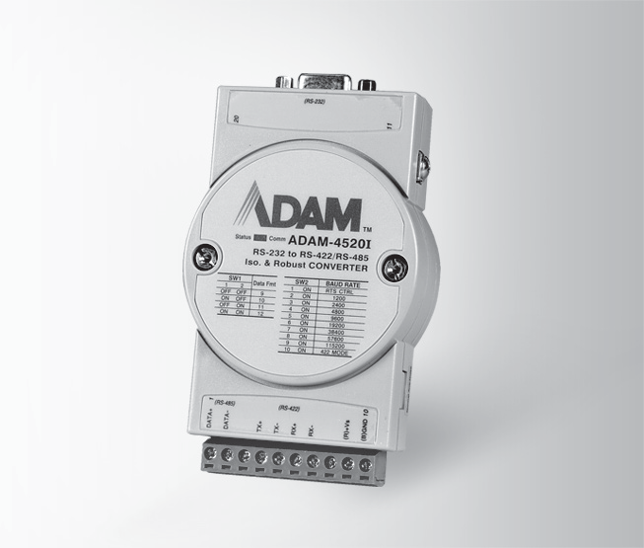

**ADAM-4520I**

RoHS

**COMPLIANT**

2002/95/EC

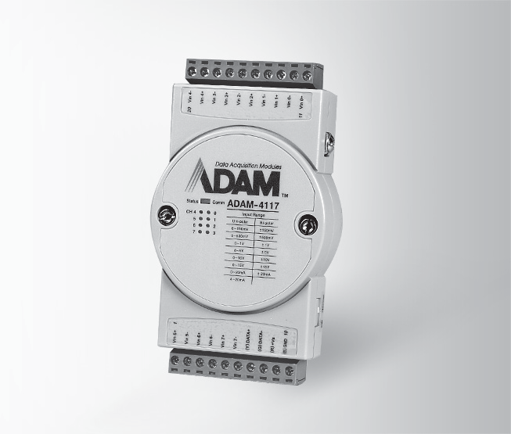

**ADAM-4117**

RoHS

**COMPLIANT**

2002/95/EC

**Specifications**

# General

* **Connectors** 2 x plug-in terminal blocks (#14 ~ 22 AWG)
* **Power Consumption** 1.4 W @ 24 VDC

# Communications

* **Input** RS-485 (2-wire) or RS-422 (4-wire)
* **Output** RS-485 (2-wire) or RS-422 (4-wire)

 **Speed Modes (bps)** 1,200, 2,400, 4,800, 9,600,

19.2 k, 38.4 k, 57.6 k,

115.2 k, RTS control and RS-422 (switchable)

* **Supports Auto Baud-Rate**
* **Provide RS-485 to RS-422 Convert Ability**

**Specifications**

**General**

* **Connectors** 1 x plug-in terminal block (#14 ~ 22 AWG)

(RS-422/485)

1 x DB9-F (RS-232)

* **Power Consumption** 1.2 W @ 24 VDC

# Communications

* **Input** RS-232 (DB9)
* **Output** RS-485 (2-wire) or RS-422 (4-wire)

 **Speed Modes (bps)** 1,200, 2,400, 4,800, 9,600,

19.2 k, 38.4 k, 57.6 k,

115.2 k, RTS control and RS-422 (switchable)

* **Supports Auto Baud-Rate**

**Specifications**

**General**

* **Connectors** 2 x plug-in terminal blocks (#14 ~ 22 AWG)
* **Watchdog Timer** System (1.6 second) &

Communication

* **Supported Protocols** ASCII Command and

Modbus/RTU

* **Power Consumption** 1.2 W @ 24 VDC
* **Interface (B version)** RS-485,micro USB

# Analog Input

* **Channels** 8 differential and independent configuration channels
* **Input Impedance** Voltage: 800 K

Current: 120 

* **lnput Type** mV, V (supports

unipolar and bipolar), mA

* **lnput Range** 0 ~ 150mV, 0 ~ 500mV, 0 ~ 1V, 0 ~ 5V, 0 ~ 10V,

0 ~ 15V, ±150 mV,

±500 mV, ±1V, ±5 V,

±10 V, ±15V, ±20 mA,

0 ~ 20 mA, 4 ~ 20mA

* + **Accuracy**

Voltage mode : ±0.1% or better

Current mode : ±0.2% or better

* + **Resolution** 16-bit
  + **Sampling Rate** 10/100 samples/sec

(selected by utility)

 **CMR @ 50/60 Hz** 92 dB

* **Operating Temperature** - 40 ~ 85°C (-40 ~ 185°F)
* **Storage Temperature** - 40 ~ 85°C (-40 ~ 185°F)
* **Supports Noise Rejection**

5 ~ 95% RH

Unregulated 10 ~ 48 VDC w/power reversal protection

3,000 VDC

* **Power Input**
* **Isolation Voltage**

**Environment**

* **Operating Humidity**

**Common Specifications**

**General**

 **NMR @ 50/60 Hz** 60 dB

* + **Over Voltage Protection** ±60 VDC
  + **High Common Mode** 200 VDC
  + **Span Drift** ±25 ppm/°C (Typical)
  + **Zero Drift** ±6μV/°C
  + **Built-in TVS/ESD Protection**

**Ordering Information**

* **ADAM-4510I** Robust RS-422/485

Repeater

* **ADAM-4520I** Robust RS-232 to

RS-422/485 Converter

* **ADAM-4117** Robust 8-ch Analog Input Module with Modbus

**RS-485 I/O Modules: ADAM-4000**

All product specifications are subject to change without notice. Last updated: 27-Jun-2018