**PCI-1620 PCI-1622**

# 8-port RS-232 PCI Communication Card 8-port RS-232/422/485 PCI

**Communication Card**

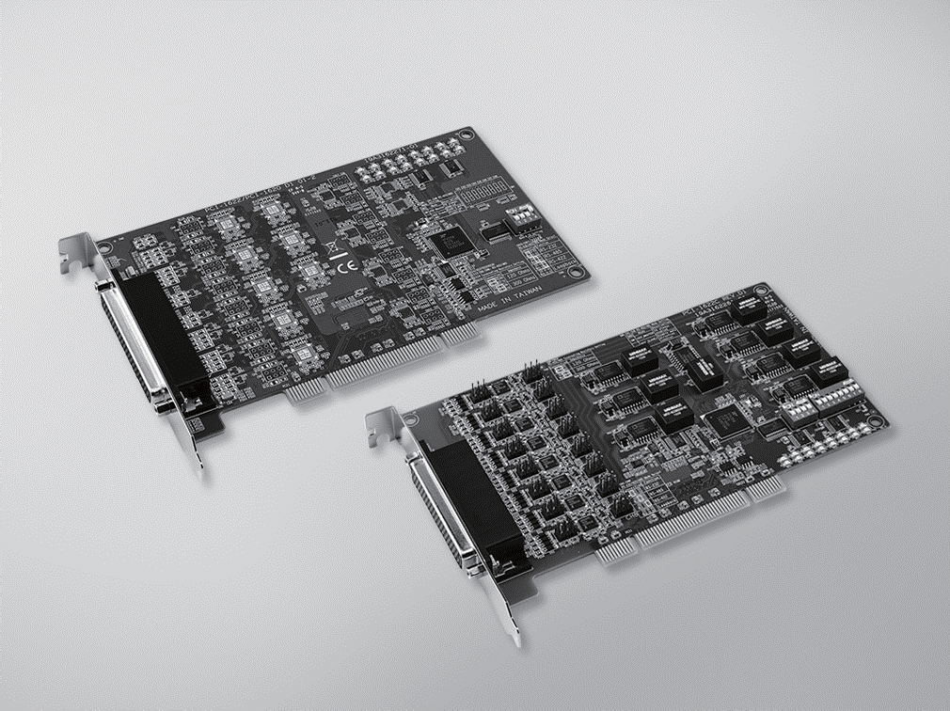

**PCI-1622**

**PCI-1620**

RoHS

**COMPLIANT**

2002/95/EC

**Features**

* PCI bus 2.2 compliant
* Speeds up to 921.6 kbps for extremely fast data transmission
* Supports any baud rate setting

 8 x RS-232 or RS-232/422/485 ports

* XR17V358 UART with 256-byte FIFOs
* Supported operating systems: Windows XP/7/8/10, and Linux

**Introduction**

The PCI-1620 is an 8-port RS-232, and the PCI-1622 is an 8-port RS-232/422/485 PCI communication cards that are compatible with the PCI 2.2 bus specification. The cards provide eight EFT protected ports up to 1,000 V, and have many functions such as high transmission speed of 921.6 kbps; The cards utilize high-performance XR17V358 UARTs with 256-byte FIFOs to reduce CPU load. Thus, the PCI-1620 and PCI-1622 are especially suitable for making reliable systems in multitasking environments.

# Specifications

## General

* **Bus Type** Universal PCI v2.2
* **Certification** CE, FCC class A
* **Connectors** 1x Female DB62 (PCI-1620A/22A/22B) 1x Female DB78 (PCI-1622C)

 **Dimensions (L x W)** 174.65 x 106.67 mm (6.88”x 4.2")

* **Power Consumption** 260 mA @ +3.3 V (typ.)

## Communications

* **Comm. Controller** XR17V358
* **Data Bits** 5, 6, 7, 8
* **Data Signals** RS-232: TxD, RxD, RTS, CTS, DTR, DSR, DCD

(PCI-1620A/22A/22B) TxD, RxD, RTS, CTS, DTR, DSR, DCD, RI (PCI-1622C)

RS-422: Tx+, Tx-, Rx+, Rx- (PCI-1620A/22A/22B) CTS+, CTS-, RTS+, RTS-, Tx+, Tx-, Rx+, Rx-

(PCI-1622C)

RS-485: Data+, Data- (PCI-1620A/22B/22C)

* **FIFO** 256 bytes
* **Flow Control** DTR/DSR, RTS/CTS, Xon/Xoff
* **Parity** None, Odd, Even, Mark, or Space
* **Speed** 50 bps ~ 921.6 kbps
* **Stop Bits** 1, 1.5, 2

## Protection

|  |  |  |  |  |
| --- | --- | --- | --- | --- |
| **Model Name** | **ESD**  **Protection** | **EFT**  **Protection** | **Surge Protection** | **Isolation Protection** |
| PCI-1620A | 15KV (air), 8KV (contact) | 1000 V |  |  |
| PCI-1620B | 15KV (air), 8KV (contact) | 1000 V | 1000V |  |
| PCI-1622B | 15KV (air), 8KV (contact) | 1000 V | 1000 V |  |
| PCI-1622C | 15KV (air), 8KV (contact) | 1000 V | 1000 V | 3000 VDC |

**Software**

* **Bundled Software** ICOM Tools
* **OS Support** Windows XP/7/8/10, and Linux (You can reference the

SW release note to know the supported OS version.)

## Environment

* **Operating Humidity** 5 ~ 95 % RH, non-condensing
* **Operating Temperature** -10 ~ 60°C (14 ~ 140°F)
* **Storage Temperature** -25 ~ 85°C (-13 ~ 185°F)

# Ordering Information

* **PCI-1620A-DE** 8-port RS-232 PCI Comm. Card
* **PCI-1620B-DE** 8-port RS-232 PCI Comm. Card w/ Surge Protection
* **PCI-1622B-DE** 8-port RS-232/422/485 PCI Comm. Card

w/ Surge Protection

* **PCI-1622C-DE** 8-port RS-232/422/485 PCI Comm. Card

w/ Surge & Isolation Protection

# Accessories

* **OPT8C-AE** DB62 x1 to DB25 x8 Cable, 1m for PCI-1620A-DE and

PCI-1622B-DE

* **OPT8H-AE** DB62 x1 to DB9 x8 Cable, 1m for PCI-1620A-DE and

PCI-1622B-DE

* **OPT8J-AE** DB78 x1 to DB9 x8 Cable, 1m for PCI-1622C-DE

**Serial Communication Cards**

All product specifications are subject to change without notice Last updated : 31-Mar-2017