|  |  |  |  |
| --- | --- | --- | --- |
| **SPEC** | Spec No. | TQ3C-8EAF0-E1YAQ08-00 |  |
| Date | November 29, 2013 |  |

**TYPE : TCG101WXLPAANN-AN20**

* 10.1 inch WXGA transmissive color TFT with LED backlight and constant current circuit for LED backlight>

**CONTENTS**

1. Application
2. Construction and outline
3. Mechanical specifications
4. Absolute maximum ratings
5. Electrical characteristics
6. Optical characteristics
7. Interface signals
8. Input timing characteristics
9. Lot number identification
10. Warranty
11. Precautions for use
12. Reliability test data
13. Outline drawing



|  |  |  |  |  |  |  |  |  |
| --- | --- | --- | --- | --- | --- | --- | --- | --- |
|  |  |  |  |  | KYOCERA DISPLAY CORPORATION | | |  |
|  | | This specification is subject to change without notice. | | | | |  |  |
|  |  | Consult Kyocera before ordering. | | |  |  |  |  |
|  | Original | Designed by: Engineering dept. | | |  | Confirmed by: QA dept. | |  |
|  | Issue Date |  |  |  |  |  |  |  |
|  | Prepared | Checked |  | Approved | Checked | Approved |  |
|  | November 29, 2013 |  |  |  |  |  |  |  |
|  |  |  |  |  |  |  |  |  |



|  |  |  |  |
| --- | --- | --- | --- |
|  | Spec No. | Part No. | Page |
|  | TQ3C-8EAF0-E1YAQ08-00 | TCG101WXLPAANN-AN20 | - |
|  |  |  |  |

**Warning**

1. **This Kyocera LCD module has been specifically designed for use only in electronic devices and industrial machines in the area of audio control, office automation, industrial control, home appliances, etc. The module should not be used in applications where the highest level of safety and reliability are required and module failure or malfunction of such module results in physical harm or loss of life, as well as enormous damage or loss. Such fields of applications include, without limitation, medical, aerospace, communications infrastructure, atomic energy control. Kyocera expressly disclaims any and all liability resulting in any way to the use of the module in such applications.**
2. **Customer agrees to indemnify, defend and hold Kyocera harmless**

**from and against any and all actions, claims, damages, liabilities, awards, costs, and expenses, including legal expenses, resulting from or arising out of Customer's use, or sale for use, or Kyocera modules in applications.**

**Caution**

1. **Kyocera shall have the right, which Customer hereby acknowledges, to immediately scrap or destroy tooling for Kyocera modules for which no Purchase Orders have been received from the Customer in a two-year period.**



|  |  |  |  |  |  |  |  |  |  |  |  |  |  |  |  |  |  |
| --- | --- | --- | --- | --- | --- | --- | --- | --- | --- | --- | --- | --- | --- | --- | --- | --- | --- |
|  |  |  |  |  |  | Spec No. | |  | Part No. | | |  |  | Page | | |  |
|  |  |  |  |  |  | TQ3C-8EAF0-E1YAQ08-00 | | |  | TCG101WXLPAANN-AN20 | | |  | - | |  |  |
|  |  |  |  |  |  |  |  |  |  |  |  |  |  |  |  |  |  |
|  |  |  |  |  | Revision record | | | | |  |  |  |  |  |  |  |  |
|  |  |  | Date | Designed by : Engineering dept. | | | | | |  | Confirmed by : QA dept. | | |  |  |  |  |
|  |  |  | Prepared | | | Checked | Approved | |  | Checked | Approved | |  |  |  |  |
|  |  |  |  |  |  |  |  |  |
|  |  |  |  |  |  | |  |  | | |  |  |  |  |  |  |  |
|  |  | Rev.No. | Date | Page |  | |  | Descriptions | | |  |  |  |  |  |  |  |
|  |  |  |  |  |  |  |  |  |  |  |  |  |  |  |  |  |  |
|  |  |  |  |  |  |  |  |  |  |  |  |  |  |  |  |  |  |



|  |  |  |  |
| --- | --- | --- | --- |
|  | Spec No. | Part No. | Page |
|  | TQ3C-8EAF0-E1YAQ08-00 | TCG101WXLPAANN-AN20 | 1 |
|  |  |  |  |

1. Application

This document defines the specification of TCG101WXLPAANN-AN20. (RoHS Compliant)

1. Construction and outline

LCD

Backlight system

Polarizer

Interface

Additional circuit

: Transmissive color dot matrix type TFT

: LED

: Anti-Glare treatment

: LVDS

: Timing controller, Power supply (3.3V input)

* + Constant current circuit for LED Backlight(12V input)

1. Mechanical specifications

|  |  |  |  |  |
| --- | --- | --- | --- | --- |
| Item |  | Specification | Unit |  |
|  |  |  |  |  |
| Outline dimensions | 1) | 236(W)×(156.8)(H)×9.4(D) | mm |  |
|  |  |  |  |  |
| Active area |  | 216.96(W)×135.6(H) | mm |  |
|  | (25.6cm/10.1 inch(Diagonal)) |  |
|  |  |  |  |
|  |  |  |  |  |
| Dot format |  | 1280×(R,G,B)(W)×800(H) | dot |  |
|  |  |  |  |  |
| Dot pitch |  | 0.0565(W)×0.1695(H) | mm |  |
|  |  |  |  |  |
| Base color | 2) | Normally White | - |  |
|  |  |  |  |  |
| Mass |  | 500 | g |  |
|  |  |  |  |  |

1. Projection not included. Please refer to outline for details.
2. Due to the characteristics of the LCD material, the color varies with environmental temperature.



M407011 

|  |  |  |  |
| --- | --- | --- | --- |
|  | Spec No. | Part No. | Page |
|  | TQ3C-8EAF0-E1YAQ08-00 | TCG101WXLPAANN-AN20 | 2 |
|  |  |  |  |

1. Absolute maximum ratings 4-1. Electrical absolute maximum ratings

|  |  |  |  |  |  |
| --- | --- | --- | --- | --- | --- |
|  | Item | Symbol | Min. | Max. | Unit |
|  |  |  |  |  |  |
| Supply voltage(+3.3V) | | VDD | -0.3 | 4.0 | V |
|  |  |  |  |  |  |
| Supply voltage(+12V) | | VIN | -0.3 | 14.0 | V |
|  |  |  |  |  |  |
|  | RxINi+, RxINi- (i=0,1,2,3) | VI1 | -0.3 | 2.8 | V |
|  |  |  |  |  |  |
| Input signal | CK IN+, CK IN- | VI2 | -0.3 | 2.8 | V |
| Voltage 1) | SELLVDS, BITSEL, SC | VI3 | -0.3 | VDD+0.5 | V |
|  |  |  |  |  |  |
|  | BLBRT, BLEN | VI4 | -0.3 | VIN | V |
|  |  |  |  |  |  |

1. VDD must be supplied correctly within the range described in 5-1. 4-2. Environmental absolute maximum ratings

|  |  |  |  |  |  |
| --- | --- | --- | --- | --- | --- |
| Item |  | Symbol | Min. | Max. | Unit |
|  |  |  |  |  |  |
| Operating temperature | 1) | TOP | -20 | 70 | °C |
|  |  |  |  |  |  |
| Storage temperature | 2) | TSTO | -30 | 80 | °C |
|  |  |  |  |  |  |
| Operating humidity | 3) | HOP | 10 | 4) | %RH |
|  |  |  |  |  |  |
| Storage humidity | 3) | HSTO | 10 | 4) | %RH |
|  |  |  |  |  |  |
| Vibration |  | - | 5) | 5) | - |
|  |  |  |  |  |  |
| Shock |  | - | 6) | 6) | - |
|  |  |  |  |  |  |

|  |  |
| --- | --- |
| 1) | Operating temperature means a temperature which operation shall be guaranteed. Since display |
|  | performance is evaluated at 25°C, another temperature range should be confirmed. |
| 2) | Temp. = -30°C 48h , Temp. = 80°C 168h |
|  | Store LCD at normal temperature/humidity. Keep them free from vibration and shock. |
|  | An LCD that is kept at a low or a high temperature for a long time can be defective due to |
|  | other conditions, even if the low or high temperature satisfies the standard. |

* + - * (Please refer to “Precautions for Use” for details.)
    1. Non-condensing
    2. Temp. 40°C, 90%RH Max.
  + Temp. 40°C, Absolute humidity shall be less than 90%RH at 40°C.
* 5)

|  |  |  |  |
| --- | --- | --- | --- |
| Frequency | 10 55 Hz |  | Acceleration value |
| Vibration width | 0.15mm |  | (0.3 9 m/s2) |
|  |  |  |  |
| Interval | 10-55-10 Hz | | minutes |
|  |  |  |  |

2 hours in each direction X, Y, Z (6 hours total)

EIAJ ED-2531

* 1. Acceleration: 490 m/s2, Pulse width: 11 ms

3 times in each direction: ±X, ±Y, ±Z

* EIAJ ED-2531

M407011 



|  |  |  |  |  |  |  |  |  |  |  |  |  |
| --- | --- | --- | --- | --- | --- | --- | --- | --- | --- | --- | --- | --- |
|  |  |  | Spec No. | |  | Part No. | | |  |  | Page |  |
|  |  |  | TQ3C-8EAF0-E1YAQ08-00 | | | TCG101WXLPAANN-AN20 | | | | | 3 |  |
|  | |  |  |  |  |  |  |  |  |  |  |  |
| 5. Electrical characteristics | | | | |  |  |  |  |  |  |  |  |
| 5-1. LCD |  |  |  |  |  |  |  |  | Temp. = -20 70°C | | |  |
|  |  |  | | | | | |  |  |
| Item |  | Symbol | | Condition | Min. | |  | Typ. | Max. |  | Unit |  |
|  |  |  | |  |  |  |  |  |  |  |  |  |
| Supply voltage | 1) | VDD | | - | 3.0 |  |  | 3.3 | 3.6 |  | V |  |
|  |  |  | |  |  |  |  |  |  |  |  |  |
| Current consumption |  | IDD | | 2) | - |  |  | 350 | 460 |  | mA |  |
|  | |  | |  |  |  |  |  |  |  |  |  |
| Permissive input ripple voltage | | VRP | | VDD=3.3V | - |  |  | - | 100 |  | mVp-p |  |
|  |  |  | |  |  |  |  |  |  |  |  |  |
| Input signal voltage | 3) | VIL | | "Low" level | 0 |  |  |  | 0.8 |  | V |  |
|  |  |  |  |  |  |  |  |  |  |  |
| VIH | | "High" level | 2.0 |  |  |  | VDD |  | V |  |
|  |  |  |  |  |  |  |
|  |  |  | |  |  |  |  |  |  |  |  |  |
| Input reek current |  | IOL | | VI3=0V | -10 |  |  | - | 10 |  | A |  |
|  |  |  |  |  |  |  |  |  |  |  |  |
|  | IOH | | VI3=3.3V | - |  |  | - | 400 |  | A |  |
|  |  |  |  |  |  |
|  |  |  | |  |  |  |  |  |  |  |  |  |
| LVDS Input voltage | 4) | VL | | - | 0 |  |  | - | 1.9 |  | V |  |
|  |  |  | |  |  |  |  |  |  |  |  |  |
| Differential input voltage |  | VID | | - | 250 |  |  | 350 | 450 |  | mV |  |
|  |  |  | |  |  | |  |  |  |  |  |  |
| Differential input | 4) 5) | VTL | | "Low" level | VCM-100 | |  |  |  |  | mV |  |
| threshold voltage | VTH | | "High" level |  |  |  |  | VCM+100 |  | mV |  |
|  |  |  |  |  |  |  |
|  |  |  | |  |  |  |  |  |  |  |  |  |
| Terminator |  | R1 | | - | - |  |  | 100 | - |  |  |  |
|  |  |  | |  |  |  |  |  |  |  |  |  |
|  |  | t1 | | - | 0.1 |  |  | - | 10 |  | ms |  |
|  |  |  | |  |  |  |  |  |  |  |  |  |
|  |  | t2 | | - | 0 |  |  | - | - |  | ms |  |
|  |  |  | |  |  |  |  |  |  |  |  |  |
|  |  | t3 | | - | 0 |  |  | - | - |  | ms |  |
|  |  |  | |  |  |  |  |  |  |  |  |  |
| VDD-turn-on conditions | 1) 6) | t4 | | - | 1.0 |  |  | - | - |  | s |  |
|  |  |  |  |  |  |  |  |  |  |  |
| t5 | | - | 200 |  |  | - | - |  | ms |  |
|  |  |  |  |  |  |
|  |  |  | |  |  |  |  |  |  |  |  |  |
|  |  | t6 | | - | 200 |  |  | - | - |  | ms |  |
|  |  |  | |  |  |  |  |  |  |  |  |  |
|  |  | t7 | | - | 0 |  |  | - | 10 |  | s |  |
|  |  |  | |  |  |  |  |  |  |  |  |  |
|  |  | t8 | | - | 0 |  |  | - | - |  | ms |  |
|  |  |  |  |  |  |  |  |  |  |  |  |  |

1) VDD-turn-on conditions

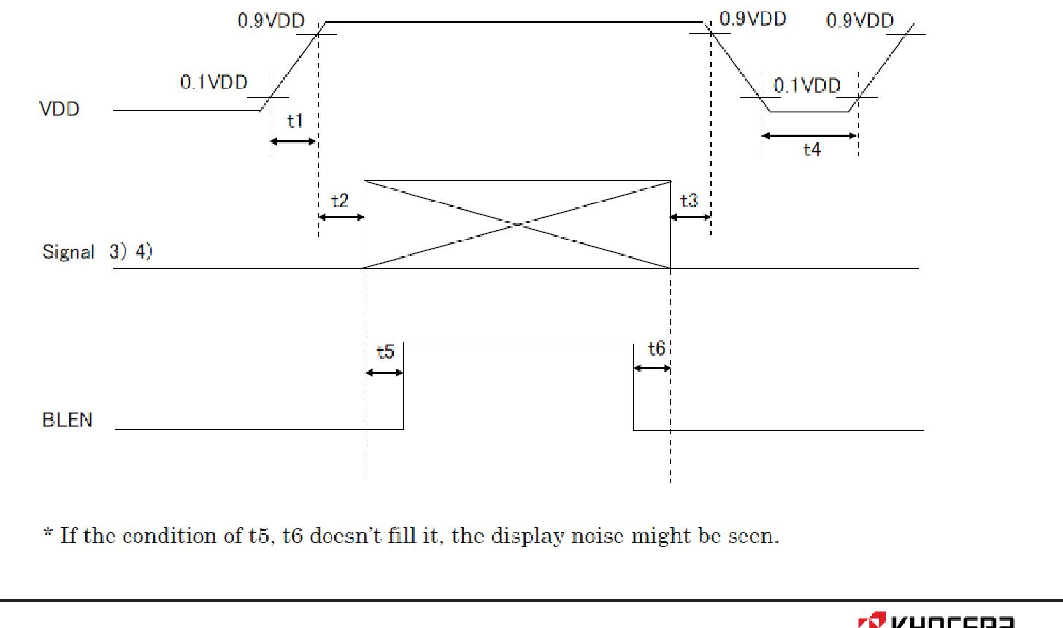

M407011 

|  |  |  |  |
| --- | --- | --- | --- |
|  | Spec No. | Part No. | Page |
|  | TQ3C-8EAF0-E1YAQ08-00 | TCG101WXLPAANN-AN20 | 4 |
|  |  |  |  |

2) Display pattern:

VDD = 3.3V, Temp. = 25°C

1 2 3 3838 3839 3840(dot)

* 1

2

3

:

:

:

799

800

(dot)

* 1. Input signal : SELLVDS, BITSEL, SC
  2. Input signal : RxIN3+, RxIN3-, RxIN2+, RxIN2-, RxIN1+, RxIN1-, RxIN0+, RxIN0-
* CK IN+, CK IN-

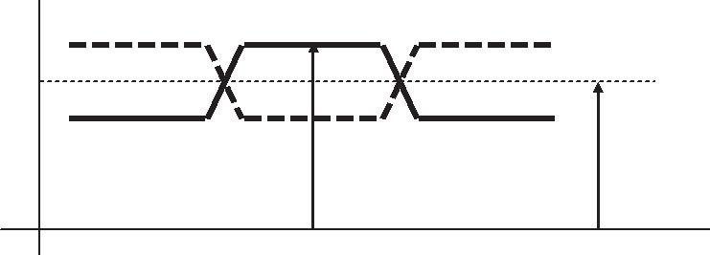

 㼂㻵㻰

㼂㻸 㼂㻯㻹

㻜㼂

1. VCM : LVDS Common mode voltage (VCM=1.25V)
2. Please power on LVDS transmitter at the same time as VDD, or LVDS transmitter should be powered on first.



M407011 

|  |  |  |  |  |  |  |  |  |  |  |  |  |  |  |  |  |  |
| --- | --- | --- | --- | --- | --- | --- | --- | --- | --- | --- | --- | --- | --- | --- | --- | --- | --- |
|  |  |  |  |  | Spec No. | |  |  | Part No. | |  |  |  |  | Page | |  |
|  |  |  |  |  | TQ3C-8EAF0-E1YAQ08-00 | | | | TCG101WXLPAANN-AN20 | | | | |  | 5 |  |  |
|  |  | | |  |  |  |  |  |  |  |  |  |  |  |  |  |  |
|  | 5-2. Constant current circuit for LED Backlight | | | | | |  |  |  |  |  | Temp. = -20 70°C | | | | |  |
|  |  |  |  |  |  |  |  |  |  |  |  |  |
|  | Item |  |  | Symbol | |  | Condition |  | Min. |  | Typ. |  | Max. |  | Unit |  |  |
|  | |  |  |  | |  |  |  |  |  |  |  |  |  |  |  |  |
| Supply voltage | |  | 1) | VIN | |  | - |  | 10.8 |  | 12.0 |  | 13.2 |  | V |  |  |
|  | |  |  |  | |  |  |  |  |  |  |  |  |  |  |  |  |
| Current consumption | |  |  | IIN | |  | 2) |  | - |  | 275 |  | 360 |  | mA |  |  |
|  | | | |  | |  |  |  |  |  |  |  |  |  | |  |  |
| Permissive input ripple voltage | | | | VRP_BL | |  | VIN=12.0V |  | - |  | - |  | 100 | mVp-p | |  |  |
|  |  |  |  |  | |  |  |  |  |  |  |  |  |  |  |  |  |
| BLBRT Input signal voltage | | |  | VIL_BLBRT | |  | "Low" level |  | 0 |  | - |  | 0.8 |  | V |  |  |
|  |  |  |  |  |  |  |  |  |  |  |  |  |  |  |
|  | VIH_BLBRT | |  | "High" level |  | 2.3 |  | - |  | VIN |  | V |  |  |
|  |  |  |  |  |  |  |  |  |  |  |
|  | | | |  | |  |  |  |  |  |  |  |  |  |  |  |  |
| BLBRT Input pull-down resistance | | | | RIN_BLBRT | |  | - |  | 100 |  | 300 |  | 500 |  | k |  |  |
|  |  |  |  |  | |  |  |  |  |  |  |  |  |  |  |  |  |
| BLEN Input signal voltage | |  |  | VIL_BLEN | |  | "Low" level |  | 0 |  | - |  | 0.8 |  | V |  |  |
|  |  |  |  |  |  |  |  |  |  |  |  |  |  |  |  |
|  |  | VIH_BLEN | |  | "High" level |  | 2.3 |  | - |  | VIN |  | V |  |  |
|  |  |  |  |  |  |  |  |  |  |  |
|  | | | |  | |  |  |  |  |  |  |  |  |  |  |  |  |
| BLEN Input pull-down resistance | | | | RIN_BLEN | |  | - |  | 100 |  | 300 |  | 500 |  | k |  |  |
|  |  |  |  |  | |  |  |  |  |  |  |  |  |  |  |  |  |
|  | Frequency |  | 3) | fPWM | |  | - |  | 200 |  | - |  | 10k |  | Hz |  |  |
|  |  |  |  |  |  |  |  |  |  |  |  |  |  |  | |  |  |
|  |  |  |  |  |  |  | fPWM=200Hz |  | 1 |  | - |  | 100 | % | |  |  |
|  | M Duty ratio |  | 3) |  | |  |  |  |  |  |  |  |  |  | |  |  |
|  |  | DPWM | |  | fPWM=2kHz |  | 10 |  | - |  | 100 | % | |  |  |
|  |  |  |  |  |  |  |  |  |  |  |  |  |  |  | |  |  |
|  |  |  |  |  |  |  | fPWM=10kHz |  | 50 |  | - |  | 100 | % | |  |  |
|  | |  |  |  | |  |  |  |  |  |  |  |  |  |  |  |  |
| Operating life time | |  | 4), 5) | T | |  | Temp.=25°C |  | - |  | 50,000 |  | - |  | h |  |  |
|  |  |  |  |  |  |  |  |  |  |  |  |  |  |  |  |  |  |

1. VIN-turn-on conditions

|  |  |  |  |
| --- | --- | --- | --- |
|  | 㻜㻚㻥㼂 |  |  |
|  | 㻵㻺 |  |  |
| 㼂 | 㻜㻚㻝㼂 |  |  |
| 㻵㻺 |  |  |
| 㻵㻺 | 㻜㼙㼟 | 㻜㼙㼟 |  |
|  |  |
|  | 㻔㼙㼕㼚㻕 | 㻔㼙㼕㼚㻕 |  |

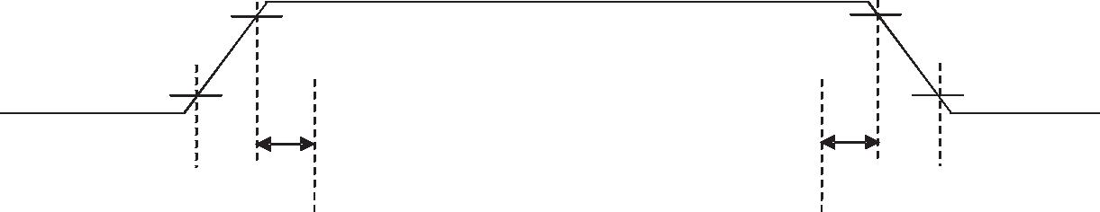

|  |  |  |  |  |  |  |  |  |  |  |  |  |  |  |
| --- | --- | --- | --- | --- | --- | --- | --- | --- | --- | --- | --- | --- | --- | --- |
|  | 㻮㻸㻱㻺 |  |  |  |  |  |  |  |  |  |  |  |  |  |
|  |  |  |  | 㻜㼙㼟 | | | 㻜㼙㼟 | |  |  |  |  |  |
|  |  |  |  |  |  |  |  |  |  |
|  |  |  |  |  | 㻔㼙㼕㼚㻕 | | | 㻔㼙㼕㼚㻕 | | | |  |  |  |
|  |  |  |  |  |  |  | 㻼㼃㻹㼟㼕㼓㼚㼍㼘 |  |  |  |  |  |  |  |
|  | 㻮㻸㻮㻾㼀 |  |  |  |  |  |  |  |  |  |  |  |  |  |
|  |  |  |  |  |  |  |  |  |  |  |  |  |  |
|  |  |  |  |  |  |  |  | |  |  |  | |  |  |
|  |  |  |  |  | 㻌 㻌㻌㻌㻌㻌㻭㼒㼠㼑㼞㻌㼟㼕㼓㼚㼍㼘㻌㼕㼟㻌㼕㼚㼜㼡㼠㻘㻌㼕㼠㻌㼣㼕㼘㼘㻌㼠㼍㼗㼑㻌㻞㻜㻜㼙㼟㻔㻹㼕㼚㻚㻕㻌㼠㼛㻌㼟㼠㼍㼎㼕㼘㼕㼦㼑㻌 | | | | | | | | |  |
|  |  |  |  |  | 㻌㻌㻌㻌㻌㻌㻌㻌㼜㼛㼣㼑㼞㻌㼛㼒㻌㼎㼍㼏㼗㼘㼕㼓㼔㼠㻚㻌 | | | | | | |  |  |  |
|  |  |  | 㻞㻜㻜㻌㻌㼙㻌㻌㼟㻌㻌㻌㻌㻹㼑㼍㼚㼣㼔㼕㼘㼑㻘㻌㼠㼛㼚㻌㼛㼒㻌㻮㻸㻮㻾㼀㻌㼟㼔㼛㼡㼘㼐㻌㼎㼑㻌㼙㼛㼞㼑㻌㼠㼔㼍㼚㻌㻞㻜㻜 | | | | | | | | | 㼟㻚 | |  |
|  |  |  | 㻔㼙㼕㼚㻕 | | | | |  |  |  |  |  |  |  |
|  |  |  |  |  |  |  | 㻻㻺 |  |  |  |  |  |  |  |
|  | 㻸㻱㻰 |  |  |  |  |  |  |  |  |  |  |  |  |  |
|  | 㻮㼍㼏㼗㼘㼕㼓㼔㼠 | 㻻㻲㻲 |  |  |  |  |  |  |  | 㻻㻲㻲 | |  |  |  |
|  |  |  |  |  |  |  |  |  |  |  |  |
|  |  |  |  |  |  |  |  |  |  |  |  |  |  |  |
| 2) VIN = 12V, Temp. = 25 | | | DPWM = 100% | | | | |  |  |  |  |  |  |  |

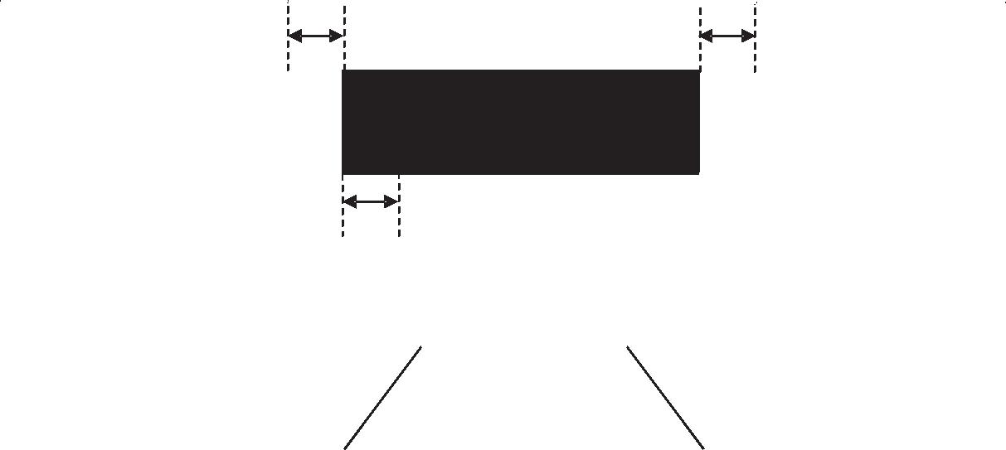

M407011 

|  |  |  |  |
| --- | --- | --- | --- |
|  | Spec No. | Part No. | Page |
|  | TQ3C-8EAF0-E1YAQ08-00 | TCG101WXLPAANN-AN20 | 6 |
|  |  |  |  |

3) Timing Diagram

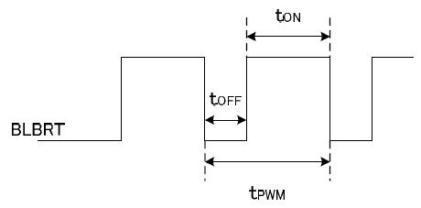

tON tOFF 50 s.

In case of lower frequency, the deterioration of the display quality, flicker etc., may occur.

* 1. When brightness decrease 50% of minimum brightness.
* 㻌 㻌 The average life of a LED will decrease when the LCD is operating at higher temperatures.

5) Life time is estimated data.(Condition : IF=60mA, Ta=25 in chamber).



M407011 

|  |  |  |  |  |  |  |  |  |  |  |  |  |  |  |  |  |  |  |  |  |  |  |  |  |  |
| --- | --- | --- | --- | --- | --- | --- | --- | --- | --- | --- | --- | --- | --- | --- | --- | --- | --- | --- | --- | --- | --- | --- | --- | --- | --- |
|  |  |  |  |  |  |  |  | Spec No. | | | |  |  | Part No. | | | |  |  |  |  |  | Page | |  |
|  |  |  |  |  |  |  |  | TQ3C-8EAF0-E1YAQ08-00 | | | | |  | TCG101WXLPAANN-AN20 | | | | | | | |  | 7 |  |  |
|  |  |  |  |  |  |  | |  |  | |  |  |  |  |  |  |  |  |  |  |  |  |  |  |  |
| 6. Optical characteristics | | | | | | | | | | | |  |  |  |  |  |  |  |  |  |  |  |  |  |  |
|  | | | | | |  |  | | | | | Measuring spot = | | | | | | 6.0mm, Temp. = 25°C | | | | | | |  |
|  |  | Item | | | Symbol |  |  | Condition | | |  | Min. |  | Typ. | | |  | Max. | | |  |  | Unit |  |  |
|  |  |  |  |  |  |  |  | |  |  |  |  |  |  |  |  |  |  |  |  |  |  |  |  |  |
|  | Response time | | | Rise | Ǖ r |  | = | | | =0° |  |  |  | 8 |  |  |  |  |  |  |  |  | ms |  |  |
|  |  |  |  |  |  |  |  |  |  |  |  |  |  |  |  |  |  |  |  |  |  |  |
|  | Down | Ǖ d |  | = | | | =0° |  |  |  | 22 |  |  |  |  |  |  |  |  | ms |  |  |
|  |  |  |  |  |  |  |  |  |  |  |  |  |  |  |  |  |  |
|  |  |  |  |  |  |  |  |  |  |  |  |  |  |  |  |  |  |  |  |  |  |  |  |  |  |
|  | Viewing angle range | | | | UPPER |  |  |  |  |  |  |  |  | 80 |  |  |  |  |  |  |  |  | deg. |  |  |
|  |  |  |  |  |  |  |  |  |  |  |  |  |  |  |  |  |  |  |  |  |
|  |  |  |  |  |  |  |  |  |  | 80 |  |  |  |  |  |  |  |  |  |  |
|  | View direction | | | | LOWER |  |  | CR | | 10 |  |  |  |  |  |  |  |  |  |  |  |  |  |  |
|  |  |  |  |  |  |  |  |  |  |  |  |  |  |  |  |  |  |  |
|  | :6 o’clock | | | | LEFT |  |  |  |  |  | 80 |  |  |  |  |  |  |  |  |  |  |  |
|  |  |  |  |  |  |  |  |  |  |  |  |  |  |  |  |  |  |  |  |
|  |  | (Gray inversion) | | |  |  |  |  |  |  |  |  |  |  |  |  |  |  |  |  |  |  | deg. |  |  |
|  | RIGHT |  |  |  |  |  |  |  |  | 80 |  |  |  |  |  |  |  |  |  |  |
|  |  |  |  |  |  |  |  |  |  |  |  |  |  |  |  |  |  |  |  |  |  |  |  |
|  |  |  |  | |  |  |  | |  |  |  |  |  |  |  |  |  |  |  |  |  |  | |  |  |
|  | Contrast ratio | | | | CR |  | = | | | =0° |  | 500 |  | 800 |  |  |  |  |  |  |  | - | |  |  |
|  |  |  |  | |  |  |  | |  | |  |  |  |  |  |  |  |  |  |  |  |  | |  |  |
|  | Brightness | | | | L |  | IF=60mA/Line | | | |  | 350 |  | 500 |  |  |  |  |  |  |  | cd/m2 | |  |  |
|  |  |  |  |  |  |  |  |  |  |  |  |  |  |  |  |  |  |  |  |  |  |  |  |  |  |
|  |  |  |  | Red | x |  | = | | | =0° |  | 0.535 |  | 0.585 | |  |  | 0.635 | | |  |  |  |  |  |
|  |  |  |  |  |  |  |  |  |  |  |  |  |  |  |  |  |  |  |  |  |
|  |  |  |  | y |  |  | 0.300 |  | 0.350 | |  |  | 0.400 | | |  |  |  |  |  |
|  |  |  |  |  |  |  |  |  |  |  |  |  |  |  |  |  |  |  |
|  |  |  |  |  |  |  |  |  |  |  |  |  |  |  |  |  |  |  |  |  |  |  |  |  |  |
|  |  |  |  | Green | x |  | = | | | =0° |  | 0.270 |  | 0.320 | |  |  | 0.370 | | |  |  |  |  |  |
|  |  |  |  |  |  |  |  |  |  |  |  |  |  |  |  |  |  |  |  |  |
|  | Chromaticity | |  | y |  |  | 0.530 |  | 0.580 | |  |  | 0.630 | | |  | - | |  |  |
|  |  | |  |  |  |  |  |  |  |  |  |  |  |  |
|  | coordinates | |  |  | x |  | = | | | =0° |  | 0.110 |  | 0.160 | |  |  | 0.210 | | |  |  |  |
|  |  | |  |  |  |  |  |  |  |  |  |  |
|  |  |  |  | Blue |  |  |  |  |  |  |  |  |  |  |  |  |  |  |  |  |  |
|  |  |  |  | y |  |  | 0.075 |  | 0.125 | |  |  | 0.175 | | |  |  |  |  |  |
|  |  |  |  |  |  |  |  |  |  |  |  |  |  |  |  |  |  |  |
|  |  |  |  |  |  |  |  |  |  |  |  |  |  |  |  |  |  |  |  |  |  |  |  |  |  |
|  |  |  |  | White | x |  | = | | | =0° |  | 0.235 |  | 0.285 | |  |  | 0.335 | | |  |  |  |  |  |
|  |  |  |  |  |  |  |  |  |  |  |  |  |  |  |  |  |  |  |  |  |
|  |  |  |  | y |  |  | 0.260 |  | 0.310 | |  |  | 0.360 | | |  |  |  |  |  |
|  |  |  |  |  |  |  |  |  |  |  |  |  |  |  |  |  |  |  |
|  |  |  |  |  |  |  |  |  |  |  |  |  |  |  |  |  |  |  |  |  |  |  |  |  |  |
| 6-1. Definition of contrast ratio | | | | | | |  |  |  |  |  |  |  |  |  |  |  |  |  |  |  |  |  |  |  |
|  |  |  |  | CR(Contrast ratio) | | |  |  | Brightness with all pixels "White" | | | | | | |  | |  |  |  |  |  |  |  |  |
|  |  |  |  |  |  | Brightness with all pixels "Black" | | | | | | | | |  |  |  |  |  |  |  |  |
|  |  |  |  |  |  |  |  |  |  |  |  |  |  |  |  |  |
| 6-2. Definition of response time | | | | | | |  |  |  |  |  |  |  |  |  |  |  |  |  |  |  |  |  |  |  |
|  |  | :KLWH | | |  |  |  |  | %ODFN | | |  |  |  |  | :KLWH | | | | | |  |  |  |  |
|  |  |  |  |  |  |  |  |  |  |  |  |  |  |  |  |  |  |  |  |  |  |  |  |  |  |
|  |  |  |  |  |  |  |  |  |  |  |  |  |  |  |  |  |  |  |  |  |  |  |  |  |  |

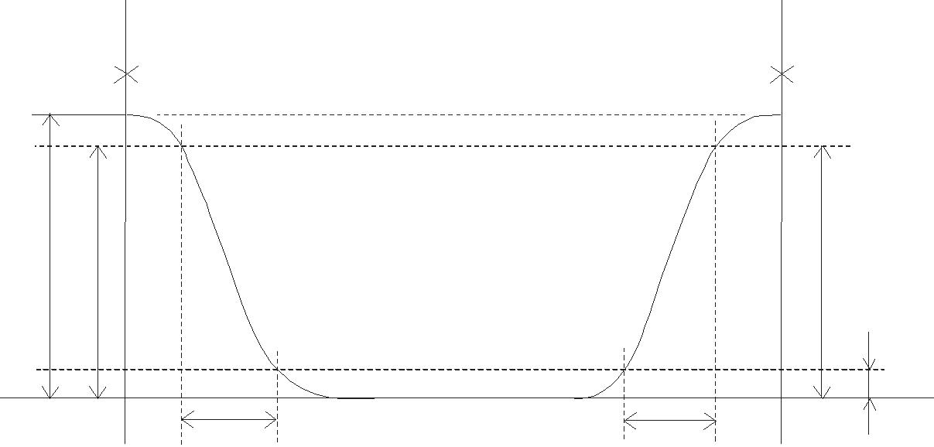

|  |  |  |  |  |  |
| --- | --- | --- | --- | --- | --- |
| %ULJKWQHVV |  |  |  |  |  |
|  |  |  |  |  |  |
|  |  |  | U | G |  |
|  |  |  |  |  |



M407011 

|  |  |  |  |  |  |  |  |  |  |  |  |  |  |  |  |
| --- | --- | --- | --- | --- | --- | --- | --- | --- | --- | --- | --- | --- | --- | --- | --- |
|  |  |  |  |  |  | Spec No. | | | | Part No. | |  |  | Page |  |
|  |  |  |  |  |  | TQ3C-8EAF0-E1YAQ08-00 | | | | TCG101WXLPAANN-AN20 | | | | 8 |  |
|  |  |  | |  |  |  |  |  |  |  |  |  |  |  |  |
| 6-3. Definition of viewing angle | | | | | |  |  |  |  |  |  |  |  |  |  |
|  | | | | | |  |  |  |  |  |  |  |  |  |  |
|  | | |  |  |  |  | | | |  |  |  |  |  |  |
| \ | | | 833(5 |  |  | \ | | | |  |  |  |  |  |  |
|  | /2:(5 |  |  |  |  |  | /()7 |  | 5,*+7 |  |  |  |
|  |  |  |  |  |  |  |  |  |  |  |  |  |  |
|  |  |  |  |  |  |  |  |  |  |  |  |  |  |  |  |
|  |  |  |  |  |  |  |  |  |  |  |  |  |  |  |  |

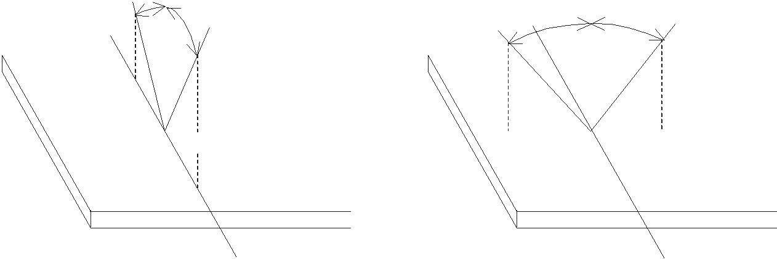

[  [ [ [

|  |  |
| --- | --- |
| \ | \ |
| GLUHFWLRQ | GLUHFWLRQ |

6-4. Brightness measuring points

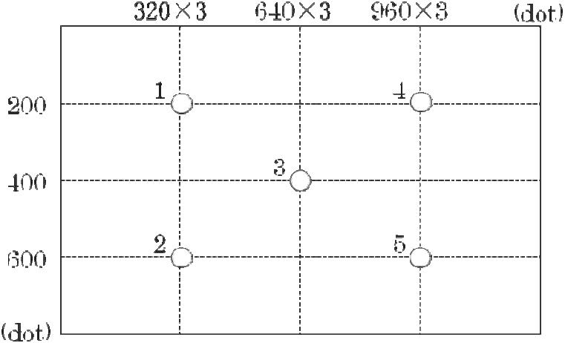

|  |  |
| --- | --- |
| 1) | Rating is defined as the white brightness at center of display screen(3). |
| 2) | 5 minutes after LED is turned on. (Ambient Temp.=25 ) |



M407011 

|  |  |  |  |
| --- | --- | --- | --- |
|  | Spec No. | Part No. | Page |
|  | TQ3C-8EAF0-E1YAQ08-00 | TCG101WXLPAANN-AN20 | 9 |
|  |  |  |  |

1. Interface signals 7-1. Interface signals

|  |  |  |  |  |
| --- | --- | --- | --- | --- |
| No. | Symbol | Description |  | Note |
| 1 | SC | Scan direction control GND or Open | Normal High Reverse | 1) |
| 2 | BITSEL | Bit data select signal(Low: 8bit mode | High: 6bit mode) |  |
| 3 | RxIN3+ | LVDS receiver signal CH3(+) |  | LVDS |
| 4 | RxIN3- | LVDS receiver signal CH3(-) |  | LVDS |
| 5 | GND | GND |  |  |
| 6 | CK IN+ | LVDS receiver signal CK(+) |  | LVDS |
| 7 | CK IN- | LVDS receiver signal CK(-) |  | LVDS |
| 8 | GND | GND |  |  |
| 9 | RxIN2+ | LVDS receiver signal CH2(+) |  | LVDS |
| 10 | RxIN2- | LVDS receiver signal CH2(-) |  | LVDS |
| 11 | GND | GND |  |  |
| 12 | RxIN1+ | LVDS receiver signal CH1(+) |  | LVDS |
| 13 | RxIN1- | LVDS receiver signal CH1(-) |  | LVDS |
| 14 | GND | GND |  |  |
| 15 | RxIN0+ | LVDS receiver signal CH0(+) |  | LVDS |
| 16 | RxIN0- | LVDS receiver signal CH0(-) |  | LVDS |
| 17 | GND | GND |  |  |
| 18 | SELLVDS | Mode select signal(LVDS Data mapping) | |  |
| 19 | VDD | +3.3V power supply |  |  |
| 20 | VDD | +3.3V power supply |  |  |

|  |  |  |  |  |  |
| --- | --- | --- | --- | --- | --- |
|  | | LCD connector | DF19G -20P-1H(54) (HIROSE) | | |
|  |  | Matching connector |  | DF19-20S-1C | (HIROSE) |
|  |  |  |  | DF19G-20S-1C | (HIROSE) |

|  |  |  |  |  |  |  |  |  |  |  |
| --- | --- | --- | --- | --- | --- | --- | --- | --- | --- | --- |
| LVDS receiver | | | | |  | Embedded in ASIC | | | | |
| Matching LVDS transmitter | | | | |  | THC63LVDM83R(THine Electronics) or compatible | | | | |
| 1) Scanning | | | | |  |  |  |  |  |  |
| SC : GND or Open | | | | |  | SC : High | | | | |
|  |  |  |  |  |  |  |  |  |  |  |
|  |  |  |  |  |  |  |  |  |  |  |
|  |  |  |  |  |  |  |  |  |  |  |
|  |  |  |  |  |  |  |  |  |  |  |



M407011 

|  |  |  |  |  |  |  |  |  |  |  |
| --- | --- | --- | --- | --- | --- | --- | --- | --- | --- | --- |
|  |  |  |  | Spec No. |  | Part No. | | Page | |  |
|  |  |  |  | TQ3C-8EAF0-E1YAQ08-00 | | TCG101WXLPAANN-AN20 | | 10 | |  |
|  |  |  |  |  |  |  |  |  |  |  |
| 7-2. LED | |  |  |  |  |  |  |  |  |  |
|  |  |  |  |  | |  |  | |  |  |
|  | No. | Symbol |  | Description | |  | Note | |  |
|  | 1 | GND | GND | |  |  |  |  |  |  |
|  | 2 | BLBRT | PWM signal(Brightness adjustment) | |  |  |  |  |  |  |
|  | 3 | BLEN | ON/OFF terminal voltage | |  |  |  |  |  |  |
|  | 4 | GND | GND | |  |  |  |  |  |  |
|  | 5 | VIN | +12V power supply | |  |  |  |  |  |  |
|  | 6 | VIN | +12V power supply | |  |  |  |  |  |  |
|  | 7 | VIN | +12V power supply | |  |  |  |  |  |  |
|  | 8 | GND | GND | |  |  |  |  |  |  |
|  | LCD connector | | SM08B-SHLS-G-TF(LF)(SN) | | JST |  |  |  |  |  |
| Matching connector | | | SHLP-08V-S-B | | JST |  |  |  |  |  |



M407011 

|  |  |  |  |
| --- | --- | --- | --- |
|  | Spec No. | Part No. | Page |
|  | TQ3C-8EAF0-E1YAQ08-00 | TCG101WXLPAANN-AN20 | 11 |
|  |  |  |  |

7-3. Data mapping (6bit input / 8bit mode)

* 1) Location of BITSEL, SELLVDS (THC63LVDM83R(THine Electronics) or compatible)

|  |  |  |  |  |  |
| --- | --- | --- | --- | --- | --- |
| Transmitter | | 2Pin BITSEL | = "L" or OPEN | 2Pin BITSEL | = "L" or OPEN |
| Pin No. | Data | 18Pin SELLVDS | = "L" or OPEN | 18Pin SELLVDS | = "H" |
| 51 | TA0 |  |  | R0(LSB) | |
| 52 | TA1 |  |  |  | R1 |
| 54 | TA2 |  |  |  | R2 |
| 55 | TA3 |  |  |  | R3 |
| 56 | TA4 |  |  |  | R4 |
| 3 | TA5 |  |  | R5(MSB) | |
| 4 | TA6 |  |  | G0(LSB) | |
| 6 | TB0 |  |  |  | G1 |
| 7 | TB1 |  |  |  | G2 |
| 11 | TB2 |  |  |  | G3 |
| 12 | TB3 |  |  |  | G4 |
| 14 | TB4 |  |  | G5(MSB) | |
| 15 | TB5 |  |  | B0(LSB) | |
| 19 | TB6 |  |  |  | B1 |
| 20 | TC0 |  |  |  | B2 |
| 22 | TC1 |  |  |  | B3 |
| 23 | TC2 |  |  |  | B4 |
| 24 | TC3 |  |  | B5(MSB) | |
| 27 | TC4 |  |  | (HS) | |
| 28 | TC5 |  |  | (VS) | |
| 30 | TC6 |  |  | DE | |
| 50 | TD0 |  |  | GND | |
| 2 | TD1 |  |  | GND | |
| 8 | TD2 |  |  | GND | |
| 10 | TD3 |  |  | GND | |
| 16 | TD4 |  |  | GND | |
| 18 | TD5 |  |  | GND | |
| 25 | TD6 |  |  | GND | |

BITSEL=L(GND) or OPEN

SELLVDS=H(3.3V)

1 CYCLE

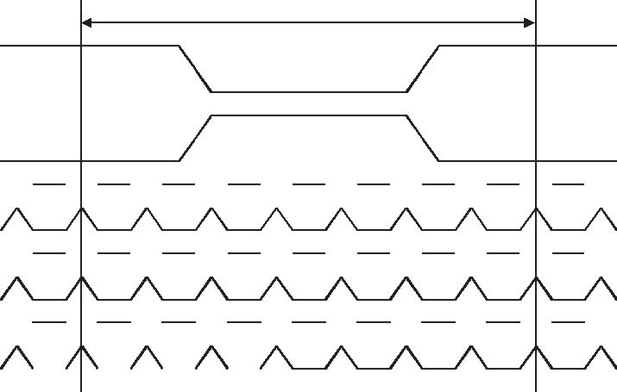

 R1  G0  R5  R4  R3  R2  R1  R0  G0 

 G1  B1  B0  G5  G4  G3  G2  G1  B1 

 B2  DE(VS)(HS  B5  B4  B3  B2  DE

|  |  |  |  |  |  |  |  |  |
| --- | --- | --- | --- | --- | --- | --- | --- | --- |
|  |  |  |  |  |  |  |  |  |
| DE | | DATA ENABLE | | | | | | |
| HS | | HSYNC | | | | | | |
| VS | | VSYNC | | | | | | |



M407011 

|  |  |  |  |
| --- | --- | --- | --- |
|  | Spec No. | Part No. | Page |
|  | TQ3C-8EAF0-E1YAQ08-00 | TCG101WXLPAANN-AN20 | 12 |
|  |  |  |  |

* 2) Block Diagram

BITSEL=L(GND) or OPEN

SELLVDS=H(3.3V)

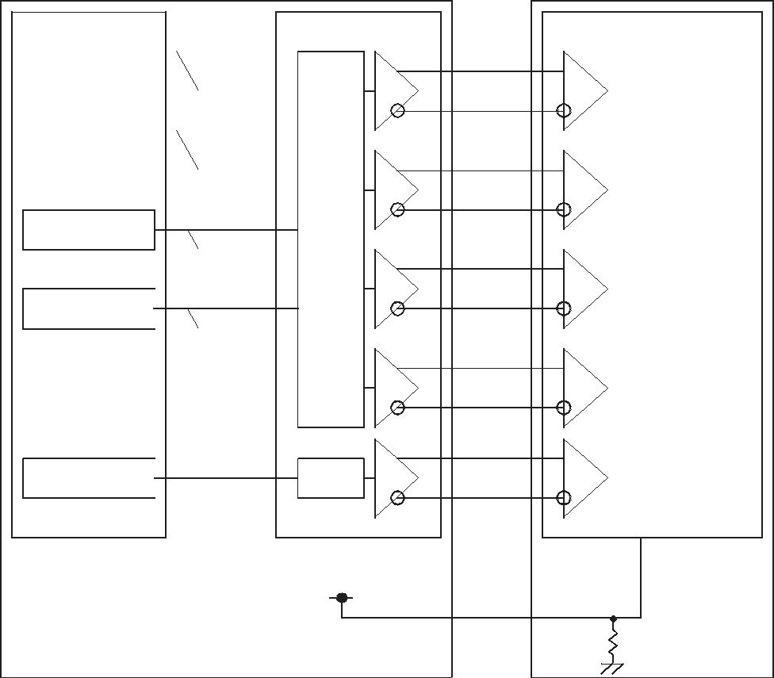

|  |  |  |  |  |
| --- | --- | --- | --- | --- |
|  | 㻯㼛㼚㼠㼞㼛㼘㼘 | |  |  |
|  |  |  | 㻣 |  |
|  | 㻾㻜㻙㻾㻡䠈㻳㻜 |  | 㼀㻭㻜㻙㻢 |  |
|  |  | 㻣 |  |
|  |  |  |  |
|  |  |  |  |
|  | 㻳㻝㻙㻳㻡䠈㻮㻜䠈㻮㻝 |  | 㼀㻮㻜㻙㻢 |  |
|  |  |  |  |
|  |  |  |  |  |

㻣

㻮㻞㻙㻮㻡  㼀㻯㻜㻙㻢㻔㻴㻿㻕䠈㻔㼂㻿㻕䠈㻰㻱

㻣

㻳㻺㻰  㼀㻰㻜㻙㻢

㻯㻷  㻯㻸㻷㻌㻵㻺

㼀㻴㻯㻢㻟㻸㼂㻰㻹㻤㻟㻾

|  |
| --- |
| 㼀㼀㻸㻌㻼㻭㻾㻭㻸㻸㻱㻸㻙㼀㻻㻙㻸㼂㻰㻿 |

㻼㻸㻸

㻟㻚㻟㼂

㻾㼤㻵㻺㻜㻗

㻾㼤㻵㻺㻜㻙

㻾㼤㻵㻺㻝㻗

㻾㼤㻵㻺㻝㻙

㻾㼤㻵㻺㻞㻗

㻾㼤㻵㻺㻞㻙

㻾㼤㻵㻺㻟㻗

㻾㼤㻵㻺㻟㻙

㻯㻷㻌㻵㻺㻗

㻯㻷㻌㻵㻺㻙

㻿㻱㻸㻸㼂㻰㻿

㻯㼛㼚㼠㼞㼛㼘㼘㻌㻵㻯䠄㻮㼡㼕㼘㼠㻙㼕㼚㻌㻸㼂㻰㻿䠅

|  |  |  |  |
| --- | --- | --- | --- |
|  |  | 㻾㻭㻜㻙㻢 |  |
|  | 㻸㼂㻰㻿㻙㼀㻻㻙㻼㻭㻾㻭㻸㻸㻱㻸㻌㼀㼀㻸 | 㻾㻮㻜㻙㻢 |  |
|  |  | 㻾㻯㻜㻙㻢 |  |
|  |  | 㻾㻰㻜㻙㻢 |  |
|  |  | 㻯㻷㻌㻻㼁㼀 |  |
|  |  |  |
|  | 㻼㻸㻸 |  |
|  |  |  |
|  |  |  |  |

㻝㻜㻷

When using 6-bit Transmitter , please connect the unused channel of the control IC receiver as described in the diagram below.

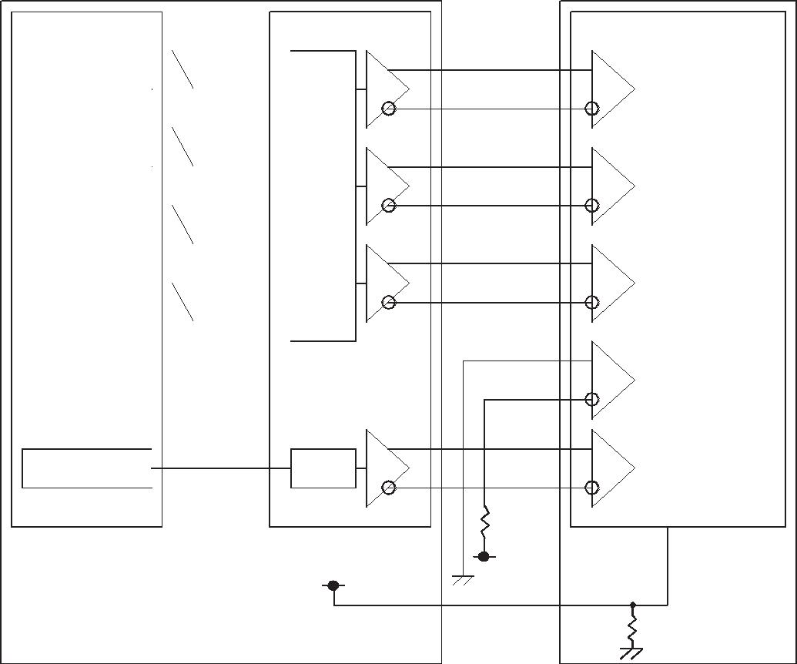

|  |  |  |  |  |
| --- | --- | --- | --- | --- |
|  | 㻯㼛㼚㼠㼞㼛㼘㼘 | |  |  |
|  |  |  | 㻣 |  |
|  | 㻾㻜㻙㻾㻡䠈㻳㻜 |  | 㼀㻭㻜㻙㻢 |  |
|  |  | 㻣 |  |
|  |  |  |  |
|  |  |  |  |
|  | 㻳㻝㻙㻳㻡䠈㻮㻜䠈㻮㻝 |  | 㼀㻮㻜㻙㻢 |  |
|  |  | 㻣 |  |
|  |  |  |  |
|  |  |  |  |
|  | 㻮㻞㻙㻮㻡 |  | 㼀㻯㻜㻙㻢 |  |
|  | 㻔㻴㻿㻕䠈㻔㼂㻿㻕䠈㻰㻱 |  |  |  |
|  |  |  | 㻣 |  |
|  | 㻳㻺㻰 |  | 㼀㻰㻜㻙㻢 |  |
|  |  |  |  |
|  |  |  |  |  |
|  |  |  |  |  |

㻯㻷  㻯㻸㻷㻌㻵㻺

㻢㼎㼕㼠㻙㼀㼞㼍㼚㼟㼙㼕㼠㼠㼑㼞

|  |
| --- |
| 㼀㼀㻸㻌㻼㻭㻾㻭㻸㻸㻱㻸㻙㼀㻻㻙㻸㼂㻰㻿 |

㻼㻸㻸

㻟㻚㻟㼂

㻾㼤㻵㻺㻜㻗

㻾㼤㻵㻺㻜㻙

㻾㼤㻵㻺㻝㻗

㻾㼤㻵㻺㻝㻙

㻾㼤㻵㻺㻞㻗

㻾㼤㻵㻺㻞㻙

㻾㼤㻵㻺㻟㻗

㻾㼤㻵㻺㻟㻙

㻯㻷㻌㻵㻺㻗

㻯㻷㻌㻵㻺㻙

㻝㼗

㻟㻚㻟㼂

㻿㻱㻸㻸㼂㻰㻿

㻯㼛㼚㼠㼞㼛㼘㼘㻌㻵㻯䠄㻮㼡㼕㼘㼠㻙㼕㼚㻌㻸㼂㻰㻿䠅

|  |  |  |  |
| --- | --- | --- | --- |
|  |  | 㻾㻭㻜㻙㻢 |  |
|  | 㻸㼂㻰㻿㻙㼀㻻㻙㻼㻭㻾㻭㻸㻸㻱㻸㻌㼀㼀㻸 | 㻾㻮㻜㻙㻢 |  |
|  |  | 㻾㻯㻜㻙㻢 |  |
|  |  | 㻾㻰㻜㻙㻢 |  |
|  |  | 㻯㻷㻌㻻㼁㼀 |  |
|  |  |  |
|  | 㻼㻸㻸 |  |
|  |  |  |
|  |  |  |  |

㻝㻜㻷



M407011 

|  |  |  |  |
| --- | --- | --- | --- |
|  | Spec No. | Part No. | Page |
|  | TQ3C-8EAF0-E1YAQ08-00 | TCG101WXLPAANN-AN20 | 13 |
|  |  |  |  |

7-4. Data mapping (8bit input / 8bit mode)

1) Location of BITSEL, SELLVDS (THC63LVDM83R(THine Electronics) or compatible)

|  |  |  |  |  |  |
| --- | --- | --- | --- | --- | --- |
| Transmitter | | 2Pin BITSEL | = "L" or OPEN | 2Pin BITSEL | = "L" or OPEN |
| Pin No. | Data | 18Pin SELLVDS | = "L" or OPEN | 18Pin SELLVDS | = "H" |
| 51 | TA0 | R0(LSB) | | R2 | |
| 52 | TA1 | R1 | | R3 | |
| 54 | TA2 | R2 | | R4 | |
| 55 | TA3 | R3 | | R5 | |
| 56 | TA4 | R4 | | R6 | |
| 3 | TA5 | R5 | | R7(MSB) | |
| 4 | TA6 | G0(LSB) | | G2 | |
| 6 | TB0 | G1 | | G3 | |
| 7 | TB1 | G2 | | G4 | |
| 11 | TB2 | G3 | | G5 | |
| 12 | TB3 | G4 | | G6 | |
| 14 | TB4 | G5 | | G7(MSB) | |
| 15 | TB5 | B0(LSB) | | B2 | |
| 19 | TB6 | B1 | | B3 | |
| 20 | TC0 | B2 | | B4 | |
| 22 | TC1 | B3 | | B5 | |
| 23 | TC2 | B4 | | B6 | |
| 24 | TC3 | B5 | | B7(MSB) | |
| 27 | TC4 | (HS) | | (HS) | |
| 28 | TC5 | (VS) | | (VS) | |
| 30 | TC6 | DE | | DE | |
| 50 | TD0 | R6 | | R0(LSB) | |
| 2 | TD1 | R7(MSB) | | R1 | |
| 8 | TD2 | G6 | | G0(LSB) | |
| 10 | TD3 | G7(MSB) | | G1 | |
| 16 | TD4 | B6 | | B0(LSB) | |
| 18 | TD5 | B7(MSB) | | B1 | |
| 25 | TD6 | (NA) | | (NA) | |

BITSEL=L(GND) or OPEN

SELLVDS=L(GND) or OPEN

1 CYCLE

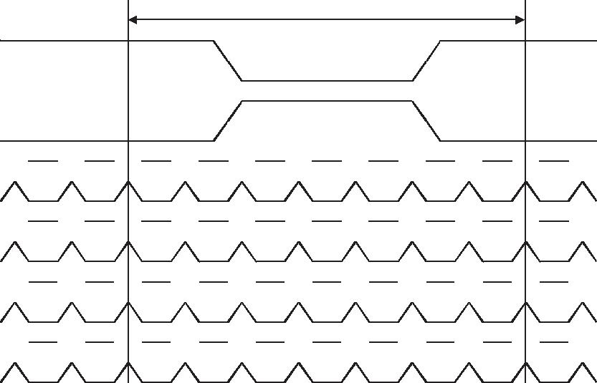

 R1  R0  G0  R5  R4  R3  R2  R1  R0  G0 

 G2  G1  B1  B0  G5  G4  G3  G2  G1  B1 

 B3  B2  DE(VS)(HS B5  B4  B3  B2  DE

 㻾㻣  㻾㻢  㻺㻭  㻮㻣  㻮㻢  㻳㻣  㻳㻢  㻾㻣  㻾㻢  㻺㻭 

DE DATA ENABLE

HS HSYNC

VS VSYNC



M407011 

|  |  |  |  |
| --- | --- | --- | --- |
|  | Spec No. | Part No. | Page |
|  | TQ3C-8EAF0-E1YAQ08-00 | TCG101WXLPAANN-AN20 | 14 |
|  |  |  |  |

BITSEL=L(GND) or OPEN

SELLVDS=H(3.3V)

1 CYCLE

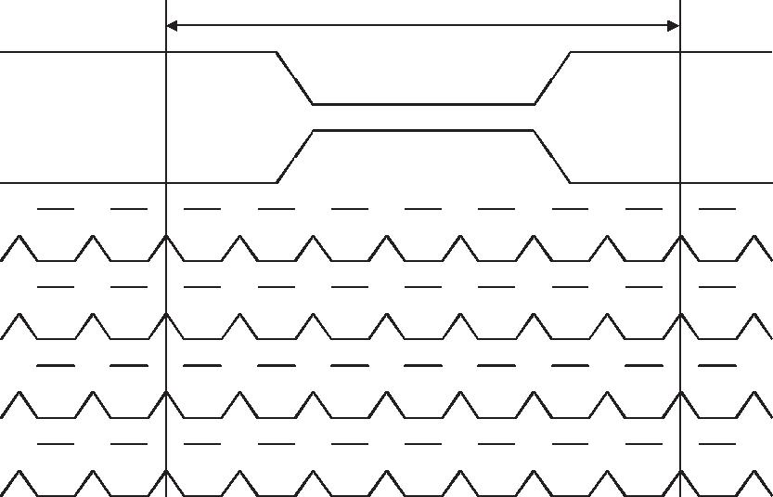

 R3  R2  G2  R7  R6  R5  R4  R3  R2  G2 

 G4  G3  B3  B2  G7  G6  G5  G4  G3  B3 

 B5  B4  DE(VS)(HS B7  B6  B5  B4  DE

 㻾㻝  㻾㻜  㻺㻭  㻮㻝  㻮㻜  㻳㻝  㻳㻜  㻾㻝  㻾㻜  㻺㻭 

DE DATA ENABLE

HS HSYNC

VS VSYNC

* 2) Block Diagram

BITSEL=L(GND) or OPEN

SELLVDS=L(GND) or OPEN

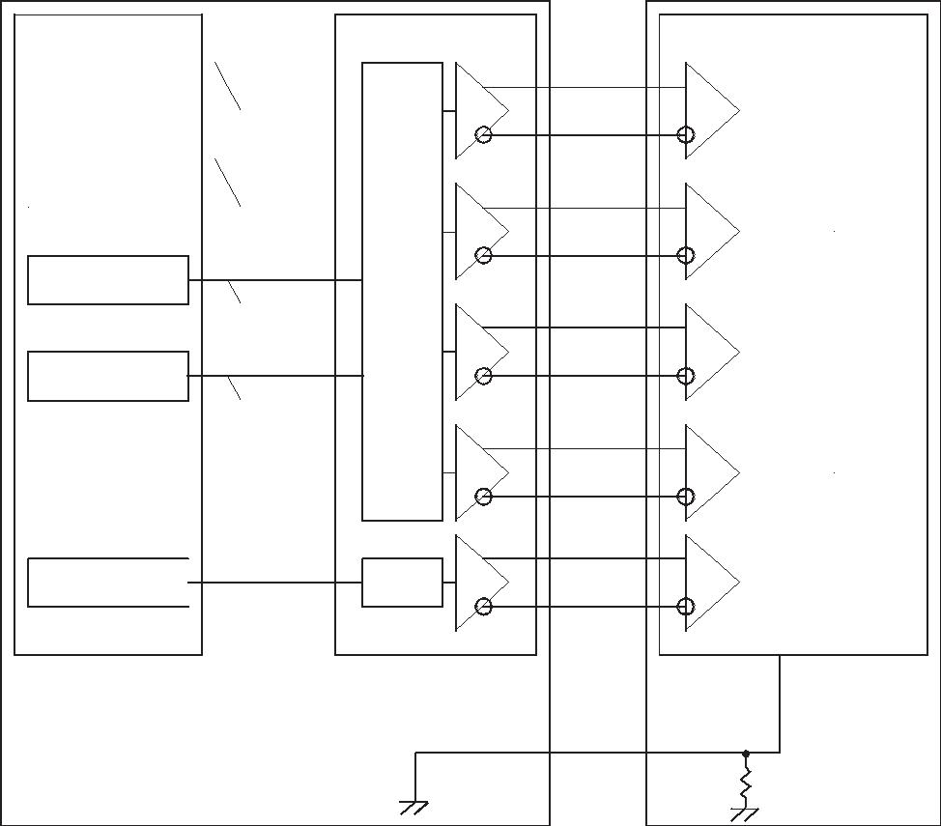

|  |  |  |  |  |
| --- | --- | --- | --- | --- |
|  | 㻯㼛㼚㼠㼞㼛㼘㼘 | |  |  |
|  |  |  | 㻣 |  |
|  | 㻾㻜㻙㻾㻡䠈㻳㻜 |  | 㼀㻭㻜㻙㻢 |  |
|  |  | 㻣 |  |
|  |  |  |  |
|  |  |  |  |
|  | 㻳㻝㻙㻳㻡䠈㻮㻜䠈㻮㻝 |  | 㼀㻮㻜㻙㻢 |  |
|  |  |  |  |
|  |  |  |  |  |

㻣

㻮㻞㻙㻮㻡  㼀㻯㻜㻙㻢㻔㻴㻿㻕䠈㻔㼂㻿㻕䠈㻰㻱

㻣

㻾㻢㻘㻾㻣㻘㻳㻢㻘㻳㻣  㼀㻰㻜㻙㻢㻮㻢㻘㻮㻣㻘㻺㻭

㻯㻷  㻯㻸㻷㻌㻵㻺

㼀㻴㻯㻢㻟㻸㼂㻰㻹㻤㻟㻾

|  |
| --- |
| 㼀㼀㻸㻌㻼㻭㻾㻭㻸㻸㻱㻸㻙㼀㻻㻙㻸㼂㻰㻿 |

㻼㻸㻸

㻾㼤㻵㻺㻜㻗

㻾㼤㻵㻺㻜㻙

㻾㼤㻵㻺㻝㻗

㻾㼤㻵㻺㻝㻙

㻾㼤㻵㻺㻞㻗

㻾㼤㻵㻺㻞㻙

㻾㼤㻵㻺㻟㻗

㻾㼤㻵㻺㻟㻙

㻯㻷㻌㻵㻺㻗

㻯㻷㻌㻵㻺㻙

㻿㻱㻸㻸㼂㻰㻿

㻯㼛㼚㼠㼞㼛㼘㼘㻌㻵㻯䠄㻮㼡㼕㼘㼠㻙㼕㼚㻌㻸㼂㻰㻿䠅

|  |  |  |  |
| --- | --- | --- | --- |
|  |  | 㻾㻭㻜㻙㻢 |  |
|  | 㻸㼂㻰㻿㻙㼀㻻㻙㻼㻭㻾㻭㻸㻸㻱㻸㻌㼀㼀㻸 | 㻾㻮㻜㻙㻢 |  |
|  |  | 㻾㻯㻜㻙㻢 |  |
|  |  | 㻾㻰㻜㻙㻢 |  |
|  |  | 㻯㻷㻌㻻㼁㼀 |  |
|  |  |  |
|  | 㻼㻸㻸 |  |
|  |  |  |
|  |  |  |  |

㻝㻜㻷



M407011 

|  |  |  |  |
| --- | --- | --- | --- |
|  | Spec No. | Part No. | Page |
|  | TQ3C-8EAF0-E1YAQ08-00 | TCG101WXLPAANN-AN20 | 15 |
|  |  |  |  |

BITSEL=L(GND) or OPEN SELLVDS=H(3.3V)

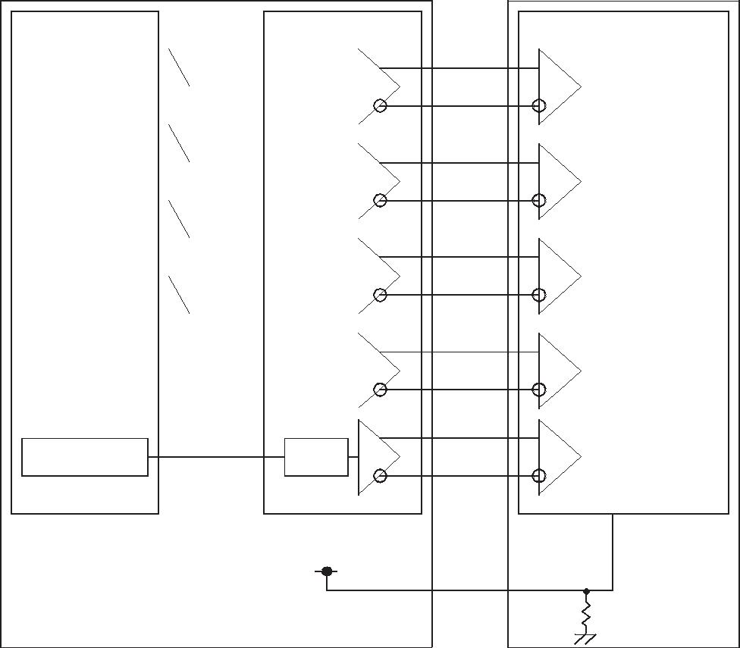

㻯㼛㼚㼠㼞㼛㼘㼘 㼀㻴㻯㻢㻟㻸㼂㻰㻹㻤㻟㻾

|  |  |  |  |  |  |
| --- | --- | --- | --- | --- | --- |
|  | 㻣 |  |  |  |  |
| 㻾㻞㻙㻾㻣䠈㻳㻞 |  | 㼀㻭㻜㻙㻢 |  |  |  |
| 㻣 |  |  |  |  |
|  |  |  |  |  |
|  |  |  |  |  |
| 㻳㻟㻙㻳㻣䠈㻮㻞䠈㻮㻟 |  | 㼀㻮㻜㻙㻢 | 㼀㼀㻸㻌㻼㻭㻾㻭㻸㻸㻱㻸㻙㼀㻻㻙㻸㼂㻰㻿 |  |  |
|  | 㻣 |  |  |  |  |
|  |  |  |  |  |
|  |  |  |  |  |
| 㻮㻠㻙㻮㻣 |  | 㼀㻯㻜㻙㻢 |  |  |  |
| 㻔㻴㻿㻕䠈㻔㼂㻿㻕䠈㻰㻱 |  |  |  |  |  |
|  | 㻣 |  |  |  |  |
| 㻾㻜䠈㻾㻝䠈㻳㻜䠈㻳㻝 |  | 㼀㻰㻜㻙㻢 |  |  |  |
| 㻮㻜䠈㻮㻝䠈㻺㻭 |  |  |  |  |  |
|  |  |  |  |  |  |
|  |  |  |  |  |  |
|  |  |  |  |  |  |
|  |  |  |  |  |  |

㻯㻸㻷㻌㻵㻺

㻯㻷 㻼㻸㻸

㻟㻚㻟㼂

㻾㼤㻵㻺㻜㻗

㻾㼤㻵㻺㻜㻙

㻾㼤㻵㻺㻝㻗

㻾㼤㻵㻺㻝㻙

㻾㼤㻵㻺㻞㻗

㻾㼤㻵㻺㻞㻙

㻾㼤㻵㻺㻟㻗

㻾㼤㻵㻺㻟㻙

㻯㻷㻌㻵㻺㻗

㻯㻷㻌㻵㻺㻙

㻿㻱㻸㻸㼂㻰㻿

㻯㼛㼚㼠㼞㼛㼘㼘㻌㻵㻯䠄㻮㼡㼕㼘㼠㻙㼕㼚㻌㻸㼂㻰㻿䠅

|  |  |  |  |
| --- | --- | --- | --- |
|  |  | 㻾㻭㻜㻙㻢 |  |
|  | 㻸㼂㻰㻿㻙㼀㻻㻙㻼㻭㻾㻭㻸㻸㻱㻸㻌㼀㼀㻸 | 㻾㻮㻜㻙㻢 |  |
|  |  | 㻾㻯㻜㻙㻢 |  |
|  |  | 㻾㻰㻜㻙㻢 |  |
|  |  | 㻯㻷㻌㻻㼁㼀 |  |
|  |  |  |
|  | 㻼㻸㻸 |  |
|  |  |  |
|  |  |  |  |

㻝㻜㻷



M407011 

|  |  |  |  |
| --- | --- | --- | --- |
|  | Spec No. | Part No. | Page |
|  | TQ3C-8EAF0-E1YAQ08-00 | TCG101WXLPAANN-AN20 | 16 |
|  |  |  |  |

7-5. Data mapping (6bit input / 6bit mode)

* 1) Location of BITSEL, SELLVDS (THC63LVDM63R(THine Electronics) or compatible)

|  |  |  |  |  |  |
| --- | --- | --- | --- | --- | --- |
| Transmitter | | 2Pin BITSEL | = "H" | 2Pin BITSEL | = "H" |
| Pin No. | Data | 18Pin SELLVDS | = "L" or OPEN | 18Pin SELLVDS | = "H" |
| 44 | TA0 | R0(LSB) | |  |  |
| 45 | TA1 | R1 | |  |  |
| 47 | TA2 | R2 | |  |  |
| 48 | TA3 | R3 | |  |  |
| 1 | TA4 | R4 | |  |  |
| 3 | TA5 | R5(MSB) | |  |  |
| 4 | TA6 | G0(LSB) | |  |  |
| 6 | TB0 | G1 | |  |  |
| 7 | TB1 | G2 | |  |  |
| 9 | TB2 | G3 | |  |  |
| 10 | TB3 | G4 | |  |  |
| 12 | TB4 | G5(MSB) | |  |  |
| 13 | TB5 | B0(LSB) | |  |  |
| 15 | TB6 | B1 | |  |  |
| 16 | TC0 | B2 | |  |  |
| 18 | TC1 | B3 | |  |  |
| 19 | TC2 | B4 | |  |  |
| 20 | TC3 | B5(MSB) | |  |  |
| 22 | TC4 | (HS) | |  |  |
| 23 | TC5 | (VS) | |  |  |
| 25 | TC6 | DE | |  |  |

BITSEL=H(3.3V)

SELLVDS=L(GND) or OPEN

1 CYCLE

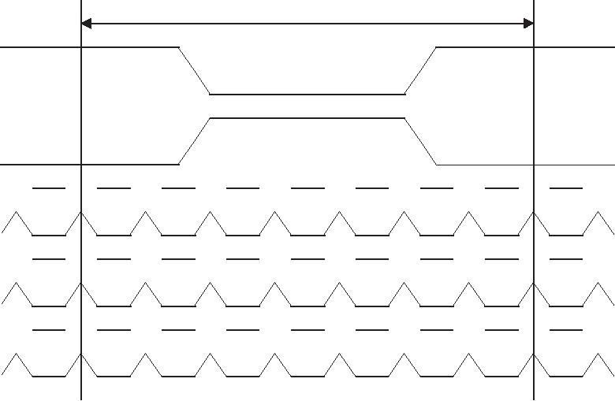

 R1  G0  R5  R4  R3  R2  R1  R0  G0 

 G1  B1  B0  G5  G4  G3  G2  G1  B1 

 B2  DE (VS)(HS) B5  B4  B3  B2  DE 

DE DATA ENABLE

HS HSYNC

VS VSYNC



M407011 

|  |  |  |  |
| --- | --- | --- | --- |
|  | Spec No. | Part No. | Page |
|  | TQ3C-8EAF0-E1YAQ08-00 | TCG101WXLPAANN-AN20 | 17 |
|  |  |  |  |

2) Block Diagram

BITSEL=H(3.3V)

SELLVDS=L(GND) or OPEN

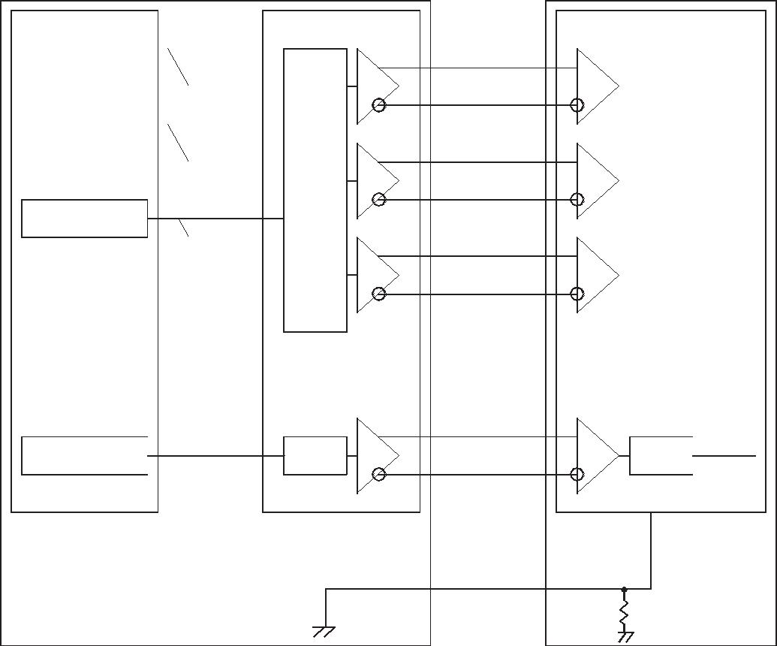

|  |  |  |
| --- | --- | --- |
| 㻯㼛㼚㼠㼞㼛㼘㼘 |  |  |
|  | 㻣 |  |
| 㻾㻜㻙㻾㻡䠈㻳㻜 | 㼀㻭㻜㻙㻢 |  |
| 㻣 |  |
|  |  |
|  |  |
| 㻳㻝㻙㻳㻡䠈㻮㻜䠈㻮㻝 | 㼀㻮㻜㻙㻢 |  |
|  |  |
|  |  |  |

㻣

㻮㻞㻙㻮㻡  㼀㻯㻜㻙㻢㻔㻴㻿㻕䠈㻔㼂㻿㻕䠈㻰㻱

㻯㻷  㻯㻸㻷㻌㻵㻺

㻢㼎㼕㼠㻙㼀㼞㼍㼚㼟㼙㼕㼠㼠㼑㼞

|  |
| --- |
| 㼀㼀㻸㻌㻼㻭㻾㻭㻸㻸㻱㻸㻙㼀㻻㻙㻸㼂㻰㻿 |

㻼㻸㻸

㻾㼤㻵㻺㻜㻗

㻾㼤㻵㻺㻜㻙

㻾㼤㻵㻺㻝㻗

㻾㼤㻵㻺㻝㻙

㻾㼤㻵㻺㻞㻗

㻾㼤㻵㻺㻞㻙

㻯㻷㻌㻵㻺㻗

㻯㻷㻌㻵㻺㻙

㻯㼛㼚㼠㼞㼛㼘㼘㻌㻵㻯䠄㻮㼡㼕㼘㼠㻙㼕㼚㻌㻸㼂㻰㻿䠅

|  |  |  |
| --- | --- | --- |
|  |  | 㻾㻭㻜㻙㻢 |
|  | 㻸㼂㻰㻿㻙㼀㻻㻙㻼㻭㻾㻭㻸㻸㻱㻸㻌㼀㼀㻸 | 㻾㻮㻜㻙㻢 |
|  |  | 㻾㻯㻜㻙㻢 |
|  |  |  |

㻼㻸㻸  㻯㻷㻌㻻㼁㼀

㻿㻱㻸㻸㼂㻰㻿

㻝㻜㻷



M407011 

|  |  |  |  |
| --- | --- | --- | --- |
|  | Spec No. | Part No. | Page |
|  | TQ3C-8EAF0-E1YAQ08-00 | TCG101WXLPAANN-AN20 | 18 |
|  |  |  |  |

1. Input timing characteristics 8-1. Timing characteristics

|  |  |  |  |  |  |  |  |  |
| --- | --- | --- | --- | --- | --- | --- | --- | --- |
|  | Item | Symbol | Min. | Typ. | Max. | Unit | Note |  |
|  |  |  |  |  |  |  |  |  |
| Clock (CK) | Frequency | 1/Tc | 60 | 71.1 | 80 | MHz |  |  |
|  |  |  |  |  |  |  |  |  |
|  | Horizontal Period | Th | 1300 | 1440 | 1800 | Dot |  |  |
|  |  |  |  |  |  |  |
| Enable signal | 16.25 | 20.25 | - | s | 1) |  |
|  |  |  |
|  |  |  |  |  |  |  |  |
| Horizontal display period | Thd |  | 1280 |  |  |  |  |
| (DE) |  |  |  |  |  |
|  |  |  |  |  |  |  |  |
| Vertical Period | Tv | 803 | 823 | 1024 | Line |  |  |
|  |  |  |
|  |  |  |  |  |  |  |  |  |
|  | Vertical display period | Tvd |  | 800 |  |  |  |  |
|  |  |  |  |  |  |  |  |  |
| Refresh rate |  | fv | 50 | 60 | 70 |  | 2) |  |
|  |  |  |  |  |  |  |  |  |

1. Please set a clock frequency, a vertical dormant period, and the horizontal dormant period so that the Horizontal Period should not reach less than Min. value.
2. If the refresh rate reach less than Min. value, the deterioration of the display quality, flicker etc., may occur.(fv=1/Tv)

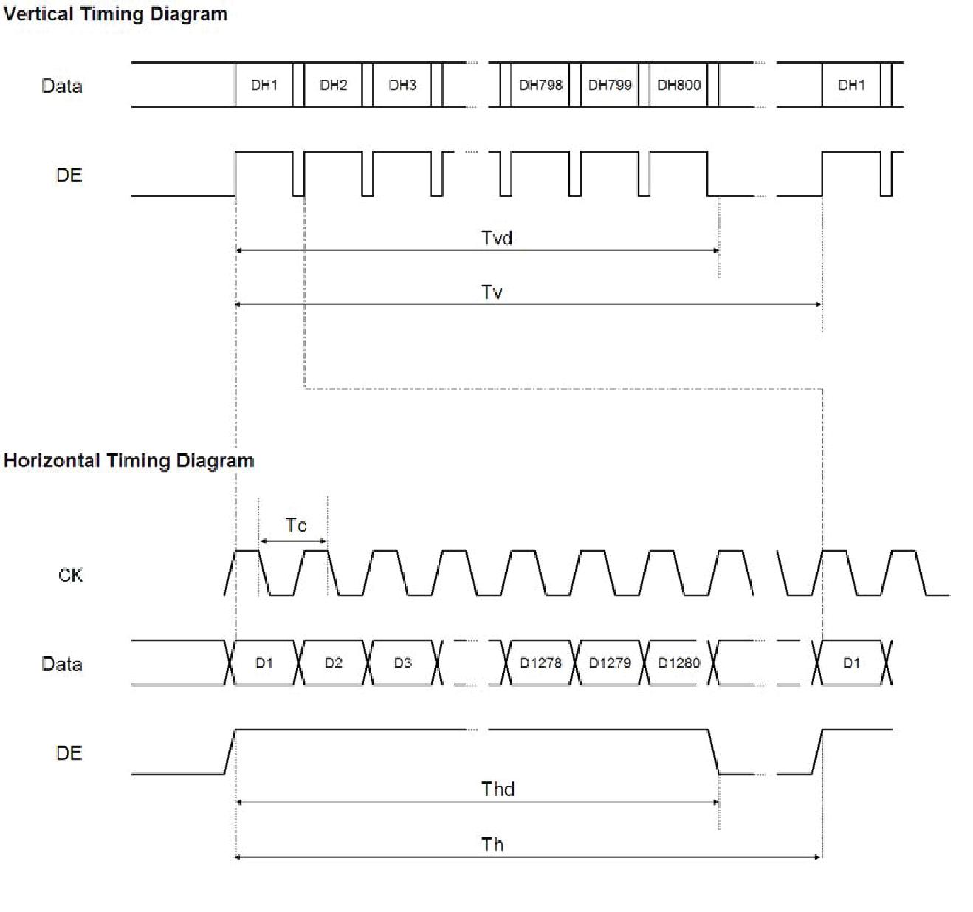

M407011 

|  |  |  |  |
| --- | --- | --- | --- |
|  | Spec No. | Part No. | Page |
|  | TQ3C-8EAF0-E1YAQ08-00 | TCG101WXLPAANN-AN20 | 19 |
|  |  |  |  |

8-2. Input Data Signals and Display position on the screen

|  |  |  |  |  |  |  |  |  |  |  |  |  |  |  |  |  |  |  |  |  |  |  |  |  |  |  |  |  |  |  |
| --- | --- | --- | --- | --- | --- | --- | --- | --- | --- | --- | --- | --- | --- | --- | --- | --- | --- | --- | --- | --- | --- | --- | --- | --- | --- | --- | --- | --- | --- | --- |
| D1, DH1 | D2, DH1 | D3, DH1 |  |  |  |  |  |  |  |  |  |  |  |  |  |  |  |  |  |  |  |  |  |  |  |  |  |  |  | D1280, DH1 |
| D1, DH2 | D2, DH2 | D3, DH2 |  |  |  |  |  |  |  |  |  |  |  |  |  |  |  |  |  |  |  |  |  |  |  |  |  |  |  |  |

**R**  **G**  **B**

D1, DH800  D2, DH800  D3, DH800 



M407011 

|  |  |  |  |
| --- | --- | --- | --- |
|  | Spec No. | Part No. | Page |
|  | TQ3C-8EAF0-E1YAQ08-00 | TCG101WXLPAANN-AN20 | 20 |
|  |  |  |  |

9. Lot number identification

* The lot number shall be indicated on the back of the backlight case of each LCD.

|  |  |  |  |  |  |
| --- | --- | --- | --- | --- | --- |
| TCG101WXLPAANN-AN20 | - ŌŌ - ŌŌ - Ō | | | MADE IN ŌŌŌŌŌ | |
|  | Ņ Ņ | Ņ | Ņ |  | Ņ |
|  | 1 2 3 | | 4 | 5 | |

No1. - No5. above indicate

1. Year code
2. Month code
3. Date
4. Version Number
5. Country of origin (Japan or China)

|  |  |  |  |  |  |  |
| --- | --- | --- | --- | --- | --- | --- |
| Year | 2013 | 2014 | 2015 | 2016 | 2017 | 2018 |
|  |  |  |  |  |  |  |
| Code | 3 | 4 | 5 | 6 | 7 | 8 |
|  |  |  |  |  |  |  |
|  |  |  |  |  |  |  |
| Month | Jan. | Feb. | Mar. | Apr. | May | Jun. |
|  |  |  |  |  |  |  |
| Code | 1 | 2 | 3 | 4 | 5 | 6 |
|  |  |  |  |  |  |  |
|  |  |  |  |  |  |  |
| Month | Jul. | Aug. | Sep. | Oct. | Nov. | Dec. |
|  |  |  |  |  |  |  |
| Code | 7 | 8 | 9 | X | Y | Z |
|  |  |  |  |  |  |  |

10. Warranty

* 10-1. Incoming inspection
* Please inspect the LCD within one month after your receipt.
* 10-2. Production warranty
* Kyocera warrants its LCD’s for a period of 12 months from the ship date. Kyocera shall, by mutual agreement, replace or re-work defective LCD’s that are shown to be Kyocera’s responsibility.



M407011 

|  |  |  |  |
| --- | --- | --- | --- |
|  | Spec No. | Part No. | Page |
|  | TQ3C-8EAF0-E1YAQ08-00 | TCG101WXLPAANN-AN20 | 21 |
|  |  |  |  |

11. Precautions for use

11-1. Installation of the LCD

1. Please ground in order to stabilize brightness and display quality.
2. A transparent protection plate shall be added to protect the LCD and its polarizer.
3. The LCD shall be installed so that there is no pressure on the LSI chips.
4. The LCD shall be installed flat, without twisting or bending.
5. A transparent protection sheet is attached to the polarizer.

Please remove the protection film slowly before use, paying attention to static electricity.

11-2. Static electricity

1. Since CMOS ICs are mounted directly onto the LCD glass, protection from static electricity is required.
2. Workers should use body grounding. Operator should wear ground straps.

11-3. LCD operation

1. The LCD shall be operated within the limits specified. Operation at values outside of these limits may shorten life, and/or harm display images.

11-4. Storage

1) The LCD shall be stored within the temperature and humidity limits specified.

Store in a dark area, and protect the LCD from direct sunlight or fluorescent light.

2) Always store the LCD so that it is free from external pressure onto it.

11-5. Usage

1. DO NOT store in a high humidity environment for extended periods. Polarizer degradation bubbles, and/or peeling off of the polarizer may result.
2. The front polarizer is easily scratched or damaged. Prevent touching it with any hard material, and from being pushed or rubbed.
3. The LCD screen may be cleaned by wiping the screen surface with a soft cloth or cotton pad using a little Ethanol.
4. Water may cause damage or discoloration of the polarizer. Clean condensation or moisture from any source immediately.
5. Always keep the LCD free from condensation during testing. Condensation may permanently spot or stain the polarizer.
6. Do not disassemble LCD because it will result in damage.
7. This Kyocera LCD has been specifically designed for use in general electronic devices, but not

for use in a special environment such as usage in an active gas. Hence, when the LCD is supposed to be used in a special environment, evaluate the LCD thoroughly beforehand and do not expose the LCD to chemicals such as an active gas.

1. Please do not use solid-base image pattern for long hours because a temporary afterimage may appear. We recommend using screen saver etc. in cases where a solid-base image pattern must be used.
2. Liquid crystal may leak when the LCD is broken. Be careful not to let the fluid go into your eyes and mouth. In the case the fluid touches your body; rinse it off right away with water and soap.



M407011 

|  |  |  |  |
| --- | --- | --- | --- |
|  | Spec No. | Part No. | Page |
|  | TQ3C-8EAF0-E1YAQ08-00 | TCG101WXLPAANN-AN20 | 22 |
|  |  |  |  |

1. Reliability test data

|  |  |  |  |  |  |  |
| --- | --- | --- | --- | --- | --- | --- |
| Test item | Test condition | | Test time | Judgement | |  |
|  |  |  |  |  |  |  |
| High temp. |  |  |  | Display function | : No defect |  |
| 80°C | | 240h | Display quality | : No defect |  |
| atmosphere |  |
|  |  |  | Current consumption | : No defect |  |
|  |  |  |  |  |
|  |  |  |  |  |  |  |
| Low temp. |  |  |  | Display function | : No defect |  |
| -30°C | | 240h | Display quality | : No defect |  |
| atmosphere |  |
|  |  |  | Current consumption | : No defect |  |
|  |  |  |  |  |
| High temp. |  |  |  | Display function | : No defect |  |
| humidity | 40°C 90% RH | | 240h | Display quality | : No defect |  |
| atmosphere |  |  |  | Current consumption | : No defect |  |
|  | -30°C | 0.5h |  | Display function | : No defect |  |
| Temp. cycle | R.T. | 0.5h | 10cycles | Display quality | : No defect |  |
|  | 80°C | 0.5h |  | Current consumption | : No defect |  |
| High temp. |  |  |  | Display function | : No defect |  |
| 70°C | | 500h | Display quality | : No defect |  |
| operation |  |
|  |  |  | Current consumption | : No defect |  |
|  |  |  |  |  |

* 1. Each test item uses a test LCD only once. The tested LCD is not used in any other tests.
  2. The LCD is tested in circumstances in which there is no condensation.
  3. The reliability test is not an out-going inspection.
  4. The result of the reliability test is for your reference purpose only.
* The reliability test is conducted only to examine the LCD's capability.



M407011 

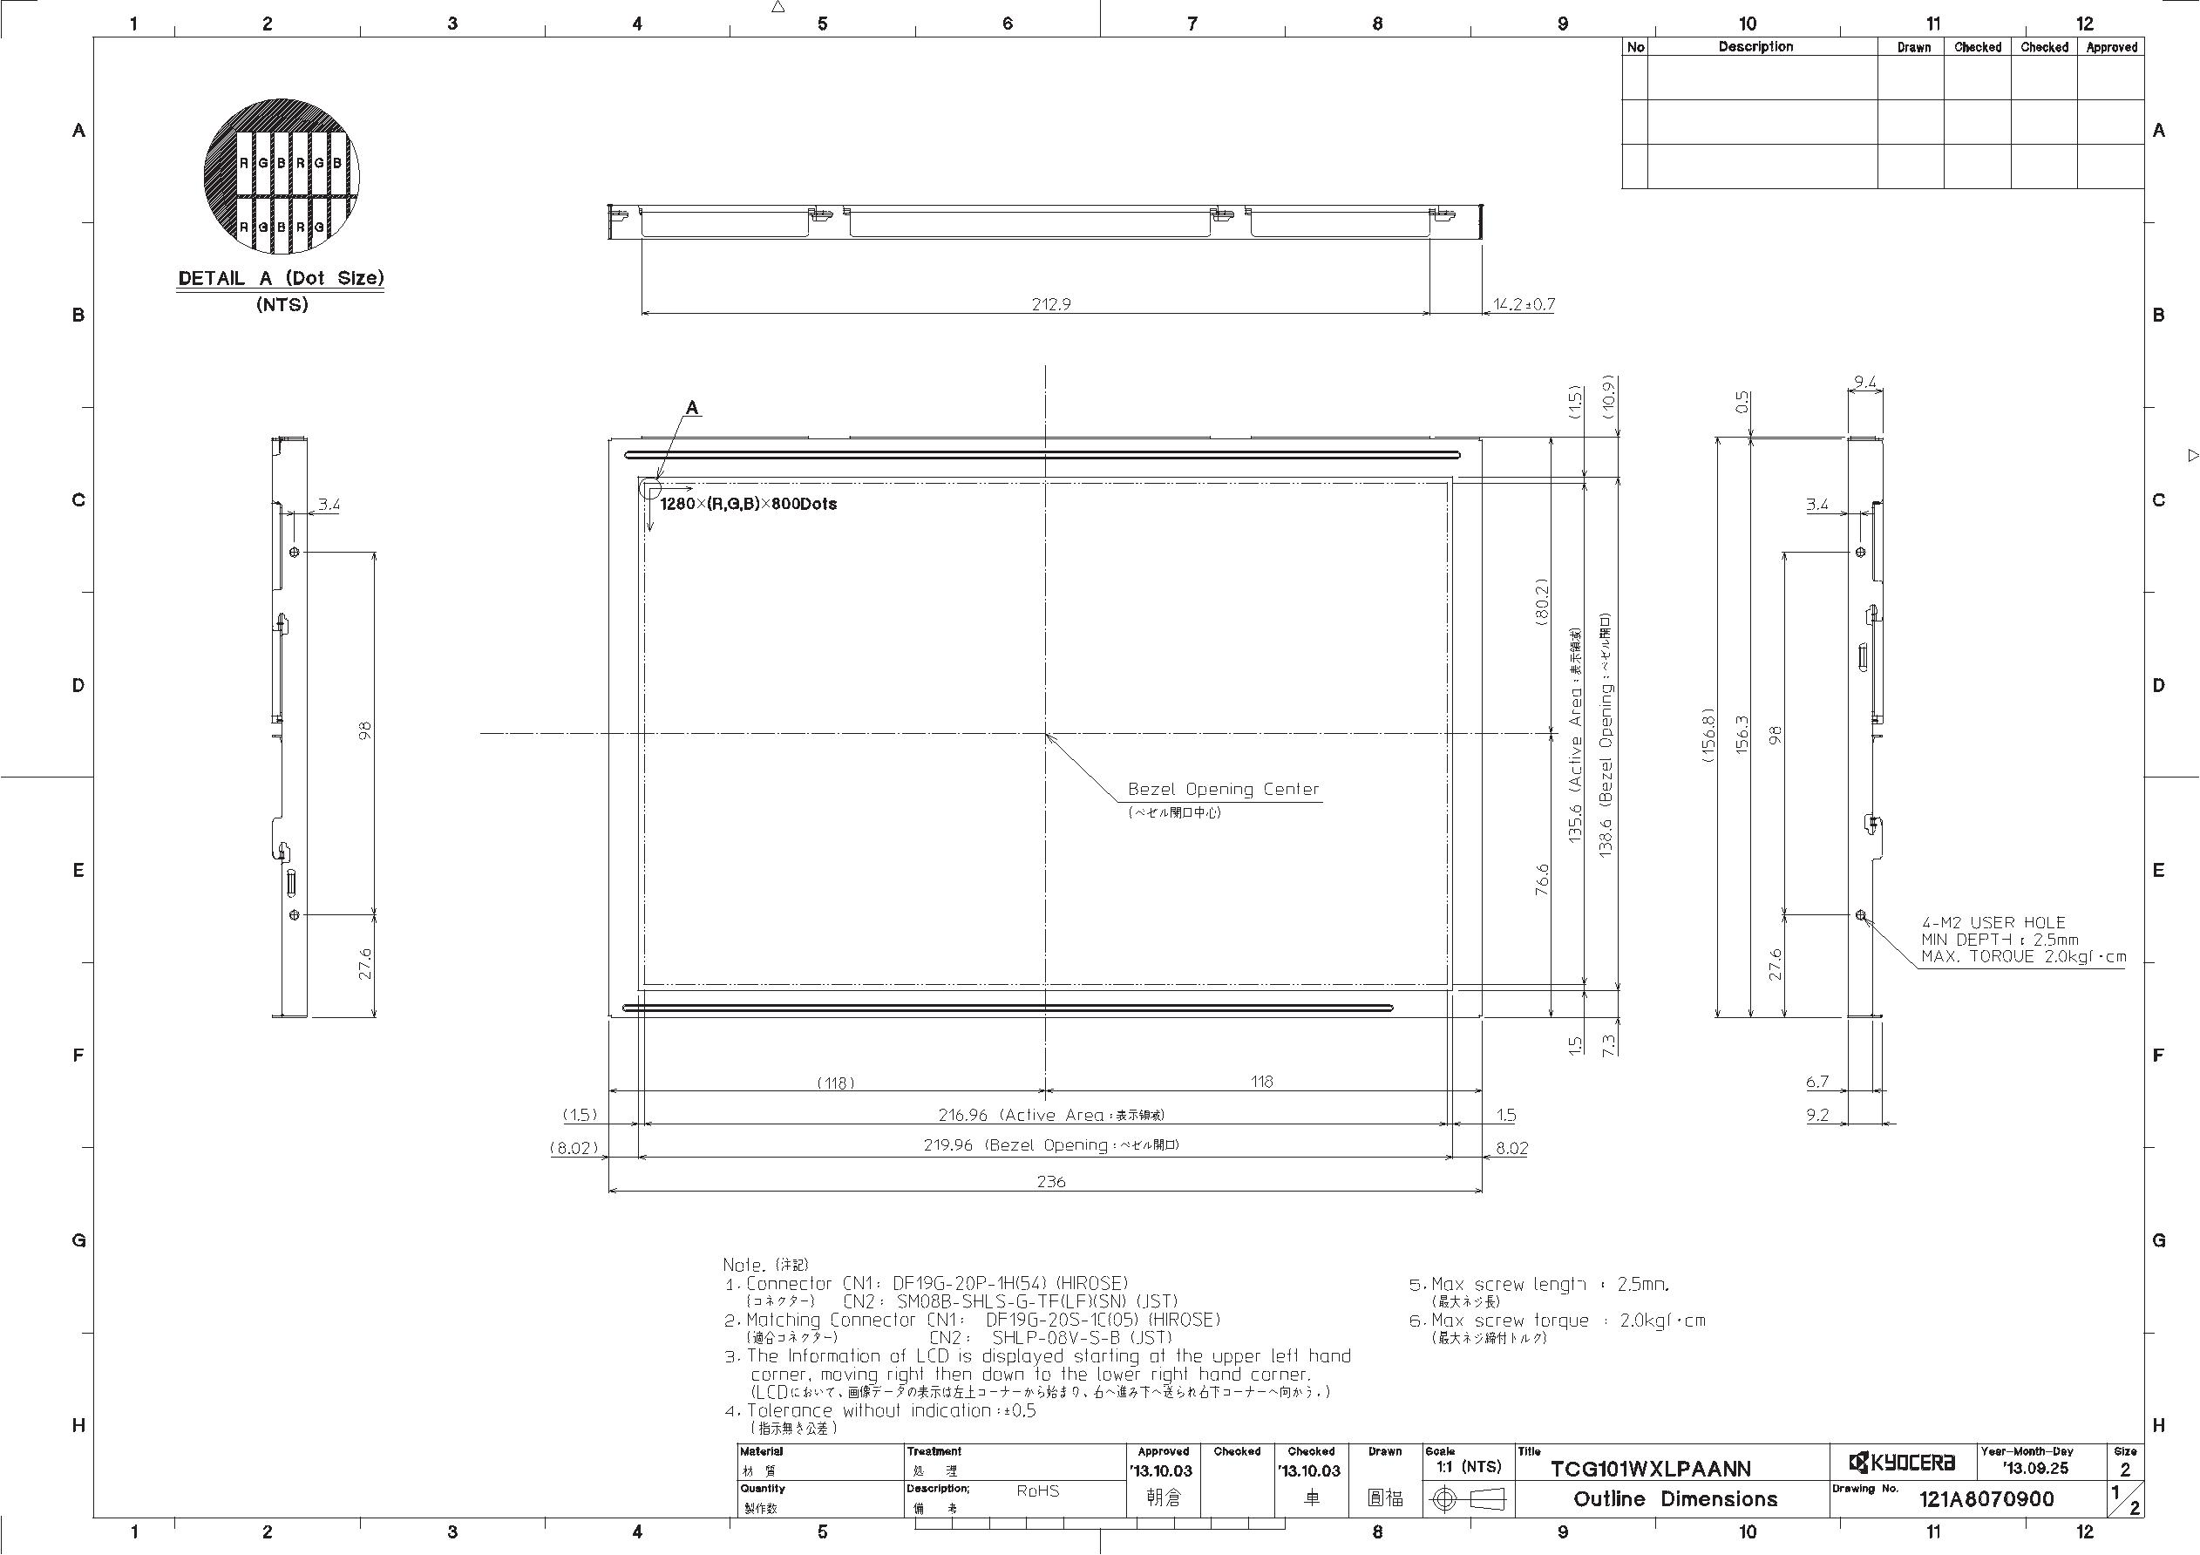

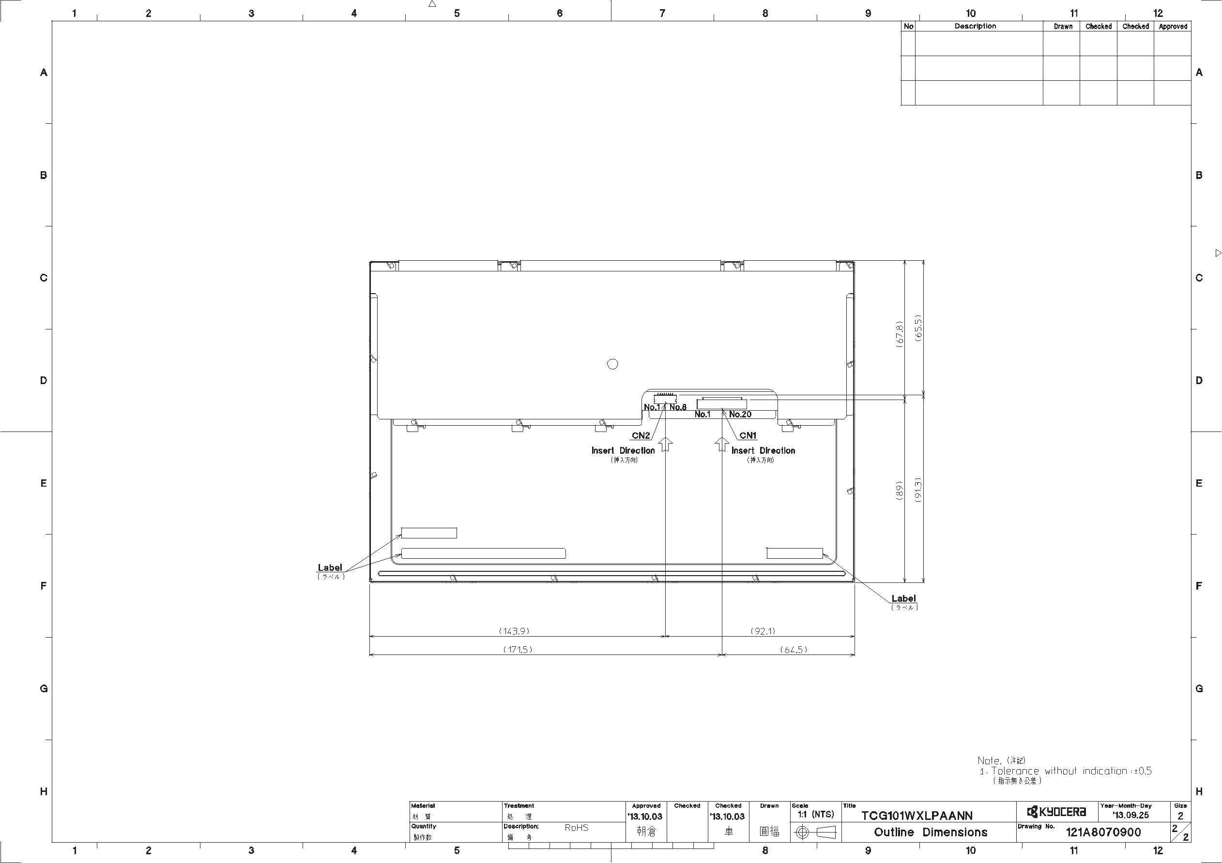

|  |  |
| --- | --- |
| Spec No. | TQ3C-8EAF0-E2YAQ08-00 |
| Date | November 29, 2013 |

**KYOCERA INSPECTION STANDARD**

**TYPE : TCG101WXLPAANN-AN20**

KYOCERA DISPLAY CORPORATION

|  |  |  |  |  |  |  |  |  |
| --- | --- | --- | --- | --- | --- | --- | --- | --- |
| Original |  | Designed by : Engineering dept. | | |  | Confirmed by : QA dept. | |  |
| Issue Date | |  |  |  |  |  |  |  |
| Prepared | Checked |  | Approved | Checked | Approved |  |
| November 29, | 2013 |  |  |  |  |  |  |  |
|  |  |  |  |  |  |  |  |  |





|  |  |  |  |
| --- | --- | --- | --- |
|  | Spec No. | Part No. | Page |
|  | TQ3C-8EAF0-E2YAQ08-00 | TCG101WXLPAANN-AN20 | - |
|  |  |  |  |

Revision record

Designed by : Engineering dept. Confirmed by : QA dept.

Date

Prepared Checked Approved Checked Approved

|  |  |  |  |  |  |
| --- | --- | --- | --- | --- | --- |
|  | Rev.No. | Date | Page | Descriptions |  |
|  |  |  |  |  |  |
|  |  |  |  |  |  |



|  |  |  |  |  |  |  |  |  |  |  |  |  |  |  |  |  |  |  |  |  |  |  |  |  |  |  |  |  |
| --- | --- | --- | --- | --- | --- | --- | --- | --- | --- | --- | --- | --- | --- | --- | --- | --- | --- | --- | --- | --- | --- | --- | --- | --- | --- | --- | --- | --- |
|  |  |  |  |  | Spec No. |  |  |  |  |  |  |  | Part No. | | | | | | | |  |  |  |  |  | Page |  |  |
|  |  |  |  |  | TQ3C-8EAF0-E2YAQ08-00 | | | | | | |  | TCG101WXLPAANN-AN20 | | | | | | | | | | | |  | 1 |  |  |
|  |  |  |  |  |  |  |  |  |
|  |  |  |  |  |  |  |  |  |  |  |  |  |  |  |  |  |  |  |  |  |  |  |  |  |  |  |  |  |
|  |  |  |  |  |  |  |  |  |  |  |  |  |  |  |  |  |  |  |  |  |  |  |  |  |  |  |  |  |
|  | Visuals specification | | | | |  |  |  |  |  |  |  |  |  |  |  |  |  |  |  |  |  |  |  |  |  |  |  |
|  | 1) Note |  |  |  |  |  |  |  |  |  |  |  |  |  |  |  |  |  |  |  |  |  |  |  |  |  |  |  |
|  |  |  |  |  |  |  |  | Note | | | |  |  |  |  |  |  |  |  |  |  |  |  |  |  |  |  |  |
|  |  |  |  | | |  |  |  |  |  |  | |  |  |  |  |  |  |  |  | |  |  |  | | |  |  |
|  | General |  | 1. Customer identified anomalies not defined within this inspection standard shall be | | | | | | | | | | | | | | | | | | | | | | | |  |  |
|  |  |  | reviewed by Kyocera, and an additional standard shall be determined by mutual | | | | | | | | | | | | | | | | | | | | | | |  |  |  |
|  |  |  | consent. |  |  |  |  |  |  |  |  |  |  |  |  |  |  |  |  |  |  |  |  |  |  |  |  |  |
|  |  |  | 2. This inspection standard about the image quality shall be applied to any defect within | | | | | | | | | | | | | | | | | | | | | | | |  |  |
|  |  |  | the active area and shall not be applicable to outside of the area. | | | | | | | | | | | | | | | | | | | | | | |  |  |  |
|  |  |  | 3. Inspection conditions | | |  |  |  |  |  |  |  |  |  |  |  |  |  |  |  |  |  |  |  |  |  |  |  |
|  |  |  | Luminance | | | : 500 Lux min. | | | | | | | | | | | | | | |  |  |  |  |  |  |  |  |
|  |  |  | Inspection distance | | | : 300 mm. | | | | | |  |  |  |  |  |  |  |  |  |  |  |  |  |  |  |  |  |
|  |  |  | Temperature | | | : 25 | 5 | | |  |  |  |  |  |  |  |  |  |  |  |  |  |  |  |  |  |  |  |
|  |  |  | Direction | | | : Directly above | | | | | | | | | | | | | | |  |  |  |  |  |  |  |  |
|  |  |  |  |  | |  | |  |  |  |  | |  | |  | |  |  | |  | |  |  | | | |  |  |
|  | Definition of |  | Dot defect | Bright dot defect | | The dot is constantly “on” when power applied to the | | | | | | | | | | | | | | | | | | | | |  |  |
|  | inspection item |  |  |  |  | LCD, even when all “Black” data sent to the screen. | | | | | | | | | | | | | | | | | | | | |  |  |
|  |  |  |  |  |  | Inspection tool: 5% Transparency neutral density filter. | | | | | | | | | | | | | | | | | | | | |  |  |
|  |  |  |  |  |  | Count dot: If the dot is visible through the filter. | | | | | | | | | | | | | | | | | | | |  |  |  |
|  |  |  |  |  |  | Don’t count dot: If the dot is not visible through the | | | | | | | | | | | | | | | | | | | | |  |  |
|  |  |  |  |  |  |  |  |  |  |  |  |  |  |  | filter. | | | | | |  |  |  |  |  |  |  |  |
|  |  |  |  |  |  |  |  |  |  |  |  | |  |  |  |  |  |  |  |  |  |  |  |  |  |  |  |  |
|  |  |  |  |  |  |  | 䠮 | 䠣 | 䠞 | 䠮 | 䠣 | | 䠞 |  | 䠮 |  | 䠣 | 䠞 |  |  |  |  |  |  |  |  |  |  |
|  |  |  |  |  |  |  |  |  |  |  |  | |  |  |  |  |  |  |  |  |  |  |  |  |  |  |  |  |
|  |  |  |  |  |  |  | 䠮 | 䠣 | 䠞 | 䠮 | 䠣 | | 䠞 |  | 䠮 |  | 䠣 | 䠞 |  |  |  |  |  | dot defect | |  |  |  |
|  |  |  |  |  |  |  |  |  |  |  |  |  |  |  |  |  |  |  |  |  |  |  |  |  |  |  |
|  |  |  |  |  |  |  | 䠮 | 䠣 | 䠞 | 䠮 | 䠣 | | 䠞 |  | 䠮 |  | 䠣 | 䠞 |  |  |  |  |  |  |
|  |  |  |  |  |  |  |  |  |  |  |  |  |  |  |  |  |  |
|  |  |  |  |  |  |  |  |  |  |  |  |  |  |  |  |  |  |  |  |  |  |  |  |  |  |  |  |
|  |  |  |  | Black dot defect | | The dot is constantly “off” when power applied to the | | | | | | | | | | | | | | | | | | | | |  |  |
|  |  |  |  |  |  | LCD, even when all “White” data sent to the screen. | | | | | | | | | | | | | | | | | | | | |  |  |
|  |  |  |  |  | |  | | | | | | | | | | | | | | | | | | | | |  |  |
|  |  |  |  | Adjacent dot | | Adjacent dot defect is defined as two or more bright dot | | | | | | | | | | | | | | | | | | | | |  |  |
|  |  |  |  |  |  | defects or black dot defects. | | | | | | | | | | | | | | | | | | | |  |  |  |
|  |  |  |  |  |  |  |  |  |  |  |  | |  | |  | |  |  | |  |  |  |  |  |  |  |  |  |
|  |  |  |  |  |  |  | 䠮 | 䠣 | 䠞 | 䠮 | 䠣 | | 䠞 | | 䠮 | | 䠣 | 䠞 | |  |  |  |  |  |  |  |  |  |
|  |  |  |  |  |  |  |  |  |  |  |  | |  | |  | |  |  | |  |  |  |  |  |  |  |  |  |
|  |  |  |  |  |  |  | 䠮 | 䠣 | 䠞 | 䠮 | 䠣 | | 䠞 | | 䠮 | | 䠣 | 䠞 | |  |  |  |  | dot defect | |  |  |  |
|  |  |  |  |  |  |  |  |  |  |  |  |  |  |  |  |  |  |  |  |  |  |  |  |  |  |  |
|  |  |  |  |  |  |  | 䠮 | 䠣 | 䠞 | 䠮 | 䠣 | | 䠞 | | 䠮 | | 䠣 | 䠞 | |  | |  |  |  |  |  |
|  |  |  |  |  |  |  |  |  | | |  |  |  |
|  |  |  |  |  |  |  |  |  | | |  |  |  |
|  |  |  |  |  | |  | | | | | | | | | | | | | | | | | | | | |  |  |
|  |  |  | External | Bubble, Scratch, | | Visible operating (all pixels “Black” or “White”) and non | | | | | | | | | | | | | | | | | | | | |  |  |
|  |  |  | inspection | Foreign particle | | operating. | | | | | |  |  |  |  |  |  |  |  |  |  |  |  |  |  |  |  |  |
|  |  |  |  | (Polarizer, Cell, | |  |  |  |  |  |  |  |  |  |  |  |  |  |  |  |  |  |  |  |  |  |  |  |
|  |  |  |  | Backlight) | |  |  |  |  |  |  |  |  |  |  |  |  |  |  |  |  |  |  |  |  |  |  |  |
|  |  |  |  |  | |  | | | | | | | | | | | | | | | | | | | |  |  |  |
|  |  |  |  | Appearance | | Does not satisfy the value at the spec. | | | | | | | | | | | | | | | | | | | |  |  |  |
|  |  |  |  | inspection | |  |  |  |  |  |  |  |  |  |  |  |  |  |  |  |  |  |  |  |  |  |  |  |
|  |  |  |  |  |  |  | | | | | |  |  |  |  |  |  |  |  |  |  | | | | |  |  |  |
|  |  |  | Definition |  | Definition of | circle size | | | | | |  |  |  |  |  |  |  |  |  | Definition of linear size | | | | |  |  |  |
|  |  |  | of size |  |  |  |  |  |  |  |  |  |  |  |  |  |  |  |  |  |  |  |  |  |  |  |  |  |

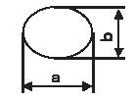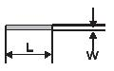

( )/2





|  |  |  |  |  |  |  |  |  |  |  |  |  |  |  |  |  |  |  |  |  |  |  |  |
| --- | --- | --- | --- | --- | --- | --- | --- | --- | --- | --- | --- | --- | --- | --- | --- | --- | --- | --- | --- | --- | --- | --- | --- |
|  |  |  |  |  |  | Spec No. | |  |  |  |  |  |  | Part No. | |  |  |  | Page | | |  |  |
|  |  |  |  |  |  | TQ3C-8EAF0-E2YAQ08-00 | | | | | | |  | TCG101WXLPAANN-AN20 | | | | |  | 2 |  |  |  |
|  |  |  |  |  |  |  |  |  |  |  |
|  |  |  |  |  |  |  |  |  |  |  |  |  |  |  |  |  |  |  |  |  |  |  |  |
|  |  |  |  |  |  |  |  |  |  |  |  |  |  |  |  |  |  |  |  |  |  |  |  |
|  | 2) Standard | | |  |  |  |  |  |  |  |  |  |  |  |  |  |  |  |  |  |  |  |  |
|  | Classification | | | Inspection item | | |  |  |  |  |  |  |  | Judgement standard | | | | | |  |  |  |  |
|  |  |  |  |  |  | |  |  |  | | |  |  |  |  |  |  |  |  |  |  |  |  |
|  | Defect |  | Dot | Bright dot defect | | |  |  | Acceptable number | | | |  |  |  | : 4 |  |  |  |  |  |  |  |
|  | (in LCD |  | defect |  |  |  |  | Bright dot spacing | | | | |  |  |  | : 5 mm or more | | | |  |  |  |  |
|  | glass) |  |  |  |  | |  |  |  | | |  |  |  |  |  |  |  |  |  |  |  |  |
|  |  |  | Black dot defect | | |  |  | Acceptable number | | | |  |  |  | : 5 |  |  |  |  |  |  |  |
|  |  |  |  |  |  |  |  | Black dot spacing | | | | |  |  |  | : 5 mm or more | | | |  |  |  |  |
|  |  |  |  |  |  | |  |  |  | | |  |  |  |  |  |  |  |  |  |  |  |  |
|  |  |  |  | 2 dot join | Bright dot | |  | Acceptable number | | | | |  |  |  | : 2 |  |  |  |  |  |  |  |
|  |  |  |  |  | defect | |  |  |  |  |  |  |  |  |  |  |  |  |  |  |  |  |  |
|  |  |  |  |  | Black dot | |  | Acceptable number | | | | |  |  |  | : 3 |  |  |  |  |  |  |  |
|  |  |  |  |  | defect | |  |  |  |  |  |  |  |  |  |  |  |  |  |  |  |  |  |
|  |  |  |  | 3 or more dots join | | |  |  | Acceptable number | | | |  |  |  | : 0 |  |  |  |  |  |  |  |
|  |  |  |  |  | | |  |  |  | | |  |  |  |  |  |  |  |  |  |  |  |  |
|  |  |  |  | Total dot defects | | |  |  | Acceptable number | | | |  |  |  | : 5 Max | |  |  |  |  |  |  |
|  |  |  |  |  | | |  |  |  |  |  |  |  |  |  |  |  |  |  |  |  |  |  |
|  |  |  | Others | White dot, Dark dot | | |  |  |  |  |  |  |  |  |  |  |  |  |  |  |  |  |  |
|  |  |  |  | (Circle) | | |  |  |  |  | |  | |  |  |  |  |  | |  |  |  |  |
|  |  |  |  |  |  |  | Size (mm) | | | | |  | Acceptable number | | | |  |  |  |  |
|  |  |  |  |  |  |  |  |  |  |  | d | | 0.2 | |  |  |  | (Neglected) | |  |  |  |  |
|  |  |  |  |  |  |  |  |  |  | 0.2 | d | | 0.4 | |  |  |  | 5 |  |  |  |  |  |
|  |  |  |  |  |  |  |  |  |  | 0.4 | d | | 0.5 | |  |  |  | 3 |  |  |  |  |  |
|  |  |  |  |  |  |  |  |  |  | 0.5 | d | |  |  |  |  |  | 0 |  |  |  |  |  |
|  |  |  | |  | | |  |  |  |  |  |  |  |  |  |  |  |  |  |  |  |  |  |
|  | External | inspection | | Polarizer (Scratch) | | |  |  |  |  |  |  |  |  |  |  |  |  |  |  |  |  |  |
|  | (Defect on | |  |  |  |  |  |  |  |  | |  |  |  | | |  |  | | | |  |  |
|  |  |  |  |  |  |  |  | Width (mm) | |  |  | Length (mm) | | |  | Acceptable number | | |  |  |  |
|  | Polarizer or | | |  |  |  |  |  |  | W | 0.1 |  |  |  |  |  |  | 1HJOHFWHG | |  |  |  |  |
|  | between Polarizer | | |  |  |  |  |  | 0.1 | W | 0.3 |  |  |  | L | 5.0 |  | 1HJOHFWHG | |  |  |  |  |
|  | and LCD glass) | | |  |  |  |  |  |  | 5.0 | | L |  |  | 0 |  |  |  |  |  |
|  |  |  |  |  |  |  |  |  |  |  |  |  |  |  |  |  |
|  |  |  |  |  |  | 0.3 | W |  |  |  |  |  |  |  | 0 |  |  |  |  |  |
|  |  |  |  |  |  |  |  |  |  |  |  |  |  |  |  |  |  |  |  |  |
|  |  |  |  |  | | |  |  |  |  |  |  |  |  |  |  |  |  |  |  |  |  |  |
|  |  |  |  | Polarizer (Bubble) | | |  |  |  |  |  |  |  |  |  |  |  |  |  |  |  |  |  |
|  |  |  |  |  |  |  |  |  |  |  | | | |  |  |  | |  | |  |  |  |  |
|  |  |  |  |  |  |  |  |  |  | Size (mm) | | | | |  | Acceptable number | | | |  |  |  |  |
|  |  |  |  |  |  |  |  |  |  |  | d | | 0.2 | |  |  |  | (Neglected) | |  |  |  |  |
|  |  |  |  |  |  |  |  |  |  | 0.2 | d | | 0.3 | |  |  |  | 5 |  |  |  |  |  |
|  |  |  |  |  |  |  |  |  |  | 0.3 | d | | 0.5 | |  |  |  | 3 |  |  |  |  |  |
|  |  |  |  |  |  |  |  |  |  | 0.5 | d | |  |  |  |  |  | 0 |  |  |  |  |  |
|  |  |  |  |  | | |  |  |  |  |  |  |  |  |  |  |  |  |  |  |  |  |  |
|  |  |  |  | Foreign particle | | |  |  |  |  |  |  |  |  |  |  |  |  |  |  |  |  |  |
|  |  |  |  | Circular shape | | |  |  |  |  | | | |  |  |  | |  | |  |  |  |  |
|  |  |  |  |  |  |  | Size (mm) | | | | |  | Acceptable number | | | |  |  |  |  |
|  |  |  |  |  |  |  |  |  |  |  | d | | 0.2 | |  |  |  | (Neglected) | |  |  |  |  |
|  |  |  |  |  |  |  |  |  |  | 0.2 | d | | 0.4 | |  |  |  | 5 |  |  |  |  |  |
|  |  |  |  |  |  |  |  |  |  | 0.4 | d | | 0.5 | |  |  |  | 3 |  |  |  |  |  |
|  |  |  |  |  |  |  |  |  |  | 0.5 | d | |  |  |  |  |  | 0 |  |  |  |  |  |
|  |  |  |  |  | | |  |  |  |  |  |  |  |  |  |  |  |  |  |  |  |  |  |
|  |  |  |  | Foreign particle | | |  |  |  |  |  |  |  |  |  |  |  |  |  |  |  |  |  |
|  |  |  |  | Linear shape | | |  |  |  |  | | |  |  | | | |  | | | |  |  |
|  |  |  |  |  |  |  | Width (mm) | | |  | Length (mm) | | | | Acceptable number | | | |  |  |
|  |  |  |  | Scratch | | |  |  |  | W | 0.03 | |  |  |  |  |  | 1HJOHFWHG | | | |  |  |
|  |  |  |  |  |  |  |  |  | 0.03 | W | 0.1 |  |  |  | L | 2.0 |  | 1HJOHFWHG | | | |  |  |
|  |  |  |  |  |  |  |  |  |  |  | 2.0 | L | 4.0 |  | 3 |  |  |  |  |  |
|  |  |  |  |  |  |  |  |  |  |  |  |  |  | 4.0 | L |  |  | 0 |  |  |  |  |  |
|  |  |  |  |  |  |  |  |  | 0.1 | W |  |  |  |  |  |  |  | (According to | | | |  |  |
|  |  |  |  |  |  |  |  |  |  |  |  |  |  |  |  |  |  | circular shape) | | | |  |  |
|  |  |  |  |  |  |  |  |  |  |  |  |  |  |  |  |  |  |  |  |  |  |  |  |
|  |  |  |  |  |  |  |  |  |  |  |  |  |  |  |  |  |  |  |  |  |  |  |  |



