

**EKI-2541M/MI EKI-2541S/SI**

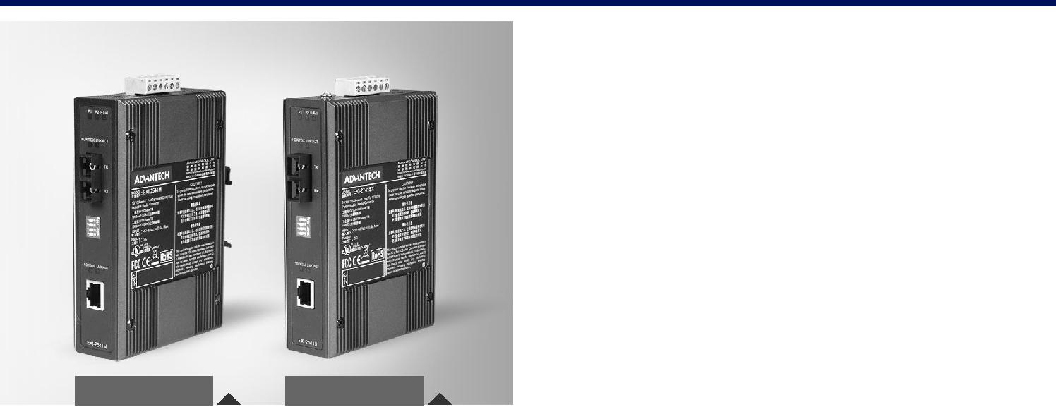

**10/100T (X) to Multi-Mode SC Type Fiber Optic Industrial Media Converter**

**10/100T (X) to Single-Mode SC Type Fiber Optic Industrial Media Converter**

**Features**

**** Provides 1 x 10/100 Mbps Ethernet port with RJ45 connector

**** Provides 1 x 100 Mbps Multi-mode/Single-mode SC type fiber port **** Provides internal jumper for Link Fault Pass-through (LFP) setting **** Supports full/half duplex flow control

**** Supports store and forward transmission

**** Supports Auto-negotiation

**** Supports MDI/MDI-X auto-crossover

**** Supports redundant 12-48 VDCpower input

**** Provides flexible mounting: DIN-rail and Panel mount

**** Supports wide operating temperatures from -40 to 75°C (EKI-2541MI/SI)

**EKI-2541M** **EKI-2541S**



**RoHS**



**COMPLIANT**

2011/65/EU

**Introduction**

The EKI-2541M/2541S is designed to convert Ethernet networks to fiber networks by transparently converting Ethernet signals to optic signals. The advantages of fiber optics are wide bandwidth, EMI immunity and long-distance transmissions.Therefore, the EKI-2541M/2541S is an ideal solution for “fiber to building” applications at central offices or local sites. EKI-2541M/2541S supports MDI/MDIX auto detection, so you don’t need to use crossover wires. Furthermore, the EKI-2541M/2541S can work normally from -10 to 60°C and accepts a wide voltage range from 12 ~ 48 VDC. Besides, it also provides 3,000 VDC surge (EFT) protection against over-voltage, so it is suitable for harsh operating environments.

**Link Fault Pass-Through (LFP)**

The EKI-2541M/2541S is an enhanced Ethernet to fiber-optic converter. Aside from its standard features, the versatile the EKI-2541M/2541S also has the LFP (Link Fault Pass-through) feature. When one side of the link fails, the other side continues transmitting packets, and waiting for a response that never arrives from the disconnected side. Use the internal jumper to enable the LFP function, then the EKI-2541M/2541S will force the link to shut down as soon as noticed that the other link has failed, giving the application software a chance to react to the situation.

**Specifications**

**Communications**

|  |  |  |  |
| --- | --- | --- | --- |
| **** | **Standard** | IEEE 802.3, 802.3u, 802.3x |  |
| **** | **LAN** | 10/100Base-T (X), 100Base-FX |  |
| **** | **Transmission Distance** | Ethernet: Up to 100 m |  |
|  |  | Fiber: Multi-mode: up to 2 km |  |
| **** | **Transmission Speed** | Fiber: Single-mode: up to 30 km |  |
| Up to 100 Mbps |  |
| **** | **Optical Fiber** |  |  |
|  | Multi-mode | Wavelength: 1310 nm |  |
|  | (EKI-2541M/MI) | Tx Power: -14/-20 dBm |  |
|  |  | Rx Sensitivity: -31 dBm |  |
|  |  | Parameters: 50/125 um,62.5/125 um |  |
|  | Single-mode | Wavelength: 1310 nm |  |
|  | (EKI-2541S/SI) | Tx Power: -8/-15 dBm |  |
|  |  | Rx Sensitivity: -34 dBm |  |
|  |  | Parameters: 9/125 um |  |

**Interface**

|  |  |  |  |
| --- | --- | --- | --- |
| **** | **Connectors** | 1 x RJ45 |  |
|  |  | 1 x SC type fiber connector |  |
| **** | **LED Indicators** | 6-pin removable screw terminal (power) |  |
| P1, P2, P-Fail |  |
|  |  | Ethernet: 10/100 m, LNK/ACT |  |
| **** | **DIP Switch** | Fiber: HDX/FDX, LNK/ACT |  |
| Port/Power Alarm, LFP |  |
|  |  | Fiber: HDX/FDX, Converter/Switch |  |

**Power**

** Power Consumption** Max. 2.7 W

** Power Input** 12 ~ 48 VDC, redundant dual inputs



**Mechanism**

|  |  |  |
| --- | --- | --- |
| **** | **Dimensions (W x H x D)** | 37 x 140 x 95 mm (1.46" x 5.51" x 3.74") |
| **** | **Mounting** | DIN-rail, Wall |
| **** | **Enclosure** | IP30, Metal shell with solid mounting |

**Protection**

** Power Reverse** Present

** Overload current** Present

**Environment**

** Operating Temperature** -10 ~ 60°C (14 ~ 140°F)

** Wide Temp. model** -40 ~ 75°C (-40 ~ 167°F)

** Storage Temperature** -40 ~ 85°C (-40 ~ 185°F)

** Operating Humidity** 5 ~ 95% (non-condensing)

** Storage Humidity** 0 ~ 95% (non-condensing)

** MTBF** 577,175 hours

**Certification**

|  |  |  |  |
| --- | --- | --- | --- |
| **** | **Safety** | UL 60950-1, CAN/CSA-C22.2 No.60950 |  |
| **** | **EMI** | FCC Part 15 Subpart B Class A, EN 55022 Class A |  |
| **** | **EMS** | EN 61000-4-2 |  |
|  |  | EN 61000-4-3 |  |
|  |  | EN 61000-4-4 |  |
|  |  | EN 61000-4-5 |  |
|  |  | EN 61000-4-6 |  |
| **** | **Shock** | EN 61000-4-8 |  |
| IEC 60068-2-27 |  |
| **** | **Freefall** | IEC 60068-2-32 |  |
| **** | **Vibration** | IEC 60068-2-6 |  |

**Industrial Ethernet Solutions**

All product specifications are subject to change without notice Last updated : 5-May-2015

**EKI-2541M/MI**

**EKI-2541S/SI**

**Dimensions**

|  |  |  |  |  |  |
| --- | --- | --- | --- | --- | --- |
| 3018. [0.72] |  |  |  | 11. [0.45]40 |  |
|  |  |  |  |
|  | 1515. [0.60] |  |  |
|  |  |
|  |  |
|  |  |  |

Unit: [mm]

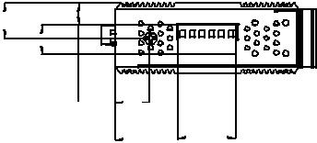

18.00

[0.71]

32.30 30.00

[1.27] [1.18]

36.60 [1.44] [0.37]

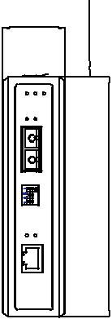

|  |
| --- |
| 509. |

|  |
| --- |
| 00140. [5.52] |

104.00 [4.10]

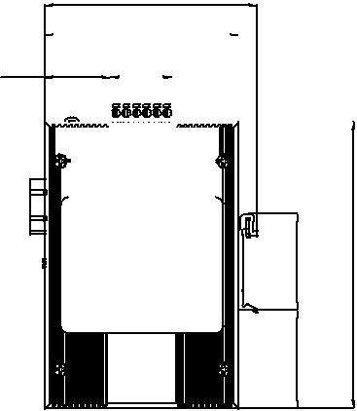

95.06 [3.75]

|  |  |  |  |  |  |  |  |  |  |  |  |  |  |  |  |  |  |  |  |  |  |  |  |  |  |  |  |  |  |  |  |  |  |  |  |
| --- | --- | --- | --- | --- | --- | --- | --- | --- | --- | --- | --- | --- | --- | --- | --- | --- | --- | --- | --- | --- | --- | --- | --- | --- | --- | --- | --- | --- | --- | --- | --- | --- | --- | --- | --- |
|  |  |  |  |  |  |  |  |  |  |  |  |  |  |  |  | 36.60 [1.44] | | | | | | | | |  | 95.00 [3.74] | | | | |  |  |  |  |  |
| 32.30 [1.27] | | | | | | |  | 30.00 [1.18] | | | | | |  |  |  |  |  |  |  |  |
|  |  |  |  |  |  |  |  |  |  |  |  |  |  |  |  |  |  |  |  |  |  |  |
|  |  |  |  |  |  |  |  |  |  |  |  |  |  |  |  |  |  |  |  |  |  |  |  |  |  |  |  |  |  |  |  |  |  |  |  |
|  |  |  |  |  |  |  |  |  |  |  |  |  |  |  |  |  |  |  |  |  |  |  |  |  |  |  |  |  |  |  |  |  |  |  |  |
|  |  |  |  |  |  |  |  |  |  |  |  |  |  |  |  |  |  |  |  |  |  |  |  |  |  |  |  |  |  |  |  |  |  |  |  |
|  |  |  |  |  |  |  |  |  |  |  |  |  |  |  |  |  |  |  |  |  |  |  |  |  |  |  |  |  |  |  |  |  |  |  |  |
|  |  |  |  |  |  |  |  |  |  |  |  |  |  |  |  |  |  |  |  |  |  |  |  |  |  |  |  |  |  |  |  |  |  |  |  |
|  |  |  |  |  |  |  |  |  |  |  |  |  |  |  |  |  |  |  |  |  |  |  |  |  |  |  |  |  |  |  |  |  |  |  |  |

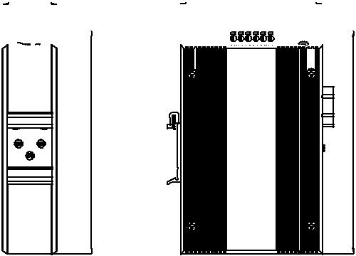

|  |  |  |  |
| --- | --- | --- | --- |
| [1.85] | 140.[5.52]00 | 50149.[5.89] | 149.[5.89]50 |
| 0547. |  |  |  |
| 47.9589][1. |  |  |  |

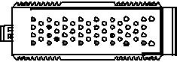

**Panel Cut-out Dimensions: 104 x 140 x 36.6 mm (4.1" x 5.52" x 1.44")**

**Ordering Information**

|  |  |  |
| --- | --- | --- |
| ** EKI-2541M** | | Ethernet to Multi-mode Fiber Converter |
| ** EKI-2541MI** | | Ethernet to Multi-mode Fiber Converter w/ Wide Temp. |
| **** | **EKI-2541S** | Ethernet to Single-mode Fiber Converter |
| **** | **EKI-2541SI** | Ethernet to Single-mode Fiber Converter w/ Wide Temp. |



**Online Download** www.advantech.com/products