

**EKI-2712G-4FPI 8G+4SFP端口千兆非管理型工业PoE交换机**

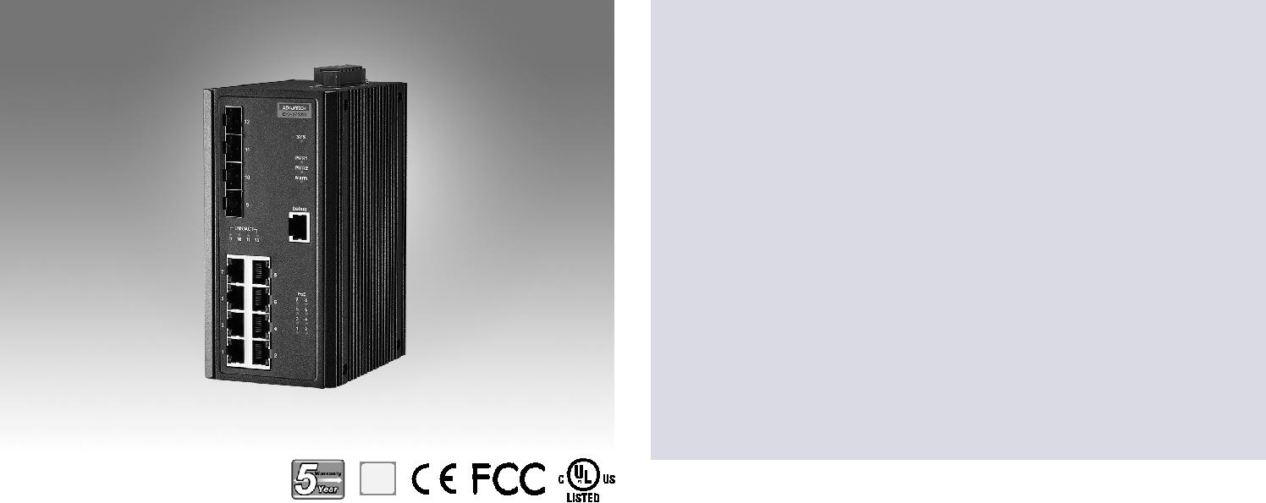

**特性**

****8个IEEE 802.3 AF/AT PoE千兆端口+4个SFP端口

****SFP插座，方便灵活的光纤扩展

****用于交通控制的NEMA TS2

****EN50121-4铁路轨旁部署审批

****-40~75°C宽范围工作温度

****双48 Vdc电源输入和1 x继电器输出

**RoHS**

**COMPLIANT**

2002/95/EC

**介绍**

EKI-2712G-4FPI支持8个千兆IEEE 802.3 AF/AT PoE端口和4个SFP（mini-GBIC）端口。它们可以为每个端口提供高达30瓦的功率，以满足高功耗PD（功率设备）。该开关还具有宽-40°至75°C的工作温度和NEMA TS2额定值，使其成为交通应用的理想解决方案，并成功地通过了EN50121-4欧洲铁路标准对铁路站台和轨旁部署的排放和抗扰度要求。

**规格**

**接口**

** I/O Port** 8 x 10/100/1000BASE-T/TX RJ-45

4 x SFP (mini-GBIC) port

** Debug Port** RS-232 (RJ45)

** Power Connector** 6-pin screw Terminal Block (including relay)

**物理特性**

** 外壳** 金属外壳

** 防护等级** IP 30

** 安装** DIN-Rail

** 尺寸(W x H x D)** 74 x 152 x 105 mm (2.91" x 5.98" x 4.13")

**LED Display**

** System LED** PWR1, PWR2, SYS, and Alarm

** Port LED** Link / Speed / Activity

**认证**

|  |  |  |
| --- | --- | --- |
| **** | **EMI** | CE, FCC Class A |
| **** | **安全** | UL61010 |
| **** | **EMC** | EN 61000-4-2 |
|  |  | EN 61000-4-3 |
|  |  | EN 61000-4-4 |
|  |  | EN 61000-4-5 |
|  |  | EN 61000-4-6 |
|  |  | EN 61000-4-8 |
|  |  | EN50121-4 |
| ** Shock** | | IEC 60068-2-27 |
| ** Freefall** | | IEC 60068-2-32 |
| ** Vibration** | | IEC 60068-2-6 |
| ** Traffic control** | | NEMA TS2 |
| ** Patent** | | http://www.advantech.com/legal/patent |

**环境**

|  |  |  |  |
| --- | --- | --- | --- |
| **** | **工作温度** | -40 | ~ 75°C (-40 ~ 167°F) |
| **** | **储存温度** | -40 | ~ 85°C |
| **** | **环境相对湿度** | 10 ~ 95% (非凝结) | |
| **** | **湿度** | 10 ~ 95% (非凝结) | |

**电源**

|  |  |  |
| --- | --- | --- |
| ** 电力消耗** | 12.1W @ 48VDC (System) | |
| ** 电源输入** | 48 | VDC (46 to 57 VDC), |
|  | 53 | -57 VDC 建议用于802.3at，冗余 |

双电源输入

** 电力预算** 240W

** 故障输出** 1 Relay Output



**Industrial Ethernet Solutions**

All product specifications are subject to change without notice. Last updated: 26-Jun-2018

**EKI-2712G-4FPI**

**结构图**

|  |  |  |
| --- | --- | --- |
| [2.222] |  |  |
| 781][1. |  |
| 4556. | 2545. |  |
|  |  |
| 591][0. |  |
|  | 15 |  |

Unit: mm [inch]

|  |
| --- |
| 1056. [2.209] |

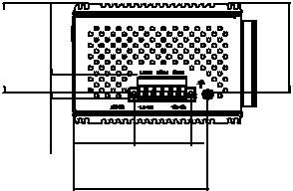

37.72 35.56

[1.485] [1.400]

83.50 [3.287] 

|  |  |  |  |  |  |
| --- | --- | --- | --- | --- | --- |
|  | 114 [4.488] | |  | 74 [2.913] |  |
|  |  | 37 [1.457] |  |
|  | 105 [4.134] | |  |  |
|  |  | 35 |  |
| 74 [2.913] | 35 | 40.64 |  |  |
| [1.385] | [1.600] |  | [1.378] |  |
|  | [0.390] |  |  |  |  |
|  | 9.90 |  |  |  |  |
|  | 152 [5.984] |  | [2.165] 47 [1.850] | 152 [5.984] |  |
|  |  |  | 55 |  |  |
|  |  |  |  | 6-M3xP0.5 |  |

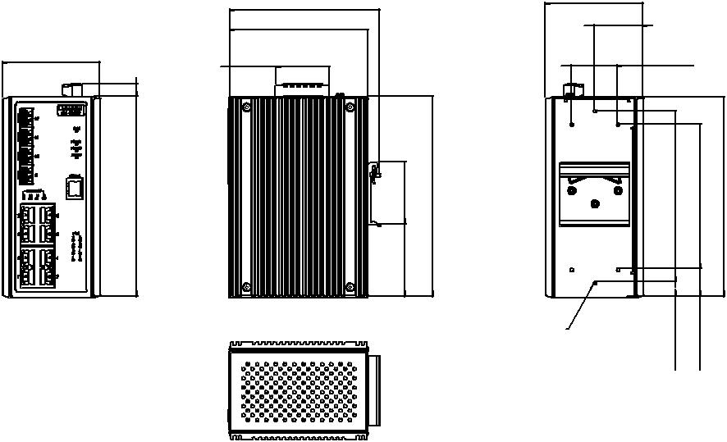

|  |  |  |  |  |
| --- | --- | --- | --- | --- |
| 19.50 |  |  | 105 [4.134] |  |
| [0.768] |  |  |  |
| 130 [5.118] | 110 [4.331] | 152 [5.984] | 152 [5.984] |  |
| 11 [0.433] | 21 [0.827] |  |  |  |

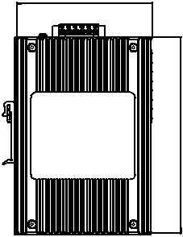

**Panel Cut-out Dimensions: 105 x 152 x 74 (4.134" x 5.98" x 2.913")**

**订购信息**

** EKI-2712G-4FPI-AE** 8GE + 4SFP Port Unmanaged PoE Ethernet Switch

w/Wide Temp

**Online Download** www.advantech.com/products