

**AIMB-217**

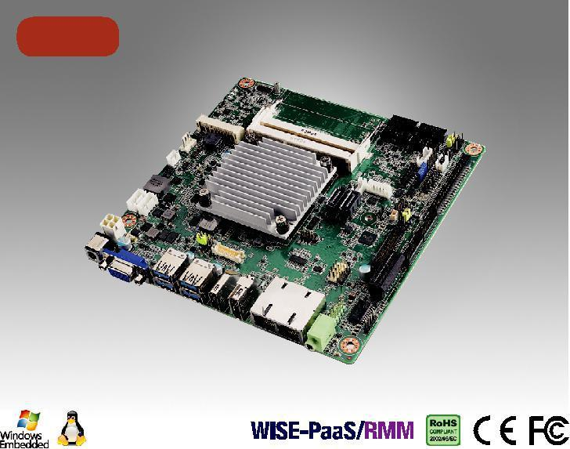

**NEW**

**Intel Pentium , Celeron & Atom x7Mini-ITX，HDMI/DP/VGA, 6 COM,和双网口**



**特性**

·支持 Intel Pentium, Celeron Quad Core & Dual Core 处理器

* 2 x 204-pin SO-DIMM 最高可达 8 GB DDR3L 1866 MHz

SDRAM

·支持 DP 1.2/HDMI 1.4b/VGA

·支持 1 PCIE x1 and 1 M.2 (E key) + 1 MiniPCIe, 6 COMs, 4 USB 3.0 和 4 USB 2.0 ·低成本DC12V电源输入，板载TPM1.2/2.0（选配）

·支持 WISE-PaaS/RMM 和嵌入式软件 APIs

**软件 API:**

H/W 监视器亮度 看门狗 GPIO

**公用设施:**

BIOS 闪存 监控

**规格表**



|  |  |  |  |  |  |  |
| --- | --- | --- | --- | --- | --- | --- |
|  | CPU (14nm) | N4200 | | N3350 | x7-E3950 |  |
| 处理器 | 芯片数 | 4 |  | 2 | 4 |  |
| 最大主频 | 1.1 GHz | | 1.1 GHz | 1.6 GHz |  |
|  |  |
|  | BIOS | AMI 128 Mbit SPI | |  |  |  |
|  | M.2 | E key for wireless module (Type: 2230) | |  |  |  |
| 扩展槽 | Mini-PCIe | 1 | (F/S with SIM card holder) |  |  |  |
|  | PCIe | PCI Express x1 (Gen2), colay M.2 E key | |  |  |  |
|  | 规范 | 双通道 DDR3L 1866 MHz SDRAM 8 | |  |  |  |
| 内存 | 最大可支持容量 | GB/8 GB per SO-DIMM | |  |  |  |
|  | 插槽 | 2 x 204-pin SO-DIMM (Non-ECC) | |  |  |  |
|  | 控制器 | Intel Gen 9 Graphics Engines and media encode/decode engine | | | |  |
|  | VGA/eDP | 1 VGA 最多可支持1920 x 1200 @ 60Hz co-lay eDP. eDP is BOM optional 最高可支持4096 x 2160 @ 60 Hz 1 HDMI | | | |  |
| 显示 | HDMI | 1.4b最多可支持3840 x 2160 @ 30 Hz | |  |  |  |
|  | DP++/LVDS | 1 | DP 1.2 最多可支持 4096 x 2160 @ 60 Hz; co-lay with LVDS 支持双通道 48-bit up to 1920 x 1200 | | |  |
|  | 三显 | VGA (or EDP) + DP (or LVDS) + HDMI | |  |  |  |
|  | 接口 | 10/100/1000 Mbps | |  |  |  |
| 以太网 | 控制器 | GbE LAN1: Realtek 8111G | |  |  |  |
| GbE LAN2: Realtek 8111G | |  |  |  |
|  |  |  |  |  |
|  | 连接器 | RJ-45 x 2 | |  |  |  |
| SATA | 带宽 | 600 MB/s | |  |  |  |
| 通道 | 2, SATA 2 colay mSATA | |  |  |  |
|  |  |  |  |
|  | VGA | 1 |  |  |  |  |
|  | DP 1.2 | 1 |  |  |  |  |
|  | HDMI 1.4b | 1 |  |  |  |  |
| 后置 I/O | 以太网 | 2 |  |  |  |  |
|  | USB | 4 | (USB 3.0) |  |  |  |
|  | Audio | 1 | (supports Line-out by default, converts to Mic in or Line in) | |  |  |
|  | DC jack | 1 | (2.5 mm) |  |  |  |
|  | LVDS & Inverter | 1/1 | |  |  |  |
|  | eDP | 1 | (optional) |  |  |  |
|  | USB | 4 | (USB 2.0) |  |  |  |
|  | Serial | 6 | (5 x RS-232, 1 x RS-232/422/485; COM 3 support RS-232/422/485 auto flow control; COM 6 support 5V/12V by jumper selection) | | |  |
|  | IDE | None | |  |  |  |
| 内置连接器 | SATA | 2 |  |  |  |  |
| SATA PWR连接器 | 2 |  |  |  |  |
|  |  |  |  |  |
|  | Parallel | None | |  |  |  |
|  | Mini-PCIe | 1 | (F/S with SIM card holder), co-lay mSATA |  |  |  |
|  | M.2 | 1 | (E key for wireless module support) |  |  |  |
|  | GPIO | 8-bit | |  |  |  |
|  | PS/2 KB & MS | 1 |  |  |  |  |
| 看门狗计时器 | 输出 | 系统复位 | |  |  |  |
| 间隔 | 可编程的1 ~ 255 sec/min | |  |  |  |
|  |  |  |  |
| 电源 | 电源类型 | 单压12V直流输入; 1 x External DC jack; 1 x Internal 4-pin (2x2) 电源连接器; 支持 AT/ATX 模式 | | | |  |
| 典型功耗 | Windows 空闲模式: 7.546W (Intel N4200 1.1GHz /DDR3L 1866MHz 4GB x 2pcs) | | | |  |
|  |  |
|  |  | 工作状态 | |  | 非工作状态 |  |
| 环境 | 温度 | 0 | ~ 60° C (32 ~ 140° F) with 0.7m/s air flow |  |  |  |
| (for D/N SKU) | |  | -40 ~ 85° C (-40 ~ 185° F) |  |
|  |  |  |
|  |  | -20 ~ 70° C (-4 ~ 158° F) with 0.7m/s air flow (for Z SKU) | | |  |  |
| 物理特性 | 尺寸 | 170 x 170 mm (6.69" x 6.69") | |  |  |  |



**Industrial Motherboards & Systems**

All product specifications are subject to change without notice. Last updated: 17-Oct-2018

**AIMB-217**

**框架图**

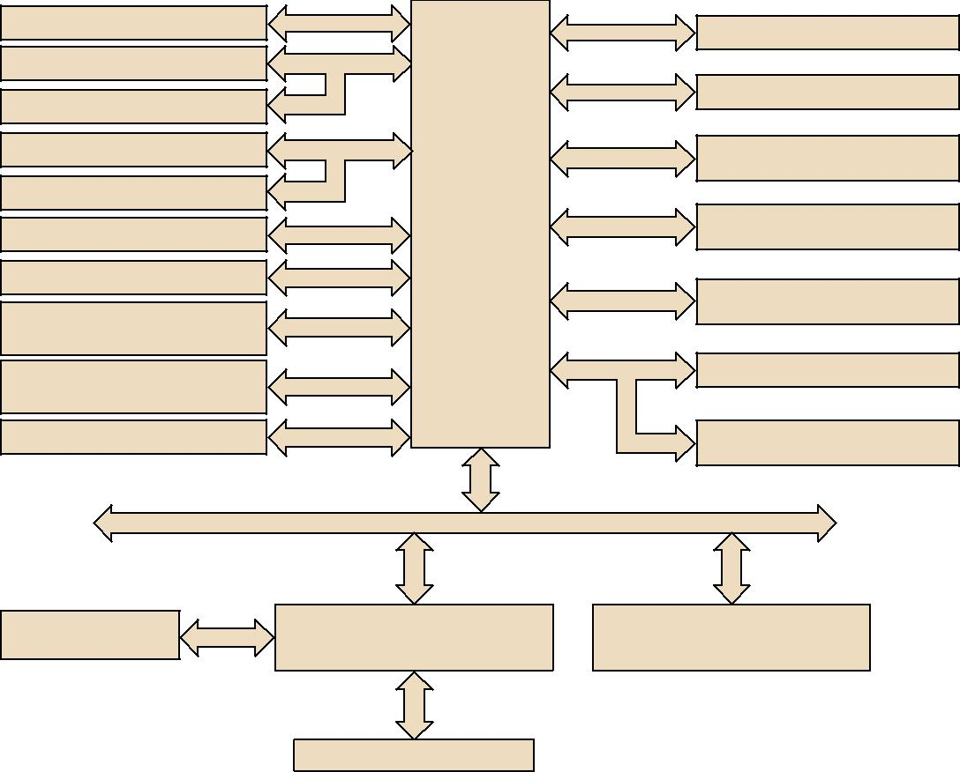

HDMI 1.4b

DP 1.2 (colay LVDS)

LVDS (colay DP)

VGA (colay eDP)

eDP (colay VGA, optional)

2 SATA ports (SATA2 colay mSATA)

4 USB 3.0 port

8 USB 2.0 ports

(USB910 & USB1112 is optional)

Realtek Audio Codec

ALC888S

BIOS

48-bit LVDS

|  |  |  |
| --- | --- | --- |
|  | Intel N4200/ |  |
| 600 MB/s | N3350/x7-E3950 |  |
| processor |  |
|  |  |
| USB 3.0 |  |  |
| USB 2.0 |  |  |

HD Audio

SPI

LPC

Channel A

Channel B

PCIe x1

PCIe x1

SATA

PCIex1/USB)

(PCIex1/USB signal)

PCIe x1

DDR3L 1866 MHz SO-DIMM

DDR3L 1866 MHz SO-DIMM

GbE LAN1:

Realtek RTL8111G

GbE LAN2:

Realtek RTL8111G

Full-size MiniPCIe with

SIM card holder (co-lay mSATA)

M.2 E key (co-lay PCIex1)

PCIe x 1 slot

(colay M.2 E key)

PS/2, WDT,

8-bit GPIO

Super I/O Nuvoton

NCT6106D

5 RS-232, 1 RS-232/422/485

Infineon TPM 1.2/2.0

(optional)

**订购信息**



|  |  |  |  |  |  |  |  |  |  |  |  |  |  |  |  |  |  |
| --- | --- | --- | --- | --- | --- | --- | --- | --- | --- | --- | --- | --- | --- | --- | --- | --- | --- |
| **料号** | **CPU** | **内存** | **VGA/eDP** | **HDMI** | **DP/LVDS** | **GbE** | **COM** | **SATA III** | **USB3.0/2.0** | **MiniPCIe** | **M.2** | **TPM** | **AMP** | **PCIex1** | **Thermal** | **Operating** |  |
| **LAN** | **Solution** | **Temp.** |  |
| AIMB-217D-S6A1E | N4200 | 2 | 1 / (1) | 1 | 1 | 2 | 6 | 2 | 4/4 | 1 (F/S) | 1 | (1) | (2 x 6W) | 1 | Passive | 0 ~ 60° C |  |
| AIMB-217N-S6A1E | N3350 | 2 | 1 / (1) | 1 | 1 | 2 | 6 | 2 | 4/4 | 1 (F/S) | 1 | (1) | (2 x 6W) | 1 | Passive | 0 ~ 60° C |  |
| AIMB-217Z-S6A1E | x7-E3950 | 2 | 1 / (1) | 1 | 1 | 2 | 6 | 2 | 4/4 | 1 (F/S) | 1 | (1) | (2 x 6W) | 1 | Passive | -20 ~ 70° C |  |
| Note: Passive = fanless | |  |  |  |  |  |  |  |  |  |  |  |  |  |  |  |  |
| * () BOM options available on MP version | | |  |  |  |  |  |  |  |  |  |  |  |  |  |  |  |

|  |  |  |  |  |  |  |  |
| --- | --- | --- | --- | --- | --- | --- | --- |
| **包装列表** |  |  | **可选附件** | |  |  |  |
|  |  |  |  |  |  |  |  |
| **料号** | **说明** | **数量** |  | **料号** | **说明** |  |  |
| 1700003194 | SATA HDD cable | 1 |  | 96PSA-A60W12V1-1 Adapter AC100-240V 60W +12V/5A | | |  |
| 1700018785 | SATA power cable | 1 |  | 96PSA-A84W12V1 | Adaptor AC100-240V 84W, 12V/7A | |  |
| 1700008876 | 1-to-4 serial ports cable kit, 35 cm | 1 | 1703060191 | | KBMS cable 1*6P-2.5/DIN-6P(F)*2, 25 cm | |  |
| 1700100250 | 1-to-1 serial port cable, 25 cm | 2 | 1700023082-11 | | ATX 2*10P to 1*3P-2.0 15cm cable | |  |
| 1960079933T000 | I/O port bracket | 1 | 1700024790-01 | | A Cable USB-A 4P(F)*2/2*5P-2.0 20CM F/10 | |  |
| 2006B21701 | Startup manual | 1 | 1700023474-01 | | A Cable USB-A 4P(F)*2/2*5P-2.0 34.5CM F/10 | |  |
| 1960064228N001 | Fanless heatsink for AIMB-217D/N | 1 | **可选底盘** | |  |  |  |
| 1960071473T011 | Fanless heatsink for AIMB-217Z | 1 |  |  |  |
| **I/O视图** |  |  |  | **料号** | **说明** |  |  |
|  |  |  | AIMB-B2000-00YE | Mini-ITX chassis with optional DC Adaptor | |  |
|  |  |  | **嵌入式OS/API** | | |  |  |
|  |  |  |  |  |  |  |  |
|  |  |  |  | **OS/API** | **料号** | **说明** |  |
|  |  |  |  | Win 10 IoT | 2070014970 | img W10 16EL AIMB-217 64bit 1701 Eng |  |

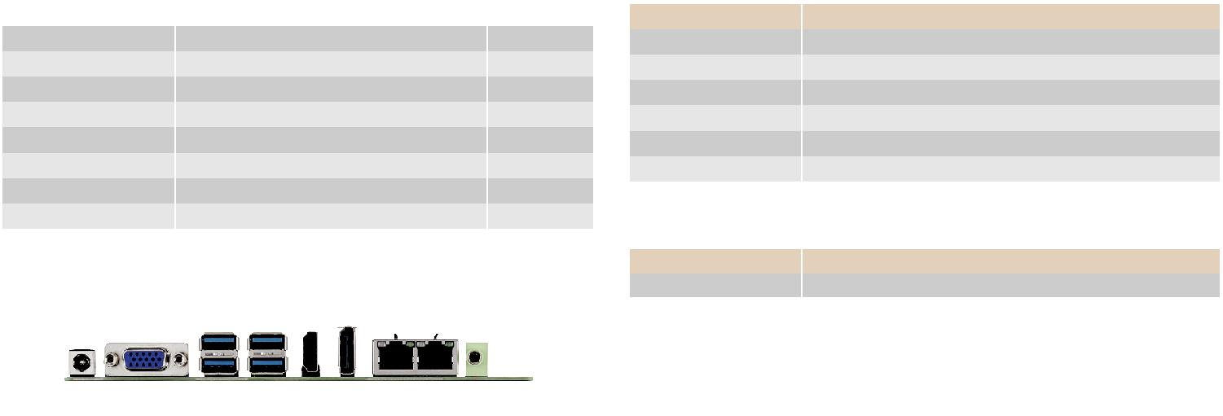

**Online Download** www.advantech.com/products