

|  |  |  |  |  |  |  |  |  |  |  |  |  |  |  |  |  |  |  |  |  |  |  |  |  |  |  |  |  |  |  |
| --- | --- | --- | --- | --- | --- | --- | --- | --- | --- | --- | --- | --- | --- | --- | --- | --- | --- | --- | --- | --- | --- | --- | --- | --- | --- | --- | --- | --- | --- | --- |
| **PCA-6028** | | | | | | | | | | | | | | | | | | | | | | | | | | | | | **SBC 带VGA/DVI/双GbE LAN** |  |
|  |  |  |  |  |  |  |  |  |  |  |  |  |  |  |  |  |  |  |  |  |  |  |  |  |  |  |  |  | **LGA1150 Intel® Core™ i7/i5/i3/Pentium** |  |
|  |  |  |  |  |  |  |  |  |  |  |  |  |  |  |  |  |  |  |  |  |  |  |  |  |  |  |  |  |  |  |
|  |  |  |  |  |  |  |  |  |  |  |  |  |  |  |  |  |  |  |  |  |  |  |  |  |  |  |  |  |  |  |
|  |  |  |  |  |  |  |  |  |  |  |  |  |  |  |  |  |  |  |  |  |  |  |  |  |  |  |  |  | **特性** |  |
|  |  |  |  |  |  |  |  |  |  |  |  |  |  |  |  | COM1 | | | | | | | | | | | | | ****支持H81 Intel®Core™ i7/i5/i3/Pentium LGA1150处理器 |  |
| DIMMB1 | | |  |  |  | SATA1~3 USB1,2 | | | | | | | | | |  | COM2 | | | | | | | | | | | |  |
|  |  |  | DIMMA1 | | |  |  | USB9~10 | | | |  |  | LPT1 | |  |  |  | USB3~6 | | | | | | | | | | ****双通道(Non-ECC) DDR3 1333/1600，最高可达16 GB |  |
|  |  |  |  |  |  |  |  |  |  |  |  |  |  |  |  |  |  |  |  |  |  |  |  |  |  |  |  | USB8 |  |
|  |  |  |  |  |  |  |  |  |  |  |  |  |  |  |  |  |  |  |  |  |  |  |  |  |  |  |  | ****支持USB 3.0, SATA3.0 |  |
|  |  |  |  |  |  |  |  |  |  |  |  |  |  |  |  |  |  |  |  |  |  |  |  |  |  |  |  | USB7 | ****VGA和DVI-D双显(可选) |  |
|  |  |  |  |  |  |  |  |  |  |  |  |  |  |  |  |  |  |  |  |  |  |  |  |  |  |  |  |
|  |  |  |  |  |  |  |  |  |  |  |  |  |  |  |  |  |  |  |  |  |  |  |  |  |  |  |  | LAN1 | ****支持Advantech LPC模块 |  |
|  |  |  |  |  |  |  |  |  |  |  |  |  |  |  |  |  |  |  |  |  |  |  |  |  |  |  |  |
|  |  |  |  |  |  |  |  |  |  |  |  |  |  |  |  |  |  |  |  |  |  |  |  |  |  |  |  | LAN2 |  |
|  |  |  |  |  |  |  |  |  |  |  |  |  |  |  |  |  |  |  |  |  |  |  |  |  |  |  |  | VGA | ****支持SUSIAccess和 嵌入式软件APIs |  |
|  |  |  |  |  |  |  |  |  |  |  |  |  |  |  |  |  |  |  |  |  |  |  |  |  |  |  |  |  |
|  |  |  |  |  |  |  |  |  |  |  |  |  |  |  |  |  |  |  |  |  |  |  |  |  |  |  |  | KBMS |  |  |
|  |  |  |  |  |  |  |  |  |  |  |  |  |  |  |  |  |  |  |  |  |  |  |  |  |  |  |  |  |  |
|  |  |  |  |  |  |  |  |  | | | |  |  |  | |  |  | |  | | | | |  |  | | | |  |  |
|  | CPU | |  | DVI | |  | PCH | | | | | mSATA | | | |  | LPC | | | | | | | | | | | |  |  |
|  |  |  |  |  |  |  |  |  |  |  |  |  |  |  |  |  |  |  |  |  |  |  |  |  |  |  |  |  |  |  |
|  |  |  |  |  |  |  |  |  |  |  |  |  |  |  |  |  |  |  |  |  |  |  |  |  |  |  |  |  |  |  |

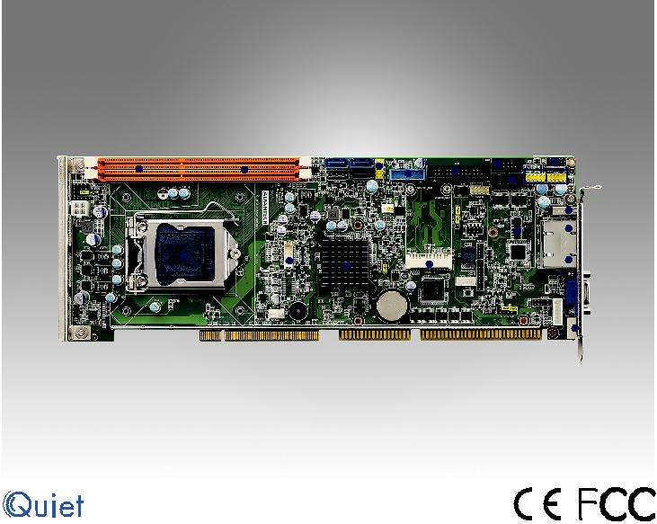

**规格**

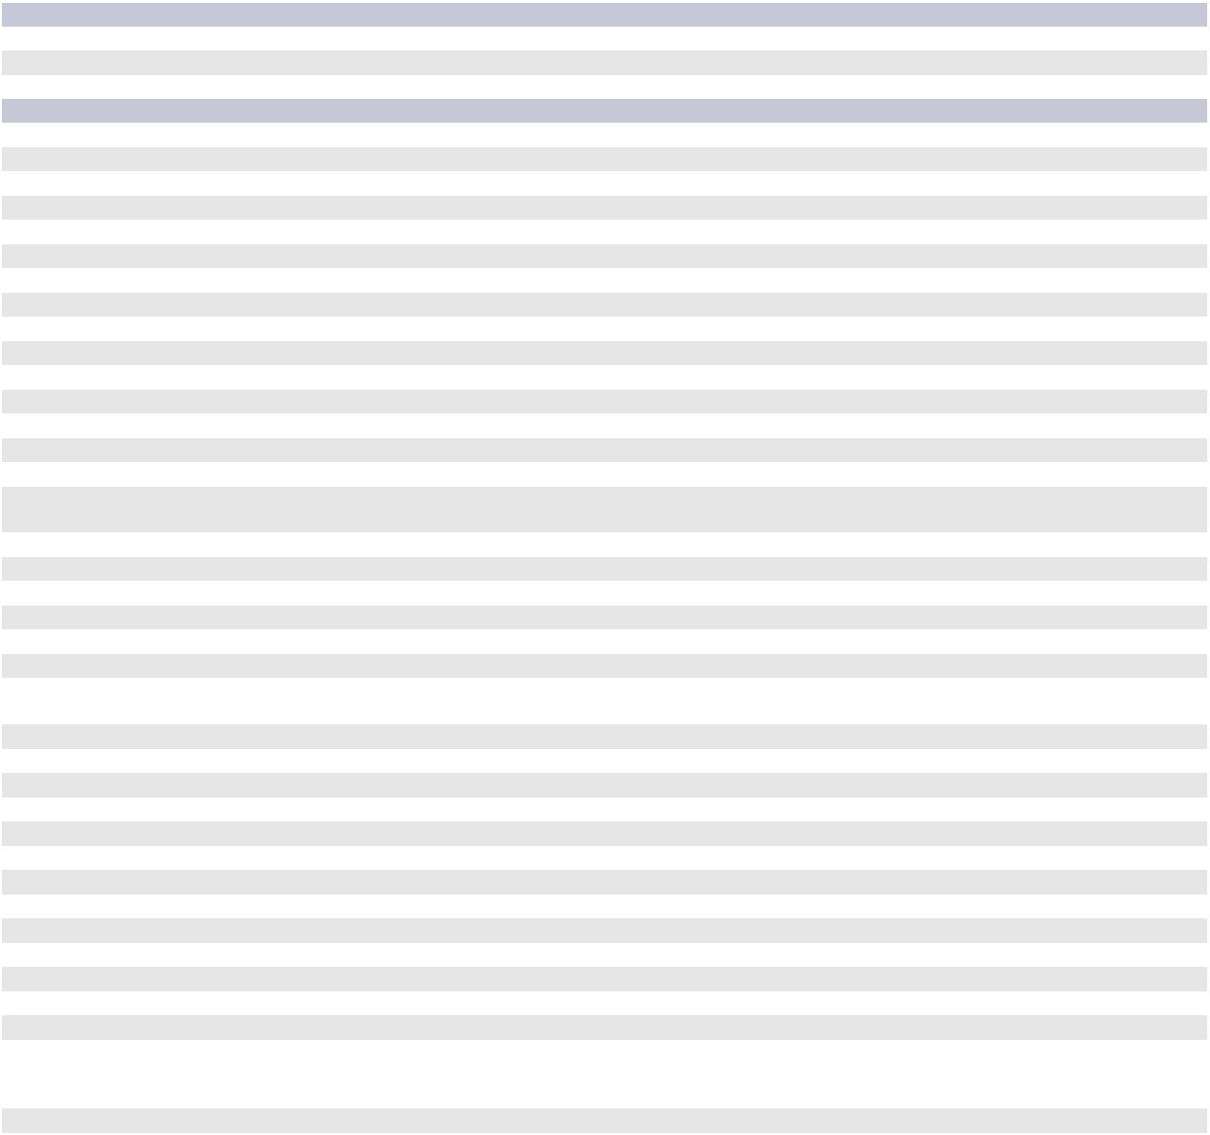

|  |  |  |  |  |  |  |  |  |  |  |
| --- | --- | --- | --- | --- | --- | --- | --- | --- | --- | --- |
|  | **BIOS 2.xx支持四代CPU** |  |  |  |  |  |  |  |  |  |
|  | CPU | i7-4790Si5-4590S | | i5-4590T | i3-4360 | i3-4350T | i3-4340TE |  |  |  |
|  | Base Frequency | 3.2GHz | 3.0GHz | 2.0GHZ | 3.7GHz | 3.1GHz | 2.6GHz |  |  |  |
|  | L3 Cache | 8MB | 6MB | 6MB | 4MB | 4MB | 4MB |  |  |  |
| 处理器系统 | **四代CPU受BIOS v1.xx和v2.xx的支持** | | |  |  |  |  |  |  |  |
| CPU | i7-4770Si7-4770TE | | i5-4570S | i5-4570TE | i3-4330 | i3-4330TE | G3420 | G3320TE |  |
|  |  |
|  | Base Frequency | 3.1GHz | 2.3GHz | 2.9GHz | 2.7GHz | 3.5GHz | 2.4GHz | 3.2GHz | 2.3GHz |  |
|  | L3 Cache SKU/ | 8MB | 8M | 6MB | 4MB | 4MB | 3MB | 3MB | 3MB |  |
|  | 芯片组 | Intel H81 |  |  |  |  |  |  |  |  |
|  | BIOS | AMI 128Mbit SPI Flash | |  |  |  |  |  |  |  |
| 系统总线 | ISA | HISA (ISA High Driver) | |  |  |  |  |  |  |  |
| PCI | 32 bit/ 33 MHz PCI | |  |  |  |  |  |  |  |
|  |  |  |  |  |  |  |  |
|  | 规范 | 双通道(Non-ECC) DDR3 1333/1600 16 | | |  |  |  |  |  |  |
| 内存 | 最大可支持容量 | GB (8 GB per DIMM) | |  |  |  |  |  |  |  |
|  | 插槽 | DDR3 240-pin DIMM x 2 | |  |  |  |  |  |  |  |
|  | 控制器 | 集成英特尔高清图形芯片组 | | |  |  |  |  |  |  |
| 显示芯片 | VRAM | 共享系统内存受制于操作系统 | | |  |  |  |  |  |  |
| CRT | 支持分辨率高达2048 x 1536像素（60Hz）支持分辨 | | | |  |  |  |  |  |
|  |  |  |  |  |  |
|  | DVI-D | 率高达1920 x 1200像素（60Hz）（仅限G2） | | | |  |  |  |  |  |
|  | 接口 | 10/100/1000 Mbps | |  |  |  |  |  |  |  |
| 以太网 | 控制芯片 | LAN 1: Intel I217V | |  |  |  |  |  |  |  |
| LAN 2: Intel I211 (Only in G2 Sku) | | |  |  |  |  |  |  |
|  |  |  |  |  |  |  |  |
|  | 带LED连接器 | RJ45 x 1 (VG sku); RJ45 x 2(G2 sku) | | |  |  |  |  |  |  |
| SATA | 通道 | SATA 3.0 x 2 (600 MB/sec), SATA2.0 x 1 (300MB/sec), mSATA x1 (300 MB/sec) | | | | |  |  |  |  |
|  | USB 2.0 | 1 (Only in G2 sku) | |  |  |  |  |  |  |  |
| 后置I/O | 以太网 | 1 (VG sku); 2 (G2 sku) | |  |  |  |  |  |  |  |
| VGA | 1 |  |  |  |  |  |  |  |  |
|  |  |  |  |  |  |  |  |  |
|  | PS/2 | 1 (PS/2Y电缆支持1个键盘和1个鼠标) | | |  |  |  |  |  |  |
|  | USB | Up to 8x USB2.0 (6x Pin header, 1x Type A, 1x Rear in G2 sku only) | | | | |  |  |  |  |
|  | 2x USB3.0 (Pin header) | |  |  |  |  |  |  |  |
|  |  |  |  |  |  |  |  |  |
|  | SATA | 4(1x SATA2.0, 2x SATA3.0, 1x mSATA) | | |  |  |  |  |  |  |
| 内置连接器 | DVI-D | 1 (Pin header) |  |  |  |  |  |  |  |  |
| COM | 2 |  |  |  |  |  |  |  |  |
|  |  |  |  |  |  |  |  |  |
|  | 并口 | 1 |  |  |  |  |  |  |  |  |
|  | IrDA | 1 |  |  |  |  |  |  |  |  |
|  | GPIO | 8-bit |  |  |  |  |  |  |  |  |
| 看门狗计时器 | 输出 | 系统复位 |  |  |  |  |  |  |  |  |
| 间隔 | 可编程1-255 sec | |  |  |  |  |  |  |  |
|  |  |  |  |  |  |  |  |
| 其他功能 | 音频输出 | Intel高清音频接口（需要音频扩展模块P/N:PCA-AUDIO-HDA1E） | | | | |  |  |  |  |
|  | 测试环境 | Core i7-4790S@3.20GHz; 8GB DDR3 1600 2Rx8*2; SATA HDD*1 | | | | |  |  |  |  |
| 电源需求 | 电压 | +12V | +5V | +3.3V | +5Vsb | -12V | -5V |  |  |  |
|  | 电流 | 4.94A | 1.83A | 0A | 0.01A | 0A | 0A |  |  |  |
|  |  | 工作状态 |  |  |  | 非工作状态 |  |  |  |  |
| 环境 | 温度/湿度 | 0 ~ 60 °C (32~140 °F); 取决于CPU频率和冷却器 | | | | -40 ~ 85 °C and 60 °C @ 95% RH Non-Condensing | | | |  |
| 解决方案 |  |  |  |  |
|  |  |  |  |  |
|  |  | 工作湿度: 40 °C @ 85% RH 非凝结 | | |  |  |  |  |  |  |
| 外观 | 尺寸(L x H) | 338 x 122 mm (13.3" x 4.8") | |  |  |  |  |  |  |  |



**Slot SBC & Passive Backplanes**

All product specifications are subject to change without notice. Last updated: 27-Jun-2018

**PCA-6028**

**系统图**

DVI (G2 only)

VGA

1 x m-SATA

1 x SATA II Ports

2 x SATA III Ports

2 x USB 3.0 by Pin Header

6 x USB 2.0 by Pin Header

1 x USB 2.0 Type A

1 x USB 2.0 rear Type A

|  |  |  |  |
| --- | --- | --- | --- |
|  | Intel LGA1150 | Channel A |  |
| Display port |  |  |
| Haswell CPU |  |  |
|  |  |  |
|  |  | Channel B |  |
|  |  |  |  |
|  | FDI x2 |  |  |
|  |  |  |  |
| 600 MHz |  | PCIe x1 |  |
| 300 MB/s |  |  |  |
| 300 MB/s |  | PCIe x1 |  |
|  |  |  |
| 600 MB/s |  | PCIeBus |  |
|  |  |  |
| USB 3.0 |  |  |  |
|  | H81 |  |  |
| USB 2.0 | PCH |  |  |
| USB 2.0 |  |  |  |
| USB 2.0 |  |  |  |

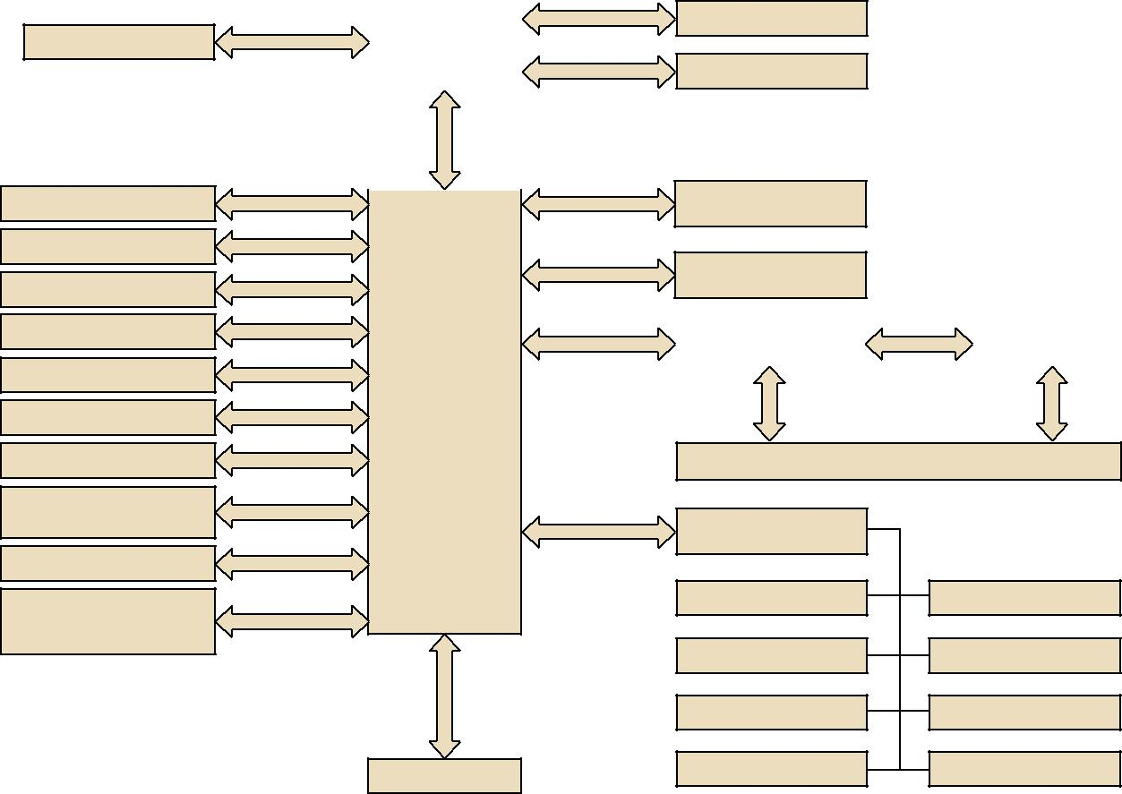

DDR3 1600/1333

DDR3 1600/1333

G-LAN1

Intel I217V

G-LAN2

Intel I211 (G2 only)

|  |  |  |
| --- | --- | --- |
| PCIe to PCI Bridge |  | PCI to ISA Bridge |
| ITE8892 |  | ITE8888 |
|  |  |  |

Backplane (PICMG 1.0)

(G2 only)

HD Audio (Optional)

2 x PCIe x1

Expansion connector

(G2 only)

LPC Bus

HD Audio

2 x PCIe x1

|  |
| --- |
| SPI |

128 Mbit SPI ROM

Super I/O

NCT 6776D

RS-232 x 2

PS/2 KB/MS

H/W Monitor

WatchDog Timer

Case Open

Parallel Port

Infrared Radiation

8 Bits GPIO

**订购信息**

|  |  |  |  |  |  |  |  |
| --- | --- | --- | --- | --- | --- | --- | --- |
| **型号** | **LAN** | **VGA** | **DVI-D** | **COM** | **SATA** | **USB** | **m-SATA** |
| PCA-6028VG-00A1E | 1 | Yes | - | 2 | 3 (1 x 2.0 + 2 x 3.0) | 9 (2 x 3.0 + 7 x 2.0) | 1 |
| PCA-6028G2-00A1E | 2 | Yes | 1* | 2 | 3 (1 x 2.0 + 2 x 3.0) | 10 (2 x 3.0 + 8 x 2.0) | 1 |

ote: Output DVI-D signal only (Required DVI-D cable: 1700021831-01)

|  |  |  |  |  |
| --- | --- | --- | --- | --- |
| **包装列表** |  |  | **配件包** |  |
|  |  |  |  |  |
| **型号** | **说明** | **数量** | **型号** | **说明** |
| 1700003194 | 串行ATA HDD数据电缆 | x2 | 1701090401 | 单COM电缆 |
| 1700022749-11 | 串行ATA HDD电源线 | x1 | 1701092300 | 双COM电缆 |
| 1701260305 | COM+打印机端口电缆套件 | x1 | 1700020277-01 | 带BKT（30cm）的2端口USB 3.0电缆 |
| 1700060202 | 键盘和鼠标Y形电缆 | x1 | 1700021831-01 | DP至DVI-D电缆，带BKT（仅数字信号） |
| 1700008461-11 | 4端口USB电缆套件 | x1 | 1960047831N001 | PCA-6028优化CPU冷却器（2U） |
| 9689000068 | 跳线包 | x1 | PCA-AUDIO-HDA1E | 7.1声道高清音频扩展模块 |
| 2190000902 | 保修卡 | x1 | PCA-COM232-00A1E | 4 x RS-232模块 |
| - | 启动手册 | x1 | PCA-COM485-00A1E | 4 x RS-422/485模块 |
| - | 实用CD | x1 | PCA-TPM-00A1E | 可信平台模块符合TCG 1.2 |

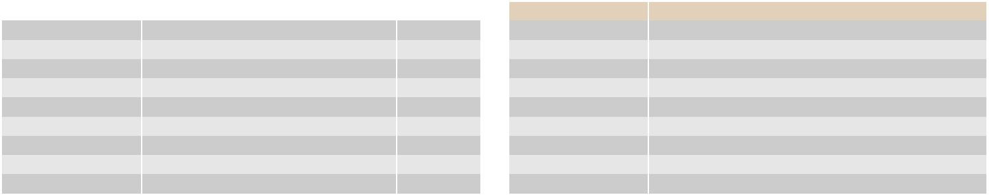

**I/O 视图**



PCA-6028G2-00A1E PCA-6028VG-00A1E

**Online Download** www.advantech.com/products