

*单板计算机*

*工业主板*



*w w w . i e i w o r l d . c o m . c n*

IMB-Q870-i2

microATX主板支持22nm LGA1150英特尔®酷睿™i7 / i5 / i3，奔腾®和

赛扬®CPU，每个英特尔®Q87，DDR3，HDMI，DVI-D，VGA，iDP，USB 3.1 Gen 1 (5Gb/s) SATA 6Gb / s，六个串行端口，iRIS-2400

|  |  |  |  |  |  |
| --- | --- | --- | --- | --- | --- |
| 双通道 DDR3 |  | TPM | 4 x RS-232 | 4 x SATA 6Gb/s |  |
| 1600/1333 MHz | RS-422/485 | DIO | 2 x USB 3.0 | |  |
|  |  |

iRIS-2400 模块插槽

Intel ®

Q87

4 x USB 2.0

前面板

|  |  |  |
| --- | --- | --- |
| iDP | PCI |  |
|  |  |

|  |  |  |  |  |  |  |
| --- | --- | --- | --- | --- | --- | --- |
|  |  |  |  |  |  |  |
| *产品规格* | PCIe x16 | |  | PCIe x4 | |  |
|  |  |
|  | PCIe x1 | | | |  |

CPU

支持 LGA1150 4th generation Intel® Core ™ i7/i5/i3, Pentium® or Celeron® 处理器

 芯片组

Intel® Q87

 内存

四个 240-pin 1600/1333 MHz 双通道 DDR3 & DDR3L SDRAM 无缓冲 DIMMs 最高支持 32

GB

BIOS

UEFI BIOS

 网络

LAN1: 支持 Intel® I217LM with Intel® AMT 9.0

LAN2: 支持 Intel® I210-AT PCIe 控制器以及 NCSI  图形引擎

Intel® HD Graphics Gen 7.5 支持 DX11.1 以及 OpenCL 1.2, OpenGL 3.2 Full MPEG2, VC1, AVC 解码

 显示输出

独立三显

1 x VGA ( 最高达 1920x1200@60Hz)

1 x DVI-D ( 最高达 2560x1600@60Hz)

1 x HDMI ( 最高达 2560x1600@60Hz)

1 x iDP interface for HDMI, LVDS, VGA, DVI, DP （最高达 3840x2160@60Hz)

 音频

Realtek ALC662 HD 音频编解码器支持 5.1-channel

3 x 音频插孔 ( 音频输出 , 音频输入 , 麦克风输入 ) on rear IO

|  |  |  |
| --- | --- | --- |
| 1 x 前置音频 (2x5 pin) |  |  |
| 外部 I/O 接口 |  |  |
| 1 x KB/MS | 2xUSB3.1 |  |
| 1 x RS-232 | 4 x USB 2.0 |  |
| 内部 I/O 接口 | 4 x SATA 6Gb/s (RAID 0/1/5/10 supported) |  |
| 1 x KB/MS (1x6 pin) |  |
| 1 x RS-422/485 (1x4 pin, P=2.0) | 4 x RS-232 (2x5 pin, P=2.54) |  |
| 2 x USB 3.0 (2x10 pin) | 4 x USB 2.0 (2x4 pin, P=2.54) |  |



前面板



1 x 前面板 (2x7 pin, 电源 LED, HDD LED, 扬声器 , 电源按钮 , 重启按钮 )

LAN LED

2 x LAN LED (1x2 pin)

TPM: 1 x TPM (2x10 pin)

SMBus: 1 x SMBus (1x4 pin)

I²C: 1 x I²C (1x4 pin)

iRIS 远程管理模块 : 1 x iRIS-2400 插槽

 扩展

1 x PCIe x16 插槽 (Gen 3) 1 x PCIe x4 插槽

1 x PCIe x1 插槽 1 x PCI 插槽

看门狗定时器



软件可编程并支持 1~255 秒系统复位

 数字 I/O: 8-bit 数字 I/O (2x5 pin)

风扇接口



1 x CPU 智能风扇 (1x4 pin)

2 x 系统智能风扇 (1x3 pin)

 电源 : ATX 电源

功耗



3.3V@0.53A, 5V@4.96A, 12V@0.12A, Vcore_12V@3.95A, 5VSB@0.18A

(Intel® Core ™ i7-4770K 3.90 GHz CPU 以及 16 GB (4x4 GB) 1333 MHz DDR3 内存 )  工作温度 : -20°C ~ 60°C

 存储温度 : -30°C ~ 70°C

 工作湿度 : 5% ~ 95%, 无冷凝

 尺寸 : 244mm x 244mm

 重量 : GW: 1200g / NW: 700g

CE/FCC 标准

新的更加强大的图形

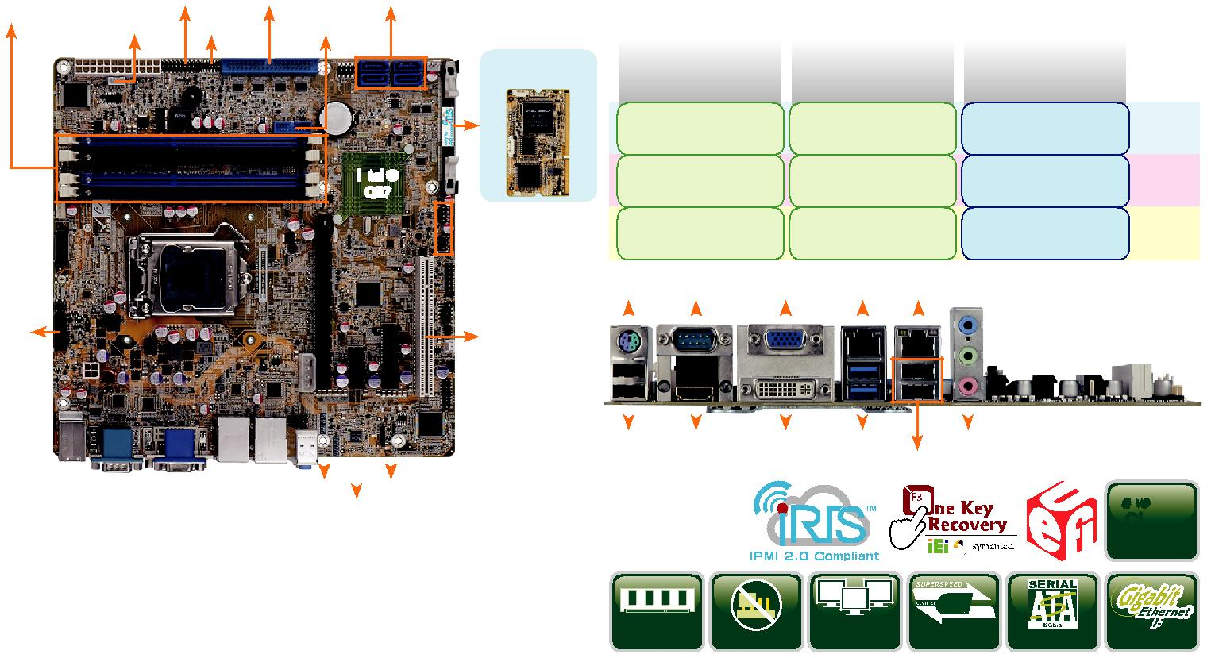

|  |  |  |  |  |  |  |  |  |  |  |  |  |  |
| --- | --- | --- | --- | --- | --- | --- | --- | --- | --- | --- | --- | --- | --- |
|  |  | 第二代 | |  |  |  | 第三代 | | | | 第四代 |  |  |
|  | Intel® Core™ 处理器 | | |  |  | Intel® Core™ 处理器 | | | | | Intel® Core™ 处理器 |  |  |
|  |  | (Sandy Bridge) | |  |  | (Ivy Bridge) | | | | | (Haswell) |  |  |
|  |  | Intel® HD 图形 | |  |  | Intel® HD 图形 | | | | | GT3- | Core i7 |  |
|  |  |  |  | Intel® HD 图形 |  |
|  |  | 3000 系列 | |  |  |  | 4000 系列 | | | |  |
|  |  |  |  |  | 5000 系列 |  |  |
|  |  |  |  |  |  |  |  |  |  |  |  |  |
|  | IIntel® HD 图形2000 系 | | | | | Intel® HD 图形 | | | | | GT2- | Core i5/ |  |
|  | Intel® HD 图形 |  |
|  |  | 列 | |  |  |  | 2500 系列 | | | | Core i3 |  |
|  |  |  |  |  | 4000 系列 |  |
|  |  |  |  |  |  |  |  |  |  |  |  |  |
|  | Intel® HD 图形系列 | | |  |  | Intel® HD 图形系列 | | | | | GT1- | Celeron/ |  |
|  |  |  | Intel® HD 图形系列 | Pentium |  |
|  |  |  |  |  |  |  |  |  |  |  |  |
| KB/MS RS-232 | | | | VGA | |  | LAN1 Combo RJ-45: LAN2 / IPMI | | | | |  |  |
|  |  |  |  |  |  |  |  |  |  |  |  |  |  |
|  |  |  |  |  |  |  |  |  |  |  |  |  |  |
|  |  |  |  |  |  |  |  |  |  |  |  |  |  |
|  |  |  |  |  |  |  |  |  |  |  |  |  |  |
|  |  |  |  |  |  |  |  |  |  |  |  |  |  |

|  |  |  |  |  |  |  |
| --- | --- | --- | --- | --- | --- | --- |
| 2 x USB 2.0 HDMI | DVI-D | 2 x USB 3.1 | 音频 |  |  |  |
|  |  | 2 x USB 2.0 | |  |  |  |
|  |  |  |  | *Native* | *3* |  |
|  |  |  |  | PCIe |  |
|  |  |  |  | Gen. |  |
|  |  | Triple | USB |  |  |  |
| DDR3 1600 | Jumper-less | USB 3.1 | SATA 6Gb/s PCIe GbE | |  |
| Display |  |

*产品特征*

* 支持 LGA1150 第四代 Intel® Core™ i7/i5/i3, Pentium® 或 Celeron® 处理器
* 支持双通道 DDR3 1600/1333 MHz
* 支持 Intel® PCIe GbE 以及 Intel® AMT 9.0
* 支持独立三显 HDMI, DVI, VGA 以及 iDP
* 支持 PCI Express generation 3.0 at 8GT/s I/O 带宽
* 支持 USB 3.1 以及 SATA 6Gb/s
* IEI 免跳线功能
* IEI 一键恢复解决方案可快速创建 OS 备份和恢复
* 支持 IPMI 2.0 via iRIS-2400 模块

*包装清单*

|  |  |
| --- | --- |
| 1 x IMB-Q870-i2 single board computer | 2 x SATA cable |
| 1 x I/O shielding | 1 x QIG |

*订购信息*



|  |  |  |
| --- | --- | --- |
| 料号 | 描述 |  |
|  |  |  |
|  | microATX motherboard supports 22nm LGA1150 Intel® Core™ i7/ |  |
| IMB-Q870-i2-R10 | i5/i3/Pentium® and Celeron® CPU per Intel® Q87, DDR3, HDMI, |  |
| DVI-D, VGA, DP, dual Intel® PCIe GbE, USB 3.0, audio, SATA |  |
|  |  |
|  | 6Gb/s, six serial ports, iRIS-2400 and RoHS |  |
| iRIS-2400-R10 | IPMI 2.0 adapter card with AST2400 BMC chip for DDR3 SO- |  |
| DIMM socket interface |  |
|  |  |
| 19800-000049-RS | LPT flat cable, 240mm, P=2.54 |  |
| 19800-000075-RS | PS/2 KB/MS cable with bracket, 220mm, P=2.0 |  |
| 19800-003100-300-RS | Dual port USB cable with bracket, 300mm, P=2.54 |  |
| 19800-010500-200-RS | USB 3.0 cable with bracket, 450mm |  |
| 32102-000100-200-RS | SATA power cable, MOLEX 5264-4P to SATA15P |  |
| 32205-001203-200-RS | RS-232 cable, 40-pin to four DB-9, 400mm, P=2.54 |  |
| 32205-003800-300-RS | RS-422/485 cable, 200mm, P=2.0 |  |
| CF-115XA-R10 | High performance LGA1155/LGA1156 cooler kit, 1U chassis |  |
| compatible, 73W |  |
|  |  |
| CF-115XE-R10 | High performance LGA1155/LGA1156 cooler kit, 95W |  |
| DP-DP-R10 | DisplayPort to DisplayPort converter board (for IEI iDP connector) |  |
| DP-DVI-R10 | DisplayPort to DVI-D converter board (for IEI iDP connector) |  |
| DP-HDMI-R10 | DisplayPort to HDMI converter board (for IEI iDP connector) |  |
| DP-LVDS-R10 | DisplayPort to 24-bit dual-channel LVDS converter board |  |
| (for IEI iDP connector) |  |
|  |  |
| DP-VGA-R10 | DisplayPort to VGA converter board (for IEI iDP connector) |  |
| TPM-IN01-R20 | 20-pin Infineon TPM module, software management tool, firmware |  |
| v3.17 |  |
|  |  |



IMB-Q870-i2-2019-V10