

*单板计算机*

*工业主板*



*w w w . i e i w o r l d . c o m . c n*

IMBA-Q170-i2

ATX 主板支持 14nm LGA1151 Intel® CPU, Intel® Q170, DDR4, 独立三显 VGA/

DVI-D/ HDMI 2.0, dual Intel® PCIe GbE, USB 3.1Gen 1 (5Gb/s), SATA 6Gb/s, HD 音频, IPMI 2.0 和 RoHS

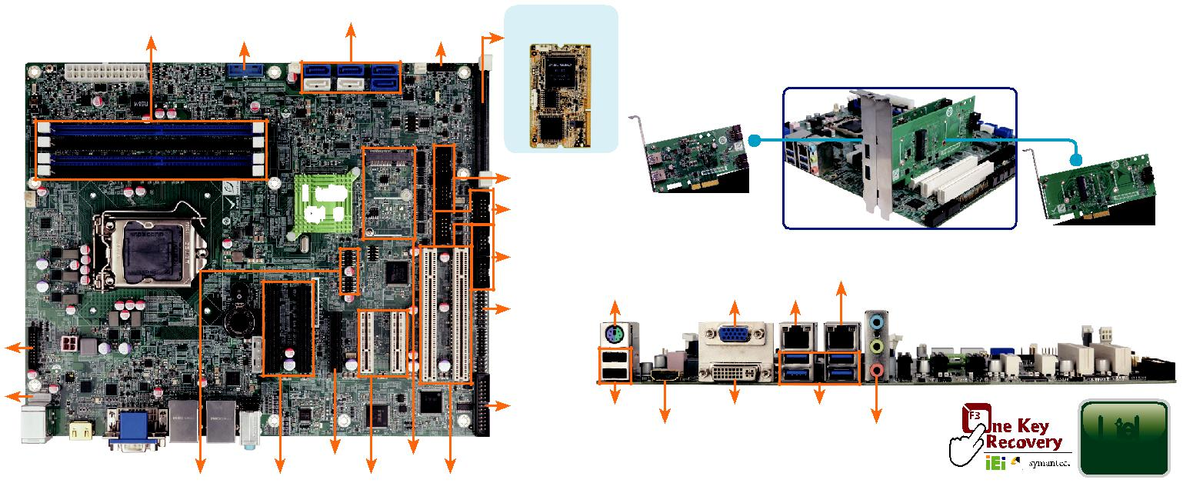

|  |  |  |  |  |  |  |  |  |  |  |  |
| --- | --- | --- | --- | --- | --- | --- | --- | --- | --- | --- | --- |
| 双通道DDR4 2133 | | 6 x SATA 6Gb/s |  | iRIS-2400 模块插 | | 支持灵活 I/O | |  |  |  |  |
| MHz | USB 3.0 | | 前面板 | 槽 (可选) |  |  |  |  |  |
|  |  |  |  |  |  | IEI USB 3.1Gen 1 (5Gb/s) & mSATA/PCIe | | | |  |  |
|  |  |  |  |  |  | Mini 扩展卡按照用户需求给出更多的选择 | | | |  |  |
|  |  | Intel® |  | RS-232/422/485 | |  |  |  |  |  |  |
|  |  |  | RS-232 |  | PCIE-USB3S | |  |  |  |  |
|  |  | Q170 |  |  |  |  |  |  |
|  |  |  |  | RS-422/485 | |  |  | Combo RJ-45 |  | PCIE-2PIMSATA |  |
|  |  |  |  |  |  |  |  |  |
|  |  |  |  |  |  |  |  | LAN2/IPMI |  |  |  |
|  |  |  |  |  | KB/MS |  | VGA | LAN 1 |  |  |  |
|  |  |  |  | TPM |  |  |  |  |  |  |  |
| iDP |  |  |  |  |  |  |  |  |  |  |  |
| KB/MS |  |  |  | LPT | 2 x USB 2.0 | | DVI-D 4 x USB 3.1 Gen1 | |  |  |  |
|  |  |  |  |  | Intel® |  |
|  |  |  |  |  |  |  |
|  |  |  |  |  | HDMI 2.0 | |  | 音频 |  |  |
|  |  | PCIe x 4 PCIe Mini | |  |  |  |  |  |  | AMT 11 |  |
|  |  |  |  |  |  |  |  |  |  |
|  | USB 2.0 | 2 x PCIe x8 2 x PCIe x4 | 2 x PCI |  |  |  |  |  |  |  |  |
|  |  | flexible I/O |  |  |  |  |  | USB |  |  |  |
| *产品规格* |  |  |  |  |  |  | Triple |  |  |  |
|  |  |  |  |  | DDR |  | USB 3.1 | SATA Gb/s | PCIe GbE |  |
| CPU |  |  |  |  | 4 2133 | Display |  |
|  |  |  |  |  |  |  | 6 |  |  |



LGA 1151 第六代 Intel® Core ™ i7/i5/i3, Pentium® or Celeron® 处理器

芯片组



Intel® Q170

 内存

四个 288-pin 2133 MHz 双通道 DDR4 SDRAM 无缓冲 DIMMs 最大支持 64 GB BIOS: UEFI BIOS

 图形引擎

Intel® HD Graphics Gen 9 engine with 16 低功耗执行单元 , 支持 DX11/12, OpenGL 4.3/4.4 和 OpenCL2.x, ES 2.0

 显示输出

独立三显

1 x VGA ( 最高达 1920x1200@60 Hz)

1 x DVI-D ( 最高达 1920x1200@60Hz)

1 x HDMI 2.0 ( 最高达 4096x2160@60Hz)

1 x iDP interface for HDMI, LVDS, VGA, DVI, DP ( 最高达 4096x2304@60Hz)

 网络

LAN1: Intel® I219LM PCIe 控制器

LAN2: 支持 Intel® I210AT PCIe 以及 Intel® AMT 11.0

|  |  |  |
| --- | --- | --- |
| 外部 I/O 接口 |  |  |
| 2 x USB 2.0 |  |  |
| 4 x USB 3.1 |  |  |
| 内部 I/O 接口 | 4 x RS-232 (2x5 pin, P=2.54) |  |
| 1 x KB/MS (1x6 pin) |  |
| 1 x LPT (2x13 pin, P=2.54) | 4 x USB 2.0 (2x4 pin, P=2.0) |  |
| 2 x USB 3.0 (2x10 pin, P=2.0) | 6 x SATA 6Gb/s (RAID 0/1/5/10 supported) |  |
| 2 x RS-232/422/485 (2x5 pin, P=2.54) |  |  |
| SMBus: 1 x SMBus (1x4 pin) |  |  |
| I²C: 1 x I²C (1x4 pin) |  |  |
| TPM: 1 x TPM (2x10 pin) |  |  |
| 音频 |  |  |



Realtek ALC662 HD 音频编解码器 支持 5.1-channel

3 x 音频插孔 ( 音频输出 , 音频输入 , 麦克风输入 ) on rear IO

1 x 前置音频 (2x5 pin)

前面板



1 x 前面板 (2x7 pin, power LED, HDD LED, 扬声器 , 电源按钮 , 重启按钮 )

LAN LED: 2 x LAN LED (1x2 pin)

扩展



1 个全尺寸 PCIe Mini card 插槽 ( 支持 mSATA)

2 x PCI 插槽

2 x PCIe x 8 插槽 (Gen3)

3 x PCIe x 4 插槽 (Gen3)

iRIS 远程管理模块 : 1 x iRIS-2400 插槽



 看门狗定时器 : 软件可编程，支持 1~255 秒系统复位

 数字 I/O: 8-bit 数字 I/O (2x5 pin)

风扇接口



1 x CPU 智能风扇 (1x4 pin)

2 x System 智能风扇 (1x3 pin)

 开放机箱 : 1 x 防盗机箱 (1x2 pin)

 电源 : ATX/AT 电源

功耗



3.3V@1.65A, 5V@3.4A, 12V@8.58A, 5VSB@3.4A

(Intel® Core ™ i7 6700K 4.0GHz CPU 以及 32 GB ( 四个 4 GB) 2133 MHz DDR4 内存 )  工作温度 : -20°C ~ 60°C

 存储温度 : -30°C ~ 70°C

 工作湿度 : 5% ~ 95%, 无冷凝

 重量 : GW: 1200g / NW: 700g

CE/FCC 标准

*产品特征*

* LGA1151 第六代 Intel® Core™ i7/i5/i3, Celeron® 和 Pentium® 处理器
* 双通道 DDR4 2133 MHz
* 支持三显 HDMI, DVI and VGA
* 支持 USB 3.0, SATA 6Gb/s 和 PCI Express Gen3
* 支持 IPMI 2.0 via iRIS-2400 模块
* IEI 一键恢复解决方案可快速创建 OS 备份和恢复

*包装清单*

|  |  |
| --- | --- |
| 1 x IMBA-Q170-i2 single board computer | 2 x SATA cable |
| 1 x I/O shielding | 1 x QIG |

*订购信息*



|  |  |  |
| --- | --- | --- |
| 料号 | 描述 |  |
|  |  |  |
|  | ATX motherboard supports 14nm LGA1151 Intel® CPU, Intel® |  |
| IMBA-Q170-i2-R10 | Q170, DDR4, triple independent display VGA/ DVI-D/ HDMI 2.0, |  |
| dual Intel® PCIe GbE, USB 3.0, SATA 6Gb/s, HD Audio, IPMI 2.0 |  |
|  |  |
|  | and RoHS |  |
|  | ATX motherboard supports 14nm LGA1151 Intel® CPU, Intel® |  |
| IMBA-Q170-ECO-R10 | Q170, DDR4, triple independent display VGA/ DVI-D/ HDMI 2.0, |  |
| dual Intel® PCIe GbE, USB 3.0, SATA 6Gb/s, HD Audio, ECO |  |
|  |  |
|  | packing and RoHS |  |
| iRIS-2400-R10 | IPMI 2.0 adapter card with AST2400 BMC chip for DDR3 SO- |  |
| DIMM socket interface |  |
|  |  |
| PCIES-2PIMSATA-R10 | Peripheral card for flexible I/O, 1 x PCIe Mini, 2 x mSATA |  |
| expansion |  |
|  |  |
| PCIES-USB3-R10 | Peripheral card for flexible I/O, USB 3.0 expansion |  |
| 19800-000049-RS | LPT flat cable, 240mm, P=2.54 |  |
| 19800-000075-RS | PS/2 KB/MS cable with bracket, 220mm, P=2.0 |  |
| 19800-003100-100-RS | Dual port USB cable with bracket, 30mm, P=2.54 |  |
| 19800-010500-200-RS | USB 3.0 cable 457mm with bracket |  |
| 32102-000100-200-RS | SATA power cable, MOLEX 5264-4P to SATA15P |  |
| 32205-000702-100-RS | RS-232 cable, 230mm, P=2.54 |  |
| CF-1156C-R20 | LGA1155/LGA1156 cooler kit, 1U chassis compatible, 45W |  |
| CF-1156D-R20 | LGA1155/LGA1156 cooler kit, 1U chassis compatible, 65W |  |
| CF-115XE-R10 | High-performance LGA1155/1156 cooler kit, 95W |  |
| DP-DP-R10 | DisplayPort to DisplayPort converter board (for IEI iDP connector) |  |
| DP-DVI-R10 | DisplayPort to DVI-D converter board (for IEI iDP connector) |  |
| DP-HDMI-R10 | DisplayPort to HDMI converter board (for IEI iDP connector) |  |
| DP-LVDS-R10 | DisplayPort to 24-bit dual-channel LVDS converter board |  |
| (for IEI iDP connector) |  |
|  |  |
| DP-VGA-R10 | DisplayPort to VGA converter board (for IEI iDP connector) |  |
| TPM-IN02-R20 | 20-pin Infineon TPM 2.0 module, software management tool, |  |
| firmware v5.5 |  |
|  |  |



IMBA-Q170-i2-2019-V10