***医疗解决方案***

***w w w . i e i w o r l d . c o m***

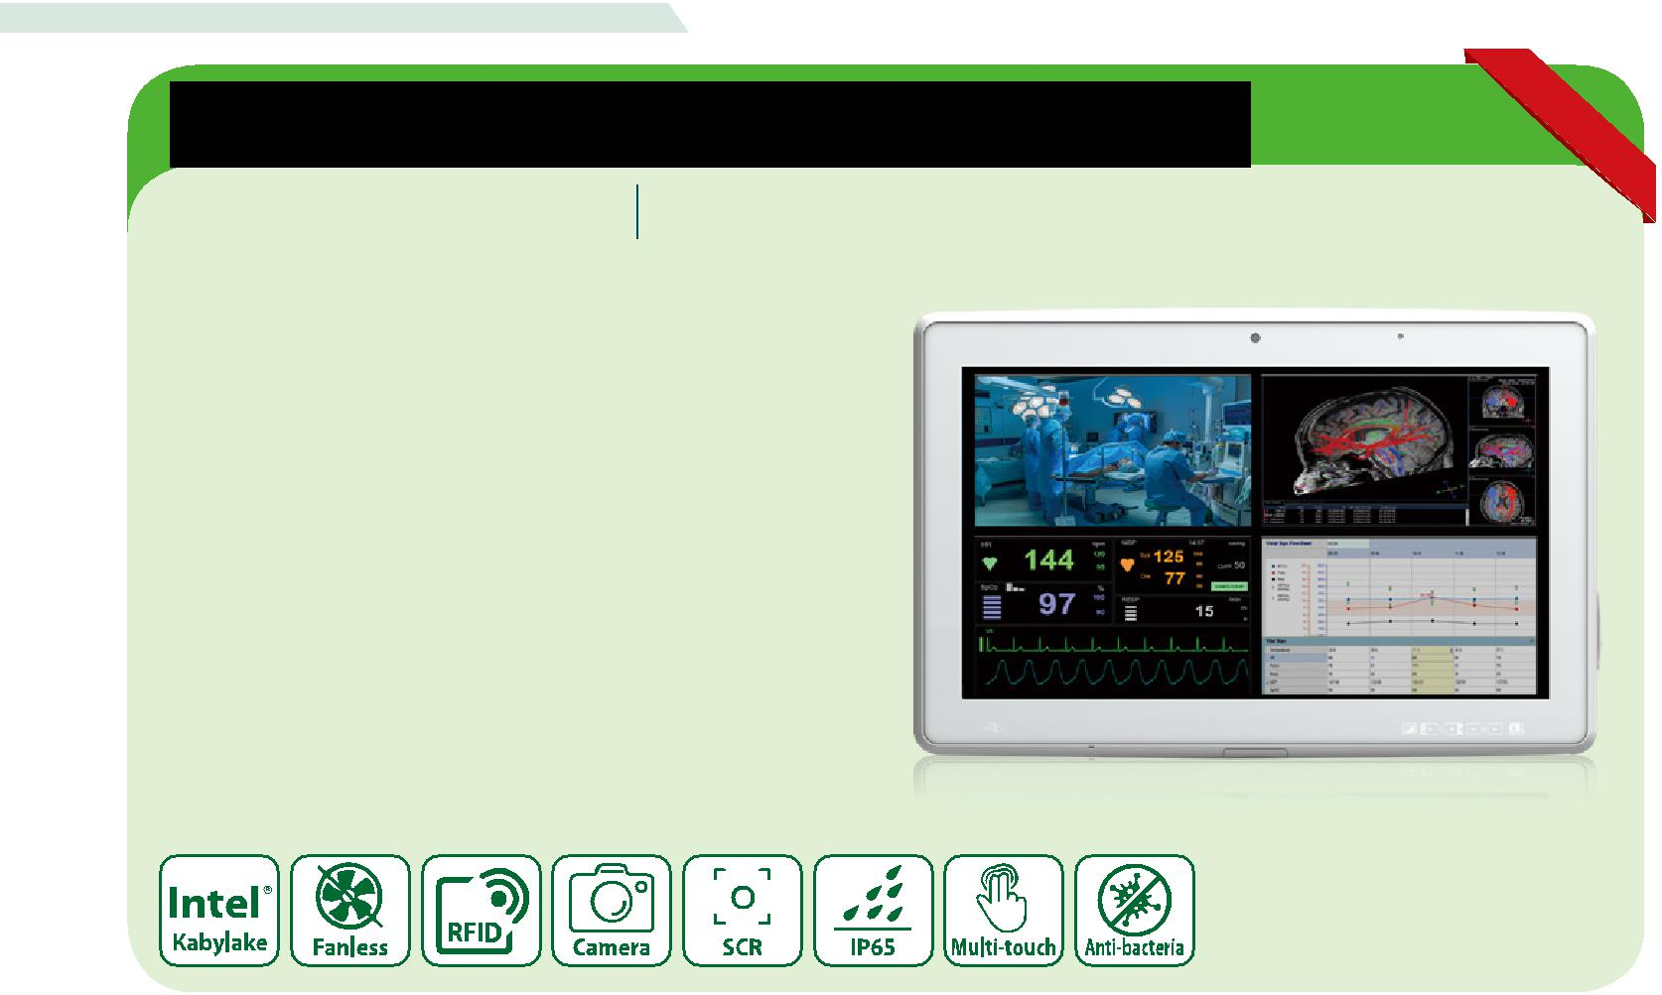

**床边信息娱乐终端**

**BIS-W19C-ULT4**

18.5” 医疗平板电脑 ，具有第七代 Intel® mobile ULT Core™ i5/Celeron® 处理器

*特征*

* 18.5" 16:9 LED 面板 (1366 x 768 / 1920 x 1080)
* Intel® 第七代 Core™ i5-7300U and Celeron® 3865 CPU
* 投射电容式触摸屏支持多点触摸
* 前面板符合 IP65
* 抗菌外壳
* 支持 HDMI 输入 (显示器模式)
* 可选 3-in-1 读卡器: MSR, SCR 和指纹
* 可选 Mifare RFID 模块
* 可选 VoIP 手机耳机
* 可选提手式模块支持条码扫描仪和阅读灯

**监控模式应用**

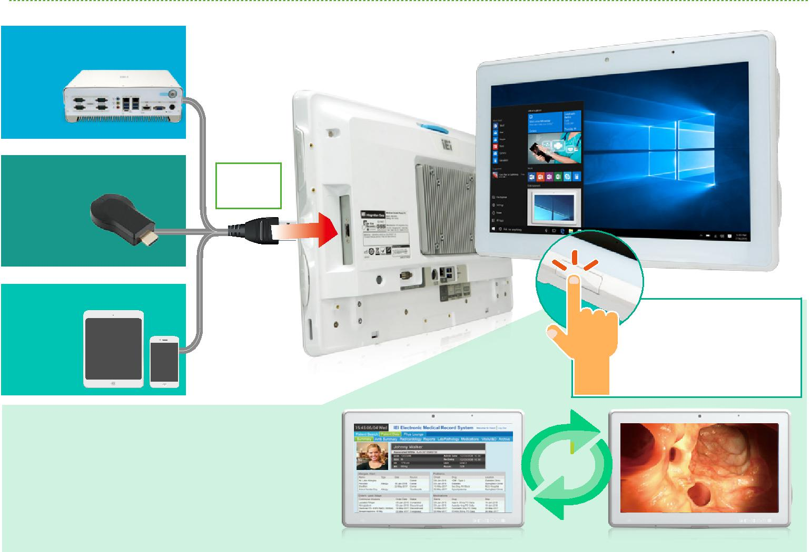

**双系统冗余**

嵌入的系统

|  |  |  |
| --- | --- | --- |
| **无线视频/音频** | **HDMI** |  |
|  |  |
| Miracast / DLNA | **Source** |  |

技术的无线加密

加密HDMI视频

传输

**小屏幕投到大屏幕**

智能手机/

IPAD / iPhone

 无线收发模块

 HDMI输入/输出

 电子病历载体

 手术室教学观察

HDMI 输入功能，我们设置一个物理按钮使模式切换流程更加流畅和人性化。

PC mode Monitor mode

***医疗解决方案***

***w w w . i e i w o r l d . c o m***



*订购信息*



|  |  |  |
| --- | --- | --- |
| 料号 | 描述 |  |
| BIS-W19CF-ULT4-C/PC/4G-R10 | 18.5” 350 cd/m² 1920 x 1080 panel PC with 7th generation 14nm Intel® mobile Celeron® 3865U (15W) on-board processor (ULT), one 4GB DDR4 |  |
| RAM, 802.11a/b/g/n/ac Wi-Fi module, PCAP touchscreen, 2-megapixel camera, microphone, R10 |  |
|  |  |
| BIS-W19CF-ULT4-i5/PC/4G-R10 | 18.5” 350 cd/m² 1920 x 1080 panel PC with 7th generation 14nm Intel® mobile Core™ i5-7300U (15W) on-board processor (ULT), one 4GB DDR4 |  |
| RAM, 802.11a/b/g/n/ac Wi-Fi module, PCAP touchscreen, 2-megapixel camera, microphone, R10 |  |
|  |  |
| BIS-W19C-ULT4-C/PC/4G-R10 | 18.5” 250 cd/m² 1366 x 768 panel PC with 7th generation 14nm Intel® mobile Celeron® 3865U (15W) on-board processor (ULT), one 4GB DDR4 RAM, |  |
| 802.11a/b/g/n/ac Wi-Fi module, PCAP touchscreen, 2-megapixel camera, microphone, R10 |  |
|  |  |
| BIS-W19C-ULT4-i5/PC/4G-R10 | 18.5” 250 cd/m² 1366 x 768 panel PC with 7th generation 14nm Intel® mobile Core™ i5-7300U (15W) on-board processor (ULT), one 4GB DDR4 RAM, |  |
| 802.11a/b/g/n/ac Wi-Fi module, PCAP touchscreen, 2-megapixel camera, microphone, R10 |  |
|  |  |
| *可选配件* |  |  |
| 料号 | 描述 |  |
| MEDP-HS-R10 | USB interface VoIP phone and its holder, white |  |
| MEDP-CR-02-R10 | Magnetic card reader/Smart card reader/Fingerprint sensor, white |  |
| MEDP-HD-R10 | Metal handle covered with soft rubber |  |
| MEDP-HD-BR-R11 | Metal handle covered with soft rubber, with barcode reader and reading light, White |  |
| MEDP-MF-RFID-04-R10 | Mifare RFID reader, 13.56MHz, with LED indicator and 100mm antenna, IEI assembly only |  |
| MEDP-TPM-04-R10 | Trusted platform module kit with 300mm cable, IEI assembly only |  |
| MEDP-EZS-R10 | VESA 100 x 100 mm panel PC stand with a cable management hole, white |  |
| BIS-W19C-ULT4-W10E64-V-R10 | OS Image with Windows Embedded Standard 10 E Value 64-bit for BIS-W19C, with DVD-ROM, RoHS |  |
| POCP-CC04-R10 | BIS-19C-ULT4 cable cover, white, plastic, R10 |  |

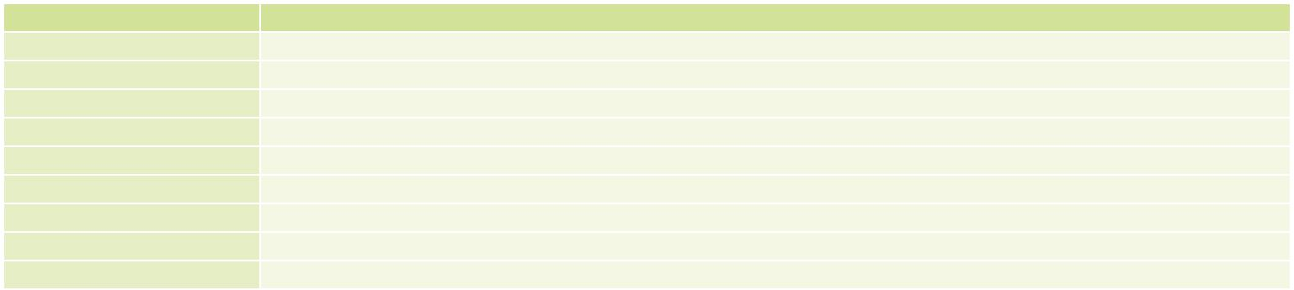

*IQ 安装选项*



|  |  |
| --- | --- |
| 名称 | 料号 |
|  |  |
| 壁挂套件 | AFLWK-19B |
| 支架臂 | ARM-31-RS |
| 支架 | STAND-A21-R10 |
|  |  |

*包装清单*

|  |  |  |  |  |
| --- | --- | --- | --- | --- |
| 名称 | 名称 | 数量 | 描述 |  |
|  |  |
| Power Adapter |  | 1 | 120W medical power adapter: Input: |  |
|  | 90V~264V AC, Output: 19 V DC |  |
|  |  |  |  |
| Power Cord |  | 1 | European power cords, 183 CM, C13 |  |

*I/O 接口*

|  |  |  |  |
| --- | --- | --- | --- |
|  |  |  |  |
| 11.5kV.IsolationCOM | | GbE LAN | |
|  |  |  |  |

12~28V DC Jack 2 x USB 3.0

478.63

385.8

|  |
| --- |
| 60.1 |

410.4

|  |
| --- |
| 231 |

Barcode Module 2 x USB 3.0

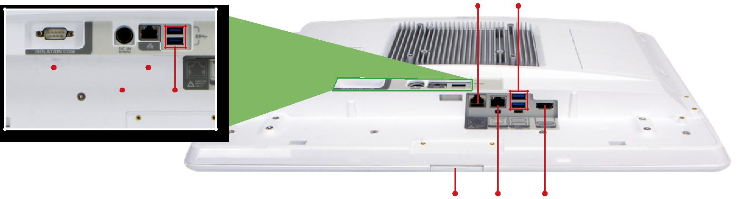

Monitor Mode Switch GbE LAN HDMI (output)

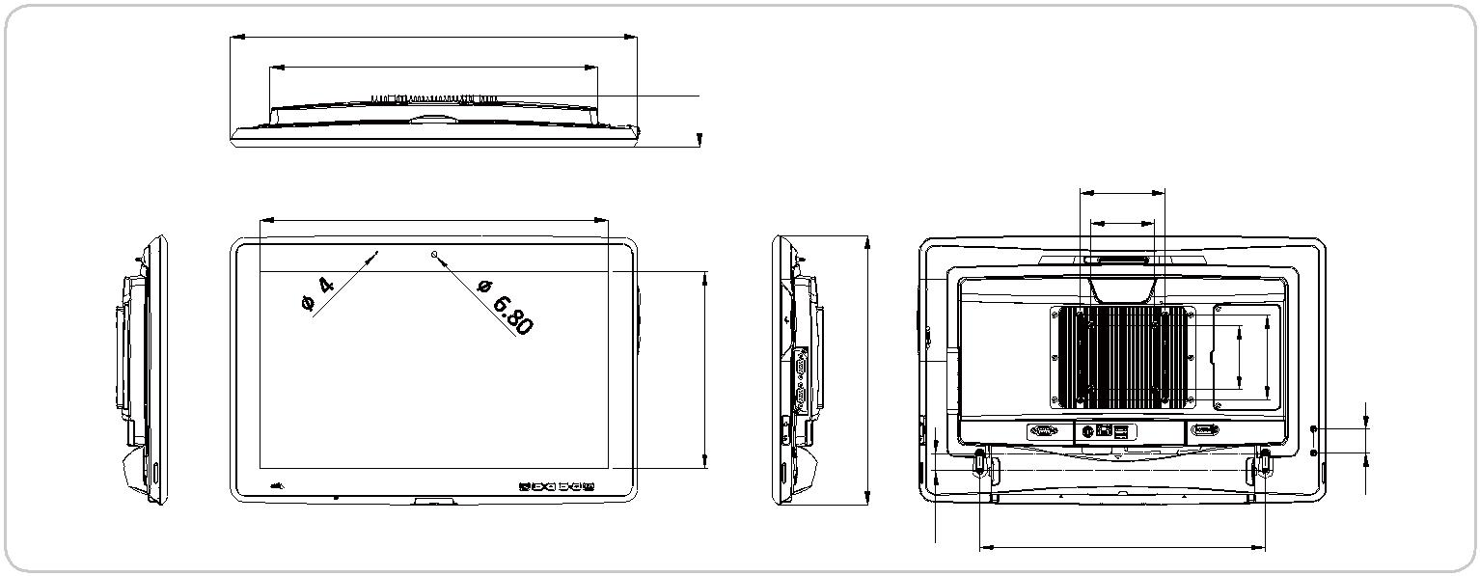

*BIS-W19C-ULT4*

*尺寸 (单位: mm)*

100

75

|  |  |  |  |  |
| --- | --- | --- | --- | --- |
| 317.34 |  | 75 | 100 |  |
|  |  |  | 28 |  |
|  | 20 | 336 |  |  |
|  |  |  |  |

***医疗解决方案***



**应用**

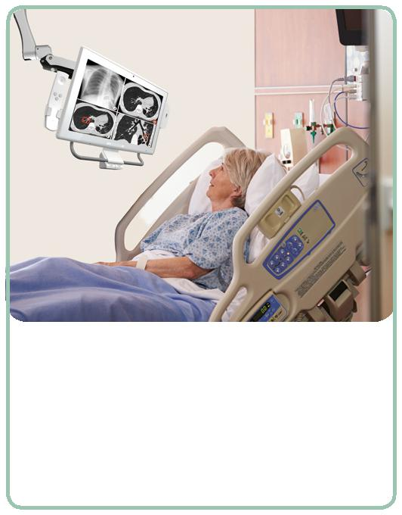

* 为病患推送通知服务

患者可能需要接受医院的健康教育或阅读术前须知。BIS-W19C-ULT3 可与医院服务器集成，实现这些功能，大多数健康教育可实现数字化减少人力。

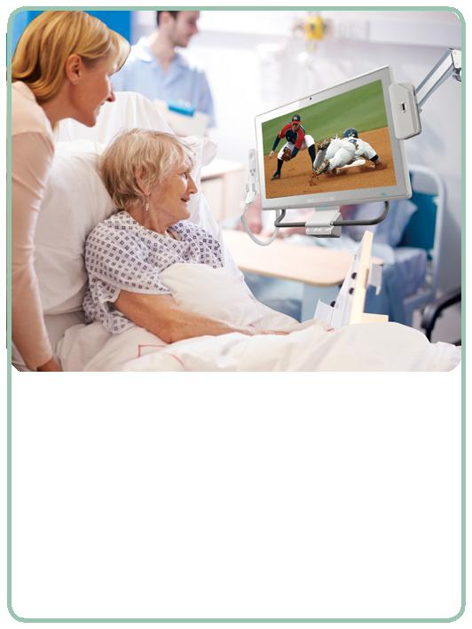

***w w w . i e i w o r l d . c o m***

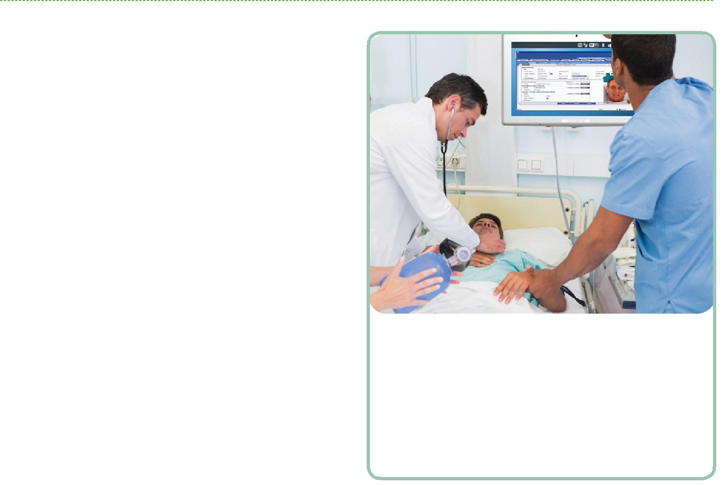

* 护士专用 HIS/NIS 系统

大多数的医院利用数字信息系统以避免人为错误和优化护理流

程。BIS-W19C-ULT3 可集成到 HIS/NIS 系统，临床医生可便利地检查医生的处方，并将病人的重要信息直接记录到数据中心。

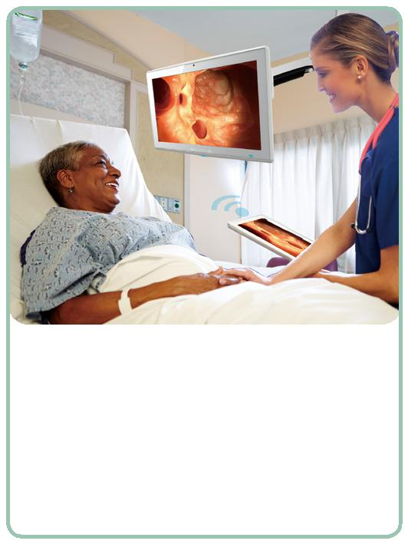

● 病患娱乐信息系统 ● 病患咨询讨论

病患在住院期间除了咨询医生或手术，有大量的空闲时间，意味 查房是医生的主要日常工作。在查房过程中携带所有病人的资料对

着病患需要一些娱乐活动。BIS-W19C-ULT3可以集成床边软件应 医生来说非常有难度。数字医疗时代正在来临。医生查房时只需带

用程序，可集成病患需要的各种功能。床边解决方案应当为病患 一台平板电脑就可以向每个病人解释所有的医疗问题。无线视频流

提供所有日常需求。 向更大的屏幕帮助医生，病人和病人家属有一个更加便利的讨论环

节。



***医疗解决方案***

***w w w . i e i w o r l d . c o m***



*规格*



|  |  |  |  |  |
| --- | --- | --- | --- | --- |
|  | Model |  | **BIS-W19C-ULT4** |  |
|  | LCD 显示 |  | 18.5” (16:9) |  |
|  | 最大分辨率 |  | 1366 (W) x 768 (H) / 1920 (W) x 1080 (H) |  |
|  | 亮度 (cd/m²) |  | 250 / 350 |  |
| LCD 规格 | 对比度 |  | 1000:1 |  |
| LCD 颜色 |  | 16.7M colors (RGB 6-bit) / 16.7M colors (RGB true 8-bit) |  |
|  |  |  |
|  | 像素间距 (mm) |  | 0.3 (H) x 0.3 (V) / 0.213 (H) x 0.213 (V) |  |
|  | 可视角度 (H-V) |  | 170°(H) / 160°(V), 178°(H) / 178°(V) |  |
|  | 背光灯平均无故障时间 (hrs) | | 30000 (LED backlight) / 50000 (LED backlight) |  |
| 触摸 | 触摸屏 |  | Projected capacitive type with USB interface |  |
| 表面硬度 |  | 6H |  |
|  |  |  |
|  | CPU 支持 |  | Intel® Kabylake ULT platform Core™ i5-7300U and Celeron® 3865U |  |
|  | 存储 | Two 260-pin 2133/1866 MHz dual-channel DDR4 non-ECC unbuffered SO-DIMMs (system | |  |
|  |  | max. 32GB) |  |
|  |  |  |  |
|  |  |  | Rear |  |
|  |  |  | 1 x 1.5kV isolation COM port |  |
|  |  |  | 1 x 12~28V DC Jack |  |
|  |  |  | 1 x GbE LAN port |  |
|  |  |  | 2 x USB 3.0 port |  |
|  |  |  | Bottom |  |
|  |  |  | 1 x RJ-11 for barcode scanner (1D/2D) |  |
|  | I/O 接口 |  | 1 x GbE LAN port |  |
| 系统 |  |  | 2 x USB 3.0 port |  |
|  |  |  | 1 x HDMI output |  |
|  |  |  | Side |  |
|  |  |  | 1 x HDMI input |  |
|  |  |  | 2 x USB 2.0 port |  |
|  |  |  | 1 x Audio out |  |
|  |  |  | 1 x Mic in |  |
|  | 存储 |  | 1 x 2.5” SATA 6Gb/s HDD bay |  |
|  |  | 1 x mSATA (Reserved) |  |
|  |  |  |  |
|  | 音频 |  | 2 x 2W speaker |  |
|  | 摄像头和麦克风 |  | 2-megapixel CMOS front-facing camera with auto-focus and digital microphone |  |
|  | LED 指示灯 |  | RFID indicator LED |  |
|  | 监控模式 |  | Yes |  |
|  |  |  | 1 x LCD on/off |  |
|  |  |  | 1 x Brightness up |  |
|  |  |  | 1 x Brightness down |  |
|  |  |  | 1 x Volume up |  |
| 其他特征 | 功能键 |  | 1 x Volume down |  |
|  |  | 1 x Touch lock button for cleaning |  |
|  |  |  |  |
|  |  |  | Combinations: |  |
|  |  |  | 1 x Auto-dimming on/off |  |
|  | 光传感器 |  | Ambient light sensor for panel brightness adjustment |  |
|  | 冷却方式 |  | Fan-less |  |
| 链接 | 无线和蓝牙 |  | IEEE 802.11 a/b/g/n/ac 2T2R module with Bluetooth V4.1 (M.2 2230 A-E key module) |  |
|  | 材质 |  | ABS+PC plastic with anti-bacterial material |  |
|  | 安装方式 |  | Wall, Stand and Arm VESA 100/75 |  |
| 物理属性 | 净重 |  | 6.5 kg |  |
|  | 尺寸 (WxHxD) (mm) |  | 478.6 x 317.3 x 60.1 |  |
|  |  |  |  |
|  | 操作温度 |  | 0°C~40°C |  |
|  | 存储温度 |  | -20°C~60°C |  |
|  | 湿度 |  | 10% to 95% (non-condensing) |  |
| 环境因素 | 震动 |  | 1G |  |
|  | 抗冲击 |  | Operating Shock: 5G peak acceleration (11ms duration) |  |
|  |  | Non-Operating Shock: 15G peak acceleration (11ms duration) |  |
|  |  |  |  |
|  | IP 等级 |  | IP65 compliant front panel |  |
| 电源 | 电源输入 |  | 12V~28V DC input |  |
| 电源适配器 |  | 120W medical power adapter: Input: 100V~240V AC, Output: 19V DC |  |
|  |  |  |
|  |  |  |  |  |
|  |  |  |  |  |
|  |  |  |  |  |