

*单板电脑*

*嵌入式主板*



*w w w . i e i w o r l d . c o m . c n*



|  |  |  |  |  |  |  |  |  |  |  |  |  |  |  |  |  |  |  |  |  |  |  |  |  |  |  |  |  |  |  |  |  |  |  |  |  |  |  |  |  |  |  |  |  |  |  |  |  |  |
| --- | --- | --- | --- | --- | --- | --- | --- | --- | --- | --- | --- | --- | --- | --- | --- | --- | --- | --- | --- | --- | --- | --- | --- | --- | --- | --- | --- | --- | --- | --- | --- | --- | --- | --- | --- | --- | --- | --- | --- | --- | --- | --- | --- | --- | --- | --- | --- | --- | --- |
|  | PM-LX2 | | | | | |  |  |  |  |  |  |  |  |  |  |  |  |  |  |  |  |  |  |  |  |  |  |  |  |  |  | PM-LX | | | | | | |  |  |  |  |  |  |  |  |  |  |
|  | AMD Geode™ LX 800 CPU on-board PC/104 Module | | | | | | | | | | | | | | | | |  |  |  |  |  |  |  |  |  |  |  |  |  |  |  | PCI-104 Module with on-board AMD Geode™ LX 800 CPU | | | | | | | | | | | | | | | |  |
|  |  |  |  |  |  |  |  |  |  |  |  |  |  |  |  |  |  |  |  |  |  | |  | |  |  |  | |  |  |  |  |  |  |  |  |  |  | |  | | |  |  |  | | | |  |
|  |  |  |  |  |  |  |  |  |  |  |  |  |  |  | KB/MS | | |  | Solder side | | | | | | | | | | | | | |  |  |  |  |  | COM | | LPT LAN | | |  |  | Solder side | | | |  |
| PC/104 | | |  |  |  |  |  |  |  |  |  |  |  |  |  |  |  |  |  |  |  |  |  |  |  | CF Type II | | | |  |  |  |  |  |  |  |  |  |  |  |  |  |  |  | CF Type II |  |
|  | |  |  |  |  |  |  |  |  |  |  |  |  |  |  |  |  |  |  |  |  |  |  |  |  |  |  |  |  |  |  |  |  |  |  |  |  |  |  |  |  |
|  | VGA | |  |  |  |  |  |  |  |  |  |  |  |  |  | 5V 电源 | |  |  |  |  |  |  |  |  |  |  |  | COM | | |  |  |  |  |  |  |  |  |  |  |  |  |  |
|  |  |  |  |  |  |  |  |  |  |  |  |  |  |  |  |  |  |  |  |  |  |  |  |  |  |  |  |  |  |  |  |  |  |  |  |  |
|  |  |  |  |  |  |  |  |  |  |  |  |  |  |  |  |  |  |  |  |  |  |  |  |  | 支持 400/333 | | | |  |  |  | |  |  |  |  |  |  |  |  |  |
|  |  |  |  |  |  |  |  |  |  |  |  |  |  |  |  |  |  |  |  |  |  |  |  |  |  |  |  |  |  |
|  |  |  |  |  |  |  |  |  |  |  |  |  |  |  |  |  |  |  |  |  |  |  |  |  |  |  |  |  |  |  |  |  |  |  |  |  |  |  |  |  |  | 400/333 MHz |  |
|  |  |  |  |  |  |  |  |  |  |  |  |  |  |  |  |  |  |  |  |  |  |  |  |  |  |  |  |  |  |  |  |  |  |  |  |  |
|  |  |  |  |  |  |  |  |  |  |  |  |  |  |  |  |  |  |  |  |  |  |  |  |  |  |  |  |  | MHz DDR | | | |  |  |  |  |  |  |  |  |  |  |  |  |  |  |  | DDR SO-DIMM |  |
|  | LPT | |  |  |  |  |  |  |  |  |  |  |  |  |  |  |  |  |  |  |  |  |  |  |  |  |  |  | Slim FDD | | | | USB 2.0 | | |  | |  | |  |  |  |  |  | IDE | | | |  |
|  |  |  |  |  |  |  |  |  |  |  |  |  |  |  |  |  |  |  |  |  |  |  |  |  |  |  |  | |  |  |  |  |  |
|  |  |  |  |  |  |  |  |  |  |  |  |  | IDE | | |  |  |  |  |  |  |  |  |  |  |  | TTL |  |  |  |  |  |  |  |  |  |  |  |  |  |  |  |  |
|  |  |  |  |  |  |  |  |  |  |  |  |  |  |  |  |  |  |  |  |  |  |  |  |  |  |  |  |  |  |  |  |  |  |  |
|  | USB |  |  |  |  |  |  |  |  |  |  |  |  |  |  |  |  |  |  |  |  |  |  |  |  |  |  |  |  |  |  | |  | | |  |  |  |  |  |  |  |  |  |  |
|  |  |  |  |  |  |  |  |  |  |  |  |  |  |  |  |  |  |  |  |  |  |  |  |  |  |  |  |  |  |  | |  |  |  |  |  |  |  |  |  |  |
|  |  | | | | |  |  |  |  |  |  |  |  |  |  |  |  |  |  |  |  |  |  |  |  |  |  |  |  |  |  |  |  |  |  |  |  |  |  |  |  |  |  |  |  |
|  | | | | |  |  |  |  |  |  |  |  |  |  |  |  |  |  |  |  |  |  |  |  |  |  |  |  |  |  |  |  |  |  |  |  |  |  |  |  |  |  |  |  |
| RS-232 | | |  |  |  |  |  |  |  |  |  |  |  |  |  |  |  |  |  |  |  |  |  |  |  |  |  |  |  |  |  |  | VGA | | |  |  |  |  |  |  |  |  |  |  |  |  |  |  |
|  |  |  |  |  |  |  |  |  |  |  |  |  |  |  |  |  |  |  |  |  |  |  |  |  |  |  |  |  |  |  |  |  |  |  |  |  |  |  |  |  |
|  |  |  |  |  |  |  |  |  |  |  |  |  |  |  |  |  |  |  |  |  |  |  |  |  |  |  |  |  |  |  |  |  |  | |  | |  |  |  |  |  |  |  |  |  |  |
|  |  |  |  |  |  |  |  |  |  |  |  |  |  |  |  |  |  |  |  |  |  |  |  |  |  |  |  |  |  |  |  |  |  | |  | |  |  |  |  |  |  |  |  |  |  |
|  |  |  |  |  |  |  |  |  |  |  |  |  |  |  |  |  |  |  |  |  |  |  |  |  |  | DDR | | | | | | | PCI-104 | |  |  |  |  |  |  |  |  |  |  | KB/MS | | | |  |
|  |  |  |  |  |  |  |  |  |  |  |  |  |  |  |  |  |  |  |  |  |  |  |  |  |  |  |  |  |  |  |  |  |  |  |  |  |
|  |  |  |  |  |  |  |  |  |  |  |  |  |  |  |  |  |  |  |  |  | 400 | | | | | | | |  |  |  |  |  | | | | |  |  |  |  |  |  |
|  |  |  |  | RS-232 | |  | 24-bit TTL | | | LAN | | | | | | | |  |  |  |  |  |  |  |  |  |  |  |  |  |  |  |  |  |  |  |  |  |  |  |  |  |  |  |  |  |  |  |  |
|  |  |  |  |  | RS-422/485 | | | | |  |  |  |  |  |  |  |  |  |  |  |  |  |  |  |  |  |  |  |  |  |  |  |  |  |  |  |  |  |  |  |  |
|  |  |  |  |  |  |  |  |  |  |  |  |  |  |  |  |  |  |  |  |  |  |  |  |  |  |  |  |  |  |  |  |  |  |  |  |  |  |  |  |  |  |  |  |  |

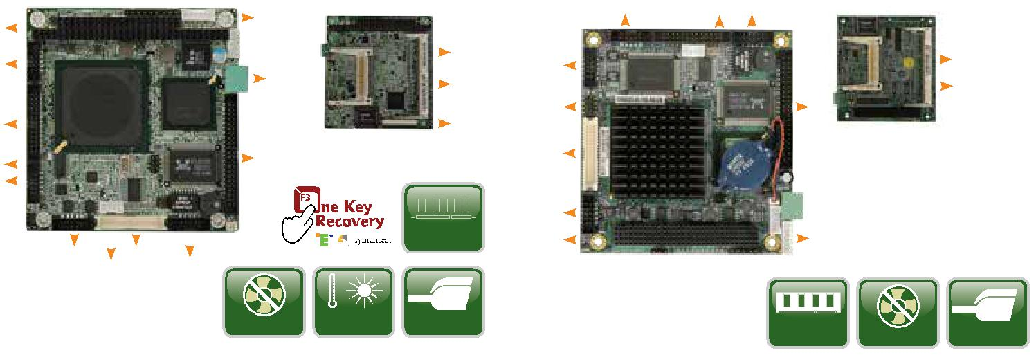

|  |  |  |  |  |
| --- | --- | --- | --- | --- |
|  |  |  | Hi-Speed |  |
|  |  | Wide | CERTIFIED USB |  |
|  | Fanless | USB 2.0 |  |
| *产品规格* | Temperature |  |
|  |  |  |  |
| CPU | 显示输出 |  |  |  |
| AMD Geode™ LX 800 (500 MHz) | 1 x VGA (高达 1920x1440@60Hz) | | |  |
| 芯片组 | 1 x 24-bit 单通道 TTL (高达 1600x1200@60Hz) | | |  |
| AMD CS5536 | 看门狗定时器 |  |  |  |
| BIOS | 软件可编程 ，支持 1~255 秒系统复位. | | |  |
| AMI BIOS | 电源 |  |  |  |
| System 内存 | 仅 5V DC 输入 |  |  |  |
| 一个 200-pin 400 MHz DDR SDRAM SO- | 1 x 内置电源接口 (1x2 pin) | |  |  |
| DIMM 支持高达 1 GB | 支持 AT 模式 |  |  |  |
| 以太网 | 功耗 |  |  |  |
| 一个 Realtek RTL8100C 10/100Mbps 网络 | 5V@1.09A (AMD Geode™ LX 800 with one | | |  |
| 芯片组 | 512MB 400 MHz DDR) | |  |  |
| 内部 I/O 接口 | 操作温度PM-LX2-800-R10: 0°C ~ 60°C | | |  |
| 1 x CF Type II | 工作湿度 |  |  |  |
| 1 x IDE (2x22 pin, P=2.0) | 5% ~ 95%, 无冷凝 | |  |  |
| 1 x LPT (2x13 pin, P=2.0) | 尺寸 |  |  |  |
| 1 x KB/MS (1x6 pin) | 96mm (L) x 90mm (W) | |  |  |
| 2 x RS-232 (2x5 pin, P=2.0) | 重量 |  |  |  |
| 1 x RS-422/485 (1x4 pin, P=2.0) | GW: 500g / NW 110g | |  |  |
| 1 x Slim FDD | CE/FCC compliant | |  |  |
| 2 x USB 2.0 (2x4 pin, P=2.0) |  |  |  |  |



 扩展

1 x PC/104

|  |  |  |  |
| --- | --- | --- | --- |
|  |  | Hi-Speed |  |
| DDR |  | CERTIFIED USB |  |
| Fanless | USB 2.0 |  |
| 400 |  |



*产品规格*

CPU 1 x VGA (高达 1920x1440@60Hz)



AMD Geode™ LX 800 (500 MHz) 处理器 1 x 24-bit 单通道 TTL (高达

 芯片组 1600x1200@60Hz)

AMD CS5536  看门狗定时器

BIOS 软件可编程，支持 1~255 秒系统复位



Award BIOS  电源

System 内存 仅 5V DC 输入



一个 200-pin 400 MHz DDR SDRAM SO- 1 x 内置电源接口 (1x2 pin)

DIMM 支持高达 1 GB 支持 AT 模式

以太网  功耗



10/100Mbps realtek RTL8100C 网络芯片组 5V@1.13A (AMD Geode™ LX 800 with

内部 I/O 接口 one 1 GB 400 MHz DDR 内存)



1 x CF Type II  操作温度0°C ~ 60°C

1 x IDE (2x22 pin, P=2.0)  存储温度

1 x LPT (2x13 pin, P=2.0) -10°C ~ 70°C

1 x KB/MS (1x6 pin)  工作湿度

2 x RS-232 (2x5 pin, P=2.0) 5% ~ 95%

1 x RS-422/485 (1x4 pin, P=2.0)  尺寸: 95 mm x 95 mm

2 x USB 2.0 (2x4 pin, P=2.0)  重量: GW: 500g / NW: 110g

扩展  CE/FCC compliant



1 x PCI-104

 显示输出

*尺寸 (mm)*

*包装清单*

|  |  |
| --- | --- |
| 1 x PM-LX2 single board computer | 1 x Power cable |
| 1 x ATA33 flat cable | 2 x RS-232 cable |
| 1 x Dual USB cable | 1 x Mini jumper pack |
| 1 x LAN cable | 1 x One Key Recovery CD |
| 1 x PS/2 KB/MS cable | 1 x QIG |
| 1 x VGA cable | 1 x Utility CD |

*订购信息*

|  |  |  |
| --- | --- | --- |
| 料号 | 描述 |  |
|  |  |  |
| PM-LX2-800-R10 | PC/104 SBC with AMD Geode™ LX 800 500 MHz, VGA/TTL, |  |
| LAN, USB 2.0 and CF Type II |  |
|  |  |
| 32200-015100-RS | LPT cable, 280mm, P=2.0 |  |
| 32205-003800-300-RS | RS-422/485 cable, 200mm, P=2.0 |  |
|  |  |  |

*尺寸 (mm)*

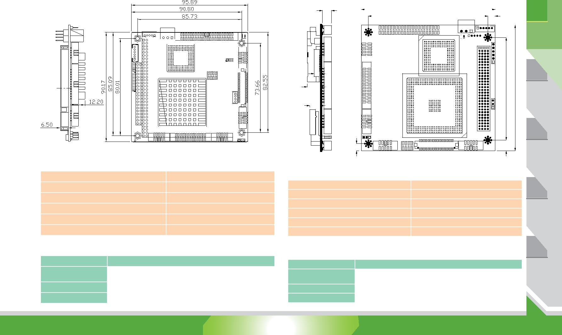

6.75

95.89

|  |  |  |  |  |  |  |  |  |  |  |  |  |  |  |  |  |  |  |  |
| --- | --- | --- | --- | --- | --- | --- | --- | --- | --- | --- | --- | --- | --- | --- | --- | --- | --- | --- | --- |
|  | 85.73 | | | | | | |  |  |  |  |  |  |  |  |  |  | 5.09 | |
|  |  |  |  |  |  |  |  |  |  |  |  |  |  |  |  |  |  |  |  |
|  |  |  |  |  |  |  |  |  |  |  |  |  |  |  |  |  |  |  |  |
|  |  |  |  |  |  |  |  |  |  |  |  |  |  |  |  |  |  |  |  |
|  |  |  |  |  |  |  |  |  |  |  |  |  |  |  |  |  |  |  |  |
|  |  |  |  |  |  |  |  |  |  |  |  |  |  |  |  |  |  |  |  |
|  |  |  |  |  |  |  |  |  |  |  |  |  |  |  |  |  |  |  |  |
|  |  |  |  |  |  |  |  |  |  |  |  |  |  |  |  |  |  |  |  |
|  |  |  |  |  |  |  |  |  |  |  |  |  |  |  |  |  |  |  |  |



|  |  |  |  |
| --- | --- | --- | --- |
| 4.30 |  |  |  |
| 9.20 | 73.66 | 90.17 |  |
|  |  |
| 7.30 |  |  |  |
| 5.08 |  |  |  |
|  | 7.62 |  |  |
| *包装清单* |  |  |  |
| 1 x PM-LX single board computer | 1 x ATA33 flat cable |  |  |
| 1 x LAN cable | 1 x KB/MS Y cable |  |  |
| 1 x Power cable | 1 x Mini jumper pack |  |  |
| 1 x USB cable | 1 x One Key Recovery CD |  |  |
| 1 x VGA cable | 1 x QIG |  |  |
| 2 x RS-232 cable | 1 x Utility CD |  |  |



*订购信息*

|  |  |  |
| --- | --- | --- |
| 料号 | 描述 |  |
|  |  |  |
| PM-LX-800-R11 | PCI-104 SBC with AMD Geode™ LX 800 processor , VGA/TTL, |  |
| LAN, USB 2.0, CF Type II |  |
|  |  |
| 32200-015100-RS | LPT cable, 280mm, P=2.0 |  |
| 32205-003800-300-RS | RS-422/485 cable, 200mm, P=2.0 |  |
|  |  |  |

*1*

工业电脑

解决方案

视频采集

解决方案

工业系统

工业电脑机箱

电源/外设

PM-LX2-2018-V10 1-132