

*单板电脑*

*嵌入式主板*



*w w w . i e i w o r l d . c o m . c n*

|  |  |  |
| --- | --- | --- |
| NANO-ULT3 | EPIC SBC supports Intel® 14nm 6th Generarion Mobile Core™ i7/i5/i3 and Celeron® on- |  |
| board Processor (ULT) with HDMI/LVDS/iDP, Dual PCIe GbE, USB 3.0, PCIe Mini, SATA |  |
| 6Gb/s, mSATA, COM, Audio and RoHS |  |

|  |  |  |  |  |  |  |  |  |  |  |  |  |
| --- | --- | --- | --- | --- | --- | --- | --- | --- | --- | --- | --- | --- |
| RS-232/422/485 USB 2.0 | | | | | | | | | | DIO | | |
| 音频 | | 2 x RS-232 | | | | |  | 2 x USB 2.0 | |  | 2 x SATA 6Gb/s12V power 输入 | |
|  |  |  |  |  |  |  |  |  |  |  |  |  |
|  |  |  |  |  |  |  |  |  |  |  |  |  |
|  |  |  |  |  |  |  |  |  |  |  |  |  |
|  |  |  |  |  |  |  |  |  |  |  |  |  |
|  |  |  |  |  |  |  |  |  |  |  |  |  |
|  |  |  |  |  |  |  |  |  |  |  |  |  |
|  |  |  |  |  |  |  |  |  |  |  |  |  |

PCIe Mini w/

SIM slot

前面板

KB/MS

PCIe Mini iDP LVDS

*产品规格*

SoC



6th generation Intel® mobile ULT 板载 SoC

Intel® Core™ i7-6600U ( 高达 3.4GHz, 双核 , 4MB 缓存 , TDP=15W)

Intel® Core™ i5-6300U ( 高达 3.0GHz, 双核 , 3MB 缓存 , TDP=15W)

Intel® Core™ i3-6100U ( 高达 2.3GHz, 双核 , 3MB 缓存 , TDP=15W)

Intel® Celeron® 处理器 3955U ( 高达 2.0GHz, 双核 , 2MB 缓存 , TDP=15W)

Intel® Celeron® 处理器 3855U ( 高达 1.6GHz, 双核 , 2MB 缓存 , TDP=15W)

BIOS



AMI UEFI BIOS

内存



两个 260-pin 2133/1866 MHz 双通道 DDR4 non-ECC unbuffered SO-DIMMs 最大支持 32GB

图形引擎



Intel® HD 显卡 Gen 9 Engine with 16 low-power execution units, supporting DX11/12, OpenGL 4.3/4.4 and OpenCL2.x, ES 2.0

|  |  |  |  |  |
| --- | --- | --- | --- | --- |
|  |  | 显示输出 |  |  |
|  |  | 独立三显 |  |  |
|  |  | 2 x HDMI ( 高达 4096x2160@24Hz) |  |  |
|  |  | 1 x 18/24-bit 双通道 LVDS ( 高达 1920x1200@60Hz) | |  |
|  |  | 1 x iDP 接口 for HDMI, LVDS, VGA, DVI, DP ( 高达 3840x2160@60Hz) (colay with HDMI1) | |  |
|  |  | 以太网 |  |  |
|  | *1* |  |  |
|  | LAN1: Intel® I219-LM PHY 支持 Intel® AMT 11.0 | |  |
|  | LAN2: Intel® I211-AT PCIe GbE 控制器 |  |  |
|  |  | 外部 I/O 接口 |  |  |
|  | 工业电脑 | 4 x USB 3.0 |  |  |
|  | 解决方案 | 内部 I/O 接口 | 1 x USB 2.0 (180° Type-A) |  |
|  |  | 1 x 8 GB eMMC ( 可选 ) |  |
|  |  | 1 x KB/MS (1x6 pin) | 2 x USB 2.0 (2x4 pin, P=2.0) |  |
|  |  |  |
|  |  | 1 x RS-232/422/485 (2x5 pin, P=2.0) | 2 x RS-232 (2x5 pin, P=2.0) |  |
|  |  | 2 x SATA 6Gb/s with 5V SATA 电源接口 ( 不支持 RAID) | |  |
|  |  | SMBus |  |  |
|  |  | 1 x SMBus (1x4 pin) |  |  |
|  | 视频采集 | 音频 |  |  |
|  | Realtek ALC662 HD 解码器 |  |  |
|  | 解决方案 |  |  |
|  | 1 x 前面板音频 (2x5 pin) |  |  |
|  |  |  |  |
|  |  | 前面板 |  |  |
|  |  | 1 x 电源 LED & HDD LED (1x6 pin) |  |  |
|  |  | 1 x 电源按键 (1x2 pin) |  |  |
|  |  | 1 x 复位按键 (1x2 pin) |  |  |
|  |  | LAN LED |  |  |
|  |  | 2 x LAN LED (1x2 pin) |  |  |
|  | 工业系统 | 扩展 |  |  |
|  |  | 1× 全长 PCIe 迷你卡插槽 ( 支持 SIM holder & mSATA ) | |  |
|  |  | 1 x 半长 PCIe 迷你卡插槽 |  |  |
|  |  | * 3855U 属于 Skylake ULT , 支持 PCIe Gen 2 信号 . | |  |
|  |  | 数字 I/O |  |  |
|  |  | 8-bit 数字 I/O (2x5 pin) |  |  |
|  |  |  |  |
|  |  | 风扇接口 |  |  |
|  |  | 1 x CPU 风扇接口 (1x4 pin) |  |  |
|  |  | 1 x System 风扇接口 (1x4 pin) |  |  |
| 工业电脑机箱 | |  |  |
| 电源 |  |  |
|  |  | 仅 12V DC 输入 |  |  |
|  |  | 1 x 内置电源接口 (2x2 pin) |  |  |
|  |  | 支持 AT/ATX 模式 |  |  |
|  |  |  |  |

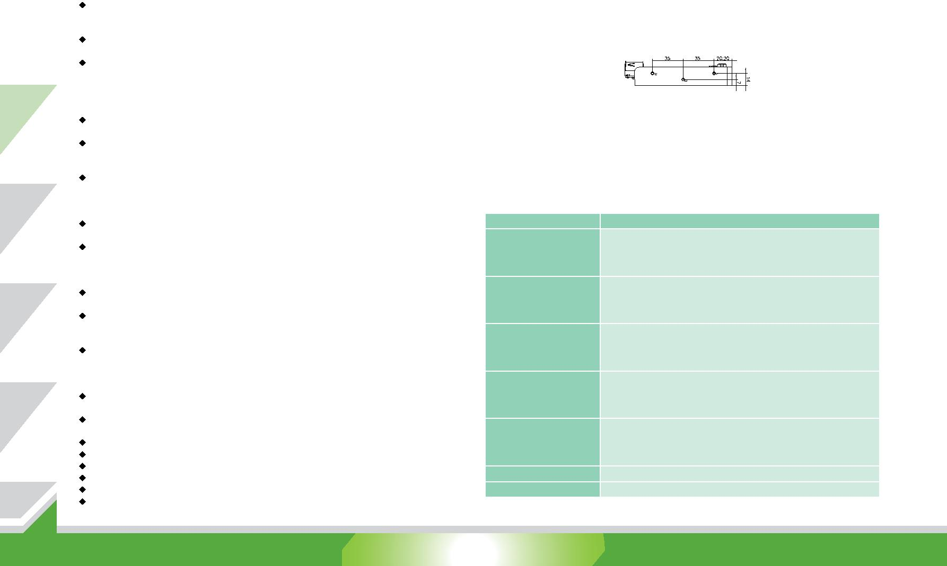

|  |  |  |  |
| --- | --- | --- | --- |
|  |  | 看门狗定时器 |  |
|  |  | 软件可编程支持 1~255 秒系统复位 |  |
|  |  | 功耗 |  |
|  |  | 12V@2.48A (Intel® Core™ i3-6100U CPU with two 8 GB 内存 ) |  |
|  | 电源/外设 | 操作温度 : -20°C ~ 60°C |  |
|  | 存储温度 : -30°C ~ 70°C |  |
|  |  |  |
|  |  | 工作湿度 : 5% ~ 95%, 无冷凝 |  |
|  |  | 尺寸 : 115mm x 165mm |  |
|  |  | 重量 : GW: 850g / NW: 350g |  |
|  |  | CE/FCC compliant |  |

2 x RJ-45 4 x USB 3.0

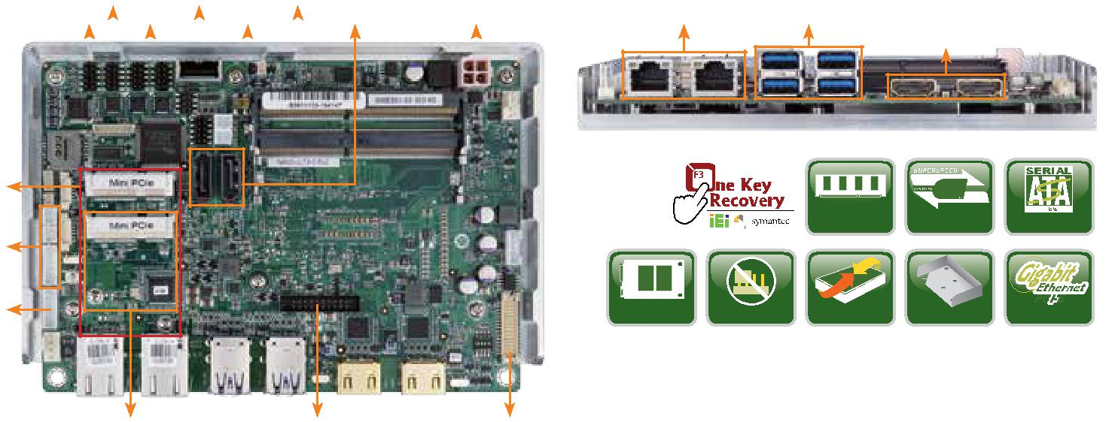

2 x HDMI

|  |  |  |  |  |
| --- | --- | --- | --- | --- |
|  |  |  | USB |  |
|  |  | DDR4 2133 | USB 3.0 | SATA 6Gb/s |
| mSATA | Jumper-less | iDP | 散热器 | PCIe GbE |

*产品特征*

* EPIC SBC with 6th generation Intel® ULT 处理器支持双通道 DDR4 SO-DIMMs
* 支持独立三显
* 易于装配的散热器用于散热管理
* 全长 PCIe 迷你卡插槽 with SIM 插槽 for 3G/LTE 扩展槽
* COM, USB 3.0, SATA 6Gb/s, mSATA, eMMC 5.0 和音频支持
* IEI 一键恢复解决方案可快速创建 OS 备份以及恢复

*尺寸 (单位: mm)*

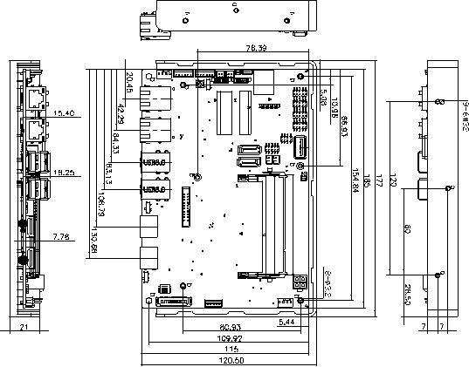

*包装清单*

|  |  |
| --- | --- |
| 1 x NANO-ULT3 single board computer with heatspreader | 1 x Audio cable |
| 1 x Power cable | 1 x One Key Recovery CD |
| 1 x RS-232 cable | 1 x QIG |
| 1 x SATA with power cable kit | 1 x Utility CD |

*订购信息*

|  |  |  |
| --- | --- | --- |
| 料号 | 描述 |  |
|  | EPIC SBC supports Intel® 14nm 6th Generation Mobile Core™ |  |
| NANO-ULT3-i7-R10 | i7-6600U (15W) on-board Processor (ULT) with HDMI/LVDS/iDP, |  |
| Dual PCIe GbE, USB 3.0, Dual PCIe Mini, SATA 6Gb/s, mSATA, |  |
|  |  |
|  | COM, Audio and RoHS |  |
|  | EPIC SBC supports Intel® 14nm 6th Generation Mobile Core™ |  |
| NANO-ULT3-i5-R10 | i5-6300U (15W) on-board Processor (ULT) with HDMI/LVDS/iDP, |  |
| Dual PCIe GbE, USB 3.0, Dual PCIe Mini, SATA 6Gb/s, mSATA, |  |
|  |  |
|  | COM, Audio and RoHS |  |
|  | EPIC SBC supports Intel® 14nm 6th Generation Mobile Core™ |  |
| NANO-ULT3-i3-R10 | i3-6100U (15W) on-board Processor (ULT) with HDMI/LVDS/iDP, |  |
| Dual PCIe GbE, USB 3.0, Dual PCIe Mini, SATA 6Gb/s, mSATA, |  |
|  |  |
|  | COM, Audio and RoHS |  |
|  | EPIC SBC supports Intel® 14nm 6th Generation Mobile |  |
| NANO-ULT3-C-R10 | Celeron® 3955U (15W) on-board Processor (ULT) with HDMI/ |  |
| LVDS/iDP, Dual PCIe GbE, USB 3.0, Dual PCIe Mini, SATA 6Gb/ |  |
|  |  |
|  | s, mSATA, COM, Audio and RoHS |  |
|  | EPIC SBC supports Intel® 14nm 6th Generation Mobile |  |
| NANO-ULT3-CE-R10* | Celeron® 3855U (15W) on-board Processor (ULT) with HDMI/ |  |
| LVDS/iDP, Dual PCIe GbE, USB 3.0, Dual PCIe Mini, SATA 6Gb/ |  |
|  |  |
|  | s, mSATA , COM, Audio and RoHS |  |
| 32000-023800-RS | PS/2 KB/MS cable, 135mm/110mm, P=2.0 |  |
| 32001-008600-200-RS | Dual-port USB cable, 210mm, P=2.0 |  |

*Without full functions support, please refer to user manual.

1-107 NANO-ULT3-2018-V10