

*单板电脑*

*嵌入式主板*



*w w w . i e i w o r l d . c o m . c n*

NANO-AL

MicroSD (可选) LVDS RS-232/422/485

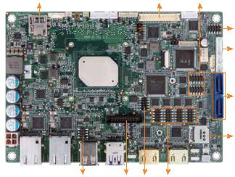

EPIC SBC supports 14nm Intel® Pentium®/Celeron®/Atom™ on -board SoC with Dual HDMI/LVDS/iDP, Dual PCIe GbE, USB 3.0, PCIe Mini, M.2, SATA 6Gb/s, COM, Audio and RoHS, -40°C ~ 85°C



极限环境

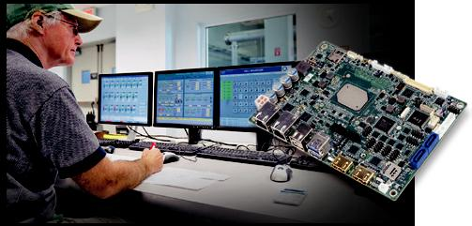

前面板音频

KB/MS

2 x SATA 6Gb/s

MicroSIM

USB 2.0 iDP DIO RS-232

*产品规格*

SoC



Intel® Pentium® N4200 板载 SoC ( 高达 2.5GHz, 四核 , 2M 缓存 , TDP=6W)

Intel® Celeron® N3350 板载 SoC ( 高达 2.4GHz, 双核 , 2M 缓存 , TDP=6W)

Intel® Atom™ E3950 板载 SoC ( 高达 2.0GHz, 四核 , 2M 缓存 , TDP=12W)

Intel® Atom™ E3940 板载 SoC ( 高达 1.8GHz, 四核 , 2M 缓存 , TDP=9W)

Intel® Atom™ E3930 板载 SoC ( 高达 1.8GHz, 双核 , 2M 缓存 , TDP=6W)

BIOS



AMI UEFI BIOS

内存



一个 204-pin 1866/1600MHz 单通道 DDR3L SO-DIMM 支持高达 8GB

图形引擎



Intel® HD 显卡 Gen9 Low Power, 18 Execution Units

4K Codec Decode & Encode for HEVC 4, H.264, VP8, SVC, MVC  显示输出

独立三显

1 x 18/24-bit 双通道 LVDS ( 高达 1920x1200@60Hz)

2 x HDMI ( 高达 3840x2160 @ 30Hz)

1 x iDP 接口 for HDMI. LVDS, VGA, DVI, DP ( 高达 4096x2304@60Hz) (colay with HDMI1)

以太网



Intel® I211-AT PCIe 控制器



外部 I/O 接口

2 x USB 3.0

2 x USB 2.0

内部 I/O 接口

1 x KB/MS (1x6 pin) 2 x USB 2.0 (2x4 pin, P=2.0)

2 x RS-232/422/485 (2x5 pin, P=2.0) 4 x RS-232 (2x5 pin, P=2.0)

2 x SATA 6Gb/s with 5V SATA 电源接口 ( 不支持 RAID)

SMBus

1 x SMBus (1x4 pin)

I²C

1 x I²C (1x4 pin)

音频

Realtek ALC662 HD 编解码器

1 x 前面板音频 (2x5 pin)

前面板

1 x 电源 LED & HDD LED (1x6 pin)

1 x 电源按键 (1x2 pin)

1 x 复位按键 (1x2 pin)

LAN LED

2 x LAN LED (1x2 pin)

扩展

1× 全 / 半长的 PCIe 迷你卡插槽 (with SIM holder)

1 x M.2 2242 (B key, SATA, USB 2.0, USB 3.0 signal only)

1 x Micro SD ( 可选 )

数字 I/O

8-bit 数字 I/O (2x5 pin)

风扇接口

1 x Smart 风扇接口 (1x4 pin)

电源

9V~30V DC input

1 x 内置电源接口 (2x2 pin)

支持 AT/ATX 模式

 看门狗定时器

软件可编程，支持 1~255 秒系统复位

功耗

12V@2.13A (Intel® Pentium® N4200 CPU with one 8GB 1600MHz DDR3L 内存 )

12V@2.81A (Intel® Atom™ x7-E3950 CPU with one 8GB 1600MHz DDR3L 内存 )

 操作温度 : -20°C ~ 70°C / -40°C ~ 85°C (NANO-AL-ExW2)

存储温度 : -40°C ~ 85°C

 工作湿度 : 5% ~ 95%, 无冷凝

 尺寸 : 115mm x 165mm

 重量 : GW: 850g / NW: 350g

 CE/FCC compliant

USB 3.0

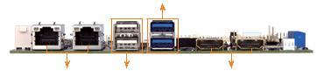

双网络 USB 2.0 HDMI

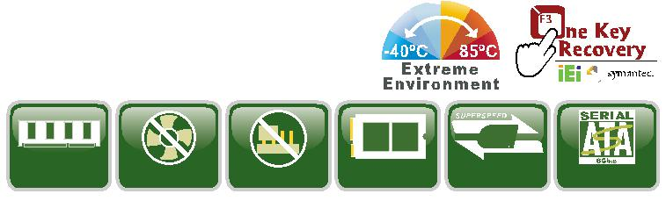

USB

|  |  |  |  |  |  |
| --- | --- | --- | --- | --- | --- |
| DDR3L | Fanless | Jumper-less M.2/NGFF | USB 3.0 | SATA 6Gb/s |  |
|  |  |

*产品特征*

* EPIC SBC 支持 Intel® 14nm Generation Atom™, Celeron® or Petium® 板载 SoC supports 单通道 DDR3L SO-DIMMs
* 支持独立三显
* 宽电压 9V~30V DC 输入设计
* COM, USB 3.0, SATA 6Gb/s, 支持 M.2 和音频
* 支持宽温操作: -40°C ~ 85°C

*包装清单*

|  |  |
| --- | --- |
| 1 x NANO-AL single board computer with Heatsink | 1 x Power cable |
| 1 x SATA with power cable kit | 1 x One Key Recovery CD |
| 1 x Screw set (for half-size PCIe Mini card) | 1 x QIG |
| 1 x RS-232 cable | 1 x Utility CD |

*订购信息*

|  |  |  |
| --- | --- | --- |
| 料号 | 描述 |  |
|  |  |  |
| NANO-AL-N2-R10 | EPIC SBC supports Intel® 14nm quad-core Pentium® N4200 2.5GHz |  |
| on-board SoC with Dual HDMI/LVDS/iDP, Dual PCIe GbE, USB 3.0, |  |
|  | PCIe Mini, M.2, SATA 6Gb/s, COM, Audio and RoHS |  |
|  | EPIC SBC supports Intel® 14nm dual-core Celeron® N3350 2.4GHz on- |  |
| NANO-AL-N1-R10 | board SoC with Dual HDMI/LVDS/iDP, Dual PCIe GbE, USB 3.0, PCIe |  |
|  | Mini, M.2, SATA 6Gb/s, COM, Audio and RoHS |  |
|  | EPIC SBC supports Intel® 14nm quad-core Atom™ E3950 2.0GHz on- |  |
| NANO-AL-E3W2-R10** | board SoC with Dual HDMI/LVDS/iDP, Dual PCIe GbE, USB 3.0, PCIe |  |
|  | Mini, M.2, SATA 6Gb/s, COM, Audio and RoHS, -40°C ~ 85°C |  |
|  | EPIC SBC supports Intel® 14nm quad-core Atom™ E3940 1.8GHz on- |  |
| NANO-AL-E2W2-R10 | board SoC with Dual HDMI/LVDS/iDP, Dual PCIe GbE, USB 3.0, PCIe |  |
|  | Mini, M.2, SATA 6Gb/s, COM, Audio and RoHS, -40°C ~ 85°C |  |
|  | EPIC SBC supports Intel® 14nm dual-core Atom™ E3930 1.8GHz on- |  |
| NANO-AL-E1W2-R10 | board SoC with Dual HDMI/LVDS/iDP, Dual PCIe GbE, USB 3.0, PCIe |  |
|  | Mini, M.2, SATA 6Gb/s, COM, Audio and RoHS, -40°C ~ 85°C |  |
| 32000-070301-RS | Dual-port USB cable, 210mm, P=2.0 |  |
| 32000-023800-RS | PS/2 KB/MS cable, 135mm, P=2.0 |  |
| DP-DP-R10 | DisplayPort to DisplayPort converter board (for IEI iDP connector) |  |
| DP-DVI-R10 | DisplayPort to DVI-D converter board (for IEI iDP connector) |  |
| DP-HDMI-R10 | DisplayPort to HDMI converter board (for IEI iDP connector) |  |
| DP-LVDS-R10 | DisplayPort to 24-bit daul-channel LVDS converter board |  |
| (for IEI iDP connector) |  |
|  |  |
| DP-VGA-R10 | DisplayPort to VGA converter board (for IEI iDP connector) |  |
|  |  |  |

**By order production, MOQ: 100

*1*

工业电脑

解决方案

视频采集

解决方案

工业系统

工业电脑机箱

电源/外设

NANO-AL/ALW2-2018-V10 1-106