

*工业电脑机箱*



*w w w . i e i w o r l d . c o m . c n*



RACK-220G 2U 6个插槽全长卡 机架式机箱

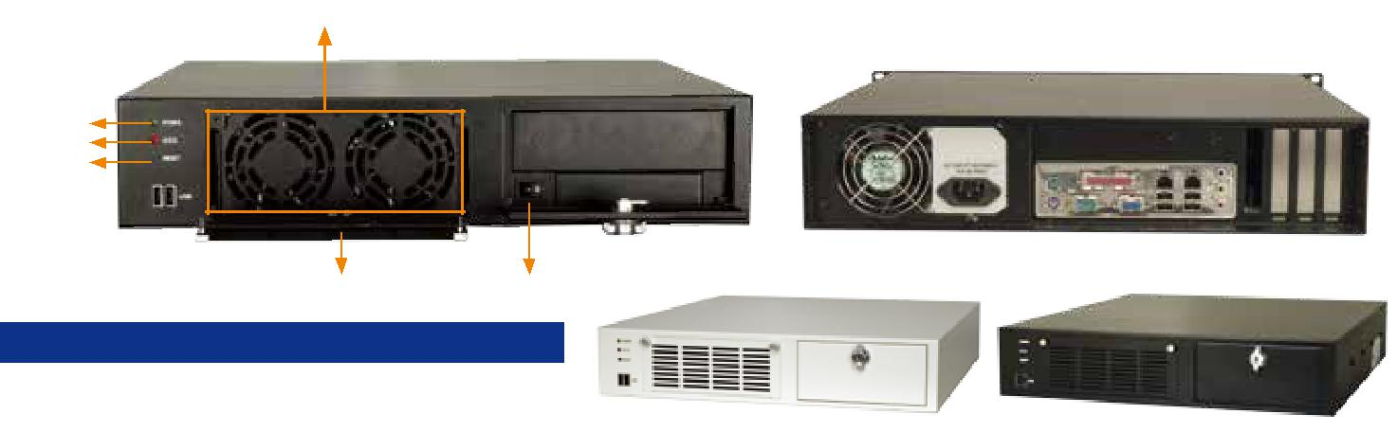

2 x 8 cm 滚轴风扇

电源 LED

HDD LED

重启键

2 x USB

RACK-220GBATX

可更换风扇过滤器 电源开关

产品包装不包括CD-ROM 和 HDD

RACK-220GW RACK-220GB

W-白色 B-黑色

*特性*

* 符合 RoHS 设计
* 前面板 2 个 USB 接口
* 2 个 8 cm 冷却风扇可更换风扇过滤器
* 1 个 5.25" 和 1 个 3.5" 驱动器
* 1 个 3.5" 内置硬盘驱动槽
* 冷却风扇可更换风扇过滤器

*规格*

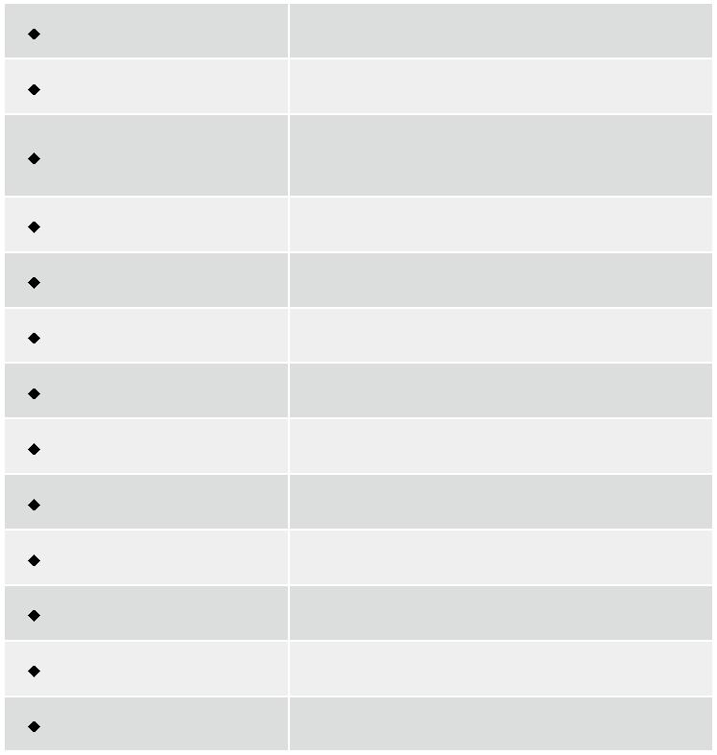

|  |  |
| --- | --- |
| 材质 | 重型金属 |
| 主板规格 | 全长CPU卡 |
|  | 1 x 5.25” |
| 驱动器 | 1 x 3.5” |
|  | 1 x 3.5” HDD (internal) |
| 散热风扇 | 2 x 8 cm |
| I/O 接口 | 2 x USB |
| 扩展槽 | 6 slots |
| 指示灯 | Power, HDD |
| 按钮 | 电源开关, 重启键 |
| 操作温度 | 0°C ~ 50°C |
| 操作湿度 | 10% ~ 90% |
| 颜色 | W: White/B: black |
| 净重/毛重 | 8.2 kg/12.4 kg |
| 尺寸(DxWxH) | 448 mm x 431 mm x 88 mm |

*尺寸 ( 单位 : mm)*

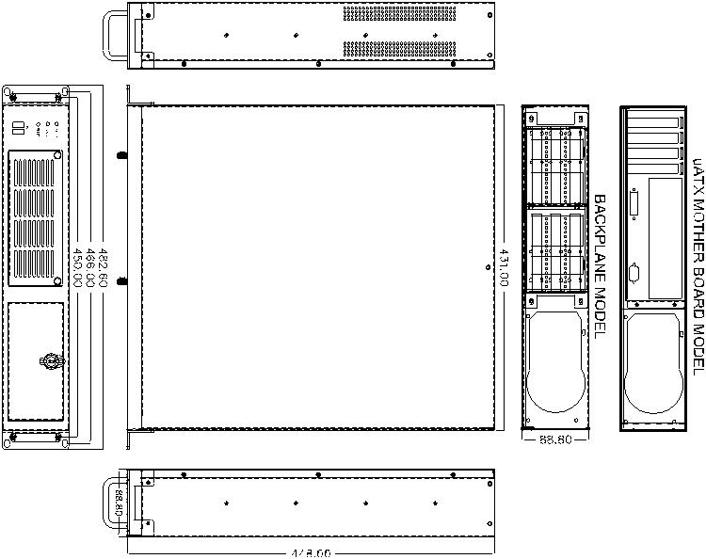

*选型指南*



|  |  |  |  |
| --- | --- | --- | --- |
| 型号 | SBC 类型 | PSU 类型 | 颜色 可选配件 |
|  |  |  |  |
| RACK-220G | PICMG 1.0 | PS/2 | black/White |
|  |  |  |  |
| RACK-220G ATX | microATX MB | PS/2 | black/White |
|  |  |  |  |

*底板 ( 选配 )*



|  |  |  |  |  |  |  |  |  |
| --- | --- | --- | --- | --- | --- | --- | --- | --- |
| 型号 | SBC 类型 | PCI | ISA |  | PCle |  | PSU 接口 |  |
|  |  |  |  |
| x1 | x4 | x16 |  |
|  |  |  |  |  |  |
|  |  |  |  |  |  |  |  |  |
| PCI-5SDA-RS | PICMG 1.0 | L2+R2 | 0 | 0 | 0 | 0 | AT/ATX |  |
|  |  |  |  |  |  |  |  |  |
| PCI-5SD5-RS | PICMG 1.0 | L2+R2 | 0 | 0 | 0 | 0 | AT |  |
|  |  |  |  |  |  |  |  |  |
| PCI-5SD6-RS | PICMG 1.0 | L2+R2 | 0 | 0 | 0 | 0 | ATX |  |
|  |  |  |  |  |  |  |  |  |
| PCI-6SD-RS | PICMG 1.0 | L1+R1 | L1+R1 | 0 | 0 | 0 | ATX |  |
|  |  |  |  |  |  |  |  |  |

*订购信息*



|  |  |
| --- | --- |
| 料号 | 描述 |

2U 6-slot full-size rackmount chassis for PICMG 1.0 SBC,

RACK-220G  /A130B (black/white), 2 x 8 cm fan, with ACE-A130B-R10 (300W ATX model), RoHS

2U microATX motherboard rackmount chassis, (black/

RACK-220G  ATX/A130B white), 2 x 8 cm fan, with ACE-A130B-R10 (300W ATX model), RoHS

 颜色 Code: B-黑色 W-白色

*电源 ( 选配 )*



|  |  |  |  |
| --- | --- | --- | --- |
| 类型 | 型号 | 功率 |  |
|  |  |  |  |
| AT | ACE-925AP-U-RS | 250W |  |
|  |  |  |
| ACE-935AL-RS | 300W |  |
|  |  |
|  |  |  |  |
| ATX | ACE-A130B-R10 | 300W |  |
|  |  |  |
| ACE-A140A-S-R11 | 400W |  |
|  |  |
|  |  |  |  |

RACK-220G 支持单个 PS/2 PSU 电源。想了解威强电更多的电源产品，请参考章节 5 或直接访问 www.ieiworld.com.cn



RACK-220G-2019-V10