单板计算机
工业主板

w w w . i e i w o r l d . c o m . c n

IMBA-C2260-i2-R11
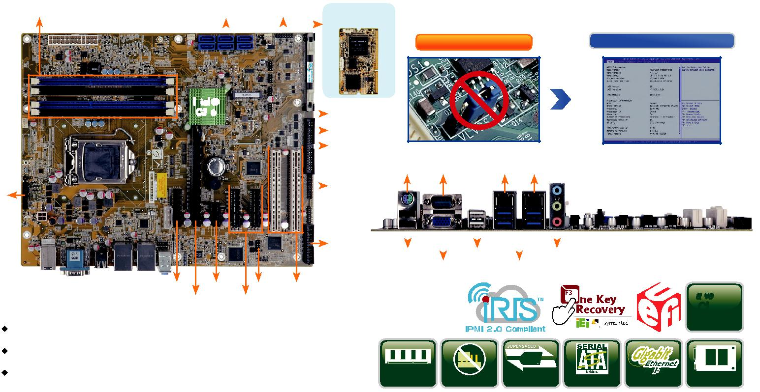

双通道 DDR3 1600/1333 MHz | SATA 6Gb/s前面板 |  |  |  |  | Slot for iRIS-
 |  |  |  |  |  | 2400 module

Intel ®
C226 |  |  |  |  |  |  |  |  |  | 2 x USB 2.0
 |  |  |  |  |  |  |  |  |  | RS-422/485
 |  |  |  |  |  |  |  |  |  | 4 x RS-232
 |  |  |  |  |  |  |  |  |  | TPM
iDP

LPT

 | PCIe x4 PCIe x1DIO 2 x PCI
产品规格 | PCIe x8PCIe x4

CPU

支持 LGA1150 Intel® Xeon® E3, Core ™ i3, Pentium® or Celeron® 处理器

芯片组

Intel® C226

内存

Four 240-pin 1600/1333 MHz 双通道 DDR3 & DDR3L SDRAM ECC 和 non-ECC 无缓冲 DIMMs 最高支持 32 GB

ATX 主板支持 22nm LGA1150 Intel® Xeon E3, Core™ i3, Pentium® 和 Celeron®, DDR3, VGA, dual Intel® PCIe GbE, USB 3.1Gen 1 (5Gb/s), SATA 6Gb/s, iRIS-2400 and RoHS

支持全免跳线

无跳线针 通过BIOS菜单进行跳线设置

Combo RJ-45:
KB/MS RS-232 LAN1 LAN2 / IPMI

2 x USB 2.0 |  |  |  |  |  | 2 x USB 2.0 |  |  |  |  | 音频
 |  |  | VGA |  |  |  |  | 4 x USB 3.1 Gen 1
Native 3
PCIe
Gen.

USB

DDR3 1600 Jumper-less USB 3.1 SATA 6Gb/s PCIe GbE mSATA

BIOS
UEFI BIOS

网络
LAN1: 支持 Intel® I217LM 以及 Intel® AMT 9.0

LAN2: 支持 Intel® I210-AT PCIe controller 以及 NCSI 图形引擎
Intel® HD Graphics Gen 7.5 支持 DX11.1 and OpenCL 1.2, OpenGL 3.2 Full MPEG2, VC1, AVC Decode
显示输出
1 x VGA ( 最高达 1920x1200@60 Hz)

1 x iDP interface for HDMI, LVDS, VGA, DVI, DP ( 最高达 3840x2160@60 Hz)‘

音频
Realtek ALC662 HD 音频编解码，支持 5.1-channel

3 x 音频插孔 ( 音频输出 , 音频输入 , 麦克风输入 ) on rear IO

1 x 前置音频 (2x5 pin)

外部 I/O 接口 |  | x | USB
1 x KB/MS | 4 |  |  | 2.0
1 x RS-232 | 4 x USB 3.1
内部 I/O 接口
1 x KB/MS (1x6 pin) | 1 x RS-422/485 (1x4 pin, P=2.0)
1 x LPT (2x13 pin, P=2.54) | 4 x RS-232 (2x20 pin, P=2.54)
1 x mSATA (colay SATA 6) | 4 x USB 2.0 (2x4 pin,P=2.54)
6 x SATA 6Gb/s ( 支持 RAID 0/1/5/10 )

前面板
1 x 前面板 (2x7 pin, power LED, HDD LED, 扬声器 , 电源按钮 , 重启按钮 )

LAN LED
2 x LAN LED (1x2 pin)

TPM
1 x TPM (2x10 pin)

SMBus
1 x SMBus (1x4 pin)

I²C
1 x I²C (1x4 pin)

iRIS 远程管理模块 : 1 x iRIS-2400 插槽

扩展
1 x PCIe x16 插槽

3 x PCIe x4 插槽 ( 支持 PCIe x1)

默认设置 : 1 x PCIe x8 Gen 3 + 2 x PCIe x4 Gen 3 signal

可选设置 : 1 x PCIe x16 Gen 3 by BIOS setting

1 x PCIe x1 插槽

2 x PCI 插槽

看门狗定时器 : 软件可编程 , 支持 1~255 秒系统复位
数字 I/O: 8-bit 数字 I/O (2x5 pin)

风扇接口
1 x CPU 风扇 (1x4 pin)

2 x 系统风扇 (1x3 pin)

电源 : ATX 电源

功耗
3.3V@0.57A, 5V@4.50A, 12V@0.14A, Vcore_12V@5.20A, 5VSB@0.19A (Intel® E3-1240 v3 3.4GHz CPU 以及 16 GB (4x4 GB) 1333 MHz DDR3 内存 )

工作温度 : -20°C ~ 60°C

存储温度 : -30°C ~ 70°C

工作湿度 : 5% ~ 95%, 无冷凝
尺寸 : 244mm x 305mm

重量 : GW: 1200g / NW: 700g

CE/FCC 标准

产品特征

1. 支持LGA1150 Intel® Xeon® E3/Core™ i3/Pentium®/Celeron® 处理器

2. 双通道 DDR3 1600/1333 MHz 最大支持 32 GB

3. 支持 Intel® PCIe GbE 以及 Intel® AMT 9.0

4. 支持 PCI Express generation 3.0 at 8GT/s I/O 带宽

5. 支持 USB 3.0, SATA 6Gb/s 和 mSATA

6. 高速接口用于一个PCIe x8 或者两个 PCIe x4 add-on 卡

7. IEI 免跳线功能

8. IEI 一键恢复解决方案可快速创建 OS 备份和恢复

9. 支持 IPMI 2.0 via iRIS-2400 模块

包装清单

1 x IMBA-C2260-i2 single board computer | 2 x SATA cable
1 x I/O shielding | 1 x QIG

订购信息
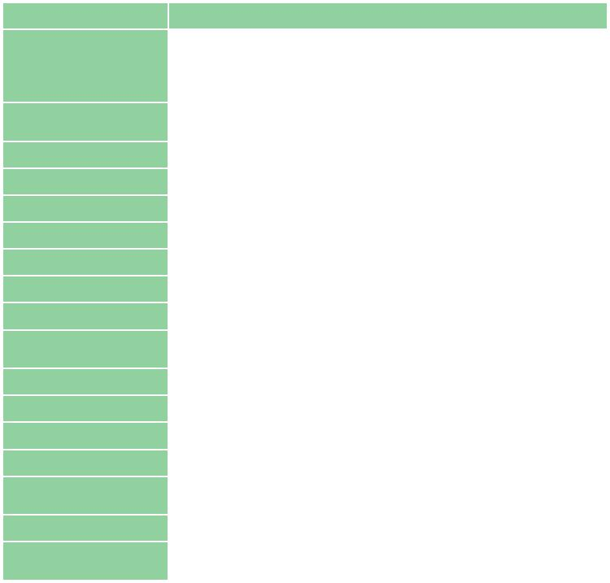

料号 | 描述
 | ATX motherboard supports 22nm LGA1150 Intel® Xeon E3,
IMBA-C2260-i2-R11 | Core™ i3, Pentium® and Celeron® per Intel® C226, DDR3, VGA,
 | Dual Intel® PCIe GbE, four USB 3.0, six SATA 6Gb/s, HD Audio,
 | iRIS-2400 and RoHS
iRIS-2400-R10 | IPMI 2.0 adapter card with AST2400 BMC chip for DDR3 SO-
 | DIMM socket interface
19800-000049-RS | LPT flat cable, 240mm, P=2.54
19800-000075-RS | PS/2 KB/MS cable with bracket, 220mm, P=2.0
19800-003100-300-RS | Dual port USB cable with bracket, 300mm, P=2.54
19800-010500-200-RS | USB 3.0 cable 457mm with bracket
32102-000100-200-RS | SATA power cable, MOLEX 5264-4P to SATA15P
32205-001203-200-RS | RS-232 cable, 40-pin to four DB-9, 400mm, P=2.54
32205-003800-300-RS | RS-422/485 cable, 200mm, P=2.0
CF-115XA-R10 | High performance LGA1155/LGA1156 cooler kit, 1U chassis
 | compatible, 73W
CF-115XE-R10 | High performance LGA1155/LGA1156 cooler kit, 95W
DP-DP-R10 | DisplayPort to DisplayPort converter board (for IEI iDP connector)
DP-DVI-R10 | DisplayPort to DVI-D converter board (for IEI iDP connector)
DP-HDMI-R10 | DisplayPort to HDMI converter board (for IEI iDP connector)
DP-LVDS-R10 | DisplayPort to 24-bit dual-channel LVDS converter board
 | (for IEI iDP connector)
DP-VGA-R10 | DisplayPort to VGA converter board (for IEI iDP connector)
TPM-IN01-R20 | 20-pin Infineon TPM module, software management tool, firmware
 | v3.17

IMBA-C2260-i2-2019-V10

